**Supplementary file**

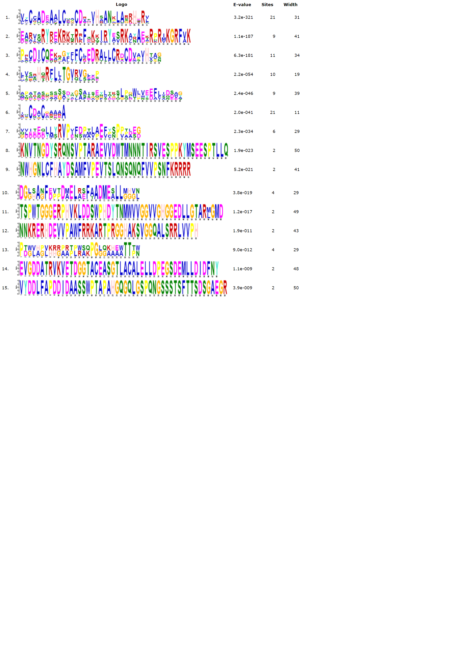

**Supplementary file S1 (Figure 1):** Sequence signatures of Sugarcane BBX domains.

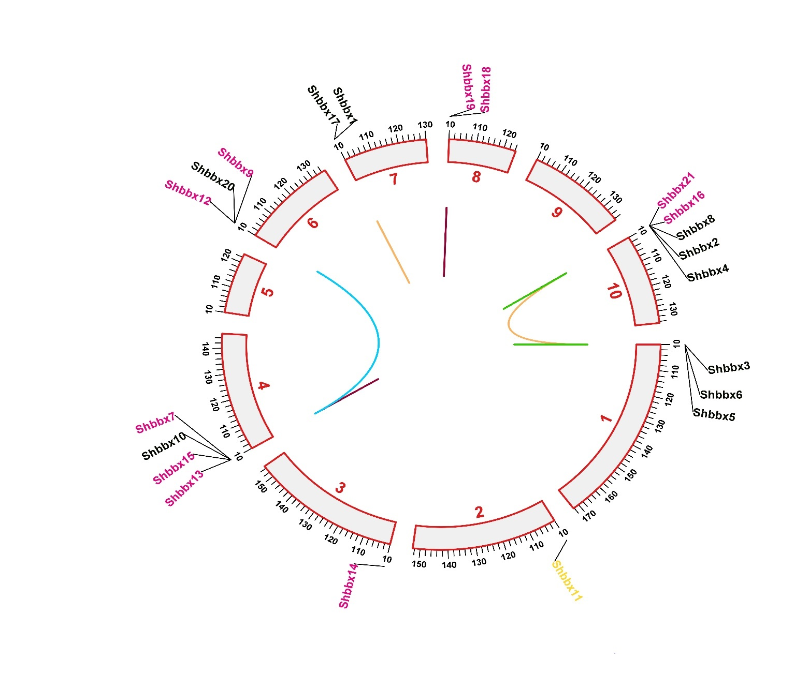

**Supplementary file S2 (Figure 2): Gene duplication of BBX gene of Sugarcane by constructing circos.**

**Supplementary file S3 (Table 1)**: Ka/Ks values of homologous *Shbbx* gene pairs

|  |  |  |  |  |  |
| --- | --- | --- | --- | --- | --- |
| **Genes pairs** | **ka** | **Ks** | **ka/ks ratio** | **Purify Selection** | **Time (Mya)** |
| *Shbbx* 1-*Shbbx*17 | 0.003148 | 0.017505 | 0.179833 | Yes | 1.334218 |
| *Shbbx4*-*Shbbx10* | 0.4274 | 0.58195 | 0.734427 | Yes | 44.35595 |
| *Shbbx3*-*Shbbx5* | 0.008107 | 0.029154 | 0.27806 | Yes | 2.222124 |
| *Shbbx2*-*Shbbx8* | 0.003495 | 0.004179 | 0.836512 | Yes | 0.318492 |
| *Shbbx*19-*Shbbx*20 | 0.4025 | 0.5602 | 0.718493 | Yes | 42.69817 |
| *Shbbx*11-*Shbbx*18 | 0.2486 | 0.46755 | 0.531708 | Yes | 35.63643 |
| *Shbbx9*-*Shbbx15* | 0.098419 | 0.20125 | 0.489038 | Yes | 15.33918 |
| *Shbbx16*-*Shbbx21* | 0.000957 | 1E-10 | 9567550 | No | 7.62E-09 |
| *Shbbx7*-*Shbbx13* | 0.028263 | 0.063735 | 0.443454 | Yes | 4.857814 |
| *Shbbx*12-*Shbbx*14 | 0.31725 | 0.37835 | 0.838509 | Yes | 28.83765 |

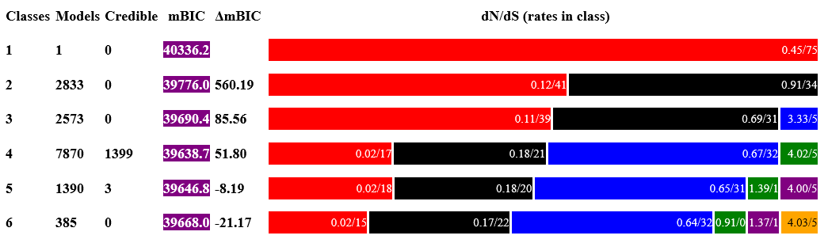

**Supplementary file S4 (Figure 3):** The credible set contains all the models evaluated by the Genetic Algorithm that are within 9.21 m BIC (Bayesian information criterion) units of the best model, or equivalently have evidence ratio of at least 0.01 compared to the best model. This set of models is used for rate estimation by model averaging.

**Supplementary file S5 (Table 2): The best model has the following rate class properties**

|  |  |  |  |  |  |
| --- | --- | --- | --- | --- | --- |
| **dN/dS** | **Rates in Class** | **Mean Model Averaged dN/dS** | **Stanfel class changes** | **Polarity changes** | **Charge changes** |
| 0.02 | 17 | 0.027 | 15 | 10 | 9 |
| 0.18 | 21 | 0.175 | 14 | 8 | 11 |
| 0.67 | 32 | 0.680 | 15 | 14 | 11 |

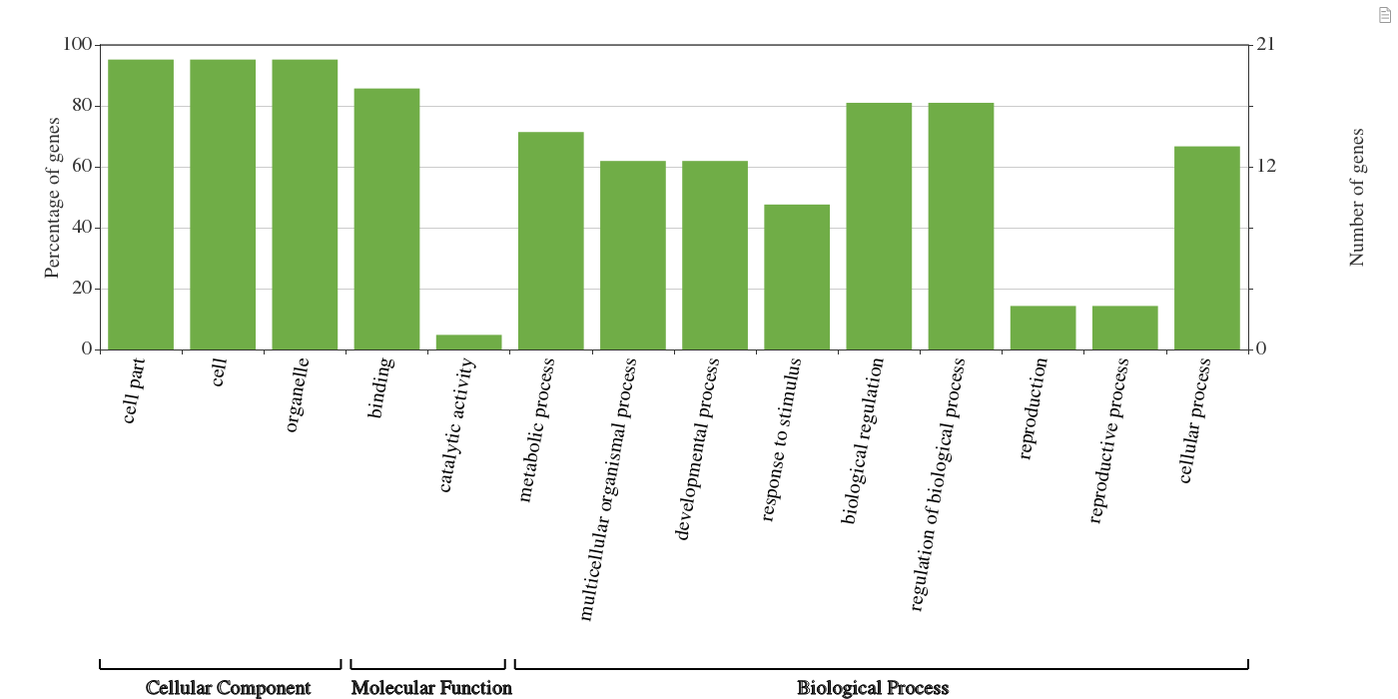

**Supplementary file S6 (Figure 4):** BBX transcription factor family members' gene ontology analysis in sugarcane

**Supplementary file S7 (Table 3): Comparison of Ramachandran plots of different *Shbbx* gene**

|  |  |  |  |  |  |
| --- | --- | --- | --- | --- | --- |
| **Gene Name** | ***Shbbx20*** | ***Shbbx17*** | ***Shbbx5*** | ***Shbbx4*** | ***Shbbx 14*** |
| Favoured regions | 93.7% | 93.2% | 92.7% | 96.5% | 83.9% |
| Allowed regions | 6.3% | 6.8% | 7.3% | 3.5% | 15.1% |
| Generously allowed | 0.0% | 0.0% | 0.0% | 0.0% | 1.1% |

**Supplementary file S8 (Table 4): Energy minimisation values for different *Shbbx* gene**

|  |  |  |  |  |  |
| --- | --- | --- | --- | --- | --- |
| **Gene Name** | ***Shbbx20*** | ***Shbbx17*** | ***Shbbx5*** | ***Shbbx4*** | ***Shbbx 14*** |
| **KJ/mol (Energy)** | **-3612.846** | **-809.338** | **-3136.952** | **-5850.369** | **-3431.020** |

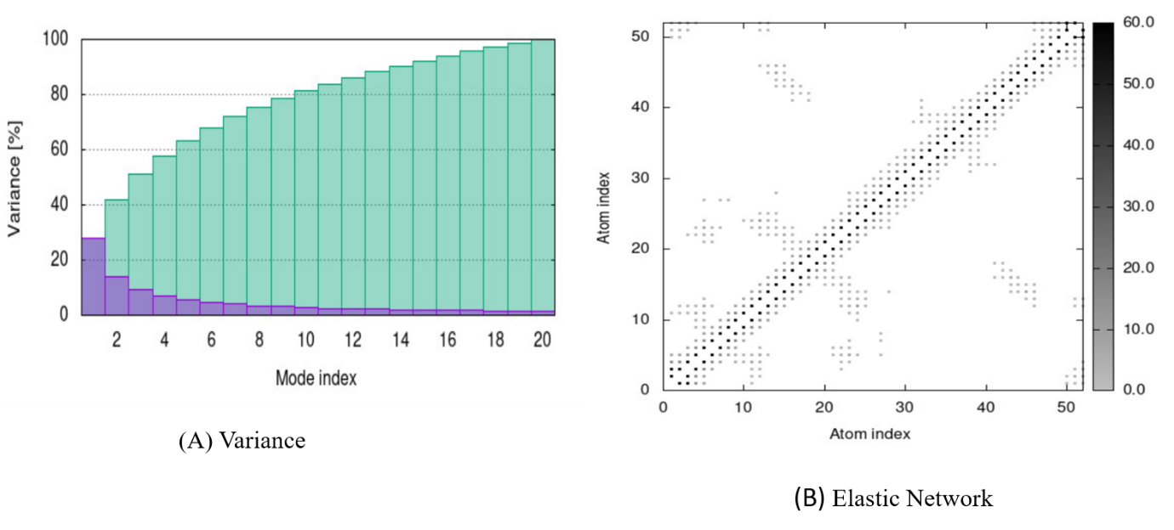

**Supplementary file S9 (**Figure 5): *In silico* simulation of SWISS-MODEL predicted 3-D structure of *Shbbx* genes