

**Fig. S1.** 1H NMR of the Bak from *Phex* of *P. corylifolia*

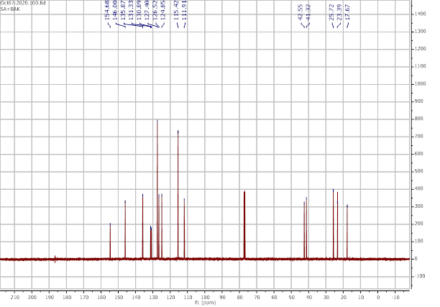

**Fig. S2.**13C NMR of the Bak from *Phex* of *P. corylifolia.*

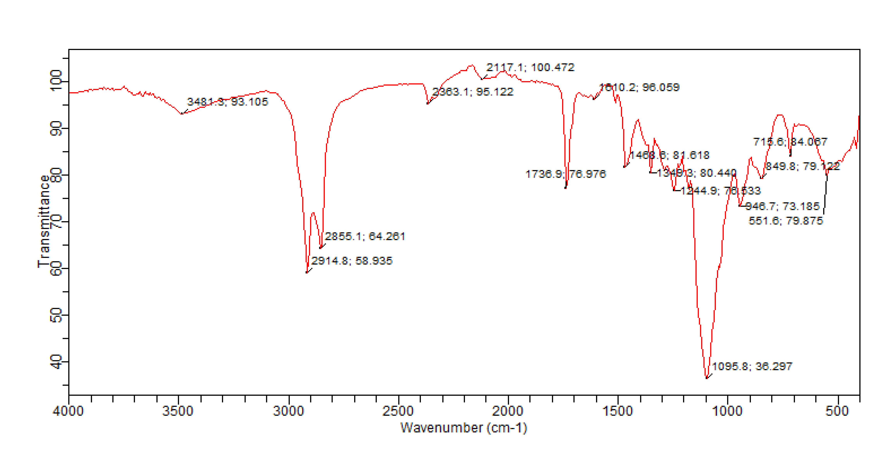

**Fig S3.** FT-IR (Fourier-transform infrared) spectrum of the Bak from *Phex* of *P. corylifolia.*

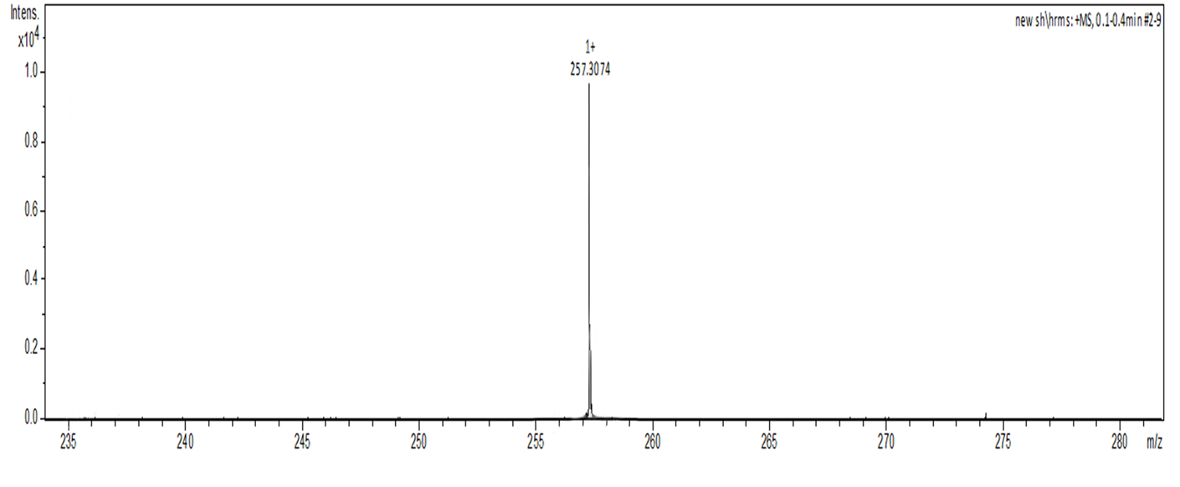

**Fig. S4.** The HRMS (High-Resonance Mass Spectroscopy) chromatogram of the Bak from *Phex* of *P. corylifolia*.

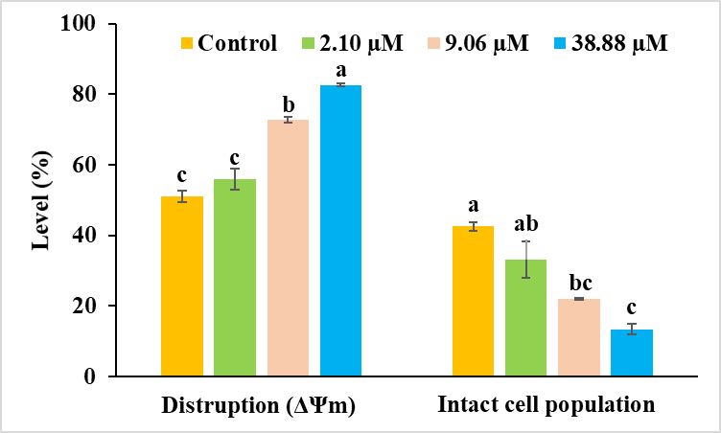

**Fig. S5.** Histograms showing disruption of mitochondrial membrane potential (ΔΨm) and intact cell population after treatment with IC30 (2.10 µM/ml), IC50 (9.06 µM/ml), IC70 (38.88 µM/ml) of bakuchiol isolated from *P. corylifolia* using flow cytometer. Experiments were repeated at least three times. Data are presented as Mean ± SE. Data labels with different letters (a, b, c and d) represent significant difference among them at the level of significance p ≤ 0.05.

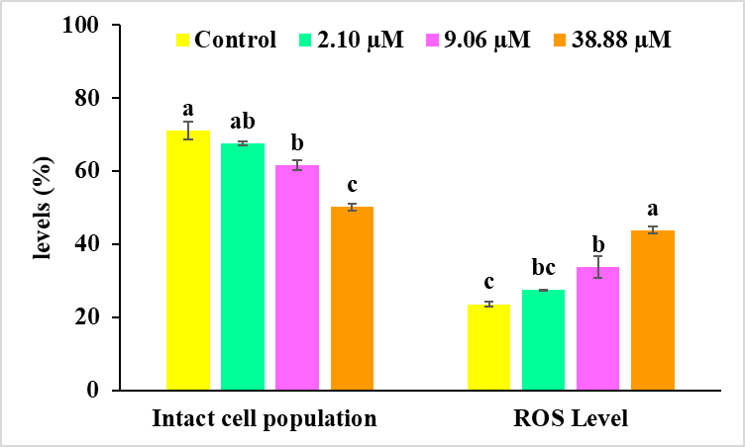

**Fig. S6.** Histograms showing accumulation of reactive oxygen species and intact cell population after treatment with IC30 (2.10 µM/ml), IC50 (9.06 µM/ml), IC70 (38.88 µM/ml) of bakuchiol isolated from *P. corylifolia* using flow cytometer. Experiments were repeated at least three times. Data are presented as Mean ± SE. Data labels with different letters (a, b, c and d) represent significant difference among them at the level of significance p ≤ 0.05.

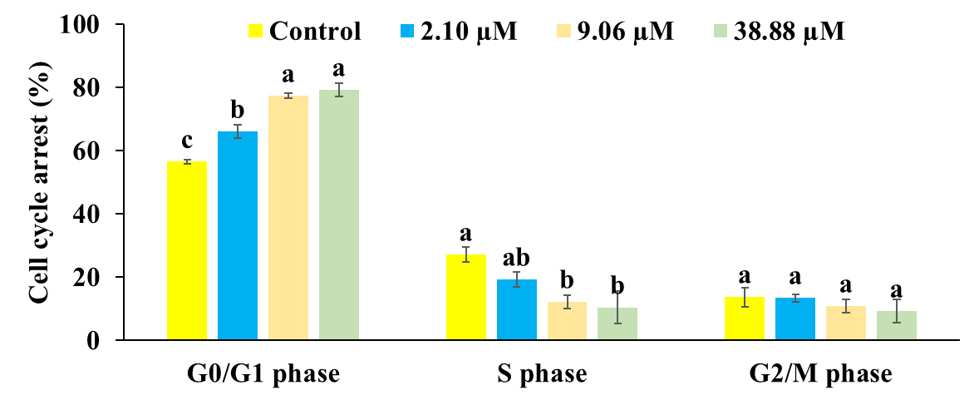

**Fig. S7.** Histograms showing distribution of cells at different phases G0/G1, S and G2/M of cell cycle after treatment with IC30 (2.10 µM/ml), IC50 (9.06 µM/ml), IC70 (38.88 µM/ml) of bakuchiol isolated from *P. corylifolia* using flow cytometer. Experiments were repeated at least three times. Data are presented as Mean ± SE. Data labels with different letters (a, b, c and d) represent significant difference among them at the level of significance p ≤ 0.05.

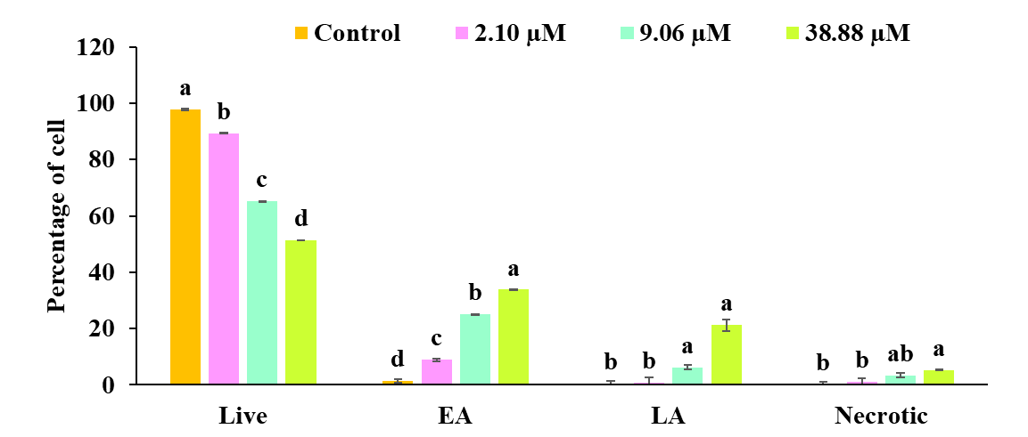

**Fig. S8.** Histograms showing percentage of Live, EA, LA and necrotic cells using Annexin V-FITC double staining using flow cytometry after treatment with IC30 (2.10 µM/ml), IC50 (9.06 µM/ml), IC70 (38.88 µM/ml) of bakuchiol isolated from *P. corylifolia* respectively. Experiments were repeated at least three times. Data are presented as Mean ± SE. Data labels with different letters (a, b, c and d) represent significant difference among them at the level of significance p ≤ 0.05.