**Supplementary file**

______________________________________________________________________________

**General Method**

*Chemistry*

All the required starting materials precured from sigma Aldrich, USA. Nuclear Magnetic Resonance (NMR) spectra were recorded on a Varian Mercury JEOL 500 NMR spectrometers in CDCl3 using TMS as internal standard. Chemical shifts are given in parts per million (δ-scale) and coupling constants are given in hertz. Elemental analyses were performed on a Perkin Elmer 2400 Series II Elemental CHNS analyzer.

Spirocompound **4a**: 1H NMR (CDCl3, 500 MHz): *δ*/ppm 2.91-2.94 (dd, 1H, *J* =13.0, 2.5 Hz), 3.23-3.28 (dd, 1H, *J* =13.0, 10.0 Hz), 4.78-4.82 (m, 1H), 4.98 (d, 1H, *J* = 9.5 Hz), 6.61 (d, 1H, *J* = 7.5 Hz, ArH), 6.71 (t, 1H, *J* = 7.5 Hz, ArH), 6.97-7.15 (m, 5H, ArH), 7.20-7.28 (m, 6H, ArH), 7.42 (s, 1H, ArH), 7.50-7.54 (m, 2H, ArH), 7.62-7.65 (m, 2H, ArH); 13C NMR (CDCl3, 125 MHz) *δ*/ppm: 41.6, 56.0, 63.5, 72.1, 73.2, 109.8, 122.2, 122.7, 122.9, 125.5, 125.6, 126.0, 127.5, 128.3, 128.5, 129.2, 129.5, 129.9, 134.7, 135.5, 135.7, 140.8, 141.1, 142.1, 142.3, 178.6, 197.8, 198.9; LC/MS(ESI): *m/z* = 484 (M+); Anal. Calcd for C32H24N2O3: C, 79.32; H, 4.99; N, 5.78; Found C, 79.44; H, 5.09; N, 5.89.

Spirocompound **4b**: 1H NMR (CDCl3, 500 MHz): *δ*/ppm 2.90-2.93 (dd, 1H, *J* = 13.0, 3.0 Hz), 3.23-3.28 (dd, 1H, *J* = 13.0, 9.5 Hz), 4.73-4.78 (m, 1H), 4.95 (d, 1H, *J* = 9.5 Hz), 6.68-6.73 (m, 2H, ArH), 6.99 (t, 1H, *J* = 7.5 Hz), 7.05 (d, 1H, *J* = 7.5 Hz, ArH), 7.10-7.14 (m, 3H, ArH), 7.19-7.30 (m, 6H, ArH), 7.55-7.57 (m, 2H, ArH), 7.65-7.67 (m, 2H, ArH); 13C NMR (CDCl3, 125 MHz) *δ*/ppm: 41.7, 55.0, 63.7, 71.8, 73.6, 110.2, 121.5, 122.2, 122.8, 123.0, 125.2, 126.1, 128.3, 129.5, 130.0, 131.0, 131.6, 134.4, 135.7, 135.9, 140.4, 141.3, 142.1, 142.2, 179.0, 197.5, 198.8; LC/MS(ESI): *m/z* = 563 (M+); Anal. Calcd for C32H23BrN2O3: C, 68.21; H, 4.11; N, 4.97; Found C, 68.32; H, 4.20; N, 5.06.

Spriocompound, **4c:** 1H NMR (CDCl3, 500 MHz): *δ*/ppm 2.91-2.94 (m, 1H), 3.30-3.35 (m, 1H), 4.63-4.65 (m, 1H), 5.85 (d, 1H, *J* = 9.5 Hz), 6.71-6.73 (m, 2H, ArH), 6.89-6.90 (m, 1H, ArH), 6.97-7.26 (m, 8H, ArH), 7.53-7.66 (m, 4H, ArH), 8.11 (s, 1H); 13C NMR (CDCl3, 125 MHz) *δ*/ppm: 41.6, 51.5, 65.3, 71.9, 72.9, 110.2, 122.1, 122.6, 123.2, 125.5, 125.7, 125.9, 128.2, 128.4, 129.2, 129.4, 129.8, 129.9, 130.0, 132.7, 135.6, 135.7, 136.0, 140.2, 141.8, 141.9, 142.3, 179.1, 196.7, 199.2 ; LC/MS(ESI): *m/z* = 518 (M+); Anal. Calcd for C32H23ClN2O3: C, 74.06; H, 4.47; N, 5.40; Found C, 74.17; H, 4.60; N, 5.51.

Spirocompound **4d:** 1H NMR (CDCl3, 500 MHz): δ/ppm 2.91-2.94 (dd, 1H, *J* = 13.0, 3.0 Hz), 3.24-3.28 (dd, 1H, *J* = 13.0, 9.5 Hz), 4.74-4.79 (m, 1H), 4.97 (d, 1H, *J* = 9.5 Hz), 6.69-6.73 (m, 2H, ArH), 6.99 (t, 1H, *J* = 7.5 Hz), 7.04-7.06 (m, 3H, ArH), 7.11-7.26 (m, 7H, ArH), 7.53-7.58 (m, 2H, ArH), 7.63-7.67 (m, 2H, ArH), 8.24 (s, NH, 1H); 13C NMR (CDCl3, 125 MHz) δ/ppm: 41.7, 55.0, 63.7, 71.9, 73.6, 110.2, 122.2, 122.8, 123.0, 125.2, 125.3, 126.1, 128.3, 128.7, 129.5, 130.1, 130.6, 133.6 135.9, 140.4, 142.1, 142.2, 179.0, 197.6, 198.8; LC/MS(ESI): m/z = 518 (M+); Anal. Calcd for C32H23ClN2O3: C, 74.06; H, 4.47; N, 5.40; Found C, 74.15; H, 4.59; N, 5.52.

Spirocompound, **4e**: 1H NMR (CDCl3, 500 MHz): *δ*/ppm 2.39 (s, 3H), 2.82-2.84 (m, 1H), 3.22-3.26 (m, 1H), 4.66-4.70 (m, 1H), 5.60 (d, 1H, *J* = 9.5 Hz), 6.70 (m, 2H, ArH), 6.91-7.02 (m, 4H, ArH), 7.12-7.23 (m, ArH, 6H), 7.40 (d, 1H, *J* = 7.5 Hz, ArH), 7.48-7.60 (m, 3H, ArH), 7.73 (d, 1H, *J* = 7.5 Hz), 8.35 (s, brs, NH); 13C NMR (CDCl3, 125 MHz) *δ*/ppm: 20.2, 41.4, 51.1, 65.9, 72.0, 73.4, 110.3, 122.3, 122.9, 123.0, 123.2, 125.8, 125.9, 125.7, 127.0, 128.3, 128.4, 129.7, 129.7, 131.1, 133.4, 135.7, 135.8, 138.7, 140.9, 141.9, 142.3, 142.5, 179.7, 198.3, 199.2; LC/MS(ESI): *m/z* = 498 (M+); Anal. Calcd for C33H26N2O3: C, 79.50; H, 5.26; N, 5.62; Found C, 79.62; H, 5.38; N, 5.71.

Spirocompound **4f**: 1H NMR (CDCl3, 500 MHz): *δ*/ppm 2.14 (s, 3H), 2.90-2.92 (m, 1H), 3.22-3.26 (m, 1H), 4.74-4.78 (m, 1H), 4.95 (d, 1H, *J* = 9.5 Hz), 6.68-6.69 (m, 2H, ArH), 6.89-7.27 (m, ArH, 11H), 7.51-7.64 (m, ArH, 4H), 8.19 (s, brs, NH); 13C NMR (CDCl3, 125 MHz) *δ*/ppm: 21.0, 41.5, 55.6, 63.7, 72.1, 73.5, 110.1, 122.1, 122.7, 122.9, 125.3, 125.6, 126.0, 128.3, 129.1, 129.2, 129.5, 129.9, 131.6, 135.4, 135.6, 137.1, 141.0, 141.4, 142.2, 142.3, 179.2, 197.9, 199.0; LC/MS(ESI): *m/z* = 498 (M+); Anal. Calcd for C33H26N2O3: C, 79.50; H, 5.26; N, 5.62; Found C, 79.63; H, 5.35; N, 5.73.

Spirocompound, **4g**: 1H NMR: *δH* 2.88-2.95 (1H, m), 3.23-3.28 (1H, m), 3.66 (3H, s), 4.75-4.79 (1H, m), 4.96 (1H, d, *J* = 10.0 Hz), 6.56-6.58 (1H, m, ArH), 6.63 (1H, d, *J* = 8.0 Hz, ArH), 6.71 (1H, t, *J* = 7.5 Hz, ArH), 6.74 (1H, m, ArH), 6.82-6.83 (1H, m, ArH), 6.97-7.00 (2H, m, ArH), 7.07 (1H, d, *J* = 7.5 Hz, ArH), 7.12-7.15 (1H, m, ArH), 7.20-7.29 (3H, m, ArH), 7.53-7.57 (2H, m, ArH), 7.64-7.65 (2H, m, ArH), 7.74 (1H, s, ArH); 13C NMR *δ*C 41.6, 55.2, 56.0, 63.6, 72.0, 73.3, 109.9, 113.5, 114.6, 121.5, 122.2, 122.8, 122.9, 125.4, 125.6, 126.0, 129.3, 129.4, 129.5, 129.9, 135.5, 135.7, 136.3, 140.8, 141.2, 142.2, 142.3, 159.4, 178.8, 197.8, 198.9, LC/MS(ESI): m/z = 514 (M+); CHN Analysis for C33H26N2O4: C, 77.03; H, 5.09; N, 5.44; Found C, 77.12; H, 5.16; N, 5.56.

Spirocompound, **4h**: 1H NMR: *δH* 2.89-2.92 (1H, m), 3.20-3.25 (1H, m), 3.64 (3H, s), 4.73-4.75 (1H, m), 4.92 (1H, d, *J* = 10.0 Hz), 6.55-6.69 (3H, m, ArH), 6.97-7.26 (11H, m, ArH), 7.52-7.63 (3H, m, ArH); 13C NMR *δ*C 41.5, 55.1, 55.4, 63.8, 72.1, 73.3, 109.9, 113.9, 122.2, 122.7, 122.9, 125.3, 125.7, 125.9, 126.5, 128.3, 129.5, 129.9, 130.3, 135.5, 135.7, 140.9, 141.3, 142.2, 142.4, 158.8, 178.9, 197.9, 199.1; LC/MS(ESI): m/z = 514 (M+); CHN Analysis for C33H26N2O4: C, 77.03; H, 5.09; N, 5.44; Found C, 77.11; H, 5.18; N, 5.52.

Spirocompound, **4i**: 1H NMR: *δH* 2.80-2.83 (1H, m), 2.91-2.94 (1H, m), 4.74-4.76 (1H, m), 4.96 (1H, d, *J* = 10.0 Hz), 6.64-6.77 (4H, m, ArH), 6.91-7.24 (9H, m, ArH), 7.50-7.64 (3H, m, ArH), 7.86-7.88 (1H, m, ArH); 13C NMR *δ*C 41.7, 55.1, 63.7, 72.0, 73.3, 109.9, 115.4, 122.2, 122.9, 125.3, 125.6, 126.0, 128.1, 128.2, 129.4, 129.9, 130.7, 130.8, 135.5, 135.8, 140.5, 141.2, 142.3, 178.9, 197.7, 198.9; LC/MS(ESI): m/z = 502 (M+); CHN Analysis for C32H23FN2O3: C, 76.48; H, 4.61; N, 5.57; Found C, 76.59; H, 4.70; N, 5.69.

Spirocompound, **4j**: 1H NMR: *δH* 2.75-2.79 (1H, m), 3.07-3.11 (1H, m), 4.61-4.67 (1H, m), 4.84 (1H, d, *J* = 10.0 Hz), 6.38-6.44 (2H, m, ArH), 6.70-7.01 (9H, m, ArH), 7.28-7.42 (4H, m, ArH), 7.59-7.61 (1H, m, ArH), 7.77-7.80 (1H, m, ArH); 13C NMR *δ*C: 46.8, 59.1, 68.2, 76.6, 78.6, 114.9, 126.3, 127.0, 127.6, 128.9, 129.5, 130.8, 132.9, 133.9, 134.1, 140.2, 140.6, 140.7, 142.5, 144.5, 146.6, 146.8, 147.0, 152.6, 183.2, 201.5, 203.1. LC/MS(ESI): m/z = 529 (M+); CHN analysis C32H23N3O5: C, 72.58; H, 4.38; N, 7.94; Found C, 72.69; H, 4.47; N, 8.05.

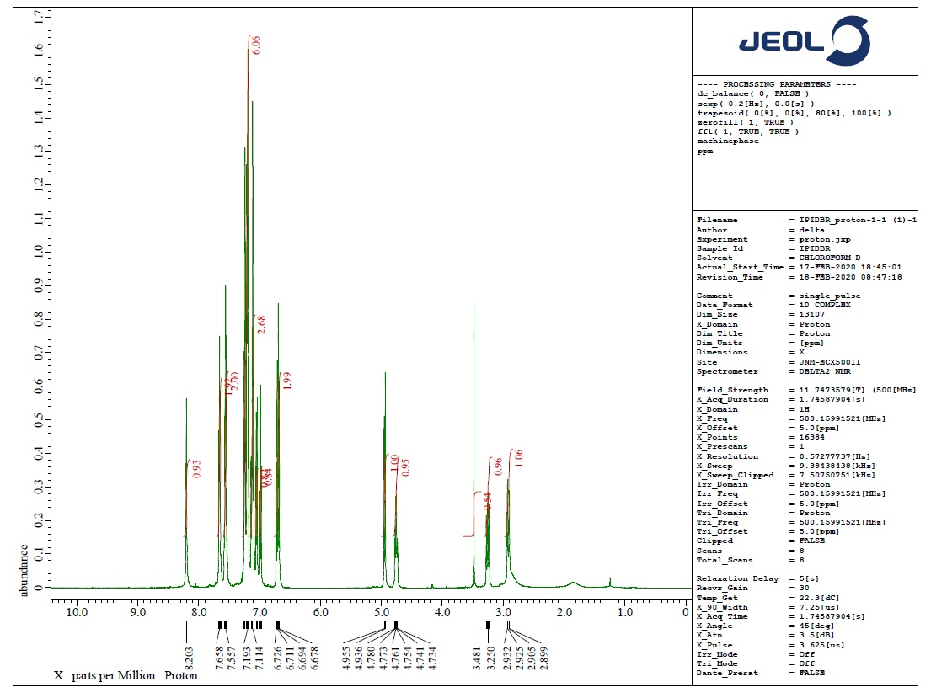

**Figure** 1. 1H NMR spectrum of **4b**

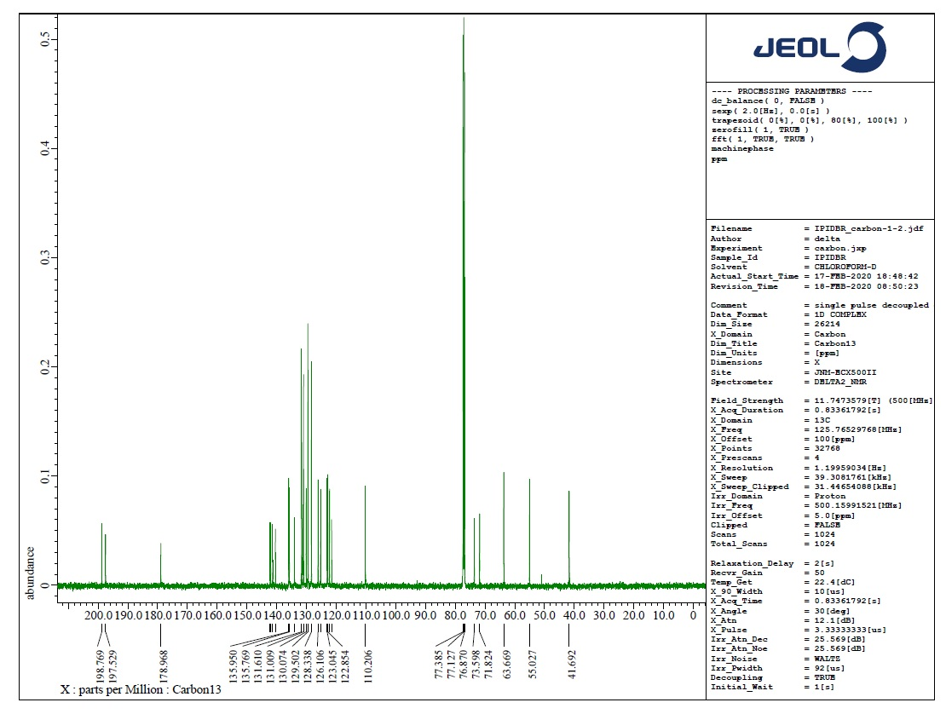

**Figure** 2. 13C NMR spectrum of **4b**

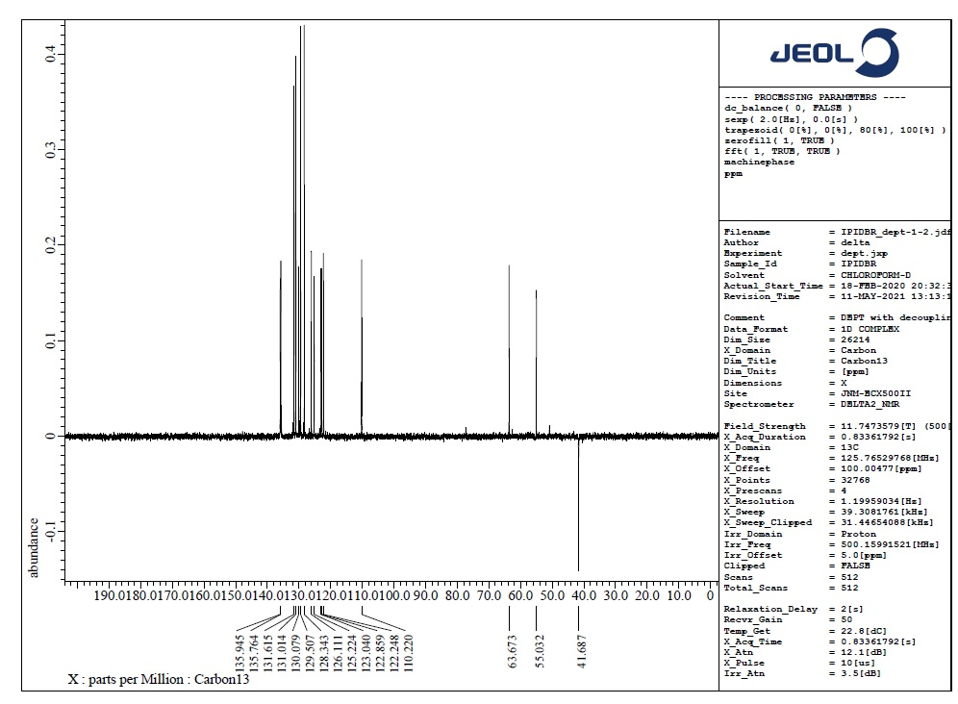

**Figure** 3. DEPT-135 spectrum of **4b**

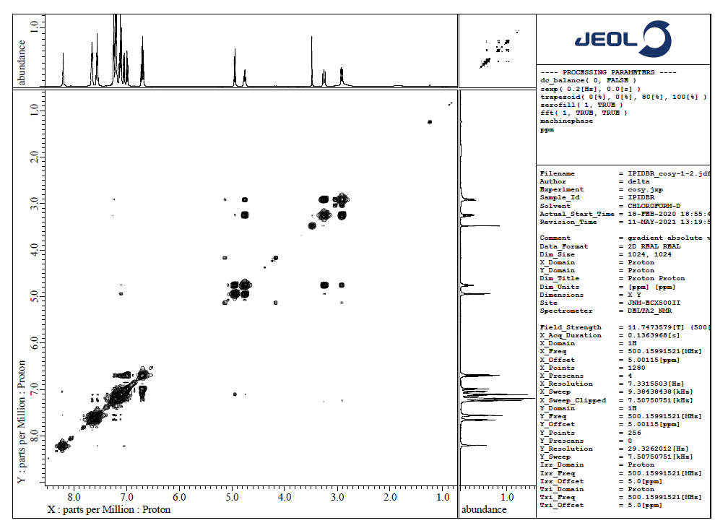

**Figure** 4. 1H, 1H-COSY NMR spectrum of **4b**

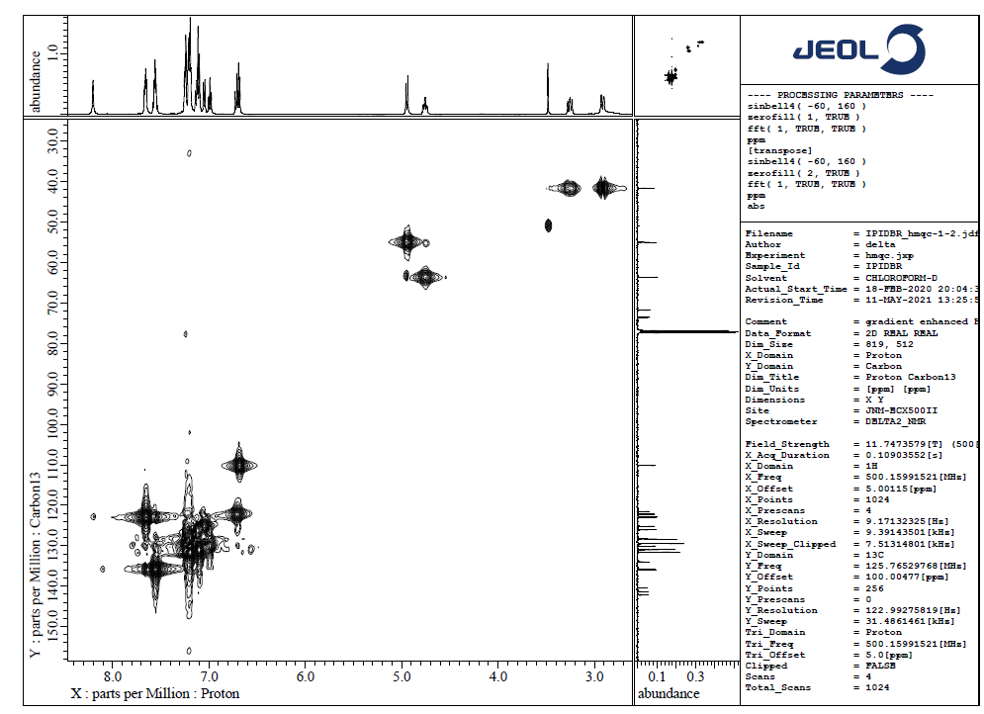

**Figure** 5. HMQC spectrum of **4b**

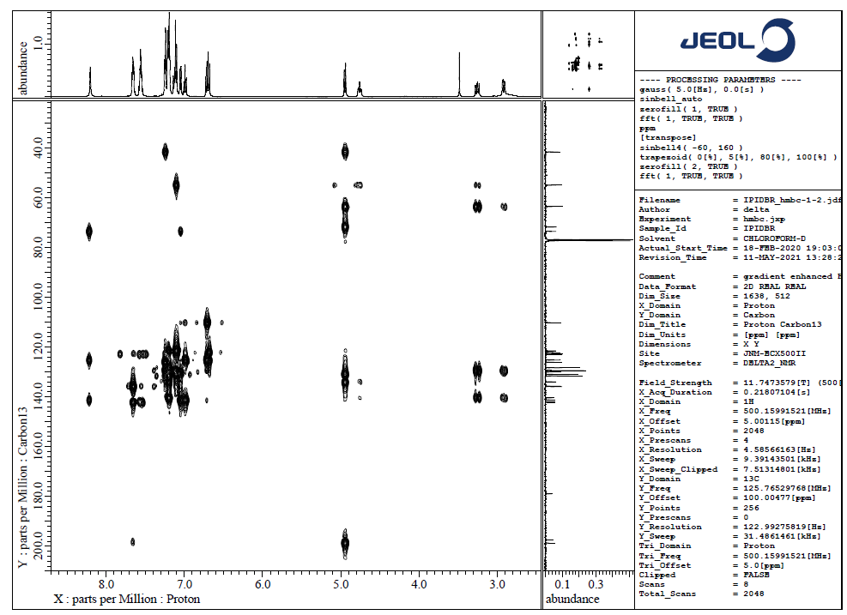

**Figure** 6. HMBC spectrum of **4b**

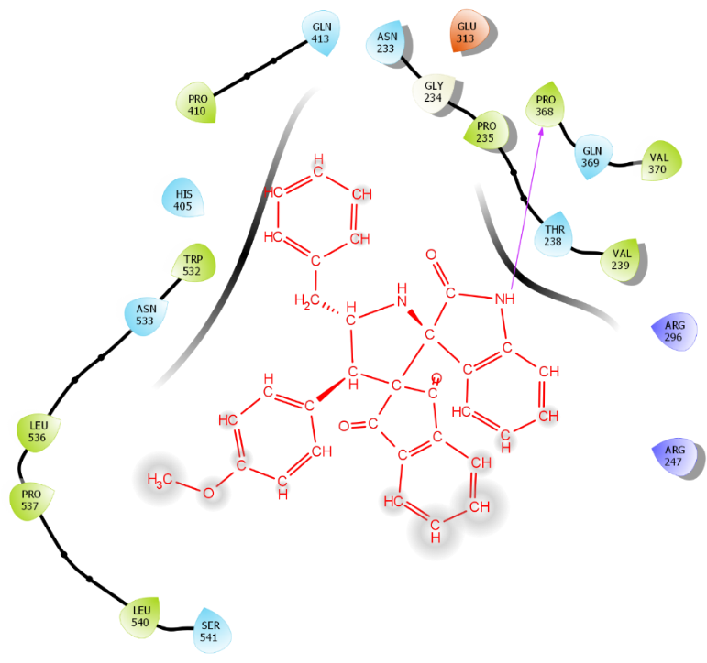

**Figure 7.** Activeamino acid in the binding site of AChE interacting with spiropyrrolidines, **4h**

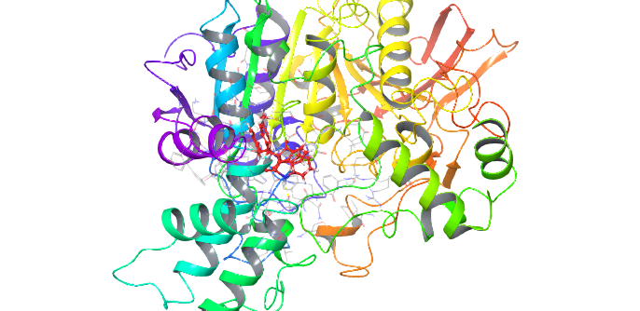

**Figure 8.** Ribbon structural view of molecular interaction on human AChE with spiropyrrolidines, **4h**

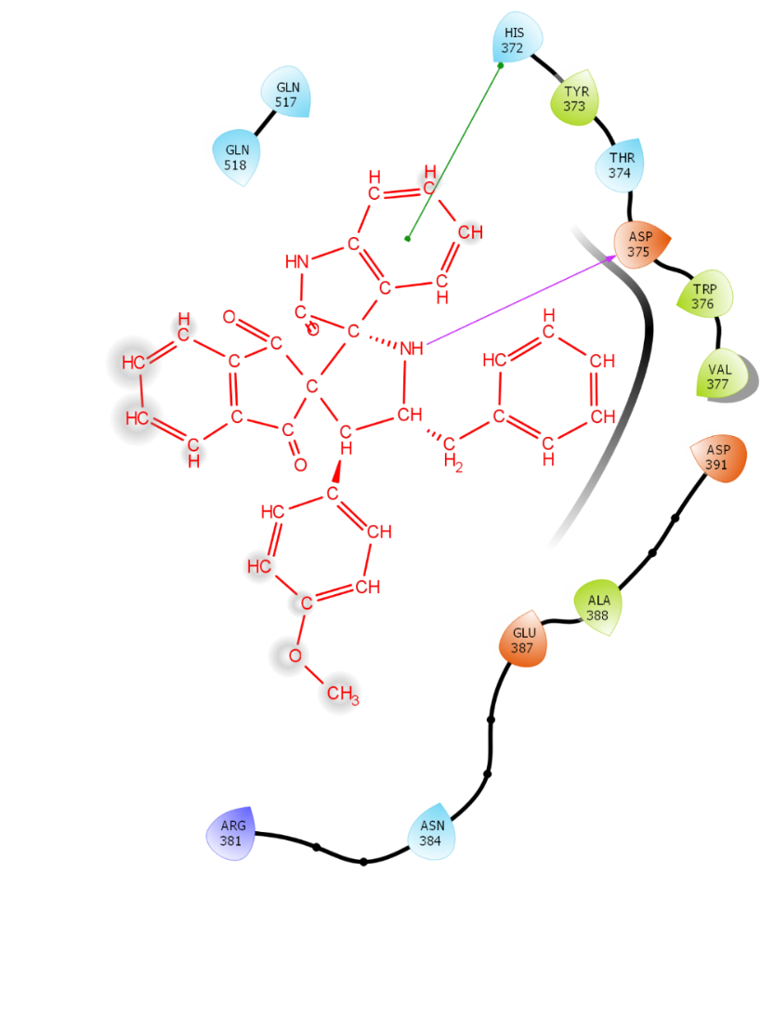

**Figure 9.** Spiropyrrolidines **4h** interaction with amino acid in the binding site of BChE

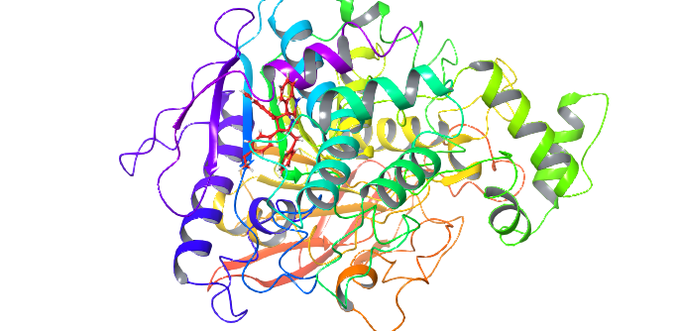

**Figure** **10**. Ribbon structural view of molecular interaction on of human BChE with spiropyrrolidines, **4h**

**Table 2.** Intermolecular interaction between the compound 4h with 2WIJ and 4EY6

|  |  |  |  |  |  |  |  |  |  |  |
| --- | --- | --- | --- | --- | --- | --- | --- | --- | --- | --- |
| **S.No** | **Protein ID** | **Energy** | **glide gscore** | **glide evdw** | **glide ecoul** | **glide energy** | **glide emodel** | **XP HBond** | **Aminoacid interaction Interaction** | **Bonding Information** |
| 1 | 2WIJ | 40.862 | -6.292 | -36.7 | -11.626 | -48.325 | -61.394 | -0.9 | ASP 375,HIS 372 | Hydrogen bond, PI-PI STACKING |
| 2 | 4EY6 | 64.078 | -5.459 | -47.094 | -6.055 | -53.149 | -71.197 | -0.9 | PRO368 | Hydrogen bonding |