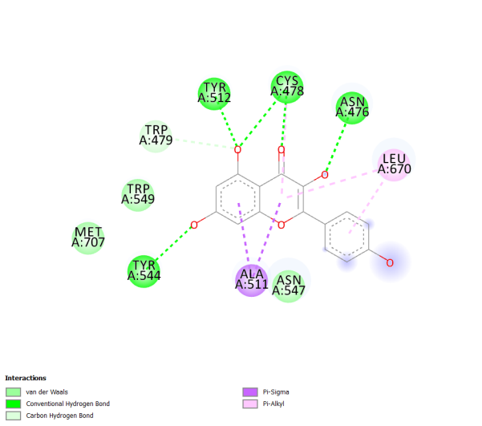 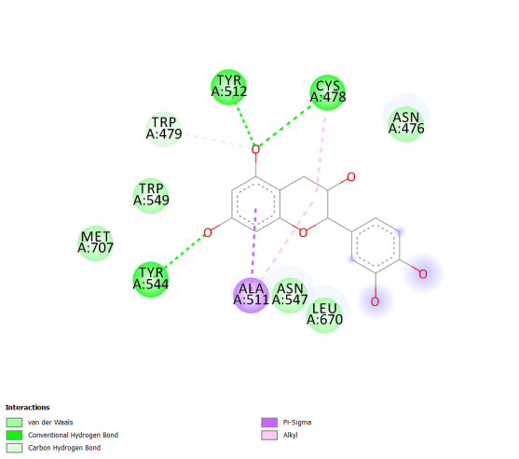

a b

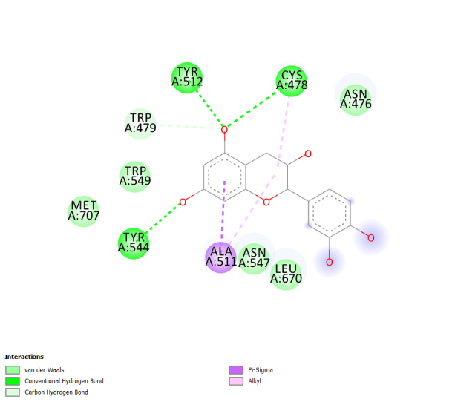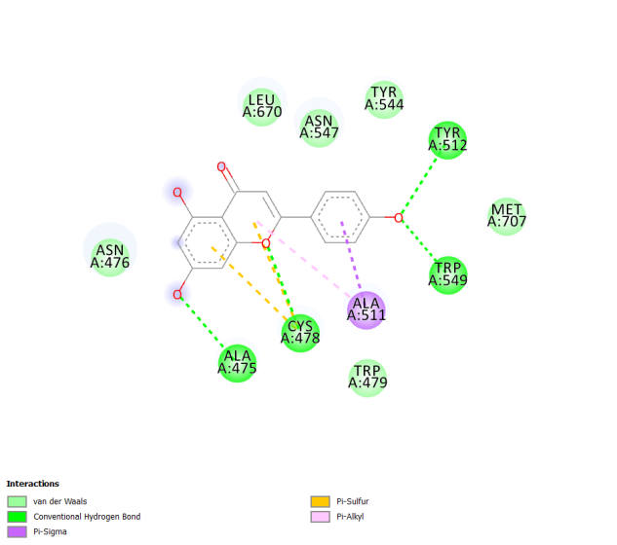

c d

Supplementary Figure 1: 2D Interaction diagram of (a) Kaempferol (b) (-)-Epicatechin (c) (+)-Catechin (d) Apigenin with residues of nsP2pro