|  |  |
| --- | --- |
| Cellular component | 1. Membrane 2. Integral to membrane |
| Biological process | 1. Metabolic process 2. Oxidation reduction 3. Cellular process 4. Cellular metabolic process |
| Biochemical function | 1. Catalytic activity 2. Oxidoreductase activity 3. Monooxygenase activity 4. Binding |

Supplementary table 1. pMMO Gene Ontology

Supplementary table 2. Characteristic comparison among pMMO proteins

|  |  |  |  |  |  |  |
| --- | --- | --- | --- | --- | --- | --- |
| ­­PDB ID | Number of amino | N.CU | N.Zn | N. Chain | Extra ligand | Organism |
| 1YEW | 382 | 1 his 48,72 , Gln 404  Cu-Cu | 1 His231  1 His 160, 173, Asp 156  1 Glu 57  1 Asp 328, Asp 326  Zn – Zn  1 His 307 | 9 chain |  | Methylococcus capsulatus |
| 3CHX | 392 | 1 Asp 129, His 133  1 His 40, Glu 42  Cu-Cu |  | 9 chain | 6 chain (20- 26 aa unknown peptide) | Methylosinus trichosporium |
| 3RFR | 419 | 1 His 29,133,135  Cu-Cu | 1 Asn 178  1 Asp 93 , His 177  1 His 133, 146, Asp 141 | 9 chain | 2 chain (19 aa unknown peptide) | Methylocystis sp. M |
| 3RGB | 431 | 1 His 48, 72, Gln 404  Cu-Cu | 1 His 11, Glu 284  1 His 160, 173, Asp 156, 168  1 Glu 57 | 9 chain |  | Methylococcus capsulatus |
| 4PHZ | 420 | 1 His 133, 135  1 His 133, 146, Asp 129 |  | 9 chain | 3 chain (24 aa unknown peptide) ,  PGT | Methylocystis sp |
| 4PI0 | 420 | 1 His 29, 133, 135  1 His 133, 146, Asp 129 |  | 9 chain | 3 chain (25 aa unknown peptide) | Methylocystis sp |
| 4PI2 | 420 | 1 His 29, 133, 135 | 1 Asp 93, His 177  1 His 133, 146, Asp 129, Glu 201 | 9 chain | 3 chain (25 aa unknown peptide) | Methylocystis sp |
| 6CXH | 414 | 1 His 33, 137, 139 |  | 3 chain | CM5 | Methylomicrobium alcaliphilum |

Supplementary table 3. Thermodynamic parameters of molecular docking of quniong and Duroquinone to pMMO

|  |  |  |  |  |
| --- | --- | --- | --- | --- |
|  | Duroquinone | | quniong | |
|  | ΔG0 (Kcal mol−1)a | Full Fitness (Kcal mol−1)b | ΔG0 (Kcal mol−1)a | Full Fitness (Kcal mol−1)b |
| 1YEW | -6.23 | -2020.33 | -6.1 | -2021.58 |
| 3CHX | -6.96 | -2106.54 | -6.51 | -2108.03 |
| 3RFR | -5.98 | -1954.8 | -5.69 | -1953.96 |
| 3RGB | -6.08 | -2016.05 | -6.17 | -2016.21 |
| 4PHZ | -5.89 | -1791.32 | -5.8 | -1790.89 |
| 4PI0 | -6.1 | -1892 | -5.78 | -1891.89 |
| 4PI2 | -5.99 | -1832.38 | -5.81 | -1832.39 |
| 6CXH | -6.07 | -2045.67 | -5.65 | -2043.71 |

aFree Gibbs energy bScore of docking analysis

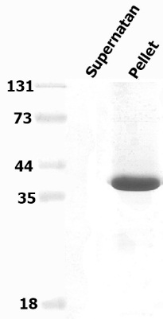

Supplementary fig 1**.** Characterization of expressed recombinant pMMO proteins**,** Results of sodium dodecyl sulfate-polyacrylamide gel electrophoresis (SDSPAGE) analysis showing solubility of expressed recombinant proteins

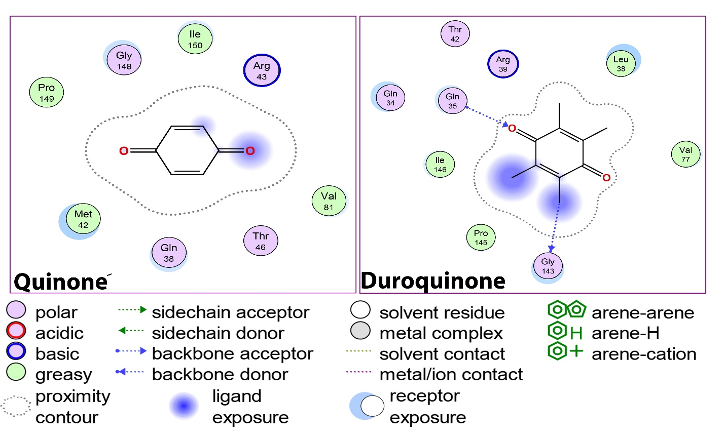

Supplementary fig 2, 2D representation showing how quniong and Duroquinone bind to pMMO