**Supplementary Material**

**Protocatechuic acid mitigates CuO nanoparticles-induced toxicity by strengthening the antioxidant defense system and suppressing apoptosis in liver cells**

Maqusood Ahamed 1, *, Mohd Javed Akhtar 1, M.A. Majeed Khan 1, Hisham A. Alhadlaq 1,2

1 King Abdullah Institute for Nanotechnology, King Saud University, Riyadh-11451, Saudi Arabia

2 Department of Physics and Astronomy, College of Science, King Saud University, Riyadh-11451, Saudi Arabia

*Corresponding author:

Maqusood Ahamed, Ph.D.

Professor at King Abdullah Institute for Nanotechnology

King Saud University

Riyadh 11451, Saudi Arabia

Phone: +966114698781

Email: mahamed@ksu.edu.sa

**Results**

***Exposure protocol and selection of concentrations of CuO NPs and PCA***

Stock solution (1 mg/ml) of CuO NPs and PCA was prepared in culture medium. First of all, we performed a screening MTT assay to choose appropriate dosages of CuO NPs and PCA. Briefly, both types of cells were individually treated to various concentrations of CuO NPs (0, 1, 2.5, 5, 10, 25, 50, and 100 µg/ml) and PCA (0, 1, 2.5, 5, 10, 25, 50, and 100 µg/ml) for 24 h. At the end of exposure time, MTT assay was performed. Results showed that PCA did not induce cytotoxicity in selected concentrations in both cells (Figure S1, Supplementary material). Conversely, CuO NPs induced a dose-dependent cytotoxicity in the concentration range of 5-100 µg/ml in both types of cells (Figure S2, Supplementary material). The IC50 values of CuO NPs were 26.56 µg/ml and 29.66 µg/ml for HepG2 cells and primary rat hepatocytes, respectively (Figure S3, Supplementary material). Therefore, in co-exposure study we selected IC50 value of CuO NPs. To further choose the appropriate concentration of PCA, we have performed an experiment where different concentrations of PCA (1-100 µg/ml) co-exposed with IC50 value of CuO NPs (Figure S4, Supplementary material). Results showed that that cell viability declined to almost 50% following exposure to CuO NPs (IC50), and treatment with PCA increased the cell viability in a dose-dependent manner in the concentration range of 1-10 µg/ml. Hence, our data suggested that treatment with PCA at the concentration of 10 µg/ml achieved maximum mitigating effect against CuO NPs (IC50) induced cytotoxicity in both cells. This indicated that 10 µg/ml PCA was enough to mitigate IC50 toxicity of CuO NPs (Figure S4, Supplementary material). Hence, for this study, we utilized 10 µg/ml of PCA to explore its mitigating potential against CuO NPs (IC50) induced toxicity. Briefly, cells were divided into four groups; control group, PCA group (10 µg/ml), CuO NPs group (IC50), and co-exposure group (PCA+CuO NPs). In co-exposure group, 10 µg/ml of PCA exposed to cells 30 min before the treatment of CuO NPs (IC50). Exposure time in all experiments were 24 h.

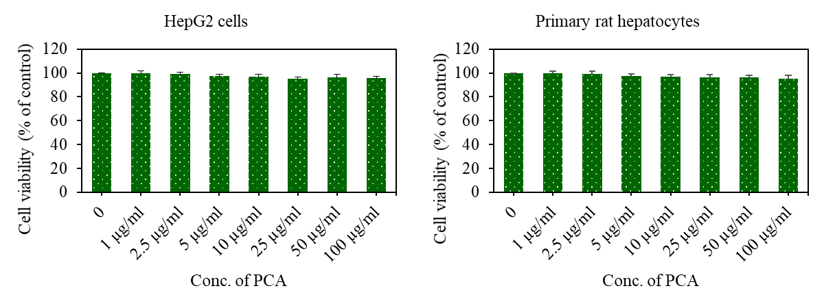

**Figure S1.** Cytotoxicity of PCA in HepG2 cells and primary rat hepatocytes. Briefly, cells were treated for 24 to different concentrations of PCA (0, 1, 2.5, 5, 10, 25, 50, and 100 µg/ml). At the end of exposure time, MTT assay was performed to assess the cytotoxicity of PCA in HepG2 cells. Results showed that PCA did not induce cytotoxicity in both types of cells. Data provided in this study are represented are mean±SD of five identical experiments (n=5).

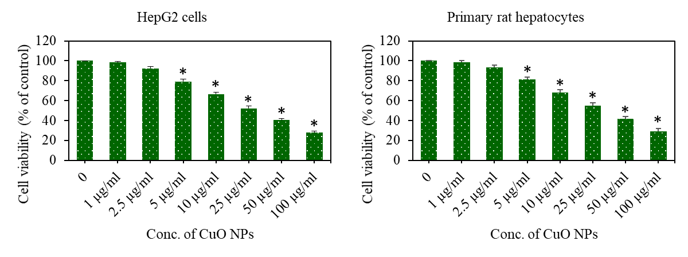

**Figure S2**. Dose-dependent cytotoxicity of CuO NPs in HepG2 cells and primary rat hepatocytes. Briefly, cells were treated for 24 to different concentrations of CuO NPs (0, 1, 2.5, 5, 10, 25, 50, and 100 µg/ml). At the end of exposure time, MTT assay was performed to assess the dose-dependent cytotoxicity of CuO NPs. Results showed that CuO NPs induced dose-dependent cytotoxicity in the concentration range of 5-100 µg/ml in both types of cells. Data provided in this study are represented are mean±SD of five identical experiments (n=5). *Significantly different from the control (p<0.05).

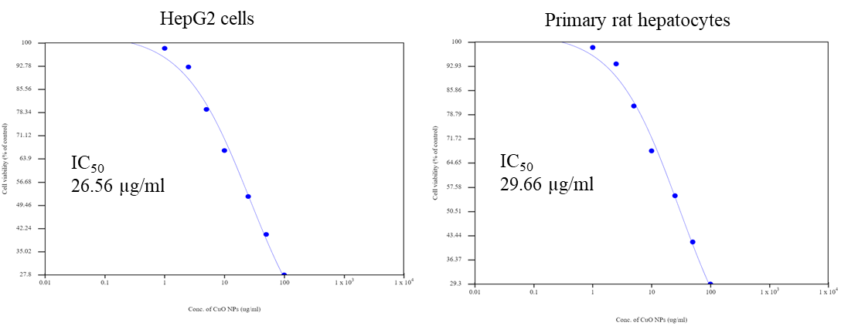

**Figure S3.** IC50 graph of CuO NPs for HepG2 cells and primary rat hepatocytes. Data from figures S1 were utilized to calculate IC50 value of CuO NPs in both cells. For concentration-dependent cytotoxicity (IC50) calculation, a scatter plot in Microsoft Excel was inserted followed by setting the *Y*-axis to logarithmic. Then a trend line was selected and ‘exponential’ picked. Then ‘display equation’ was used in calculating IC50. IC50 calculations were further verified and confirmed from the online IC50 calculator ([**https://www.aatbio.com/tools/ic50-calculator**](https://www.aatbio.com/tools/ic50-calculator)) provided by AAT BioQuest, Inc. (CA 94085, USA).

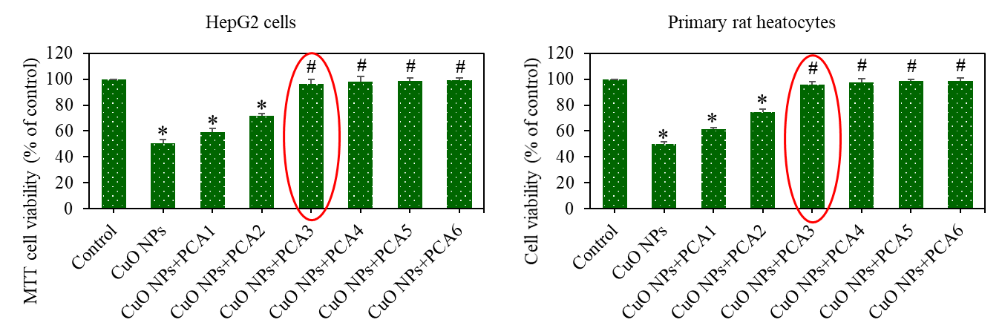

CuO NPs = IC50

PCA1 = 1 µg/ml

PCA2 = 5 µg/ml

**PCA3 = 10 µg/ml**

PCA4 = 25 µg/ml

PCA5 = 50 µg/ml

PCA6 = 100 µg/ml

**Figure S4.** Cell viability of HepG2 cells and primary rat hepatocytes after pre-treatment (30 min before) of PCA along with CuO NPs for 24 h. Cell viability was determined by MTT assay. Data provided in this study are represented are mean±SD of five identical experiments (n=5). *Significantly different from the control (p<0.05). #significant attenuating effects of PCA against CuO NPs induced cytotoxicity.

Figure S4 demonstrated the mitigating potential of different concentrations of PCA (1-100 µg/ml) against CuO NPs (IC50) induced cytotoxicity in HepG2 cells and primary rat hepatocytes. We observed that cell viability declined to almost 50% following exposure to CuO NPs (IC50), and treatment with PCA increased the cell viability in a dose-dependent manner in the concentration range of 1-10 µg/ml. Hence, our data suggested that treatment with PCA at the concentration of 10 µg/ml achieved maximum mitigating effect against CuO NPs (IC50) induced cytotoxicity in both cells. Above the concentration of 10 µg/ml of PCA, mitigating effects against CuO NPs induced toxicity was not much different. This indicated that 10 µg/ml PCA was enough to mitigate IC50 toxicity of CuO NPs. Hence, for further co-exposure studies we have selected 10 µg/ml concentration of PCA.