**Design of MEMS Capacitive Comb Accelerometer with Perforated Proof Mass for Seismic Applications**

Ghada Ahmed Khouqeera, Suganthi Sb†*, Nadyah Alanazic, Abdullah Alodhaybc,d, Muthumareeswaran Muthuramamoorthyd†*, Saravanan Pandiaraje

*a Department of Physics, Imam Mohammad Ibn Saud Islamic University (IMSIU), Riyadh, Saudi Arabia.*

*bDepartment of Electronics and Communication Engineering, Rajalakshmi Engineering College, Thandalam - 602105, Tamilnadu, India*

*cDepartment of Physics and Astronomy, College of Science, King Saud University, Riyadh 11451, Saudi Arabia*

*dKing Abdullah Institute for Nanotechnology, King Saud University, Riyadh,11451, Saudi Arabia*

*eDepartment of Self Development Skills, CFY Deanship, King Saud University, Riyadh, Saudi Arabia*

*Author to whom correspondence should be addressed.

†Authors equally contributed to this work.

*Corresponding author.

E-mail addresses: [suganthirec@yahoo.com](mailto:suganthirec@yahoo.com) (Suganthi S), [mramamoorthy@ksu.edu.sa](mailto:mramamoorthy@ksu.edu.sa) (M. Muthuramamoorthy)

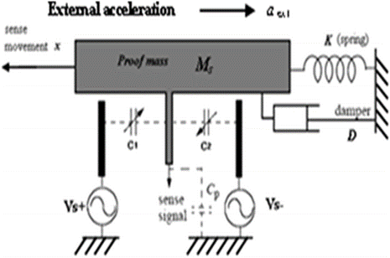

**Fig. S1.** Mass-Spring-Damper system of the device

**Table s1**

Comparison of geometrical parameters of proposed and existing systems

| Design Parameters | Dimensions | |
| --- | --- | --- |
| Proposed Model | Existing Model |
| Beam length*, Lb* | 280 μm | 350μm |
| Beam width, *Wb* | 2 μm | 2 μm |
| Proof mass length, *Lm* | 448 μm | 350 μm |
| Proof mass width, *Wm* | 200 μm | 70 μm |
| Number of sensing fingers, *Ns* | 42 | 24 |
| Number of driving fingers, *Nd* | 12 | 8 |
| Spring constant, *K* | 0.1567 N/m | 0.4564 N/m |
| Capacitance gap, *d* | 1 μm | 2 μm |
| Anchor size | 17*17 μm2 | 40*40 μm² |
| Length of fingers, *Lf* | 140 μm | 200 μm |
| Width of fingers, *Wf* | 4 μm | 4 μm |
| Acceleration due to gravity*, g* | 9.8m/s² | 9.8m/s² |
| Device thickness*, h* | 5μm | 4μm |