**Finite Element Analysis of a Three-Stage Micro-sieves based Microfiltration Technique**

Suganthi S1†* ,Khuloud A. Alibrahim2† , Senthil Kumar S3 , Saminathan P3 , Abdullah Alodhayb4,5 , Aneeba.B6 ,Vignesh Ram Petha Sethuraman7 , Muthumareeswaran MR5

1Department of Electronics and Communication Engineering, Rajalakshmi Engineering College, Thandalam, Tamil Nadu 602105

2Department of Chemistry, College of Science, Princess Nourah bint Abdulrahman University, P.O. Box 84428, Riyadh 11671, Saudi Arabia

3Department of Physiotherapy, Saveetha Medical College, Chennai, Tamil Nadu, India 4Department of Physics and Astronomy, College of Science, King Saud University, Riyadh 11451, Saudi Arabia

5King Abdullah Institute for Nanotechnology, King Saud University, Riyadh,11451, Saudi Arabia.

6Department of Physics, Malankara Catholic College, Mariagiri, Kaliakkavilai Tamil Nadu, India

7Departmetn of Aerospace system Enginerring, Sejong University, Seoul,05006, South Korea

† Authors equally contributed to this work.

* Corresponding Author: Email: suganthirec@Yahoo.com

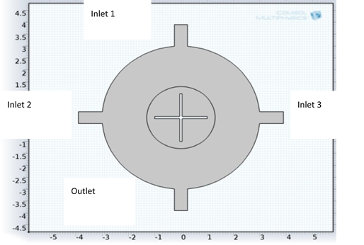

**Fig. S1.** Pictorial representation of process flow of micromixer and different stages of filtration using microsieves.

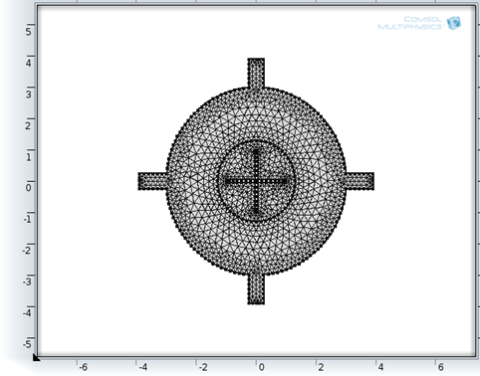

**Fig. S2.** Triangular meshing

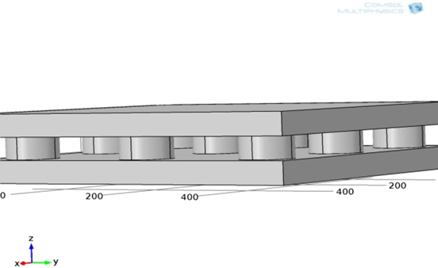

**Fig. S3.** Geometry of 50µm microsieves

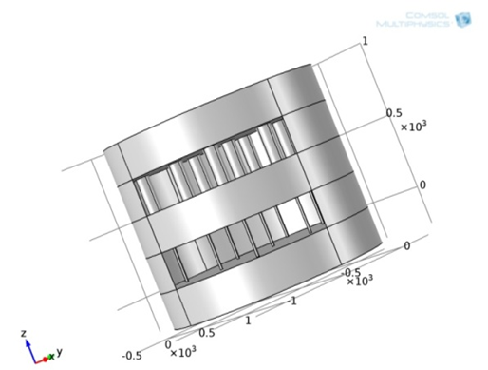

**Fig. S4.** Two- Stage microsieves

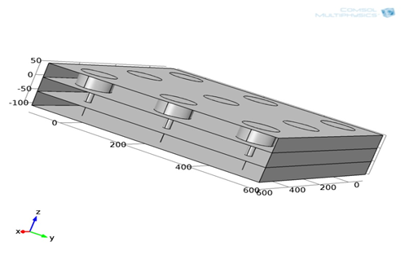

**Fig. S5.** Particle tracing geometry