Table 1: MICs of the plant extracts against human pathogens
Samples | Solvents |  | Inhibition zone (mm)
 |  |  | Conc. | P. aeruginosa | Conc. | S. aureus | Conc. | S. typhi
Pinus roxburghii | Hexane |  | 20 | ND | 0.5 | ND | 1 | ND
 |  |  | 25 | 12.33±0.6 | 1 | 12.00 | 10 | 10.33±0.6
 | Methanol |  | 25 | ND | 10 | ND | 1 | ND
 |  |  | 30 | 13.67±0.6 | 20 | 11.33±0.6 | 10 | 9.667±0.6
 | Acetone |  | 25 | ND | 10 | ND | 1 | ND
 |  |  | 30 | 15.33±0.6 | 20 | 10.67±0.6 | 10 | 12.33±0.6
Cedrus deodara | Hexane |  | 25 | ND | 0.5 | ND | 1 | ND
 |  |  | 30 | 13.33±0.6 | 1 | 9.667±0.6 | 10 | 11.67±0.6
 | Methanol |  | 30 | ND | 1 | ND | 25 | ND
 |  |  | 50 | 12.67±0.6 | 10 | 10.33±0.6 | 30 | 11.67±0.6
 | Acetone |  | 30 | ND | 25 | ND | 30 | ND
 |  |  | 50 | 10.33±0.6 | 30 | 9.667±0.6 | 50 | 10.67±0.6
Positive Control |  |  | 1 | 19.7±0.6 | 1 | 26.7±0.6 | 1 | 19.7±0.6
Negative Control |  |  | 1 | ND | 1 | ND | 1 | ND
Conc. Concentration (mg/ml)

Table 2: Binding affinity of bioactive compounds with bacterial proteases
Ligand name & ID source | Ligand source | Structural formula | Target protein ID (PDB) | Protein source | Binding affinity
Linalool (monoterpenoid)  ZINC1529819 | P. roxburghii  (Hexane extract) | 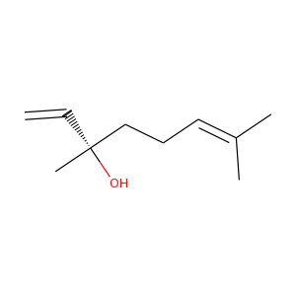 | 7CO5 | P. aeruginosa | -5.5
 |  |  | 4CNN | S. typhi | -5.3
 |  |  | 2AS9 | S. aureus | -4.9
Ocimene (monoterpenoid)  ZINC1531618 | C. deodara (Hexane extract) | 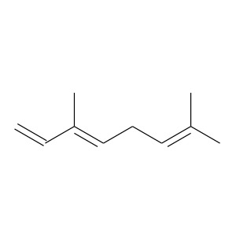 | 7CO5 | P. aeruginosa | -5.7
 |  |  | 4CNN | S. typhi | -4.9
 |  |  | 2AS9 | S. aureus | -4.8
Bisabolene (sesquiterpenoid)  ZINC13377648 | P. roxburghii (Hexane extract) | 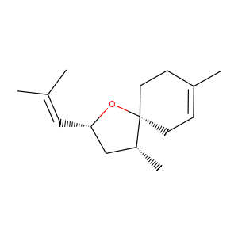 | 2GQC | P. aeruginosa | -5.1
 |  |  | 4EZE | S. typhi | -7
 |  |  | 2W7S | S. aureus | -7.4
Valencene (sesquiterpenoid)  ZINC1734352 | C. deodara (Hexane extract) | 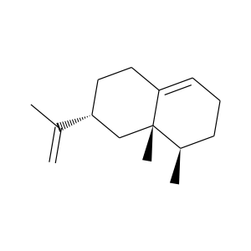 | 2GQC | P. aeruginosa | -5.5
 |  |  | 4EZE | S. typhi | -6.6
 |  |  | 2W7S | S. aureus | -7.7
Limonene  ZINC967513 | P. roxburghii (Methanol extract) | 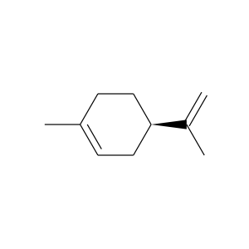 | 7CO5 | P. aeruginosa | -6.4
 |  |  | 4CNN | S. typhi | -5
 |  |  | 2AS9 | S. aureus | -5
Eugenol  ZINC1411 | C. deodara (Methanol extract) | 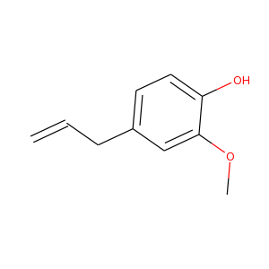 | 7CO5 | P. aeruginosa | -5.8
 |  |  | 4CNN | S. typhi | -5.3
 |  |  | 2AS9 | S. aureus | -5.7
Anethole  ZINC967630 | P. roxburghii (Methanol extract) | 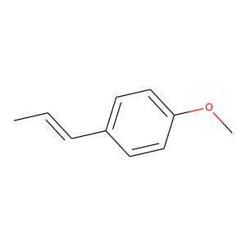 | 2GQC | P. aeruginosa | -4.5
 |  |  | 4EZE | S. typhi | -5.9
 |  |  | 2W7S | S. aureus | -5.7
Caryophyllene  ZINC2039864 | C. deodara (Methanol extract) | 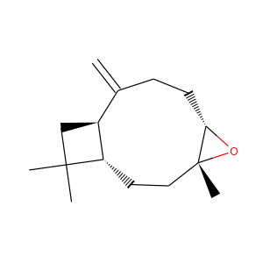 | 2GQC | P. aeruginosa | -5.7
 |  |  | 4EZE | S. typhi | -6.6
 |  |  | 2W7S | S. aureus | -7.2
Nortrachelogenin  ZINC900254 | P. roxburghii (Acetone extract) | 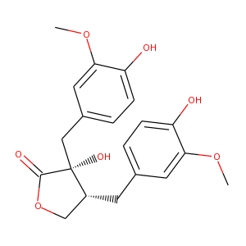 | 7CO5 | P. aeruginosa | -7.2
 |  |  | 4CNN | S. typhi | -6.8
 |  |  | 2AS9 | S. aureus | -6.7
Taxifolin (flavonoid)  ZINC105076 | C. deodara (Acetone extract) | 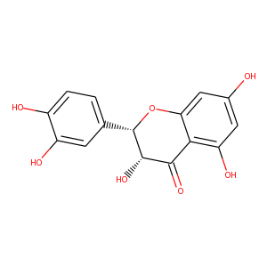 | 7CO5 | P. aeruginosa | -7.6
 |  |  | 4CNN | S. typhi | -7.6
 |  |  | 2AS9 | S. aureus | -8.3
Binding affinity = (kcal/mol)

