**Supplementary Information**

**Figure S1**: *M. uniflorum* of seeds soaked without or with Se for different period of time and germinated for 48hrs. Right side of the photograph shows scale par. (Fig. S1a) Soaked without or with Se for 3hrs, (Fig. S1b) Soaked without or with Se for 6hrs, (Fig. S1c) Soaked without or with Se for 9hrs, d) Soaked without or with Se for 12hrs. 1- 0mg Se /dL (control); 2- 5mg Se/dL; 3- 25mg Se/dL and 4- 50mg Se/dL.

C:\Users\welcome\Pictures\SELENIUM PAPER IMAGE\48 HRS GER MU.tif

**Figure S2**: *M. uniflorum* of seeds soaked without or with Se for different period of time and germinated for 72hrs. Right side of the photograph shows scale par. (Fig. S3a) Soaked without or with Se for 3hrs, (Fig. S3b) Soaked without or with Se for 6hrs, (Fig. S3c) Soaked without or with Se for 9hrs, d) Soaked without or with Se for 12hrs. 1- 0mg Se /dL (control); 2- 5mg Se/dL; 3- 25mg Se/dL and 4- 50mg Se/dL.

C:\Users\welcome\Pictures\SELENIUM PAPER IMAGE\72 HOUR GER MU.tif

**Figure S3**: *V. radiata* of seeds soaked without or with Se for different period of time and germinated for 48hrs. Right side of the photograph shows scale par. (Fig. S2a) Soaked without or with Se for 3hrs, (Fig. S2b) Soaked without or with Se for 6hrs, (Fig. S2c) Soaked without or with Se for 9hrs, d) Soaked without or with Se for 12hrs. 1- 0mg Se /dL (control); 2- 5mg Se/dL; 3- 25mg Se/dL and 4- 50mg Se/dL.

C:\Users\welcome\Pictures\SELENIUM PAPER IMAGE\48 HRS GER VR.tif

**Figure S4**:*V. radiata* of seeds soaked without or with Se for different period of time and germinated for 72hrs. Right side of the photograph shows scale par. (Fig. S4a) Soaked without or with Se for 3hrs, (Fig. S4b) Soaked without or with Se for 6hrs, (Fig. S4c) Soaked without or with Se for 9hrs, d) Soaked without or with Se for 12hrs. 1- 0mg Se /dL (control); 2- 5mg Se/dL; 3- 25mg Se/dL and 4- 50mg Se/dL.

C:\Users\welcome\Pictures\SELENIUM PAPER IMAGE\72 HOUR GER VR.tif

**Figure S5**: Effect of Se on germination. (Fig. S5A) Percent germination of *M. uniflorum* seeds soaked without or with different concentration of Se for 6hrs. (Fig. S5B) Percent germination of *V. radiata* seeds soaked without or with different concentration of Se for 6hrs. Data's were expressed as mean ± SEM. *represents the level of significance at *P*<0.05 compared to control seeds.

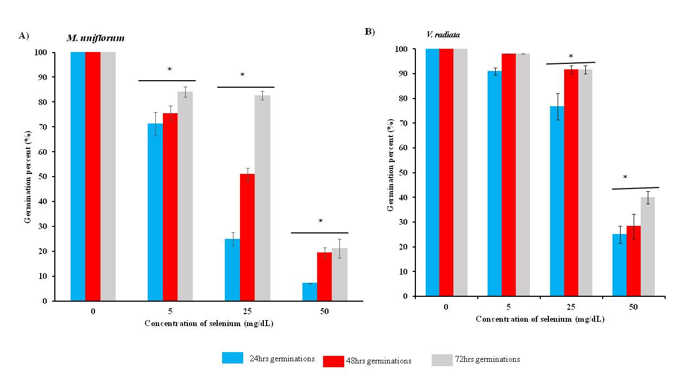

**Figure S6**: Effect of Se on germination. (Fig. S6A) Percent germination of *M. uniflorum* seeds soaked without or with different concentration of Se for 9hrs. (Fig. S6B) Percent germination of *V. radiata* seeds soaked without or with different concentration of Se for 9hrs. Data's were expressed as mean ± SEM. *represents the level of significance at *P*<0.05 compared to control seeds.

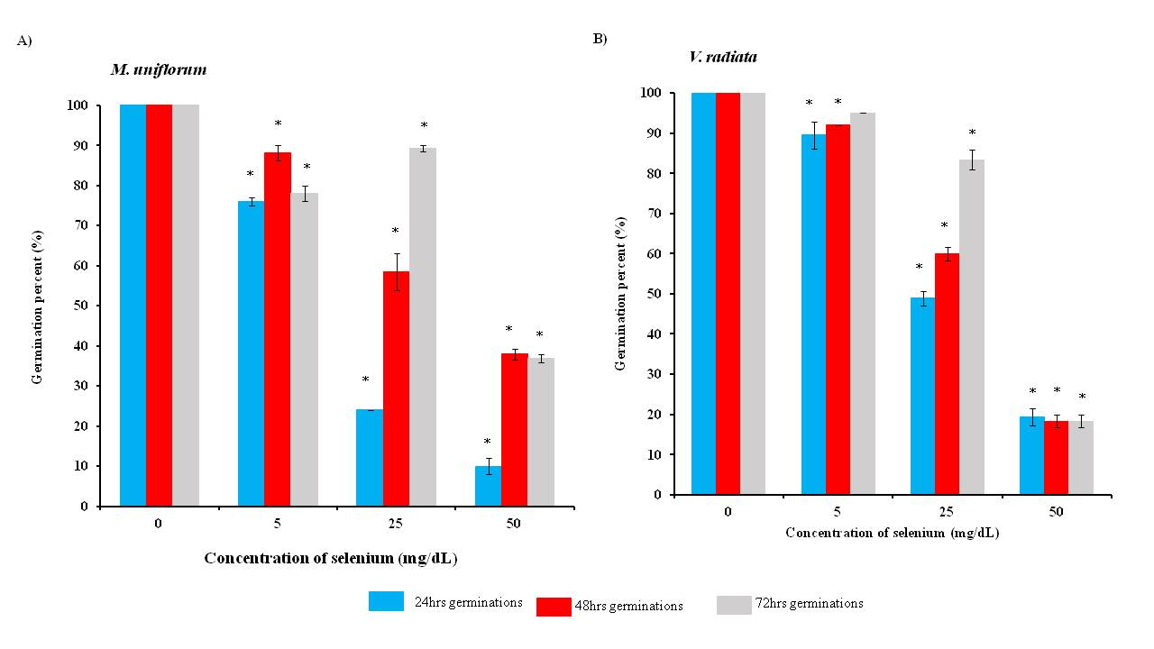

**Figure S7**: Effect of Se on germination. (Fig. S7A) Percent germination of *M. uniflorum* seeds soaked without or with different concentration of Se for 12hrs. (Fig. S7B) Percent germination of *V. radiata* seeds soaked without or with different concentration of Se for 12hrs. Data's were expressed as mean ± SEM. *represents the level of significance at *P*<0.05 compared to control seeds.

