**Supplementary files**

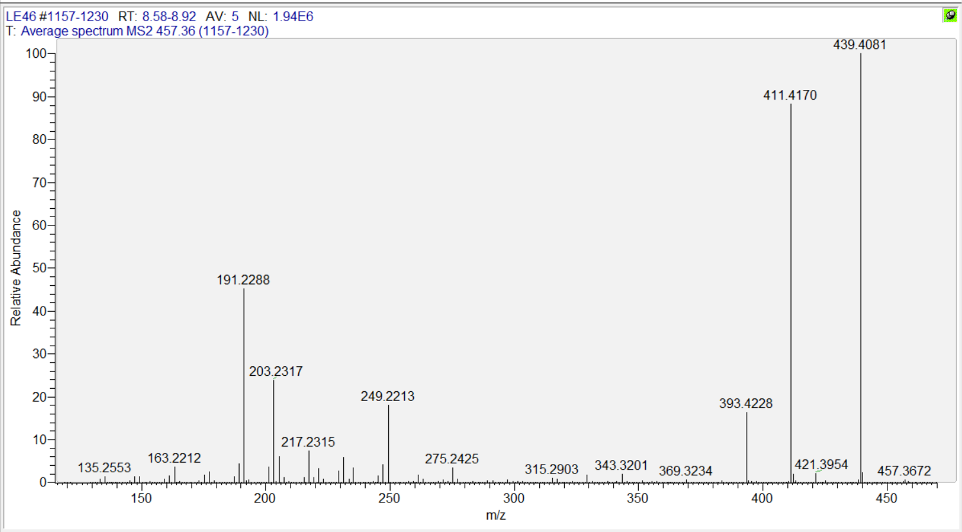

**Fig. S1:** MS2 spectra of oleanolic acid.



**Fig. S2:** FT-IR spectra of oleanolic acid.

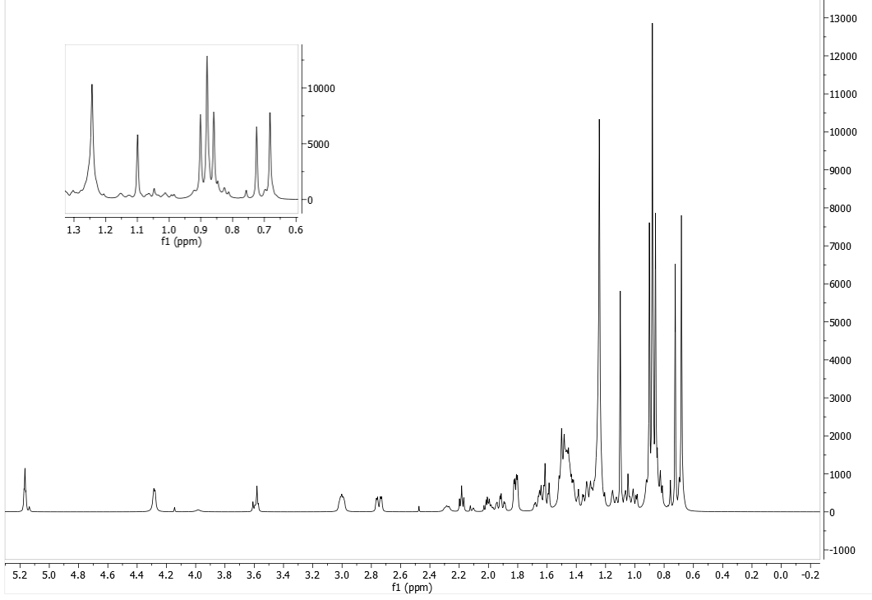

**Fig. S3:** 1H-NMR spectra of oleanolic acid.



**Fig. S4:** TheHSQC spectra of oleanolic acid.