**Supplementary Materials**

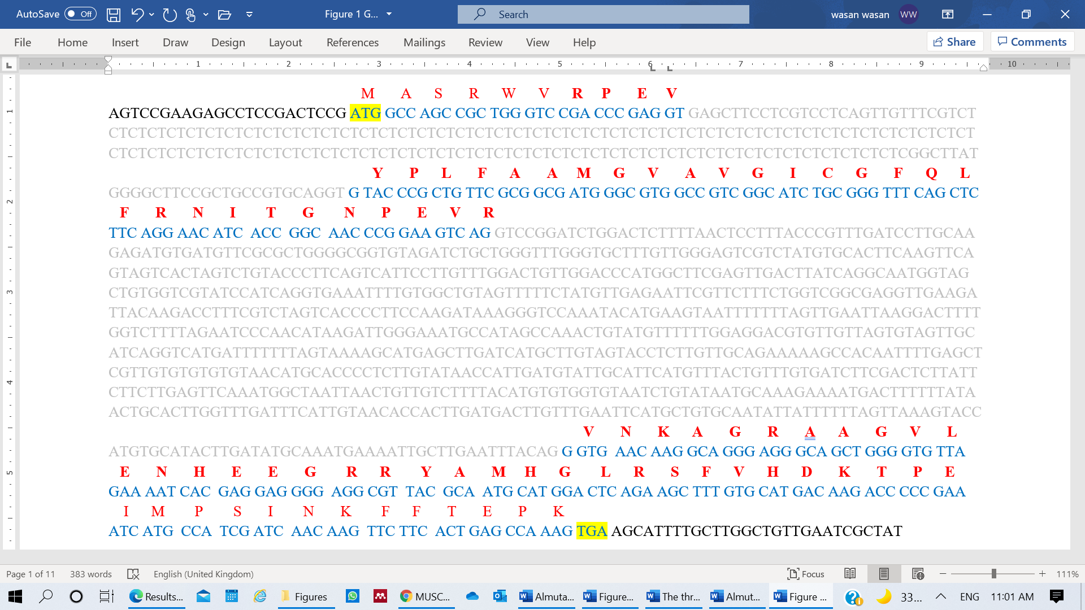

**Supplementary Fig. S1:** The structure of PgB12Dg, based on the alignment of cDNA sequence (NCBI #MW092093) with the reversed sequence of the genomic region from nucleotide 114,581,417 to 114,582,817 of chromosome number 2 (#LKME02052028.1) of ***P. glaucum*.** Exons are shown as blue letters, the intron is in grey letters, and the 3ʹ and 5ʹ UTR are the black letters. The amino acid sequences (red letters) are written above the nucleotide sequence of ORFs, and the B12D domain in the deduced proteins are in bold. The start and stop codons are highlighted in yellow.

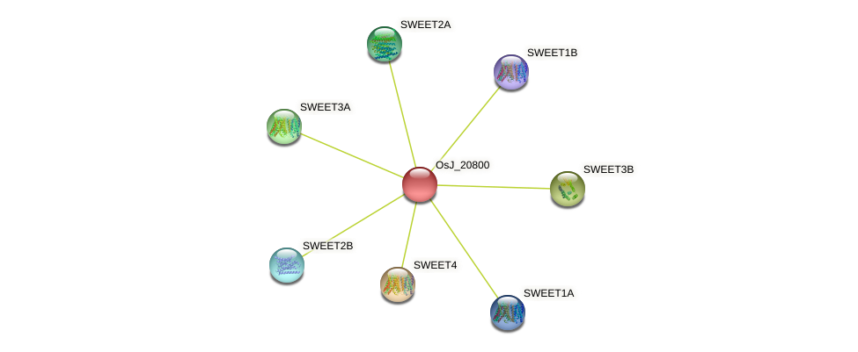

**Supplementary Fig. S2.** Functional protein association for the G-box B12D protein from *O. sativa*; OsJ_20800, the rice homolog to the deduced PgB12Dg protein predicted by STRING database. The associated proteins SWEET1A, SWEET1B, SWEET2A, SWEET2B, SWEET3A, SWEET3B, and SWEET4, are bidirectional sugar transporters.

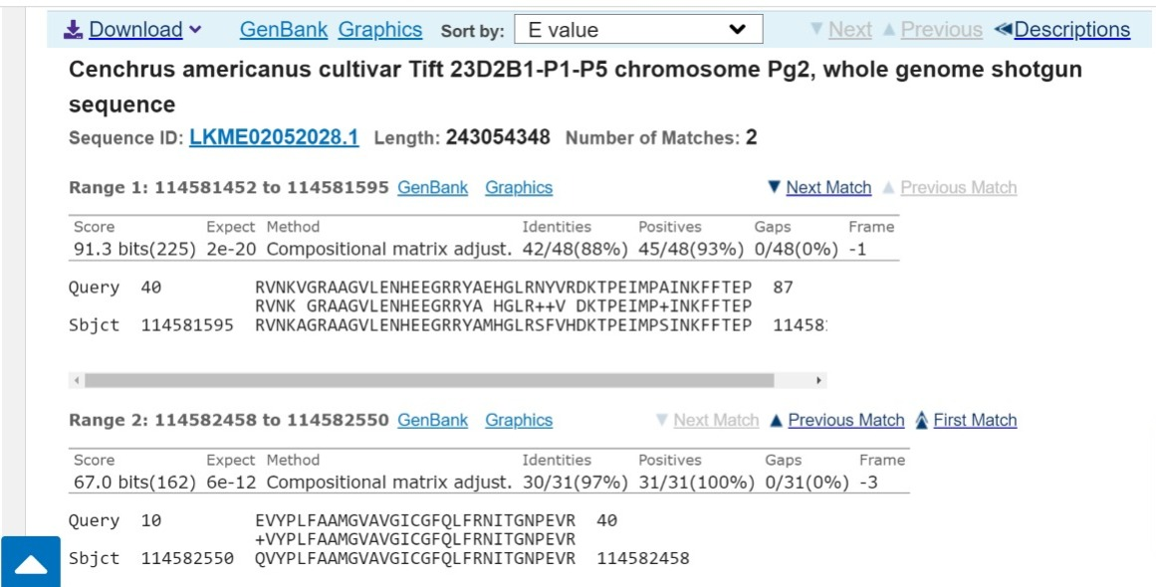

**Supplementary Fig S3:** The NCBI tBLASTn hit for *O. sativa* protein #OsJ_20800 against the Whole Genome Shotgun Contigs database, limited by the *Pennisetum glaucum* genome. The shown alignment includes the genomic region of chromosome 2 of *P. glaucum* (LKME02052028.1) from nucleotides 114,581,452 to 114,582,550.