**Clicnic Registeration Certificate:**

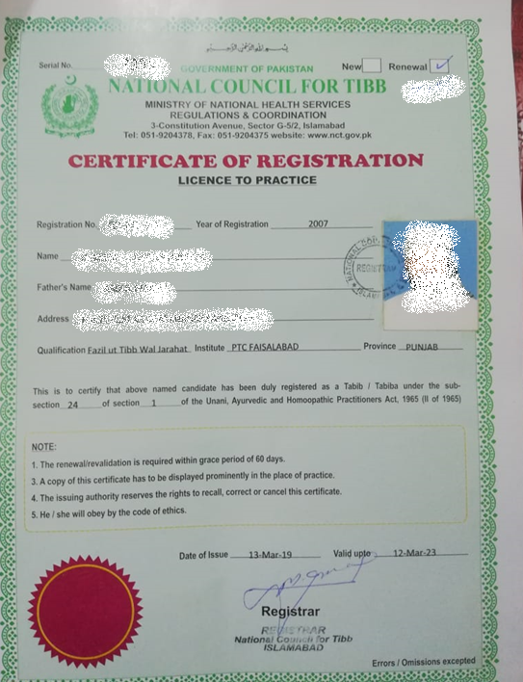

**Formulae in Practice:**

Followng herbs were used along with common available drugs in market recommended to treat flue.

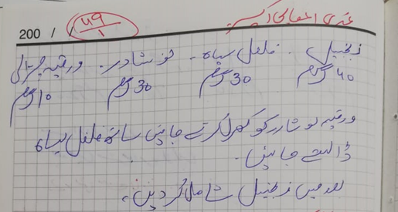

**Procedure to prepare formulae:**

Following picture represented general procedure to prepare formulae.

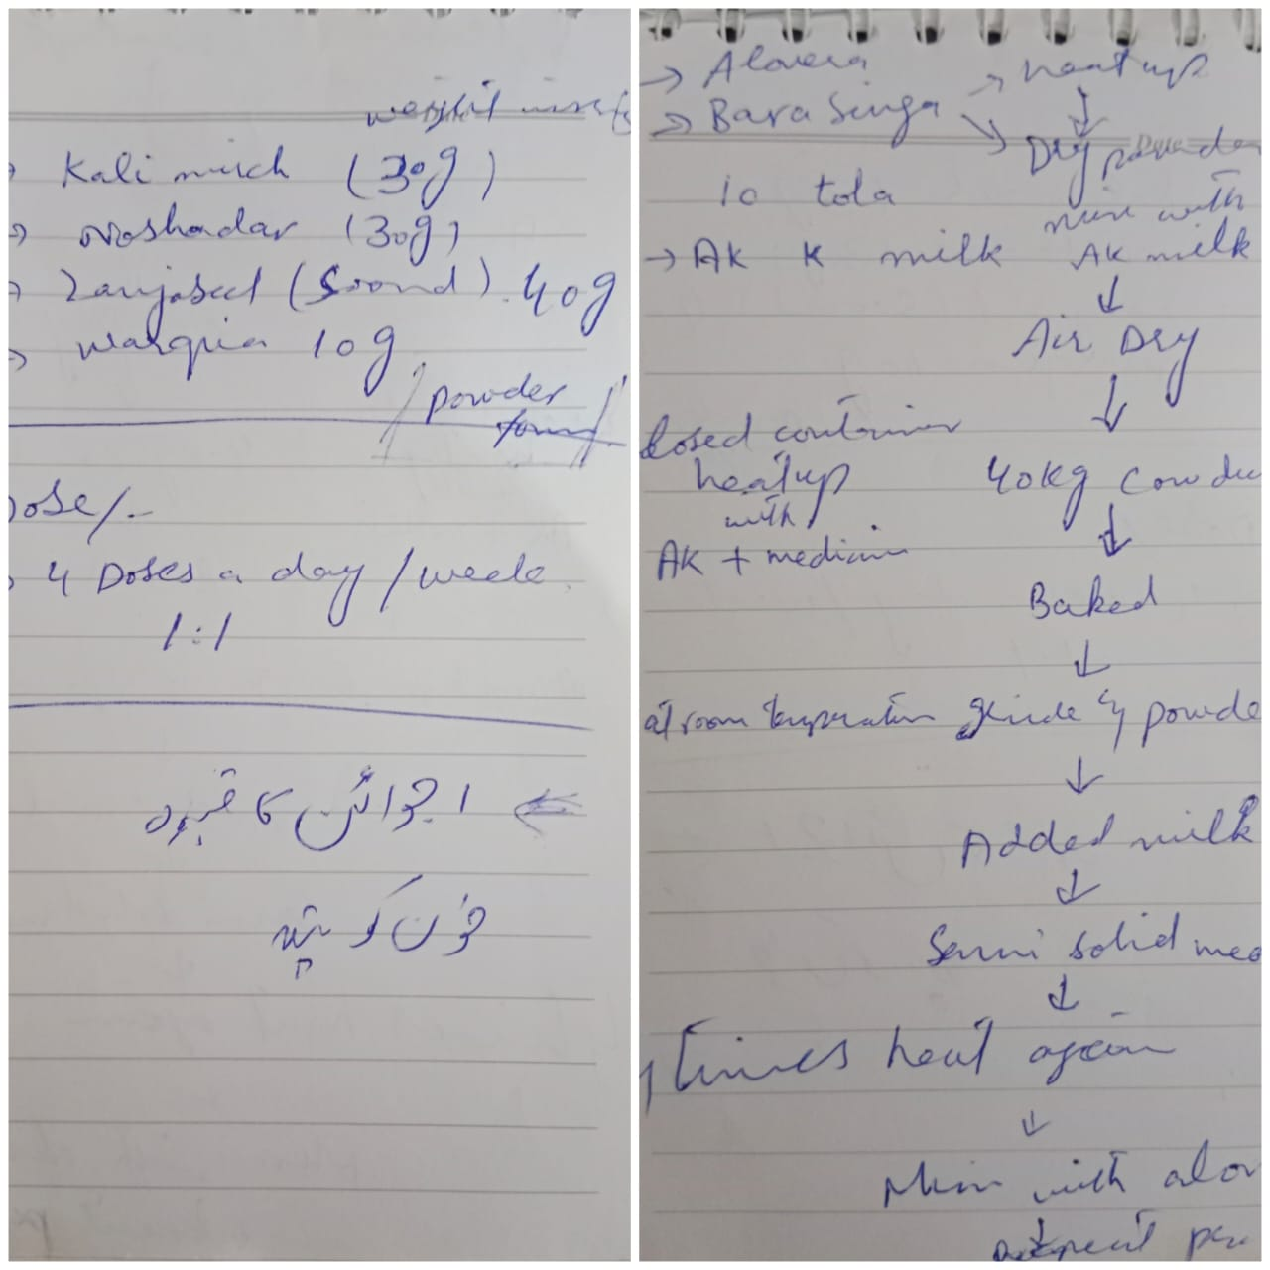

**Patient’s registration at clinic:**

Each patient as registered with complete detail of disease and address. In addition, each patient designated with a serial number as shown in following picture.

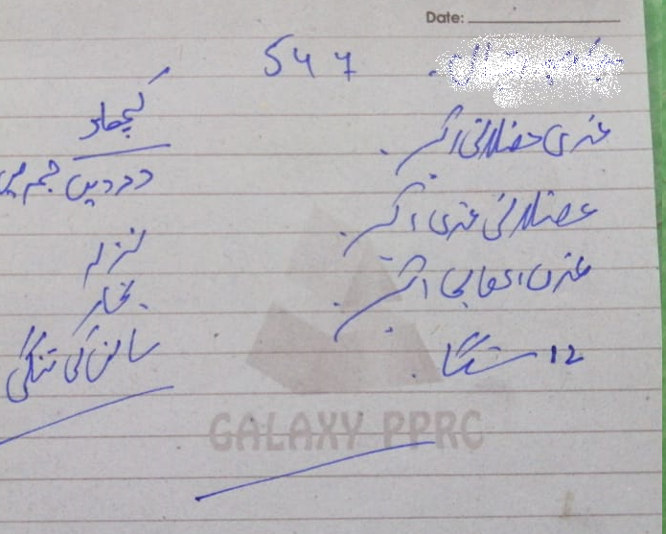

**Patients Details:**

Data used in this study was recorded with serial numbers on daily basis.

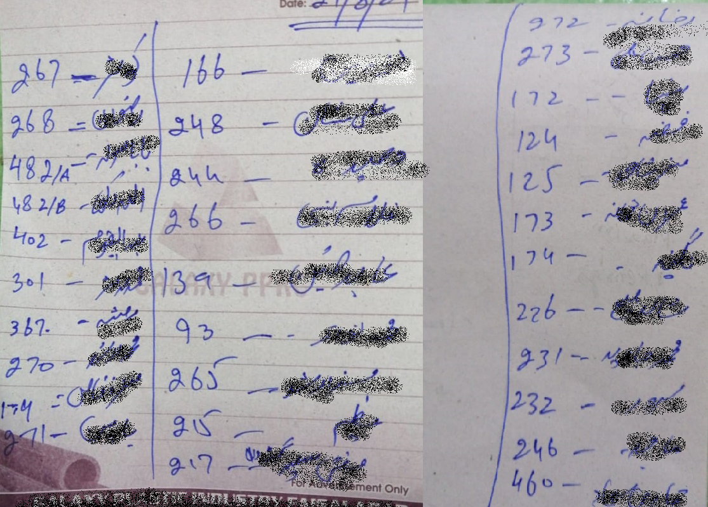

**Reports**

Most of the patients visit health clinic was with average to low economic status; that is why they avoid taking PCR test while observing Covid-19 symptoms. Some take test after using herbal medicine and share their reports as given below.

