Supplementary Materials for

**Essential Oils from Wild *Mentha longifolia* subspecies *typhoides* and subspecies *schimperi*: Burn Wound Healing and Antimicrobial Candidates**

**ABSTRACT**

A comparative study was conducted on the chemical composition of essential oils (EOs) from two subspecies of wild *Mentha longifolia* *typhoides* and *schimperi*, growing in Egypt, followed by biological investigation of EOs as antibacterial, antiquorum sensing and burn wound healing agents. Gas chromatography/mass spectrometry analysis of hydro-distillated EOs led to identification of 99% of oil components. *Schimperi* oil exhibited antibacterial activity against both Gram-positive and Gram-negative bacteria with MIC values of 156~625 μg/ml, lower than or close to ampicillin. The oil from *typhoides* exhibited a higher antiquorum-sensing effect. The potential of oils to heal burn injuries was assessed by applying the oils in ointment form to second-degree burn injury in mice for 21 days. Interestingly, skin healing activity in group treated with *typhoides* oil was more effective than that of the positive control (Silver sulfadiazine 1%). These results suggest a promising candidate in the area of burn wound healing therapy.

**Keywords:** *Mentha longifolia*, Lamiaceae, Essential oils, Burn wound healing activity, Antiquorum-sensing activity, Antimicrobial activity.

**Table of Contents**

|  |  |  |
| --- | --- | --- |
|  |  | Page |
| **Experimental Section** | | 3 |
| **Table 1S:** |  | 7 |
| **Fig. 1S.** | **The condition of skin burn wounds at the beginning of therapy (3rd day).** | 8 |
| **Fig. 2S.** | **The condition of skin burn wounds at the end of therapy period (21st day).** | 8 |

**Experimental procedures:**

***Plant material***

The aerial parts of wild *M. longifolia* subsp. *typhoides* and subsp. *schimperi*, family Lamiaceae, were collected in flowering stage from Dakhlia, and Ras El-Bar, Egypt in July 2017 and the identity of the plants was confirmed by Prof. Dr. Ibrahim Mashaly; Faculty of Science, Mansoura University. The voucher specimens (AGM485717 and AGM485718, respectively) are deposited in the Department of Pharmacogonsy, Faculty of Pharmacy, Mansoura University.

**Analysis of essential oil by gas chromatography-mass spectrometry:** GC/MS analysis was carried out using an Agilent 19091S-433 system with a mass selective detector. HP-5 MS capillary column (30 m×0.25 mm, film thickness: 0.25 μm); injection mode: splitless; split-flow: 10 ml/min; splitless time: 0.80 min; injector and detector temperature: 250°C; oven temperature was programmed as follows: 60˚C for 2 minutes and then 5˚C/min programmed at 240˚C; the carrier gas was helium with a constant flow of 1 mL/min; injection volume: 1 µL of diluted essential oil (1% w/v in CH2Cl2).

**Biological activities of essential oils**

***Antimicrobial assay***

Distilled essential oils were tested for their antimicrobial activities against Gram-positive bacteria (*Staphylococcus aureus* DSM 799 and *Bacillus cereus* ATCC 11778), Gram-negative bacteria (*Escherichia coli* DSM 498 and *Klebsiella pneumoniae* DSM 681) and the yeast-like pathogenic fungus *Candida albicans* ATCC 10231 (Leibniz institute DSMZ- German collection of microorganisms and cell cultures GmbH and The American type culture collection – USA). This activity was performed at the Nile Center for Experimental Research (accredited research laboratory). Ampicillin (69-52-3, Sigma-Aldrich) and amphotericin B (1397-89-3, Sigma-Aldrich) were used as standard materials.

*Determination of Minimum inhibitory concentrations (MICs):*

Minimum inhibitory concentrations (MICs) for essential oils were measured in 96-well plates using broth microdilution method (El-Gohary and Shaaban, 2015; CLSI, 2008a, 2008b). A stock solution (5000 μg/mL) in DMSO (100%) was prepared for each essential oil. Eight concentrations (2500, 1250, 625, 312.5, 156.25, 78.125, 39.06 and 19.53 μg/ml) were prepared for each oil and antibiotics by two-fold serial dilutions. All strains were diluted to OD600 0.01 (equivalent to 8 x106 cells/mL). The diluted cultures (10 μL) were mixed with the test solutions (100 μL, each) into the wells. The plates were incubated for 24 h at 37°C. MIC values were detected visually as the least concentration of the oil that inhibits bacterial and / or fungal growth (no turbidity). Ampicillin and amphotericin B were used as a positive control to assess the efficacy of the tested oils in this assay.

**Histopathological examination:**

*The modified scoring system of histopathological criteria for assessing surgical wound healing:*

The extent of granulation tissue was scored based on seven parameters at day 7 and day 14 after burn injury including: (i) monocytic macrophage (0-3), (ii) neovascularization (0-3), (iii) fibroblastic proliferation (0-3), (iv) degree of granulation tissue (0-3), (v) matrix (mucopolysaccharide deposition) (0-3), (vi) degree of inflammation (0-3) and (vii) extent of bacterial colonization (-3 to 0). The sum of scales regarding granulation state was in the range from -3 to 18. The 18 value was the highest degree of granulation tissue formation on the 7th day and 14th day after a burn injury; as the following: [-3-0] = absent granulation, [1-4] = low, [5-12] = moderate and [13-18] was recorded as the good extent of granulation tissue. The re-epithelization was evaluated based on six components on day 7: (i) extent of epidermal thickness with (0-3), (ii) thickness of granular cell layer (0-3), (iii) maturation and organization of squamous cells (0-3), (iv)extent of keratin layer (0-3), (v) orthokeratin (0-3) and (vi) parakeratosis (0-3). Skin with score 3 was full-thickness and well-structured. The sum of re-epithelization scales was in the range of 0 to 18. The value of 18 was the highest degree of re-epithelization at day 7 after burn injury including 0 = no epithelization, [1-6] = low, [7-12] = moderate and [13-18] was set as good re-epithelization.

Histopathological investigation of the complete wound healing or the new dermis was scored on the 21st day after burn injury depending on five components: (i) degree of scar formation (0-3), (ii) matrix of collagen organization (0-3), (iii) extension of hair follicles (0-3), (iv) extent of lymphatic ducts (0-3), and (v) degree of innervation (0-3). The sum of the score was at a range between 0 to15. The best condition for new dermis was scored 15 on 21st day after burn injury. The sum of scales for wound healing was divided into four groups: 0 = no healing, (1-5) = low, (6-10) = moderate healing and (11-15) = good healing. The sum of scales for each part of histopathological evaluation was classified into three groups: extent of granulation, new dermis and re-epithelization. The fundamental parameters of the new dermis and collagen organization were marked at four levels, and each level was scored and defined as follows: (-) or 0 = collagen fibers are poorly oriented or absent. (+) or 1 = 10-20% collagen fibers are horizontally oriented. (++) or 2 = 30-40% collagen fibers are horizontally oriented. (+++) or 3 = well-formed and horizontally oriented collagen fiber. Complete healing was assessed by degree of scar formation, collagen organization, hair follicles and the degree of innervations after three weeks of burn induction. A score was assigned for all parameters estimated: including 0 = absent, 1 = mild presence, 2 = moderate presence and 3 = strong presence.

*Statistical analysis and software used*

Data are expressed as mean ± standard deviation (S.D), and statistical significance between experimental and control values was analyzed by one-way analysis of variance ANOVA test in GraphPad Prism (version 5). A *p-*value less than 0.05 was considered to be statistically significant.

**References:**

El-Gohary, N. S., Shaaban, M. I., 2015 . Synthesis, antimicrobial, antiquorum-sensing, and cytotoxic activities of new series of isoindoline‐1, 3‐dione, pyrazolo [5, 1‐a]‐isoindole, and pyridine derivatives. Archiv der Pharmazie, 348(11), 835-835. DOI: [10.1002/ardp.201500037](https://www.researchgate.net/deref/http%3A%2F%2Fdx.doi.org%2F10.1002%2Fardp.201500037)

Clinical Laboratory Standards Institute (CLSI)., 2008a. Reference method for broth dilution antifungal susceptibility testing of Filamentous Fungi: Second informational supplement M38-A2: CLSI Wayne, PA, USA.

Clinical Laboratory Standards Institute (CLSI)., 2008b. Reference method for broth dilution antifungal susceptibility testing of yeasts: Third informational supplement M27-A3: CLSI Wayne, PA, USA.

**Table 1S:** Scales for the burn wound healing in untreated and treated groups of second-degree burn according to histopathological parameters.

|  |  |
| --- | --- |
| **Sum of components variables** | **Definition of Scales** |
| 1- Granulation tissue extent (7 parameters) [(-3) -18] on 7th day post-burn injury | (-3-0) = not healing  (1-4) = low  (5-12) = moderate healing  (13-18) = good wound healing |
| 2- Re-epithelization (6 parameters) [0-18] on 7th day post-burn injury | 0 = not healing  (1-6) = low  (7-12) = moderate healing  (13-18) = good wound healing |
| 3-New dermis (5 parameters) [0-15] at 21st day post-burn injury time | 0 = not healing  (1-5) = low  (6-10) = moderate healing  (11-15) = good wound healing |
| 4-Sum of three components | (-3) - 0 = not healing  (1-18) = low  (19-37) = moderate healing  (38-57) = good wound healing |

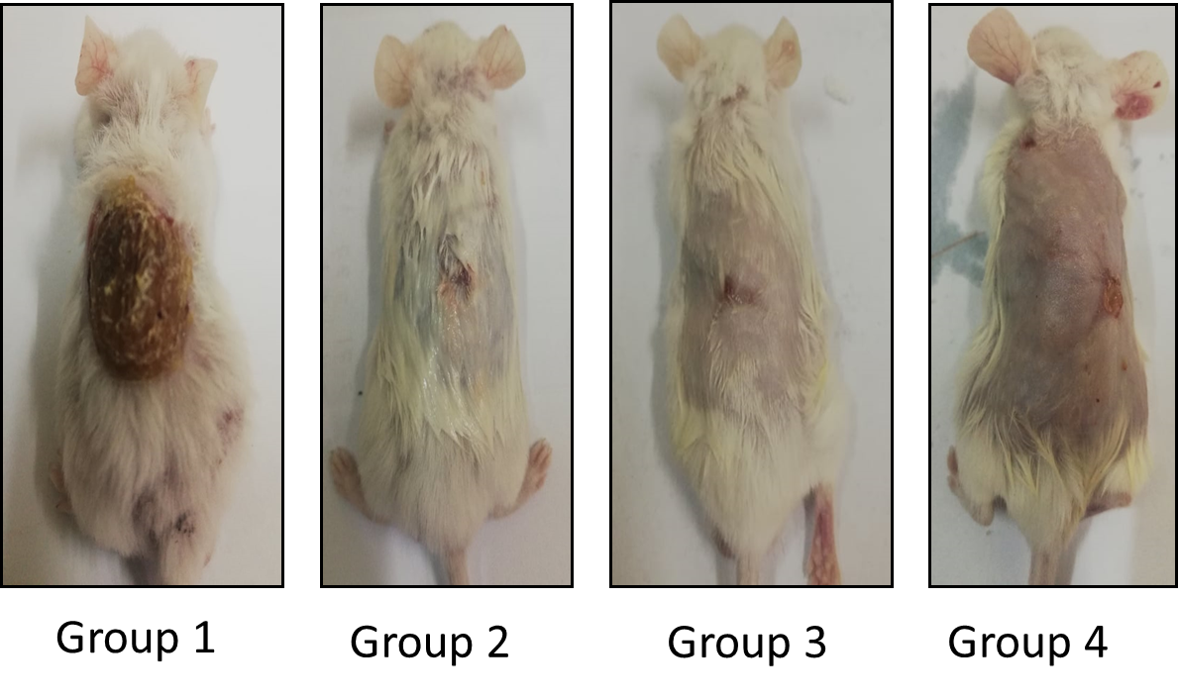

**Fig. 1S:** The condition of skin burn wounds at the beginning of therapy (3rd day).

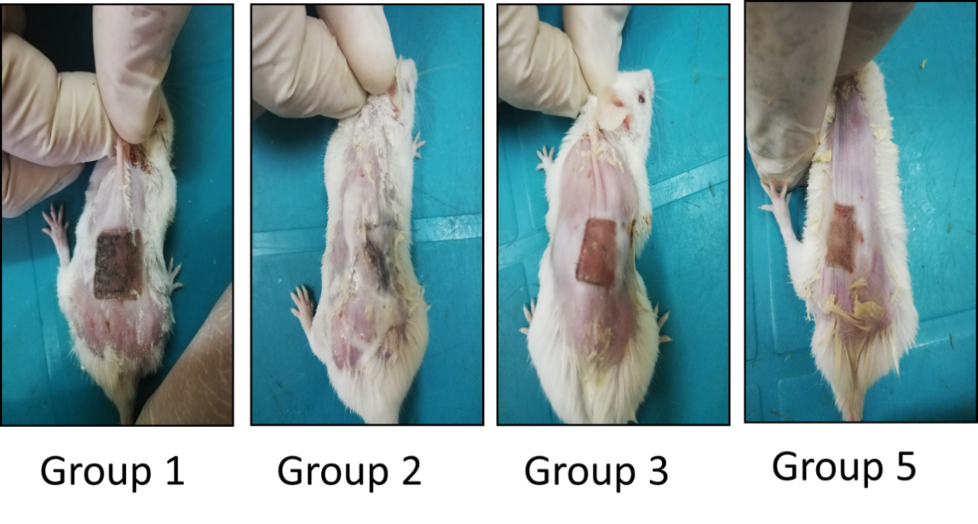

**Fig. 2S:** The condition of skin burn wounds at the end of therapy period (21st day).