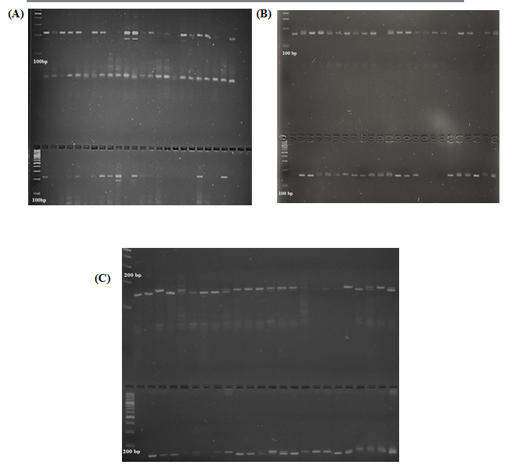

**Supp Fig 1 (A) SSR profile of Cotg-28 in 48 *desi* cotton genotypes on agarose gel (3%)**

**(B) SSR profile of CES-21 in 48 *desi* cotton genotypes on agarose gel (3%)**

**(C) SSR profile of CES-7 in 48 *desi* cotton genotypes on agarose gel (3%)**

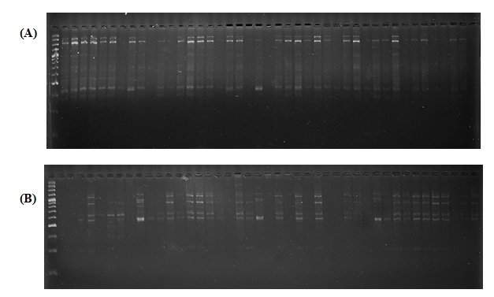

**Supp Fig 2 (A) ISSR profile of HB-08 in 48 *desi* cotton genotypes on agarose gel (3%)**

**(B) ISSR profile of HB-10 in 48 *desi* cotton genotypes on agarose gel (3%)**