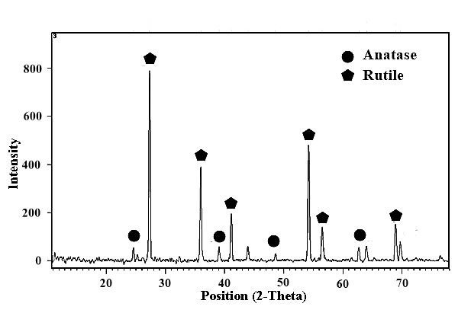

**Supplementary data Fig. 1.** XRD confirmation of the TiO2 nano-catalyst

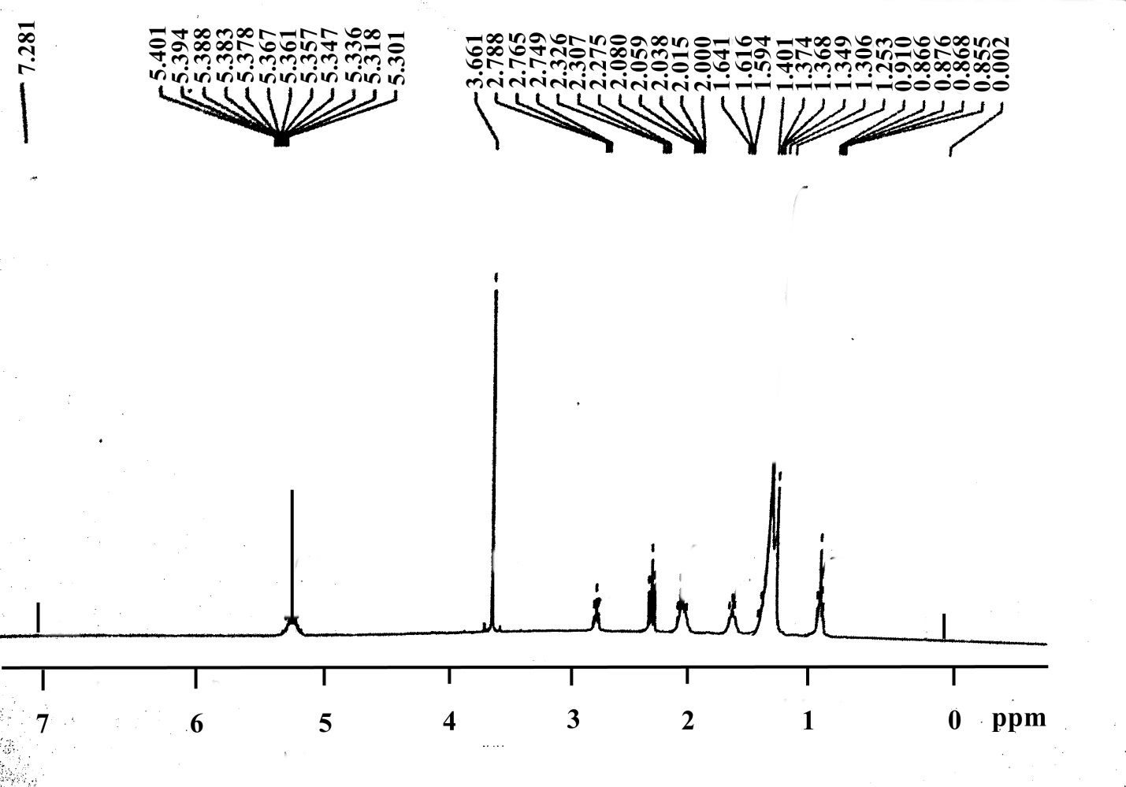

**Supplementary data Fig. 2.** H-NMR result of the synthesized biodiesel

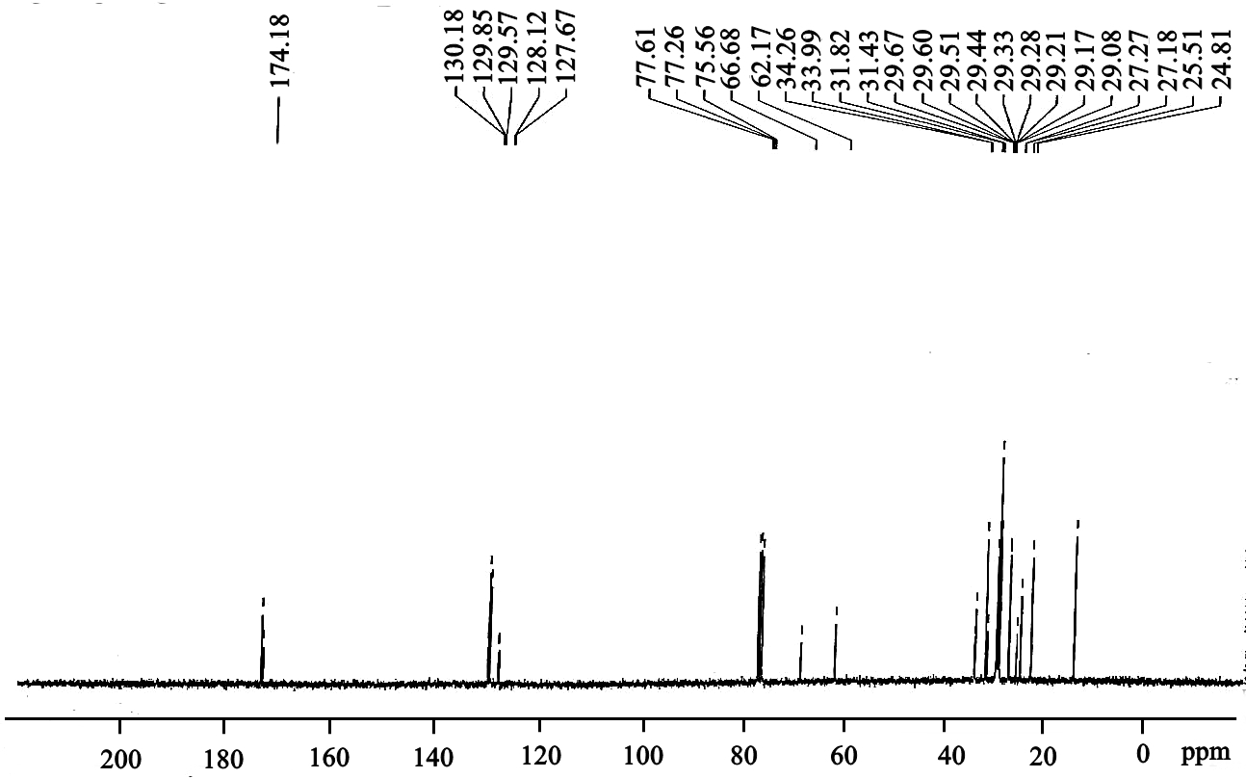

**Supplementary data Fig. 3.** C-NMR analysis result of synthesized biodiesel