**Supplementary data**

Figure S1: Mass spectra of Dimethyl trisulfide identified from *T. violacea* stem and leaves extracts

Figure S2: Mass spectra of 1-Butanamine, 2-methyl-N-(2-methylbutylidene)- identified from *T. violacea* rhizome and bulb extracts

Figure S3: Mass spectra of 1-Butanamine, 3-methyl-N-(3-methylbutylidene)- identified from *T. violacea* rhizome extracts

Figure S4: Mass spectra of 3,5,5-Trimethylhexyl S-2-(dimethylamino)ethyl propylphosphonothiolate

identified from *T. violacea* bulb extracts

Figure S5: Mass spectra of Disulfide, methyl (methylthio)methyl identified from *T. violacea* extracts

Figure S6: Mass spectra of 4H-Pyran-4-one, 2,3-dihydro-3,5-dihydroxy-6-methyl- identified from *T. violacea* stem and bulb extracts

Figure S7: Mass spectra of Benzene, 1,3-bis(1,1-dimethylethyl)- identified from *T. violacea* stem and leaves extracts

Figure S8: Mass spectra of 2-Methoxy-4-vinylphenol identified from *T. violacea* rhizome extracts

Figure S9: Mass spectra of Methylthio(methylthio-methyl)sulfone, identified from *T. violacea* bulb extracts

Figure S10: Mass spectra of Phosphine, tris(trifluoromethyl) identified from *T. violacea* extracts

Figure S11: Mass spectra of 3-Isopropoxy-1,1,1,7,7,7-hexamethyl-3,5,5-tris(trimethylsiloxy)tetrasiloxane identified from *T. violacea* bulb extracts

Figure S12: Mass spectra of Phenol, 2,5-bis(1,1-dimethylethyl)- identified from *T. violacea* stem and leaves extracts

Figure S13: Mass spectra of Phenol, 2,6-bis(1,1-dimethylethyl)- identified from *T. violacea* rhizome and bulb extracts

Figure S14: Mass spectra of 2,4,5,7-Tetrathiaoctane identified from *T. violacea* bulb extracts

Figure S15: Mass spectra of Methane, (methylsulfinyl)(methylthio)- identified from *T. violacea* extracts

Figure S16: Mass spectra of Tetradonium Bromide identified from *T. violacea* leaves extracts

Figure S17: Mass spectra of Glycine, N, N-dimethyl-, ethyl ester identified from *T. violacea* rhizome extracts

Figure S18: Mass spectra of Isomer2: 2,3,5,7-Tetrathiaoctane 3,3-dioxide identified from *T. violacea* stem extracts

Figure S19: Mass spectra of Hexadecanoic acid, methyl ester identified from *T. violacea* extracts

Figure S20: Mass spectra of 2,4,5,6,8-Pentathianonane identified from *T. violacea* stem extracts

Figure S21: Mass spectra of Dibutyl phthalate identified from *T. violacea* bulb extracts

Figure S22: Mass spectra of Nonanamide identified from *T. violacea* stem extracts

Figure S23: Mass spectra of Pentadecanoic acid, 14-methyl-, methyl ester identified from *T. violacea* rhizome extracts

Figure S24: Mass spectra of Dodecanoic acid, ethyl ester identified from *T. violacea* extracts

Figure S25: Mass spectra of Undecanoic acid, methyl ester identified from *T. violacea* bulb extracts

Figure S26: Mass spectra of Neophytadiene identified from *T. violacea* leaves extracts

Figure S27: Mass spectra of Tridecanoic acid, methyl ester identified from *T. violacea* rhizome extracts

Figure S28: Mass spectra of 9,12-Octadecadienoic acid, methyl ester identified from *T. violacea* bulb extracts

Figure S29: Mass spectra of 9,12-Octadecadienoic acid, methyl ester, (E, E)- identified from *T. violacea* rhizome and leaves extracts

Figure S30: Mass spectra of Isomer1: 9,12-Octadecadienoic acid, methyl ester, (E, E)- identified from *T. violacea* stem extracts

Figure S31: Mass spectra of 9-Octadecenoic acid (Z)-, methyl ester identified from *T. violacea* stem extracts

Figure S32: Mass spectra of 9,12,15-Octadecatrienoic acid, methyl ester, (Z,Z,Z)- identified from *T. violacea* leaves extracts

Figure S33: Mass spectra of 1-Decanamine, N-decyl-N-methyl- identified from *T. violacea* rhizome extracts

Figure S34: Mass spectra of Ethylamine, N-decyl-N-methyl-2-(2-thiophenyl)- identified from *T. violacea* leaves extracts

Figure S35: Mass spectra of Tridecanoic acid, 12-methyl-, methyl ester identified from *T. violacea* leaves extracts

Figure S36: Mass spectra of Isomer2: 9,12-Octadecadienoic acid, methyl ester, (E, E)- identified from *T. violacea* stem extract

Figure S37: Mass spectra of Isomer1: 9-Octadecenamide, (Z)- identified from stem extract *T. violacea*

Figure S38: Mass spectra of Hexadecanamide identified from *T. violacea* stem extracts

Figure S39: Mass spectra of Dodecanamide identified from *T. violacea* rhizome and leaves extracts

Figure S40: Mass spectra of Isomer1: 2,3,5,7-Tetrathiaoctane 3,3-dioxide identified from *T. violacea* stem extracts

Figure S41: Mass spectra of 2,3,5,7-Tetrathiaoctane 3,3-dioxide identified from *T. violacea* extracts

Figure S42: Mass spectra of Isomer2: 9-Octadecenamide, (Z)-identified from *T. violacea* stem extracts

Figure S43: Mass spectra of 9-Octadecenamide, (Z)-identified from *T. violacea* extracts

Figure S44: Mass spectra of Bis(2-(Dimethylamino)ethyl) ether identified from *T. violacea* stem extracts

Figure S45: Mass spectra of 2,6,10-Dodecatrien-1-ol, 3,7,11-trimethyl- identified from *T. violacea* extracts

Figure S46: Mass spectra of dl-a-Tocopherol identified from *T. violacea* leaves extracts

Figure S47: Mass spectra of Ergost-5-en-3-ol, acetate, (3ß,24R)- identified from *T. violacea* leaves extracts

Figure S48: Mass spectra of ß-Sitosterol identified from *T. violacea* extracts

Figure S49: Mass spectra of cis-3,14-Clerodadien-13-ol identified from *T. violacea* stem extracts

Figure S50: Mass spectra of a-Amyrin identified from *T. violacea* stem extracts

data

Figure S1:

Figure S2:

Figure S3:

Figure S4:

Figure S5:

Figure S6:

Figure S7:

Figure S8:

Figure S9:

Figure S10:

Figure S11:

Figure S12:

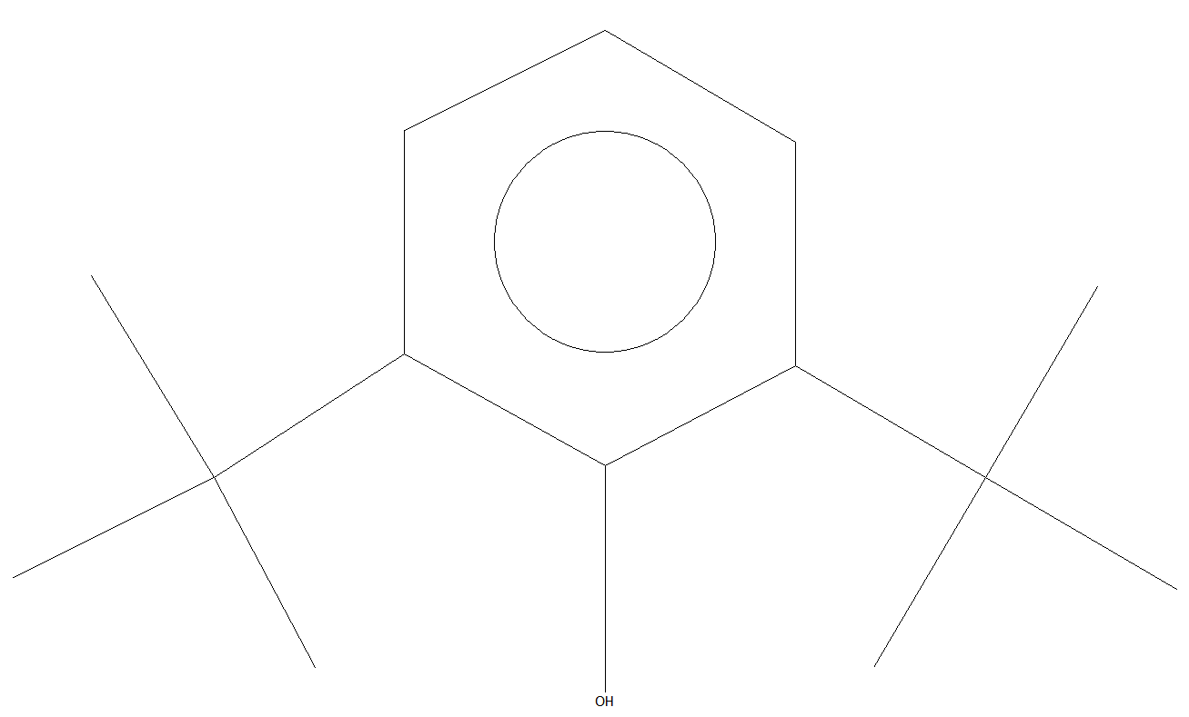

Figure S13:

Figure S14:

Figure S15:

Figure S16:

Figure S17:

Figure S18:

Figure S19:

Figure S20:

Figure S21:

Figure S22:

Figure S23:

Figure S24:

Figure S25:

Figure S26:

Figure S27:

Figure S28:

FigureS29:

Figure S30:

Figure S31:

Figure S32:

Figure S33:

Figure S34:

Figure S35:

Figure S36:

Figure S37:

Figure S38:

Figure S39:

Figure S40:

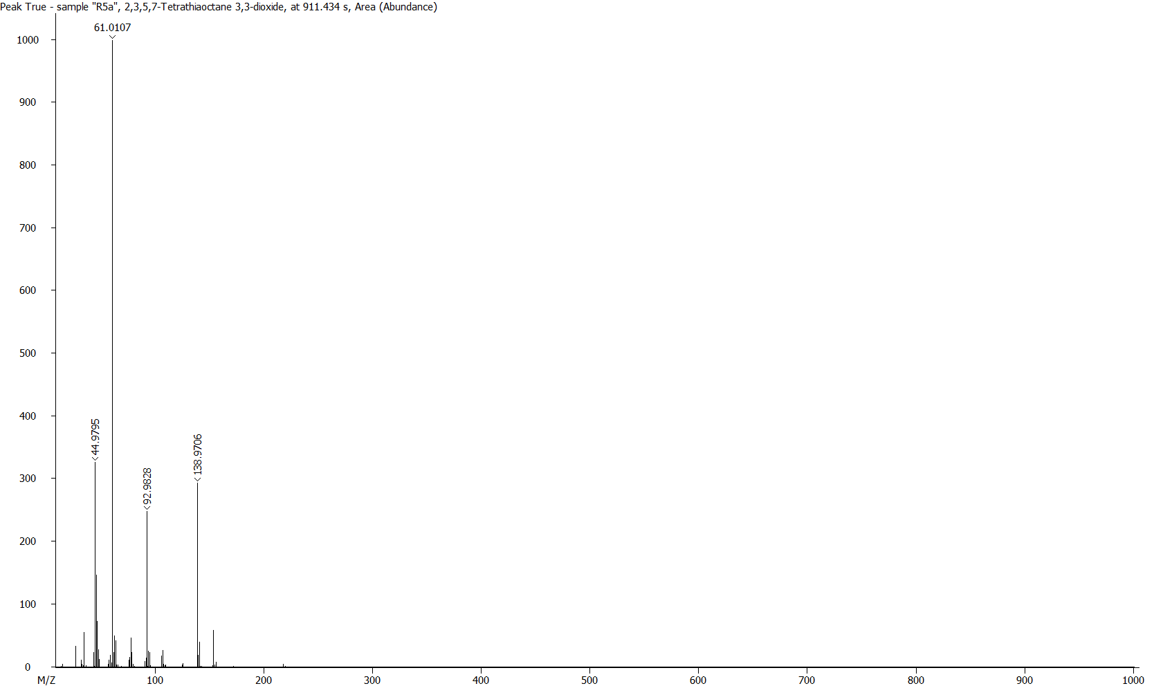

Figure S41:

Figure S42:

Figure S43:

Figure S44:

Figure S45:

Figure S46:

Figure S47:

Figure S48:

Figure S49:

Figure S50: