**Supplementary file**

**Spatio-temporal characterization of nutrient and organic pollution along with nutrient-chlorophyll-a dynamics in the Geum River**

**Md Mamun, Namsrai Jargaland Kwang-Guk An\***

Department of Bioscience and Biotechnology, Chungnam National University, Daejeon 34134, South Korea; Md Mamun ([mamun1006001@gmail.com](mailto:mamun1006001@gmail.com)), Namsrai Jargal (jargal.namsrai.sci@gmail.com)

**Corresponding Author**: Professor Kwang-Guk An, Email: [kgan@cnu.ac.kr](mailto:kgan@cnu.ac.kr); Tel.: +82 42 821 6408; Fax: +82 42 822 9690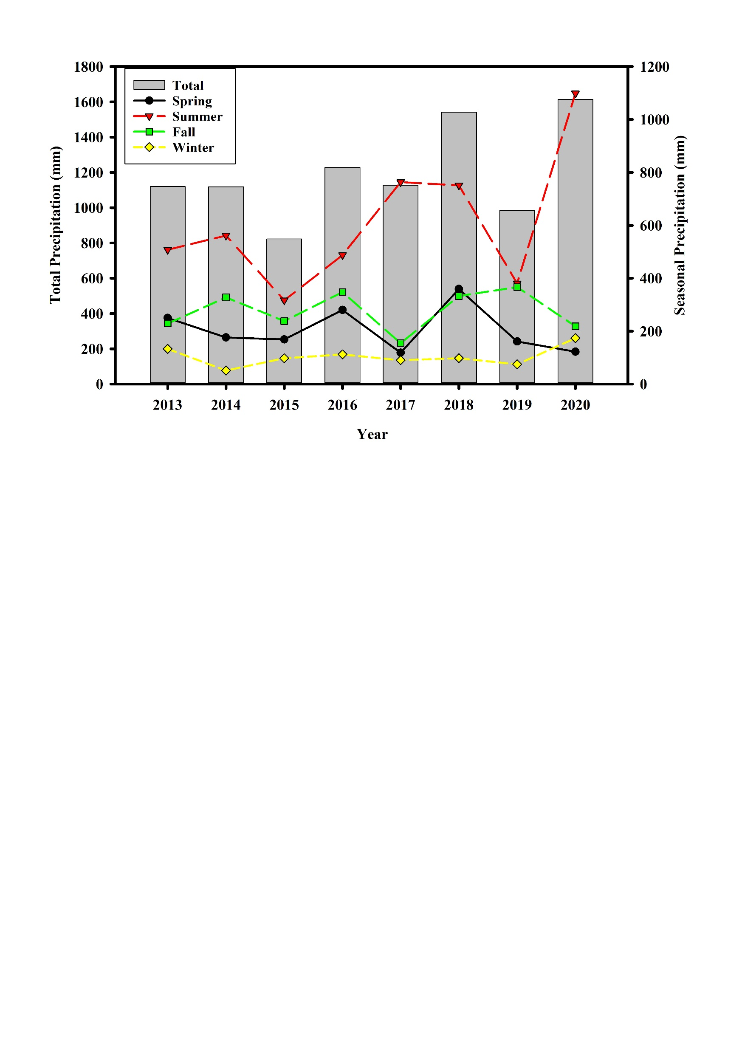

Fig. S1. Total and seasonal rainfall pattern of the studied area.

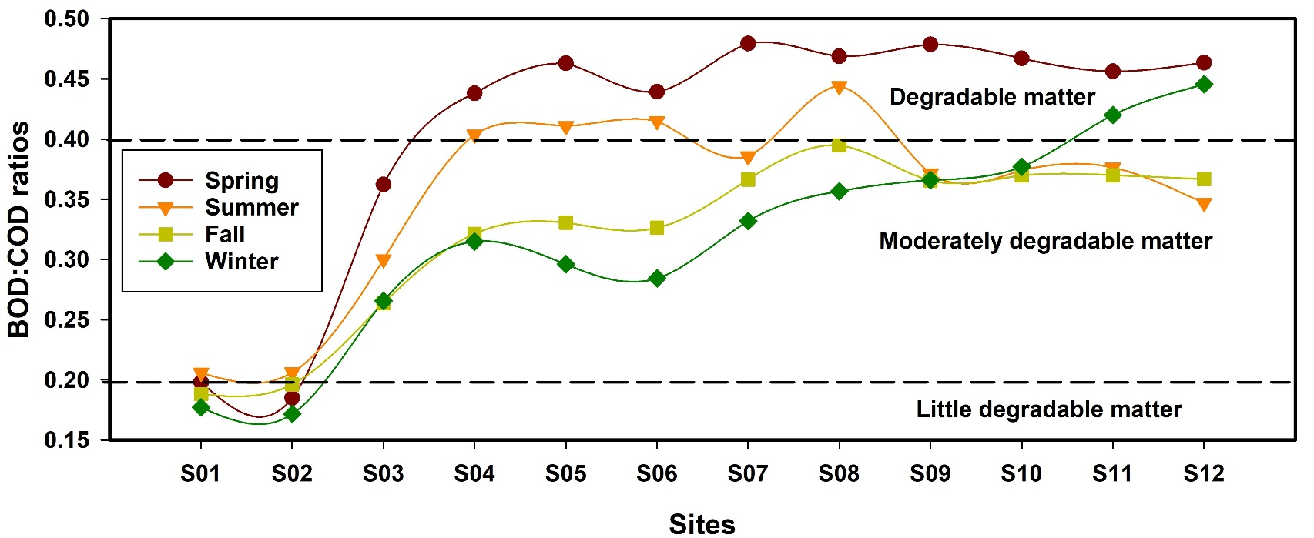

Fig. S2. Biodegradability Index in the Geum River. (BOD: biological oxygen demand, COD: chemical oxygen demand, Spring: Mar-May, Summer: Jun-Aug, Fall: Sep-Nov, Winter: Dec-Feb).

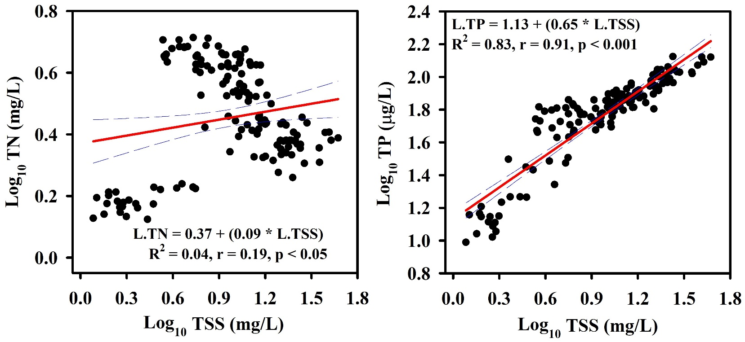

Fig. S3. Associations among suspended solids with total nitrogen (TN) and total phosphorus (TP)

Table S1. WQI range, status, and possible usage of the water sample (Brown et al.1972)

|  |  |  |
| --- | --- | --- |
| Water quality index (WQI) | Water quality status (WQS) | Possible usage |
| 0-25 | Excellent | Drinking, irrigation and industrial |
| 26-50 | Good | Drinking, irrigation and industrial |
| 51-75 | Poor | Irrigation and industrial |
| 76-100 | Very poor | Irrigation |
| Above 100 | Unsuitable for drinking and fish culture | Proper treatment required before use |