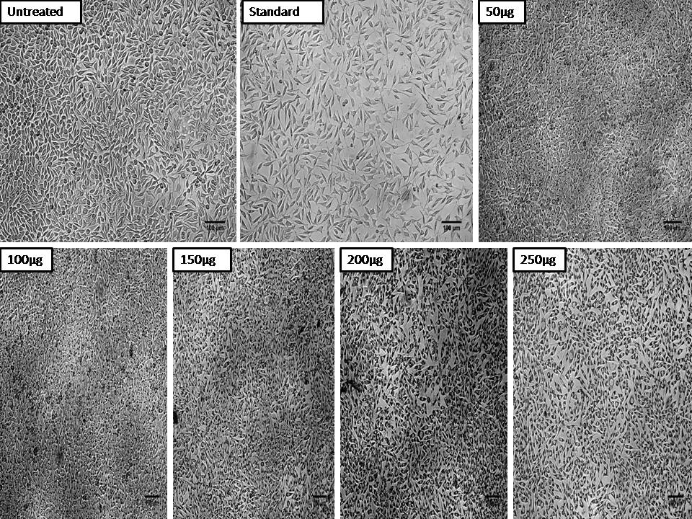

**Figure S1. Cytotoxicity of Hexane extract of *C. olitorius* on non-cancerous fibroblast L929 cell line**

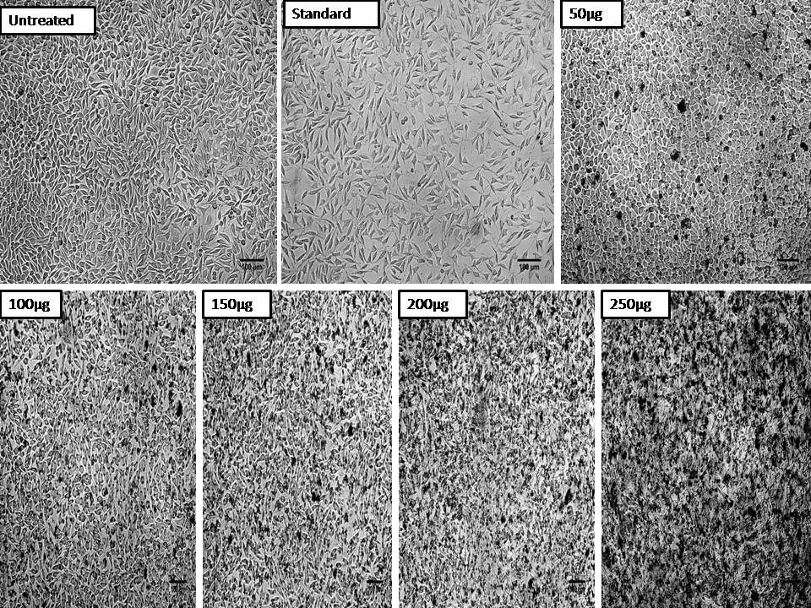

**Figure S2. Cytotoxicity of Ethyl acetate extract of *C. olitorius* on non-cancerous fibroblast L929 cell line**

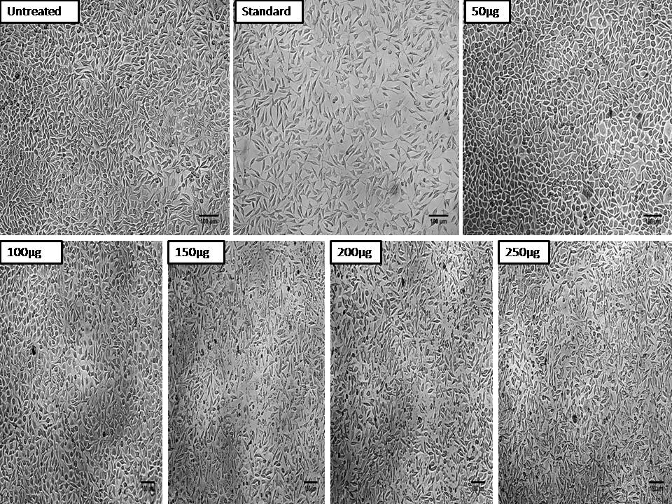

**Figure S3. Cytotoxicity of Methanol extract of *C. olitorius* on non-cancerous fibroblast L929 cell line**

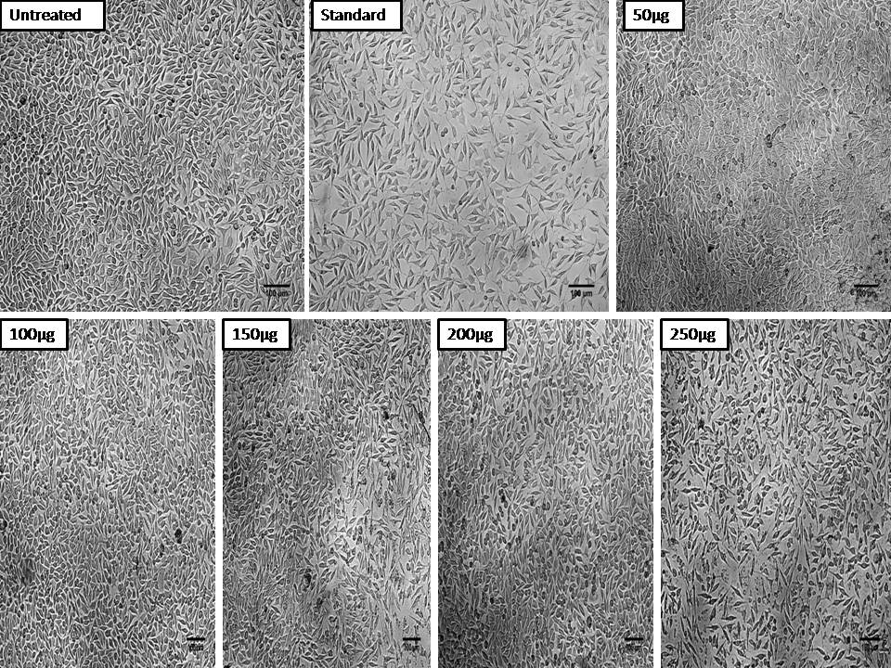

**Figure S4. Cytotoxicity of Aqueous extract of *C. olitorius* on non-cancerous fibroblast L929 cell line**

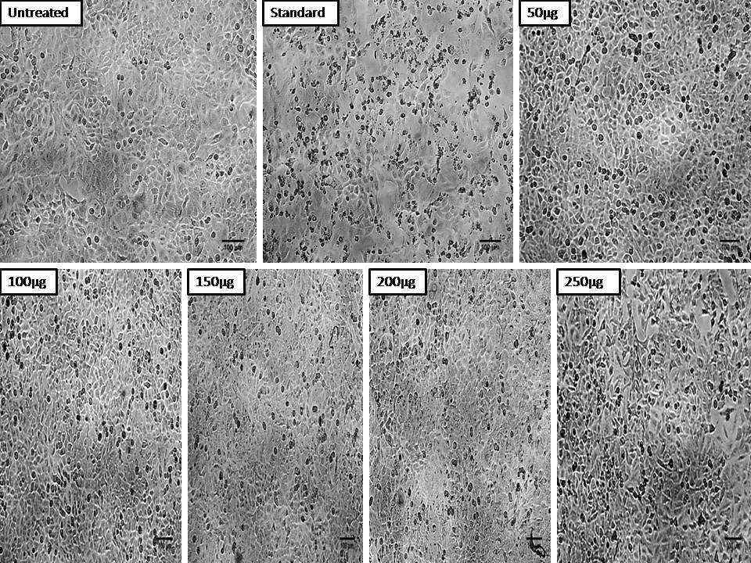

**Figure S5. Anticancer activity of Hexane extracts of *C. olitorius* on Lung cancer A549 cell line**

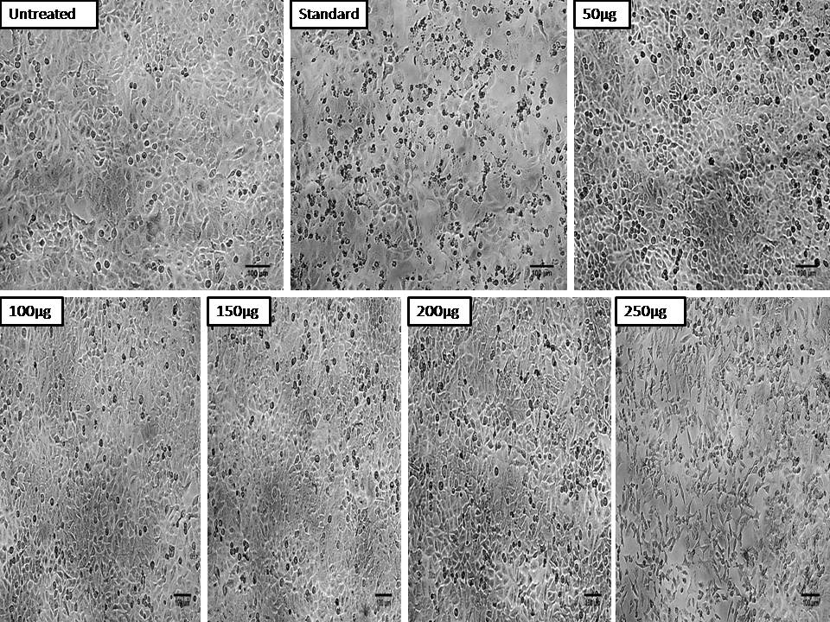

**Figure S6. Anticancer activity of Ethyl acetate extracts of *C. olitorius* on lung cancer A549 cell line**

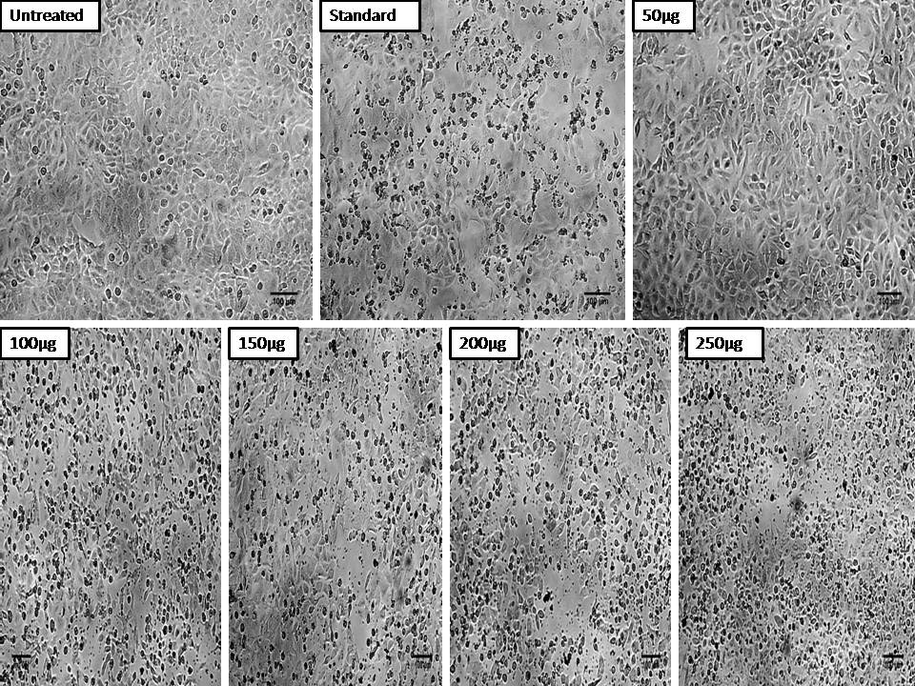

**Figure S7. Anticancer activity of Methanol extracts of *C. olitorius* on lung cancer A549 cell line**

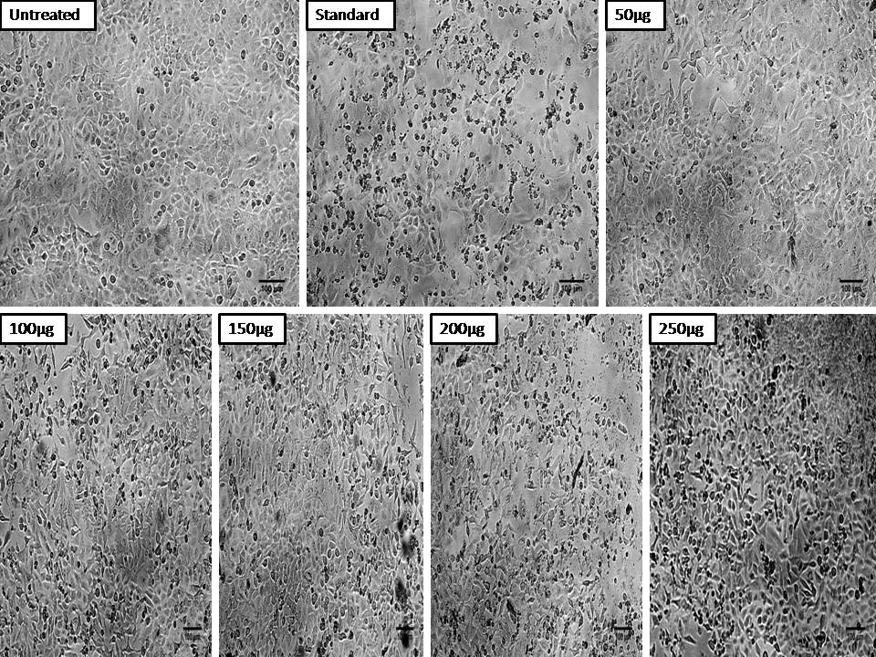

**Figure S8. Anticancer activity of Aqueous extracts of *C. olitorius* on lung cancer A549 cell line**

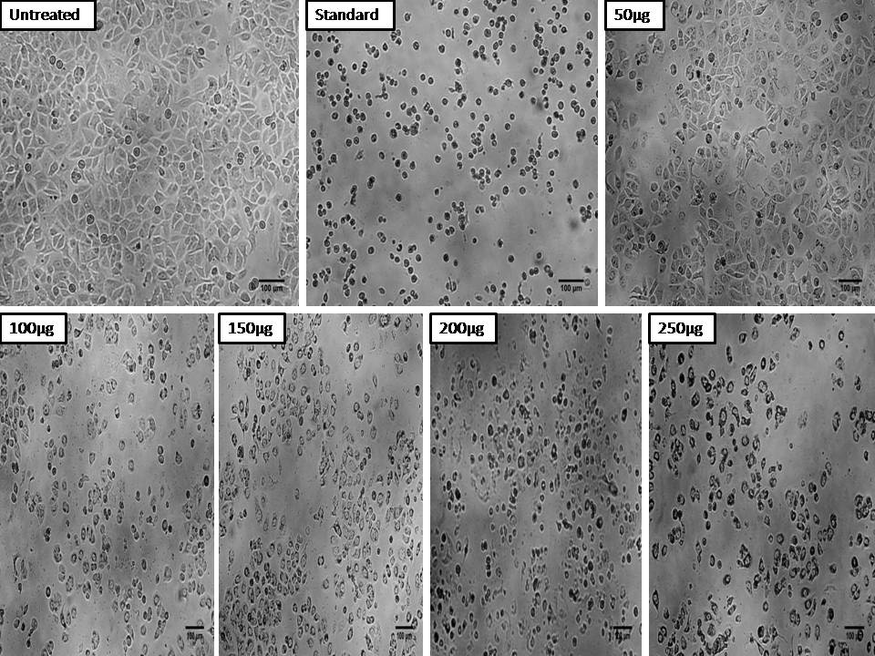

**Figure S9. Anticancer activity Hexane extracts of *C. olitorius* on Breast cancer MCF-7 cell line**

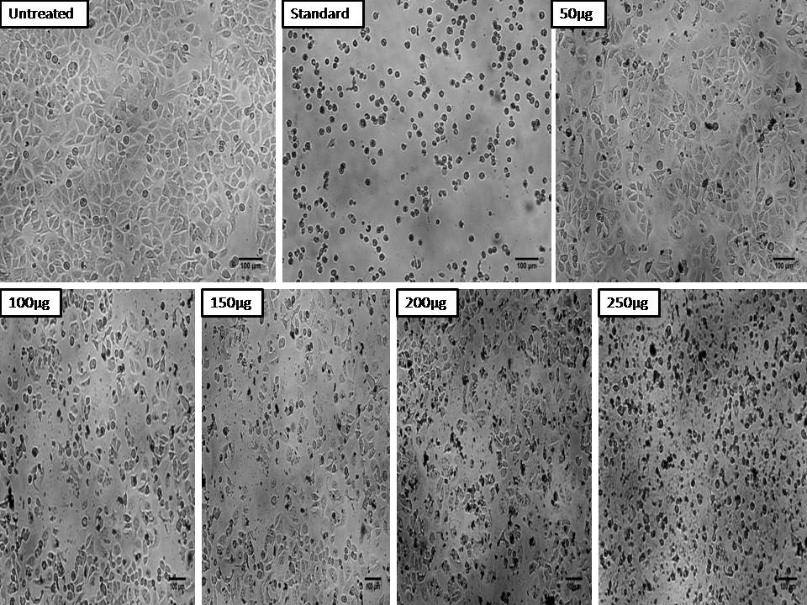

**Figure S10. Anticancer activity of Ethyl acetate extracts of *C. olitorius* on Breast cancer MCF-7 cell line**

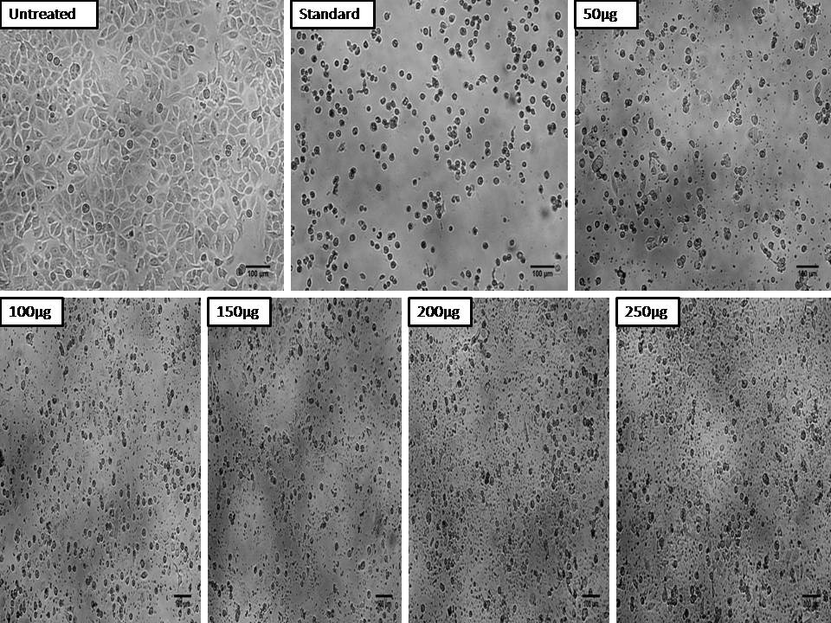

**Figure S11. Anticancer activity of Methanol extracts of *C. olitorius* on Breast cancer MCF-7 cell line**

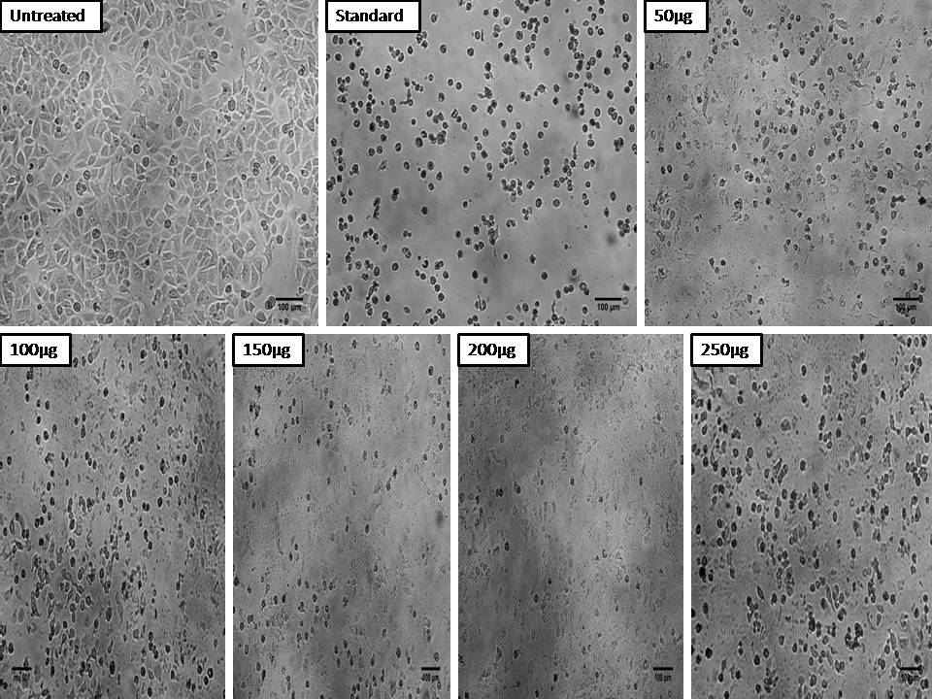

**Figure S12. Anticancer activity of Aqueous extracts of *C. olitorius* on Breast cancer MCF-7 cell line**

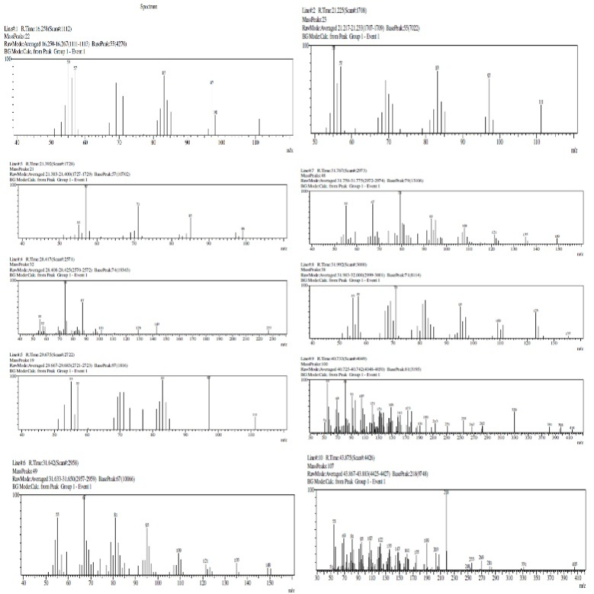

**Figure S13.GC-MS Profiling of Methanol extract of *C. olitorius* using the NIST library database to identify the compounds**

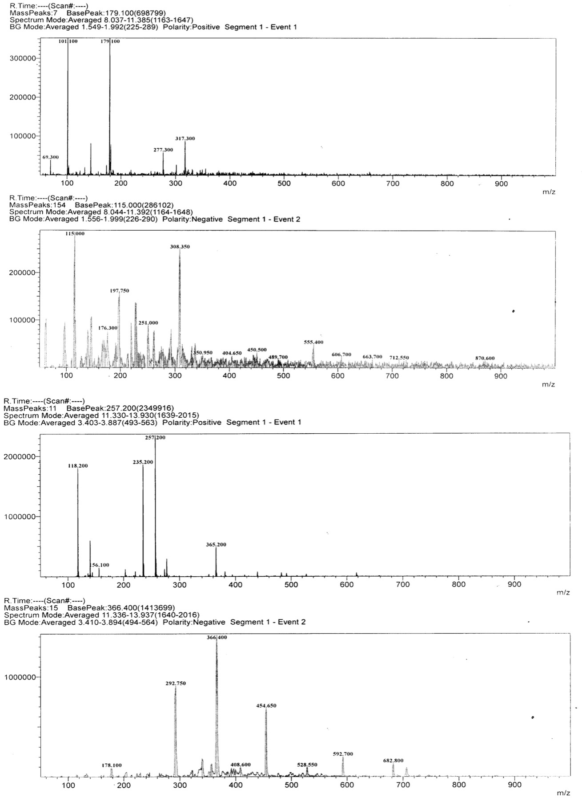

**Figure S14.LC-MS based profiling of Methanol extract of *C. olitorius***

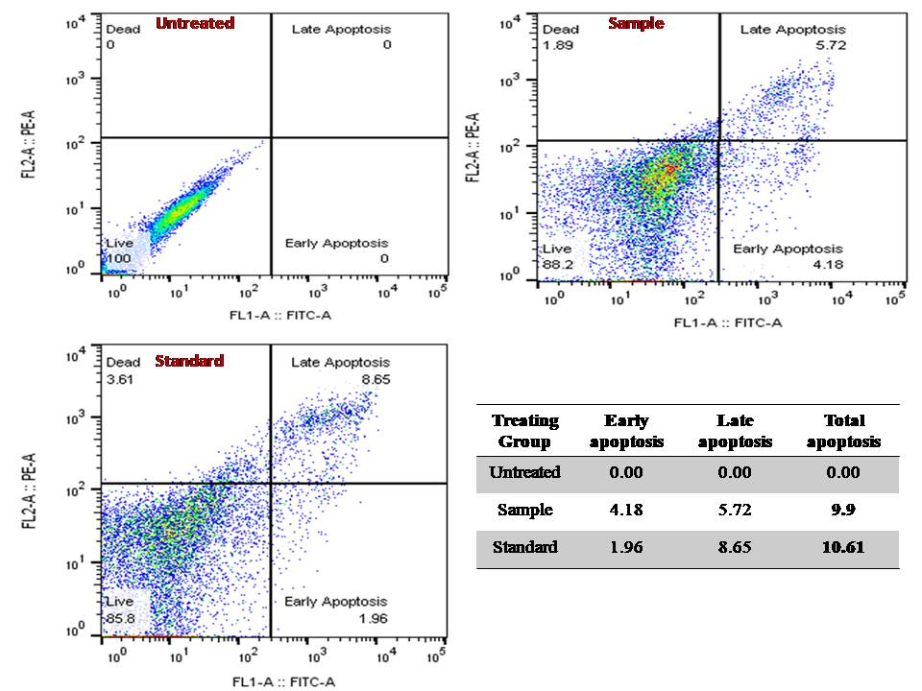

**Figure S15.**Detection of early and late apoptosis induced by methanol extract of *C. olitorius* in MCF-7 cell line

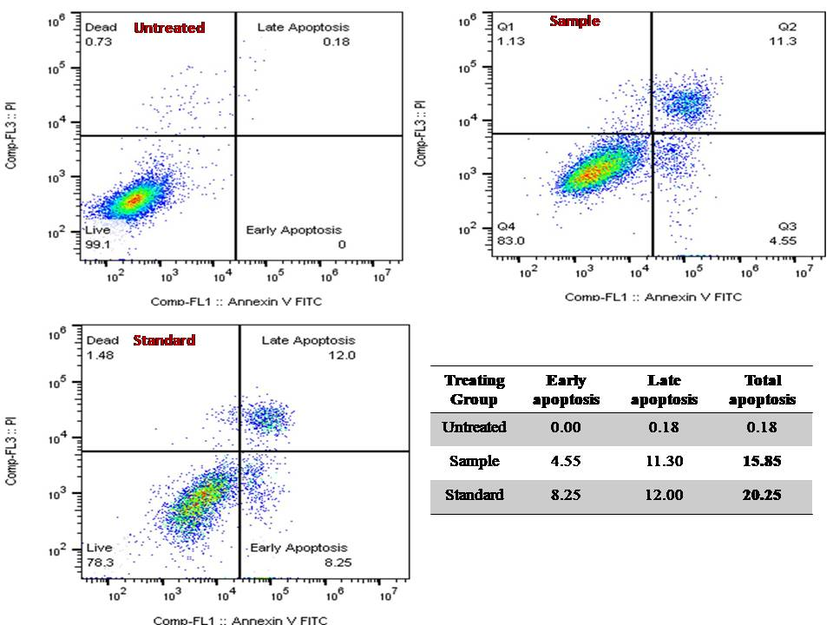

**Figure S16.** Detection of early and late apoptosis induced by methanol extract of *C. olitorius* in A549 cell line

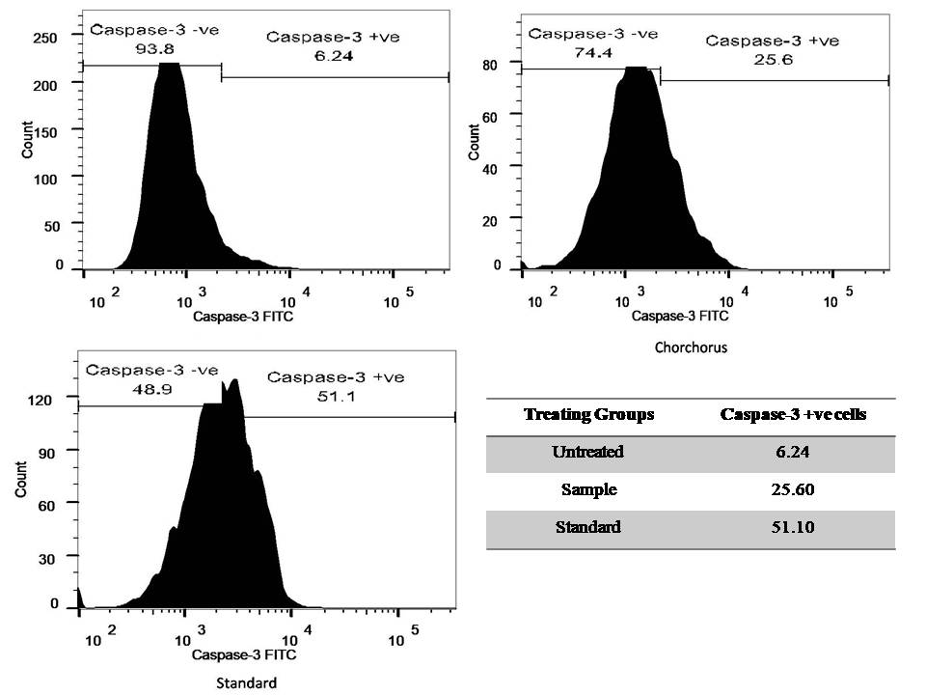

**Figure S17.** Confirmation of apoptosis induced by methanol extract of *C. olitorius* in MCF-7 cell line through Caspase-3 assay

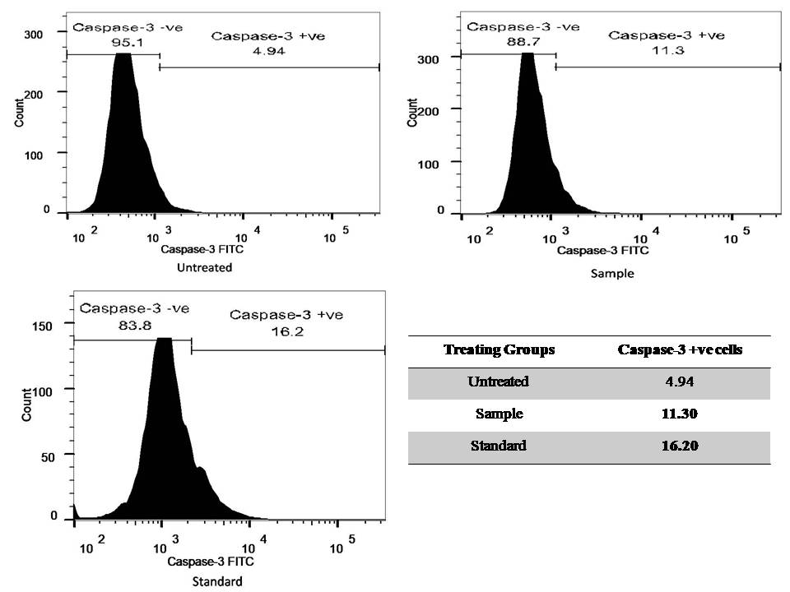

**Figure S18.** Confirmation of apoptosis induced by methanol extract of *C. olitorius* in A549 cell line through caspase-3 assay

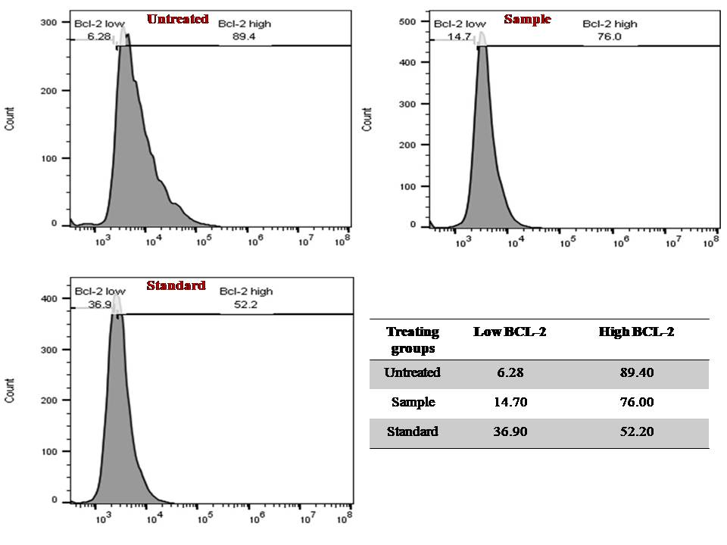

**Figure S19.** Flow cytometry-based study of inhibition of Anti-apoptotic protein BCL-2 through methanol extract of *C. olitorius* in MCF-7 cell line

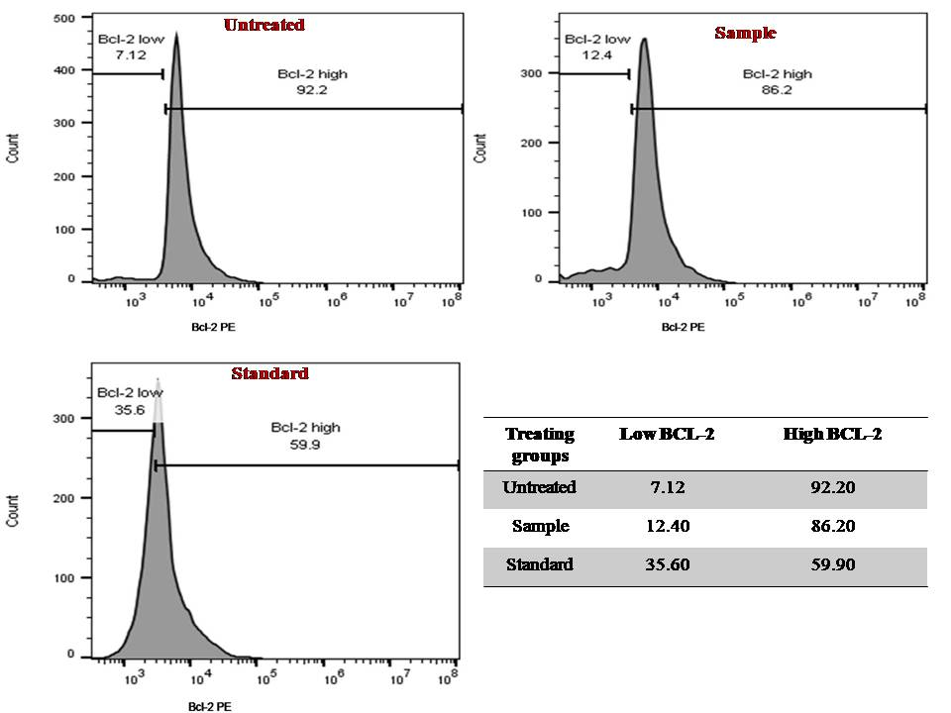

**Figure S20.** Flow cytometry-based study of inhibition of Anti-apoptotic protein BCL-2 through methanol extract of *C. olitorius* in A549 cell line

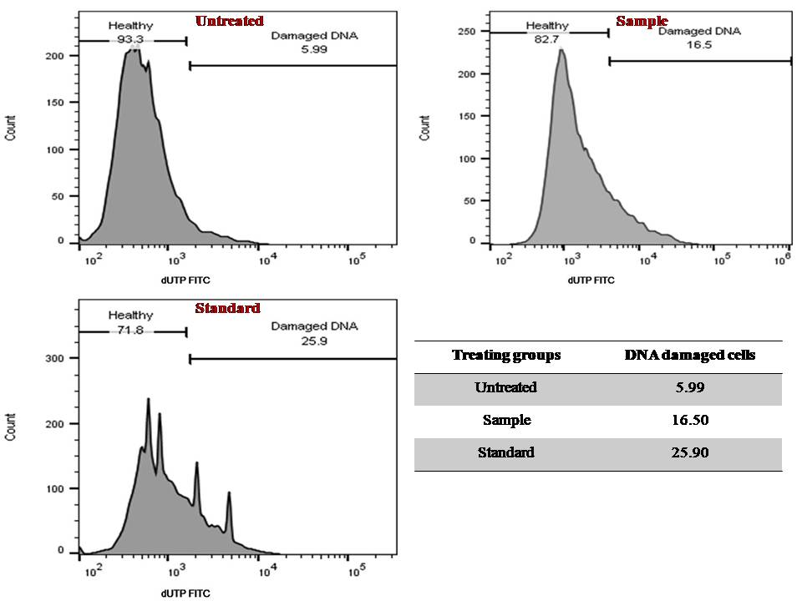

**Figure S21.** Flow cytometry-based study of DNA damage induced by methanol extract of Chorchorus plant in MCF-7 cell line

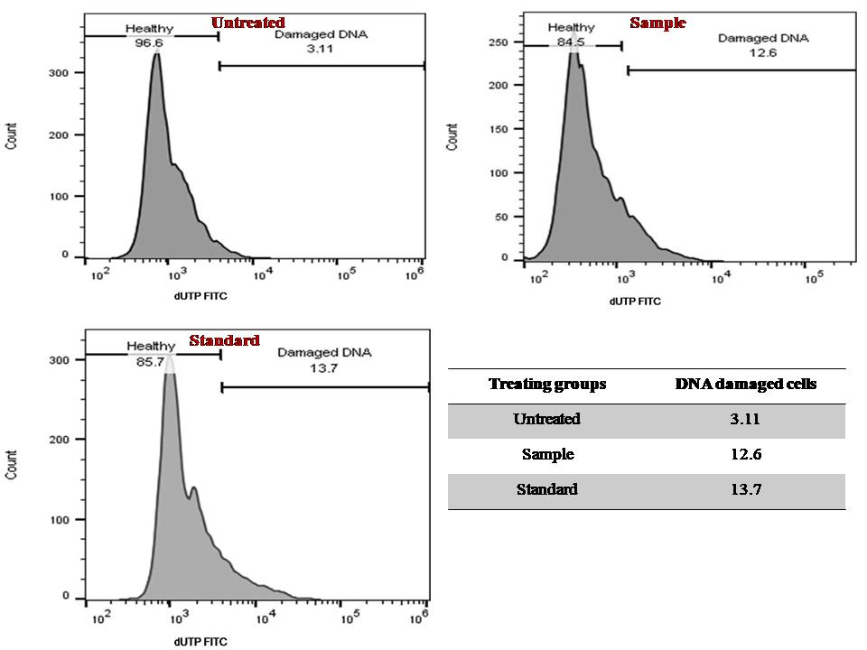

**Figure S22.** Flow cytometry-based study of DNA damage induced by methanol extract of *C. olitorius* in A549 cell line