S1: Tables
Table S1
Optimized structures and IUPAC names of the 40 unsymmetrical aromatic disulfides
N° | Optimized structure | IUPAC name | N° | Optimized structure | IUPAC name
1 |  | 2-((4-Chlorophenyl) disulfaneyl)thiazole | 21 | 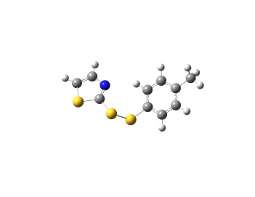 | 2-(p-Tolyldisulfaneyl) thiazole
2 |  | N-(2-(p-tolyldisulfaneyl) thiazol-5-yl)acetamide | 22 | 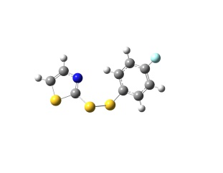 | 2-((4-Fluorophenyl) disulfaneyl)thiazole
3 | 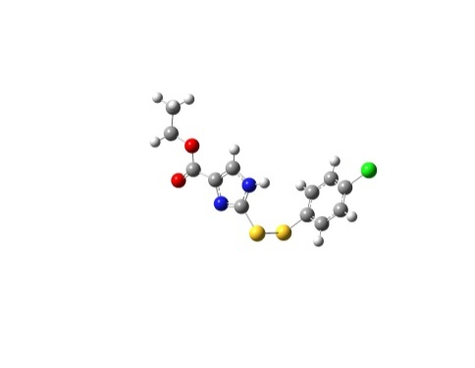 | Methyl 2-((4-chlorophenyl) disulfaneyl)-1H-imidazole-4-carboxylate | 23 | 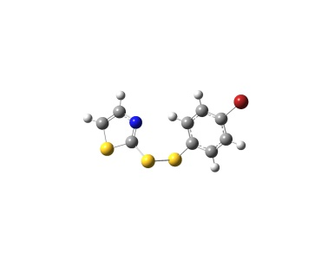 | 2-((4-Bromophenyl) disulfaneyl)thiazole
4 | 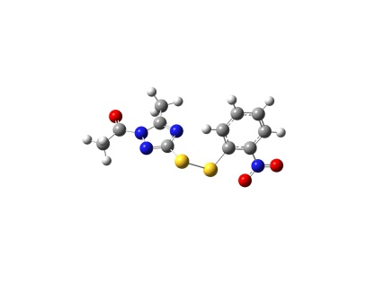 | 1-(5-Methyl-3-((2-nitrophenyl)disulfaneyl)-1H-1,2,4-triazol-1-yl)ethan-1-one | 24 | 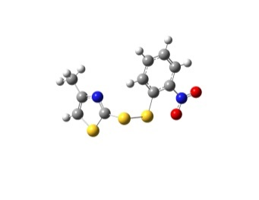 | 4-Methyl-2- ((2-nitrophenyl)disulfaneyl) thiazole
5 | 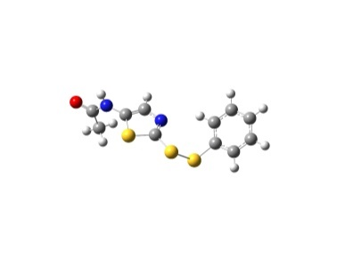 | N-(2-(phenyldisulfaneyl) thiazol-5-yl)acetamide | 25 | 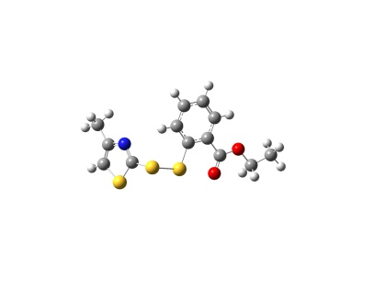 | Ethyl 2-((4-methylthiazol-2-yl) disulfaneyl)benzoate
6 | 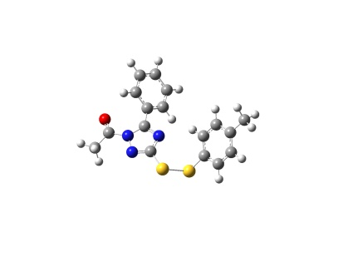 | 1-(5-Phenyl-3-(p-tolyldisulfaneyl)-1H-1,2,4-triazol-1-yl)ethan-1-one | 26 | 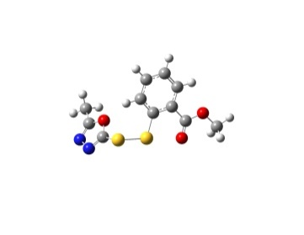 | Methyl 2-((5-methyl-1,3,4-oxadiazol-2-yl) disulfaneyl)benzoate
7 | 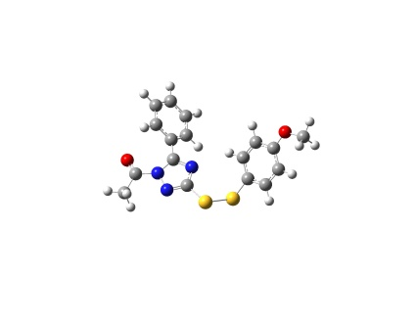 | 1-(3-((4-Methoxyphenyl) disulfaneyl)-5-phenyl-1H-1,2,4-triazol-1-yl)ethan-1-one | 27 | 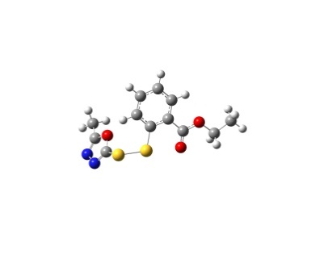 | Ethyl 2-((5-methyl-1,3,4-oxadiazol-2-yl) disulfaneyl)benzoate
8 | 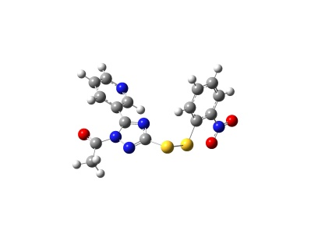 | 1-(3-((2-Nitrophenyl) disulfaneyl)-5-(pyridin-3-yl)-1H-1,2,4-triazol-1-yl)ethan-1-one | 28 | 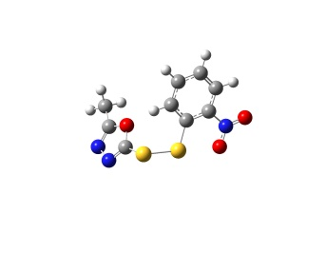 | 2-Methyl-5-((2-nitrophenyl) disulfaneyl)-1,3,4-oxadiazole
9 | 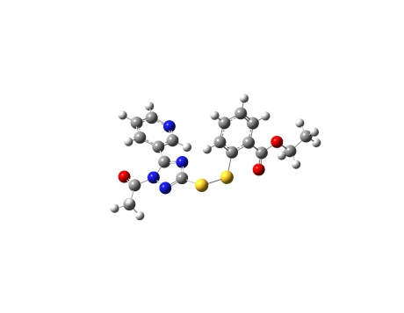 | Ethyl 2-((1-acetyl-5-(pyridin-3-yl)-1H-1,2,4-triazol-3-yl)disulfaneyl) benzoate | 29 | 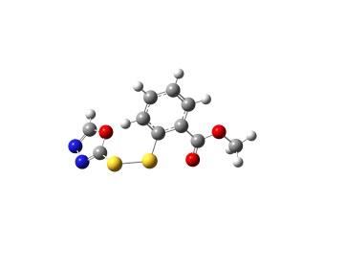 | Methyl 2-((1,3,4-oxadiazol-2-yl) disulfaneyl)benzoate
10 | 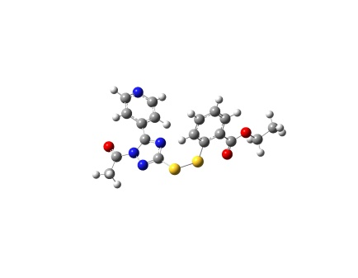 | Ethyl 2-((1-acetyl-5-(pyridin-4-yl)-1H-1,2,4-triazol-3-yl)disulfaneyl) benzoate | 30 | 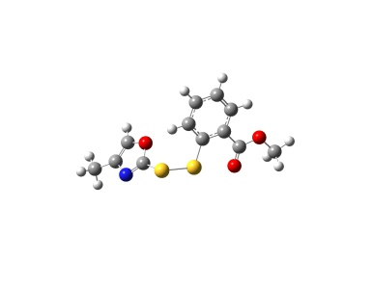 | Methyl 2-((4-methyloxazol-2-yl) disulfaneyl)benzoate
11 | 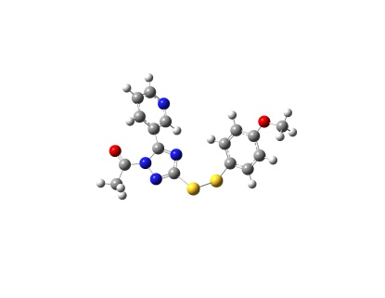 | 1-(3-((4-Methoxyphenyl) disulfaneyl)-5-(pyridin-3-yl)-1H-1,2,4-triazol-1-yl)ethan-1-one | 31 | 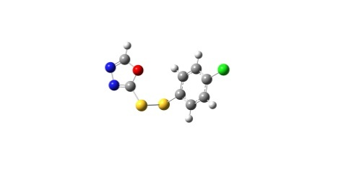 | 2-((4-Chlorophenyl) disulfaneyl)-1,3,4-oxadiazole
12 | 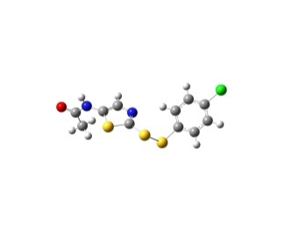 | N-(2-((4-Chlorophenyl) disulfaneyl)thiazol-5-yl)acetamide | 32 | 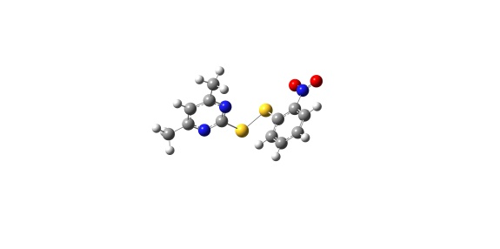 | 4,6-Dimethyl-2-((2-nitrophenyl)disulfaneyl) pyrimidine
13 | 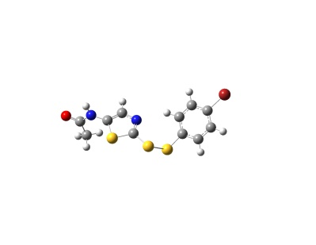 | N-(2-((4-bromophenyl) disulfaneyl)thiazol-5-yl)acetamide | 33 | 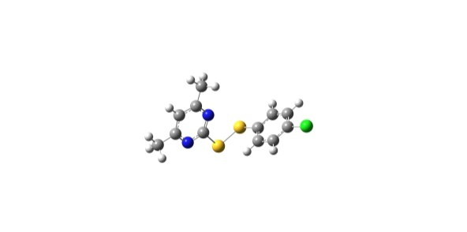 | 2-((4-Chlorophenyl) disulfaneyl)-4,6-dimethylpyrimidine
14 | 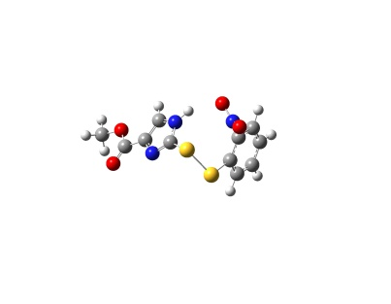 | Methyl 2-((2-nitrophenyl) disulfaneyl) -1H-imidazole-4-carboxylate | 34 | 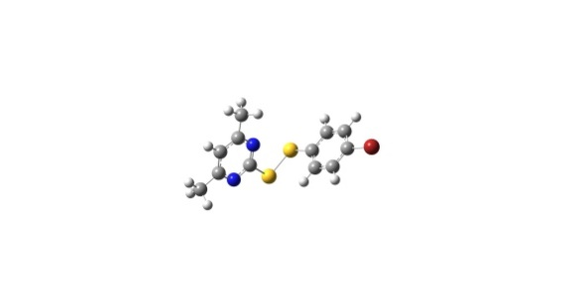 | 2-((4-Bromophenyl) disulfaneyl)-4,6-dimethylpyrimidine
15 | 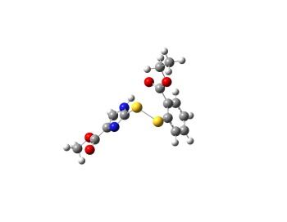 | Methyl 2-((2-(ethoxycarbonyl)phenyl) disulfaneyl)-1H-imidazole-4-carboxylate | 35 | 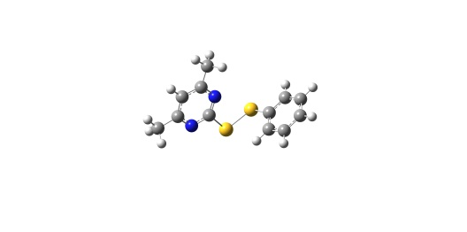 | 4,6-Dimethyl-2-(phenyldisulfaneyl) pyrimidine
16 | 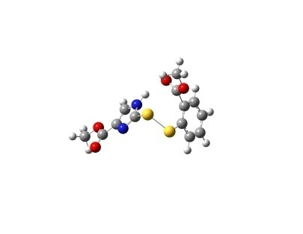 | Methyl 2-((2-(methoxycarbonyl)phenyl) disulfaneyl)-1H-imidazole-4-carboxylate | 36 | 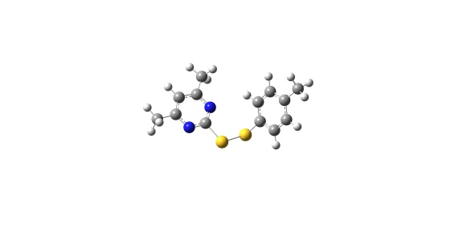 | 4,6-Dimethyl-2-(p-tolyldisulfaneyl) pyrimidine
17 | 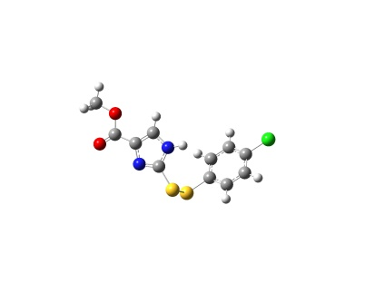 | Methyl 2-((4-chlorophenyl) disulfaneyl)-1H-imidazole-4-carboxylate | 37 | 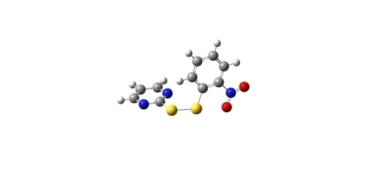 | 2-((2-Nitrophenyl) disulfaneyl) pyrimidine
18 | 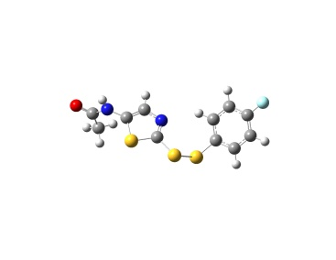 | N-(2-((4-chlorophenyl) disulfaneyl)thiazol-5-yl)acetamide | 38 | 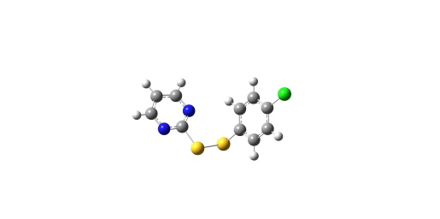 | 2-((4-Chlorophenyl) disulfaneyl)pyrimidine
19 | 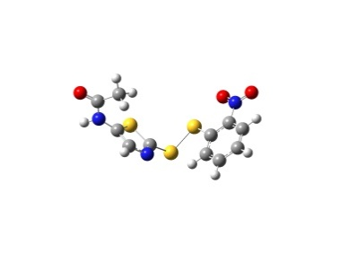 | N-(2-((2-nitrophenyl) disulfaneyl)thiazol-5-yl)acetamide | 39 | 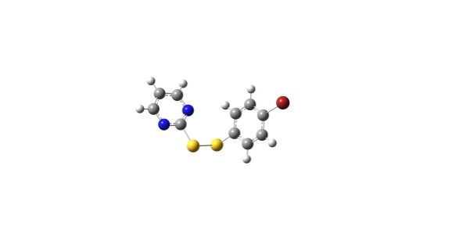 | 2-((4-Bromophenyl) disulfaneyl)pyrimidine
20 | 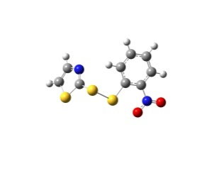 | 2-((2-Nitrophenyl) disulfaneyl)thiazole | 40 | 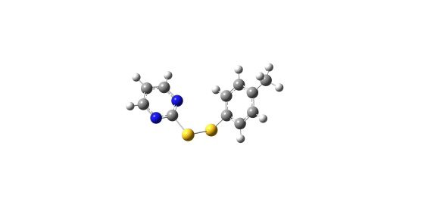 | 2-(p-Tolyldisulfaneyl) pyrimidine
Table S2
Optimized structures and IUPAC names of the 40 unsymmetrical aromatic disulfides.
N° | IUPAC name | Formula weight | Molecular weight | Optimized structure
1 | 2-((4-Chlorophenyl) disulfaneyl)thiazole | C9H6ClNS3 | 258.935
2 | N-(2-(p-tolyldisulfaneyl) thiazol-5-yl)acetamide | C12H12N2OS3 | 296.011
3 | Methyl 2-((4-chlorophenyl) disulfaneyl)-1H-imidazole-4-carboxylate | C11H9ClN2O2S2 | 313.995
4 | 1-(5-Methyl-3-((2-nitrophenyl)disulfaneyl)-1H-1,2,4-triazol-1-yl)ethan-1-one | C11H10N4O3S2 | 310.019
5 | N-(2-(phenyldisulfaneyl) thiazol-5-yl)acetamide | C11H10N2OS3 | 281.996
6 | 1-(5-Phenyl-3-(p-tolyldisulfaneyl)-1H-1,2,4-triazol-1-yl)ethan-1-one | C17H15N3OS2 | 341.066
7 | 1-(3-((4-Methoxyphenyl) disulfaneyl)-5-phenyl-1H-1,2,4-triazol-1-yl)ethan-1-one | C17H15N3O2S2 | 357.061
8 | 1-(3-((2-Nitrophenyl) disulfaneyl)-5-(pyridin-3-yl)-1H-1,2,4-triazol-1-yl)ethan-1-one | C15H11N5O3S2 | 373.03
9 | Ethyl 2-((1-acetyl-5-(pyridin-3-yl)-1H-1,2,4-triazol-3-yl)disulfaneyl) benzoate | C18H16N4O3S2 | 400.066
10 | Ethyl 2-((1-acetyl-5-(pyridin-4-yl)-1H-1,2,4-triazol-3-yl)disulfaneyl) benzoate | C18H16N4O3S2 | 400.066
11 | 1-(3-((4-Methoxyphenyl) disulfaneyl)-5-(pyridin-3-yl)-1H-1,2,4-triazol-1-yl)ethan-1-one | C16H14N4O2S2 | 358.056
12 | N-(2-((4-Chlorophenyl) disulfaneyl)thiazol-5-yl)acetamide | C11H9ClN2OS3 | 315.957
13 | N-(2-((4-bromophenyl) disulfaneyl)thiazol-5-yl)acetamide | C11H9BrN2OS3 | 359.906
14 | Methyl 2-((2-nitrophenyl) disulfaneyl) -1H-imidazole-4-carboxylate | C11H9N3O4S2 | 311.003
15 | Methyl 2-((2-(ethoxycarbonyl)phenyl) disulfaneyl)-1H-imidazole-4-carboxylate | C14H14N2O4S2 | 338.039
16 | Methyl 2-((2-(methoxycarbonyl)phenyl) disulfaneyl)-1H-imidazole-4-carboxylate | C13H12N2O4S2 | 324.024
17 | Methyl 2-((4-chlorophenyl) disulfaneyl)-1H-imidazole-4-carboxylate | C11H9ClN2O2S2 | 299.979
18 | N-(2-((4-chlorophenyl) disulfaneyl)thiazol-5-yl)acetamide | C11H9ClN2OS3 | 299.986
19 | N-(2-((2-nitrophenyl) disulfaneyl)thiazol-5-yl)acetamide | C11H9N3O3S3 | 326.981
20 | 2-((2-Nitrophenyl) disulfaneyl)thiazole | C9H6N2O2S3 | 269.959
21 | 2-(p-Tolyldisulfaneyl) thiazole | C10H9NS3 | 238.99
22 | 2-((4-Fluorophenyl) disulfaneyl)thiazole | C9H6FNS3 | 242.965
23 | 2-((4-Bromophenyl) disulfaneyl)thiazole | C9H6BrNS3 | 302.885
24 | 4-Methyl-2- ((2-nitrophenyl)disulfaneyl) thiazole | C10H8N2O2S3 | 283.975
25 | Ethyl 2-((4-methylthiazol-2-yl) disulfaneyl)benzoate | C13H13NO2S3 | 311.011
26 | Methyl 2-((5-methyl-1,3,4-oxadiazol-2-yl) disulfaneyl)benzoate | C11H10N2O3S2 | 282.013
27 | Ethyl 2-((5-methyl-1,3,4-oxadiazol-2-yl) disulfaneyl)benzoate | C12H12N2O3S2 | 296.029
28 | 2-Methyl-5-((2-nitrophenyl) disulfaneyl)-1,3,4-oxadiazole | C9H7N3O3S2 | 268.993
29 | Methyl 2-((1,3,4-oxadiazol-2-yl) disulfaneyl)benzoate | C10H8N2O3S2 | 267.998
30 | Methyl 2-((4-methyloxazol-2-yl) disulfaneyl)benzoate | C12H11NO3S2 | 281.018
31 | 2-((4-Chlorophenyl) disulfaneyl)-1,3,4-oxadiazole | C8H5ClN2OS2 | 243.953
32 | 4,6-Dimethyl-2-((2-nitrophenyl)disulfaneyl) pyrimidine | C12H11N3O2S2 | 293.029
33 | 2-((4-Chlorophenyl) disulfaneyl)-4,6-dimethylpyrimidine | C12H11ClN2S2 | 282.005
34 | 2-((4-Bromophenyl) disulfaneyl)-4,6-dimethylpyrimidine | C12H11BrN2S2 | 325.955
35 | 4,6-Dimethyl-2-(phenyldisulfaneyl) pyrimidine | C12H12N2S2 | 248.044
36 | 4,6-Dimethyl-2-(p-tolyldisulfaneyl) pyrimidine | C13H14N2S2 | 262.06
37 | 2-((2-Nitrophenyl) disulfaneyl) pyrimidine | C10H7N3O2S2 | 264.998
38 | 2-((4-Chlorophenyl) disulfaneyl)pyrimidine | C10H7ClN2S2 | 253.974
39 | 2-((4-Bromophenyl) disulfaneyl)pyrimidine | C10H7BrN2S2 | 297.923
40 | 2-(p-Tolyldisulfaneyl) pyrimidine | C11H10N2S2 | 234.029

Table S3
Prediction of pharmacokinetic properties for the top six compounds.
N° | GI absorption | Cytochrome inhibitor |  |  |  |  | Bioavailability
 |  | CYP1A2 | CYP2C19 | CYP2C9 | CYP2D6 | CYP3A4
6 | High | Yes | Yes | Yes | No | No | 0.55
7 | High | Yes | Yes | Yes | No | Yes | 0.55
8 | Low | Yes | Yes | Yes | No | Yes | 0.55
9 | Low | Yes | Yes | Yes | No | Yes | 0.55
10 | Low | Yes | Yes | Yes | No | Yes | 0.55
11 | High | Yes | Yes | Yes | No | Yes | 0.55

Table S4
Predicted in silico values of distribution and excretion parameter
N° | Distribution |  | Excretion
 | Pgp substrate | BBB | Renal OCT2 substrate | Total Clearance
6 | No | No | Yes | 0.047-
7 | No | No | Yes | 0.045
8 | No | No | No | 0.151-
9 | No | No | No | 0.008-
10 | No | No | No | 0.006-
11 | No | No | No | 0.091-

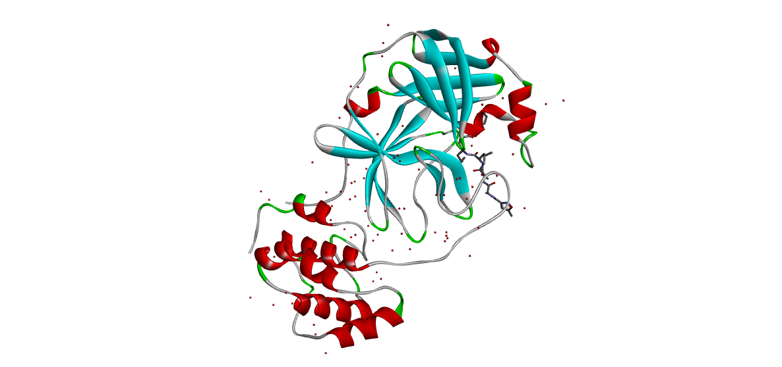 | 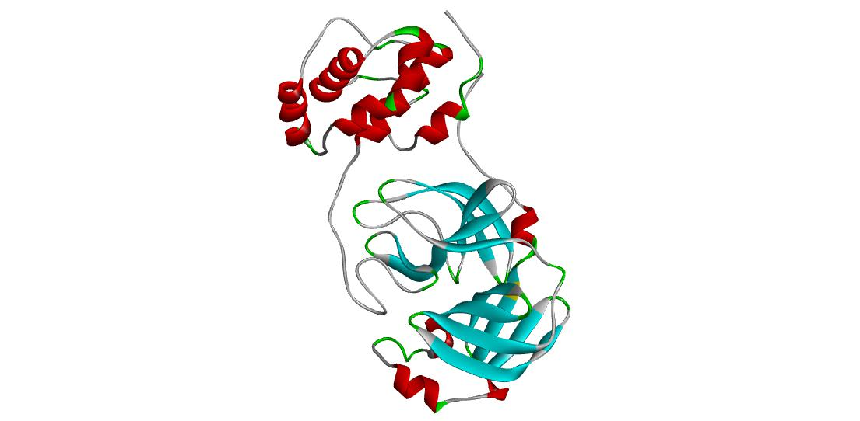  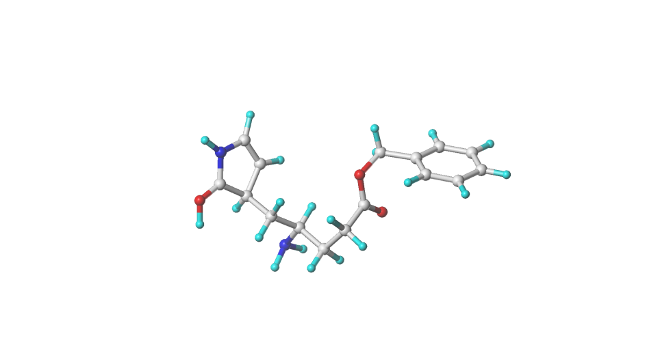
Fig. S1. Crystal structure of SARS-CoV-2 Mpro (PDB ID: 6LU7), co-crystallized ligand, and prepared protein for docking.
S2: Figures

A)
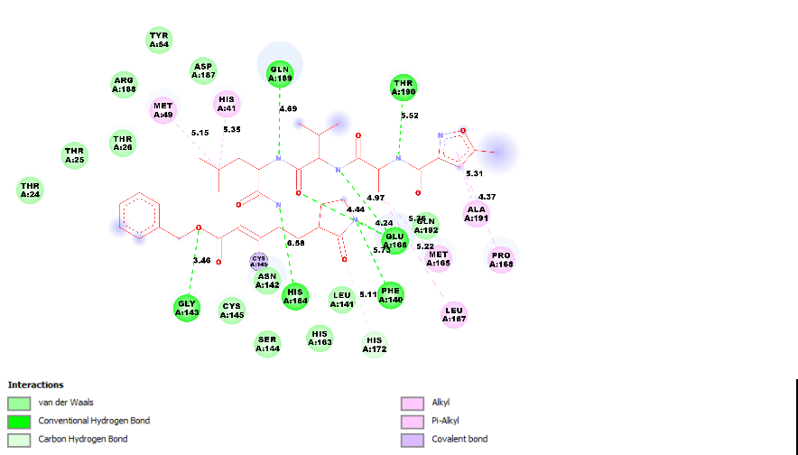
B)
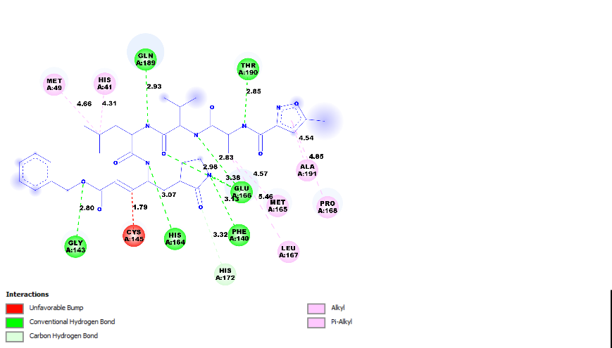
Fig. S2. 2D visualizations of the interactions of N3 ligand with various active residues in the 6LU7 complex: (A) original co-crystallized ligand, (B) prepared ligand.

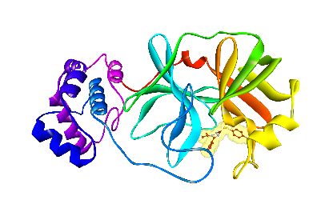 | 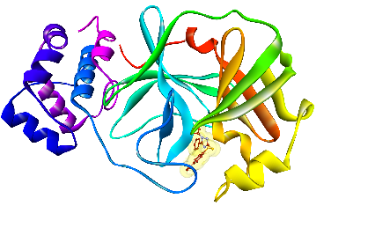 | 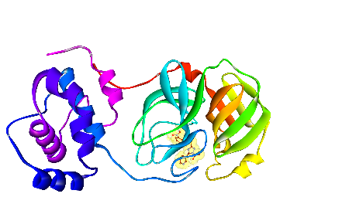
Mpro-Lig6 | Mpro-Lig7 | Mpro-Lig8
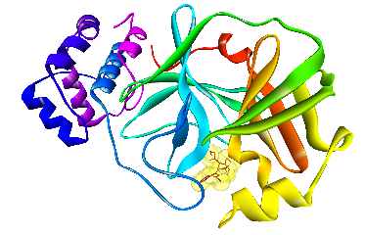 | 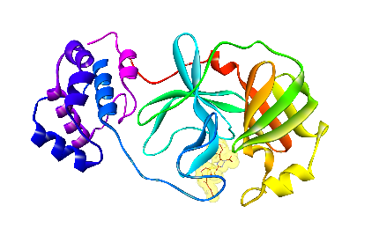 | 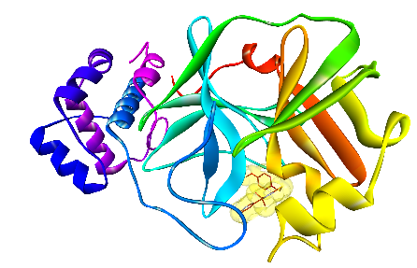
Mpro-Lig9 | Mpro-Lig10 | Mpro-Lig11
B)
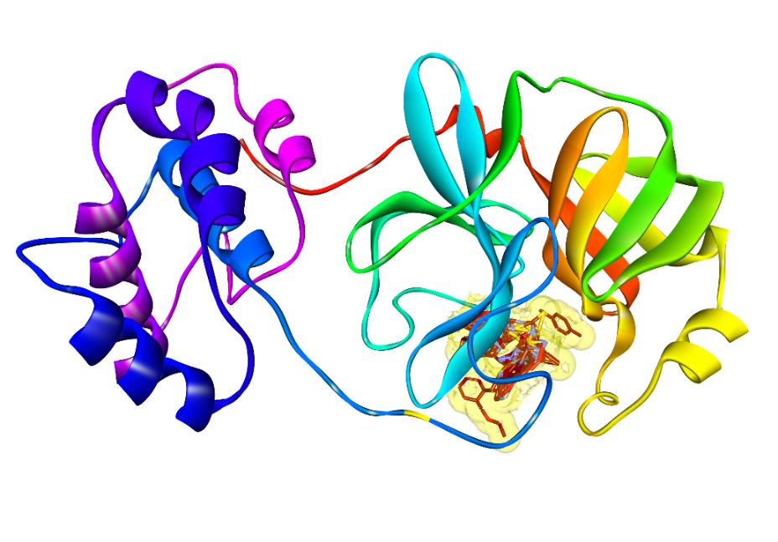
Fig. S3. (A) Docked conformation poses of ligands 6, 7, 8, 9, 10, 11 inside the Mpro receptor pocket. (B) Superimposed view of ligands 6, 7, 8, 9, 10, 11 inside the Mpro receptor pocket

S3. Material and Methods
3.1 Molecular docking
The in silico investigation was performed using Molecular docking to examine the probable binding mode established by the studied compounds with the amino acid residues of the SARS-CoV-2 Mpro.
3.2 SARS-CoV-2 Mpro
On 5th February 2020, the structure of the SARS-CoV-2 6LU7 protein (DOI: 10.2210/pdb6LU7/pdb) has been deposited in the RSCB PDB (Figure S1). It describes the three-dimensional (3D) crystal structure of the SARS-CoV-2 Mpro in the complex associated with N3 inhibitor(Liu et al., 2020). The protein structure has allowed an improved insight into virus replication in human cells and has enhanced the current research to define potential drugs that may protect against SARS-CoV-2 infection.

3.3 SARS-CoV-2 protein preparation
The published crystal structure of SARS-CoV-2 Mpro protein (PDB: 6LU7) was downloaded from the PDB (http://www.rcsb.org). The protein preparation module in Discovery Studio software (Dassault Systèmes BIOVIA, 2020) was used to prepare the PDB protein structure. The co-crystallized ligand of the 6LU7 structure was extracted, prepared, and saved in PDBQT format, and it was used as a reference in virtual screening with AutoDock tools 1.5.4. Water and solvent molecules were removed, and the protein was protonated to add polar hydrogens .
3.4 Construction of ligand dataset
The dataset of 40 unsymmetrical aromatic disulfide derivatives exhibiting Anti-SARS-CoV activity has been collected from literature (Wang et al., 2017). The structure of ligands and their IUPAC names are embedded in the Table S1.
3.5 Ligands preparation
The Discovery Studio software was used to prepare the PDB ligand structures. Partial charges and energy minimization of the 3D structures of all ligands were prepared under the Tripos standard force field with Gasteiger-Hückel atomic partial charges by the Powell method with a convergence criterion of 0.01 kcal/(mol.Å) in the SYBYL software (Tripos International, St. Louis, MS, USA). The QTPDB format required for the docking protocol was performed in AutoDock tools, a docking grid box (x = -10.641, y = 11.847, and z = 68.346 at 1 Å spacing and 20 Åsize) was set to cover the binding site in the protein and was generated by sitting the co-crystallized ligand (the inhibitor N3) as a center of the box. Bioactive conformations of ligands were simulated and docked in the active binding site of the prepared protein, and any interactions with amino acid residues were identified using AutoDock Vina(Trott et al., 2010, Chtita et al., 2021, Fouedjou, et al., 2021, Aouidate et al., 2018). The number of docking positions was fixed to 10 while all remaining parameters of AutoDock Vina were set to default values. The two-dimensional (2D) and 3D interactions of the docking result were obtained by importing our result into Discovery Studio Visualizer, thereby enabling us to identify any significant interaction between the ligands and receptor-binding site.
3.6 Pharmacokinetic profile
The chemical structures of compounds with high molecular docking scores, proposed as novel anti-SARS-CoV-2 candidates, were submitted in the form of canonical simplified molecular input line entry system (SMILES) to estimate several in silico pharmacokinetic parameters using the SwissADME tool at the Swiss Institute of Bioinformatics (http://www.sib.swiss). The pharmacokinetic profile of the compound was evaluated with respect to Lipinski’s rules(Lipinski et al., 2001). Gastrointestinal absorption and drug-likeness were predicted based on Lipinski and Veber rules, the interaction of molecules with cytochromes P450 (CYP), and bioavailability score(Veber et al., 2002; Cherkasov et al., 2014).
3.7 Molecular dynamics simulations
The selected docked complexes of Mpro were further studied for their dynamic behavior by performing molecular dynamics (MD) simulations using GROMACS 2018.1 packages with amber99sb-ILDN force field (Berendsen et al., 1995; Hornak et al., 2006).
All complexes were solvated using TIP3P water model in a triclinic box. Four sodium ions were added to neutralize the protein or complexes. The topology of ligands was separately produced using antechamber package in AmberTools19. Energy minimization was performed using the steepest descent minimization of 5,000 steps to remove weak Van der Waals contacts. Each system was equilibrated for constant number of atoms, volume, and temperature (NVT) using V-rescale thermostat for 1000 ps at 300 K temperature, and constant number of atoms, pressure, and temperature (NPT) was performed at 1.0 bar by Parrinello-Rahman barostat for 1000 ps. The MD simulations of Mpro and associated complexes were run for 100 ns. Using GROMACS, root-mean-square deviation (RMSD), root-mean-square fluctuation (RMSF), radius of gyration (R_{g}), solvent-accessible surface area (SASA), hydrogen bond, and secondary structure were analyzed. Binding energies were calculated using MM-PBSA calculation(Kumari et al., 2014).

References
Aouidate, A., Ghaleb, A., Ghamali, M., Chtita, S., Ousaa, A., Choukrad, M., Sbai, A., Bouachrine, M., Lakhlifi, T., 2018, Molecular Docking and 3D-QSAR Studies on 7-azaindole Derivatives as Inhibitors of Trk A: A Strategic Design in Novel Anticancer Agents, Letters in Drug Design & Discovery, 15(11):1-13. https://doi.org/10.2174/1570180815666171229151138
Berendsen, H. J. C., van der Spoel, D.,and van Drunen, R., 1995. “GROMACS: A message-passing parallel Molecular Dynamics implementation.” Comput. Phys. Commun. 91(1–3), 43–56. https://linkinghub.elsevier.com/retrieve/pii/001046559500042E.
Cherkasov, A., Muratov, E. N., Fourches, D., Varnek, A., Baskin, I. I., Cronin, M., Dearden, J., Gramatica, P., Martin, Y. C., Todeschini, R., Consonni, V., Kuz’min, V. E., Cramer, R., Benigni, R., Yang, C., Rathman, J., Terfloth, L., Gasteiger, J., Richard, A., and Tropsha, A., 2014. QSAR modeling: where have you been? Where are you going to? J. Med. Chem. 57(12), 4977–5010.
Chtita, S., Belhassan, A., Bakhouch, M., Taourati, A.I., Aouidate, A., Belaidi, S., Moutaabbid, M., Belaaouad, S., Bouachrine, M., Lakhlifi, T., 2021, QSAR study of unsymmetrical aromatic Disulfides as potent avian SARS-CoV main protease inhibitors using quantum chemical descriptors and statistical methods, Chemometrics and Intelligent Laboratory Systems, 210(15), 104266
https://doi.org/10.1016/j.chemolab.2021.104266
Chtita, S., Belhassan, A., Aouidate, A., Belaidi, S., Bouachrine, M., Lakhlifi, 2021, Discovery of Potent SARS-CoV-2 Inhibitors from Approved Antiviral Drugs via Docking Screening, Combinatorial Chemistry & High Throughput Screening, 24(3), 441 – 454.
https://doi.org/10.2174/1386207323999200730205447
Dassault Systèmes BIOVIA, Discovery Studio Modeling Environment, Release 2017, Dassault Systèmes: San Diego, 2020.
Fouedjou, R.T., Chtita, S., Bakhouch, M, Belaidi, S., Ouassaf, M., Djoumbissie, L.A., Tapondjou, L.A., Abul Qais, F., 2021, Cameroonian Medicinal plants as Potential candidates of SARS-CoV-2 Inhibitors, Journal of Biomolecular Structure and Dynamics.
Hornak, V., Abel, R., Okur, A., Strockbine, B., Roitberg, A., andSimmerling, C., 2006. Comparison of multiple Amber force fields and development of improved protein backbone parameters. Proteins 65(3), 712–725. http://doi.wiley.com/10.1002/prot.21123.
Kumari, R., Kumar, R., Open Source Drug Discovery Consortium, and Lynn, A., 2014. G_mmpbsa—A GROMACS tool for high-throughput MM-PBSA calculations. J. Chem. Inf. Model. 54(7), 1951–1962. https://pubs.acs.org/doi/10.1021/ci500020m.
Lipinski, C. A., Lombardo, F., Dominy, B. W., and Feeney, P. J., 2001. Experimental and computational approaches to estimate solubility and permeability in drug discovery and development settings. Adv. Drug Deliv. Rev. 23(1–3), 3-26.
Liu, X., Zhang, B., Jin, Z., Yang, H., and Rao, Z. The Crystal Structure of COVID-19 Main Protease In Complex With an Inhibitor N3 Complex (PDB ID:6lu7), 2020.
Trott, O., and Olson, A. J., 2010. AutoDock Vina: improving the speed and accuracy of docking with a new scoring function, efficient optimization, and multithreading. J. Comp. Chem. 31(2), 455–461.
Veber, D. F., Johnson, S. R., Cheng, H. Y., Smith, B. R., Ward, K. W., and Kopple, K. D., 2002. Molecular properties that influence the oral bioavailability of drug candidates. J. Med. Chem. 45(12), 2615–2623.
Wang, L., Bao, B. B., Song, G. Q., Chen, C., Zhang, X. M., Lu, W., Wang, Z., Cai, Y., Li, S., Fu, S., Song, F. H., Yang, H., and Wang, J. G., 2017. Discovery of unsymmetrical aromatic disulfides as novel inhibitors of SARS-CoV main protease: chemical synthesis, biological evaluation, molecular docking and 3D-QSAR study. Eur. J. Med. Chem. 137, 450–461.

