**Journal: Journal of King Saud University-Science**

**Title: The potential mosquitocidal activity of *cry4A* toxic region crystal protein gene from local isolates of *Bacillus thuringiensis* against *Aedes aegypti***

**Authors:** Dilara Abbas Bukhari,a Tehmina Kanwal,a Sehrish Iftikhar,a Abdul Rehmanb*

aDepartment of Zoology, Government College University, Lahore, Pakistan

bInstitute of Microbiology and Molecular Genetics, University of the Punjab, New Campus, Lahore 54590, Pakistan

## *Correspondence author

## Dr. Abdul Rehman

Associate Professor

Department of Microbiology & Molecular Genetics

University of the Punjab, New Campus,

Lahore 54590, Pakistan

Tel: 92-42-9231249

Email: rehman_mmg@yahoo.com

**Supplementary data (Tables and figures)**

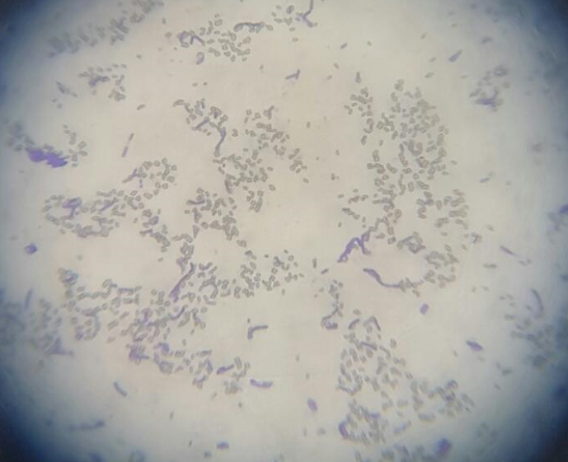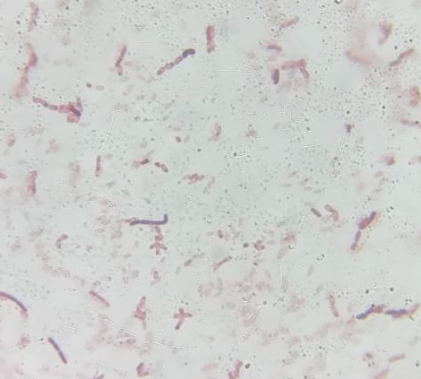

**(A) (B)**

**Figure S1(a):** Crystal staining of bacterial isolates

(A) GCU-DAB-TK-09, (B) HD500.

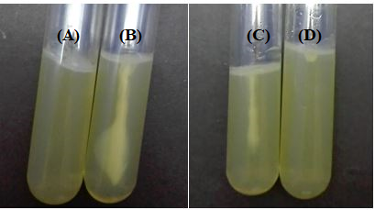

**Figure S1(b):** Motility test haze around the stab by motile bacteria (A) Control, (B) GCU-DAB-TK-12 while (D) control and (C) GCU-DAB-TK-04.

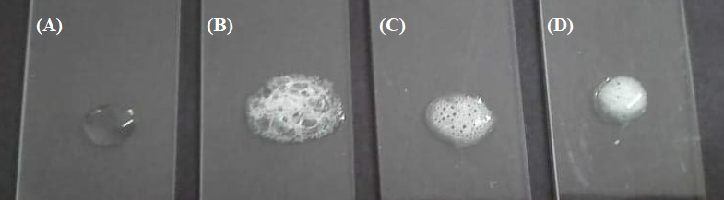

**Figure S1©:** Catalase test (A) Control, (B) GCU-DAB-TK-13,

(C) GCU-DAB-TK-04, and (D) GCU-DAB-TK-19.

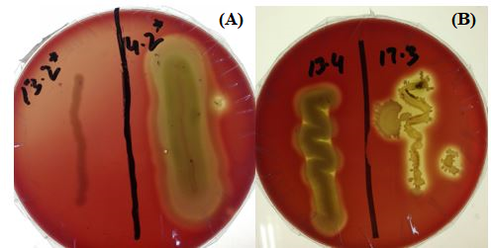

**Figure S2(a):** *B.t.* showing hemolysis on sheep blood agar (A) GCU-DAB-TK-04, (B) GCU-DAB-TK-13 and GCU-DAB-TK-17.

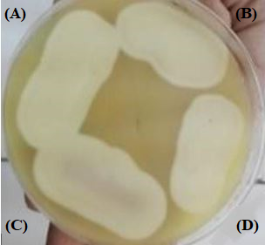

**Figure S2(b):** Lecithinase production test (A) GCU-DAB-TK-04, (B) GCU-DAB-TK-09, (C) GCU-DAB-TK-13, and (D) HD500.

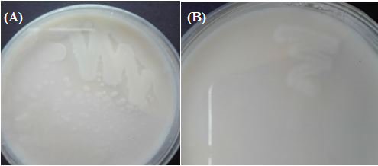

**Figure S2(c):** Casein hydrolysis test (A) GCU-DAB-TK-12, (B) GCU-DAB-TK-09.

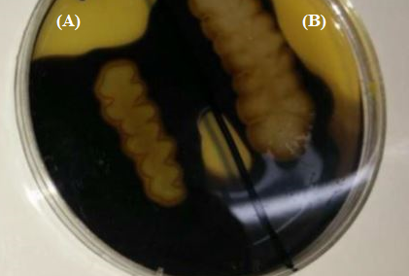

**Figure S2(d):** Starch hydrolysis test (A) GCU-DAB-TK-12, (B) GCU-DAB-TK-23.

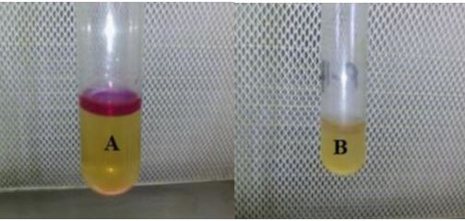

**Figure S2(e):** Indole test (A) GCU-DAB-TK-11, and (B) GCU-DAB-TK-14.

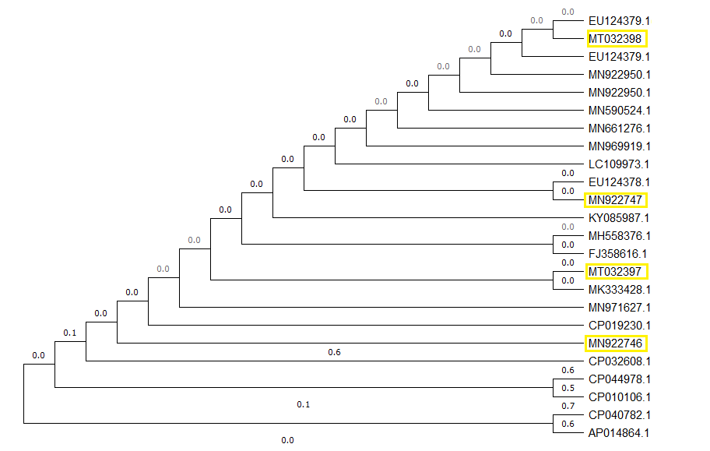

**Figure S3:** Dendrogram representing 16S rRNA gene relatedness of four most toxic *B.t.* isolates GCU-DAB-TK-13, GCU-DAB-TK-09, GCU-DAB-TK-06 and GCU-DAB-TK-04 with accession numbers MT032398, MN922747, MT032397 and MN922746 with already reported genes in GenBank DNA database.