Supplementary Material

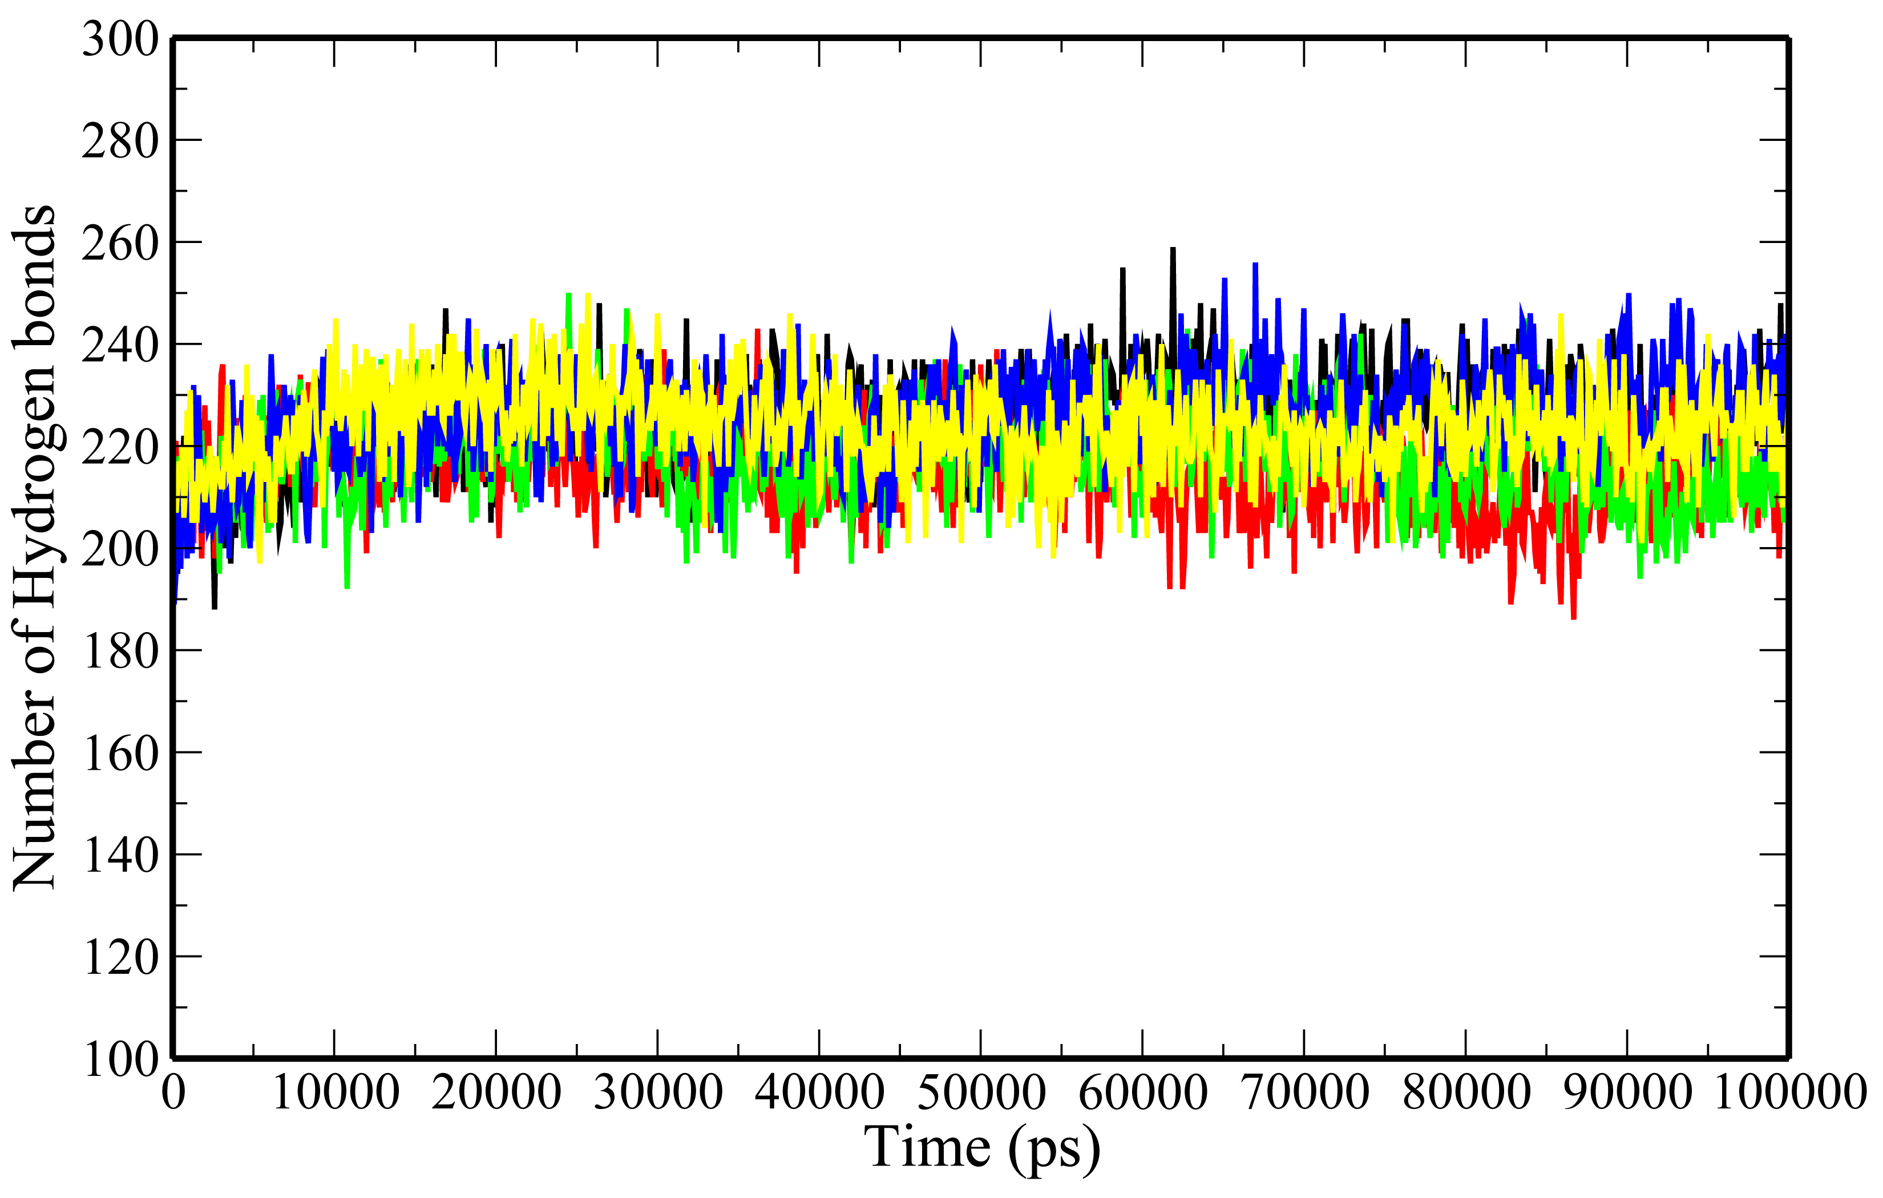
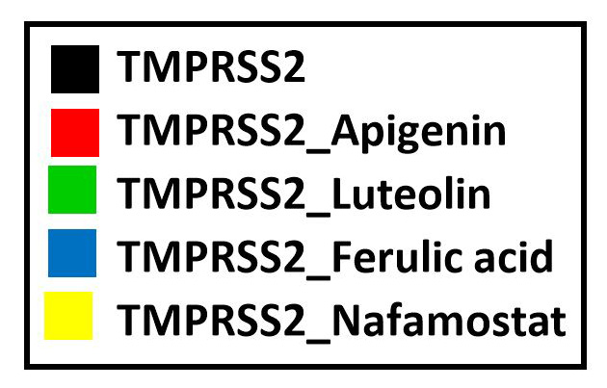

(A)

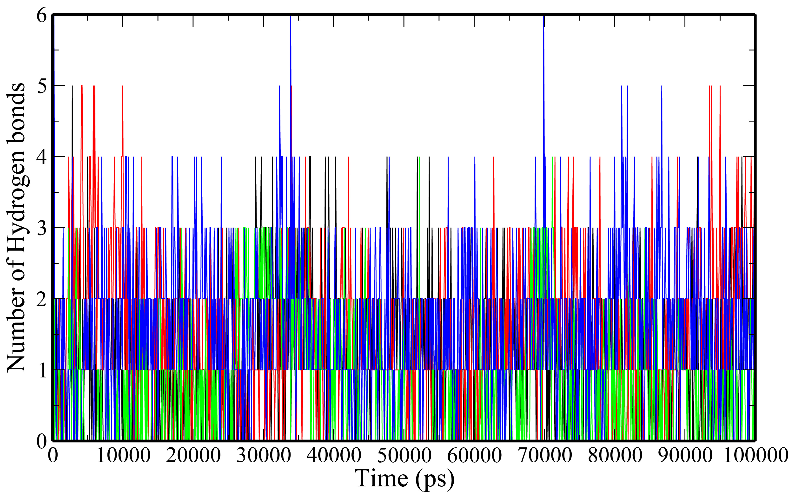
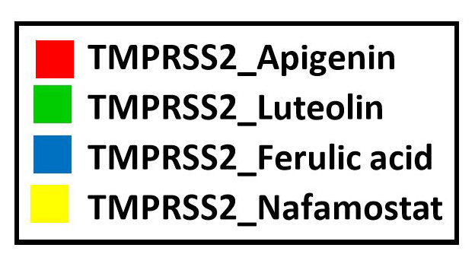

(B)

Figure S1: Plot of the number of hydrogen bonds-(A) intramolecular H-bonds (B) Intermolecular H-bonds for unbound TMPRSS2 (black) and TMPRSS2 docked complexes (TMPRSS2_Apigenin: red; TMPRSS2_Luteolin: green; TMPRSS2_Ferulic acid: blue and TMPRSS2_Nafamostat).

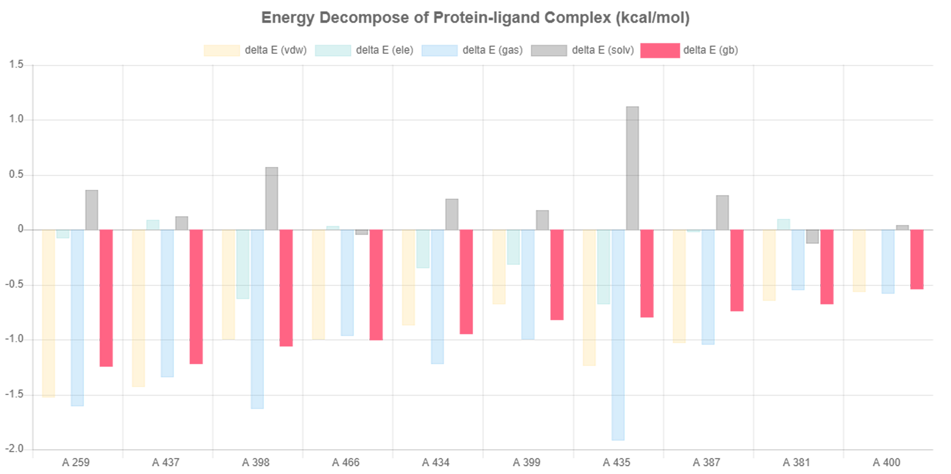
(A)

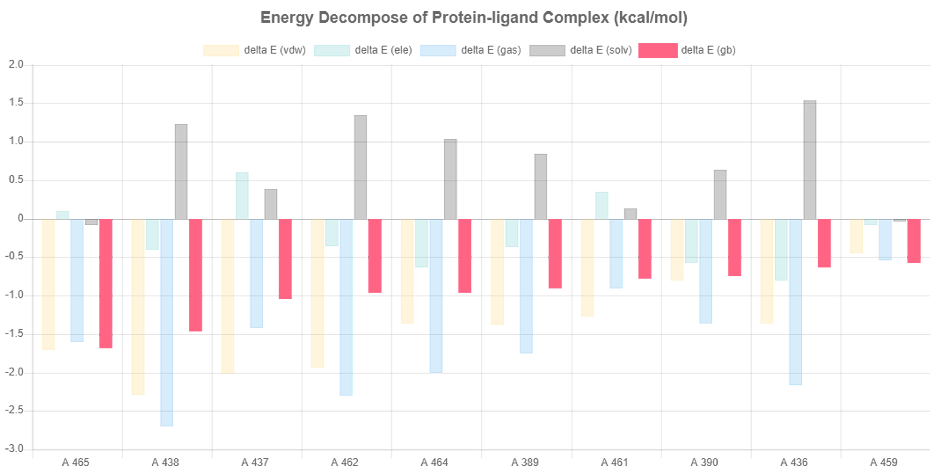
(B)

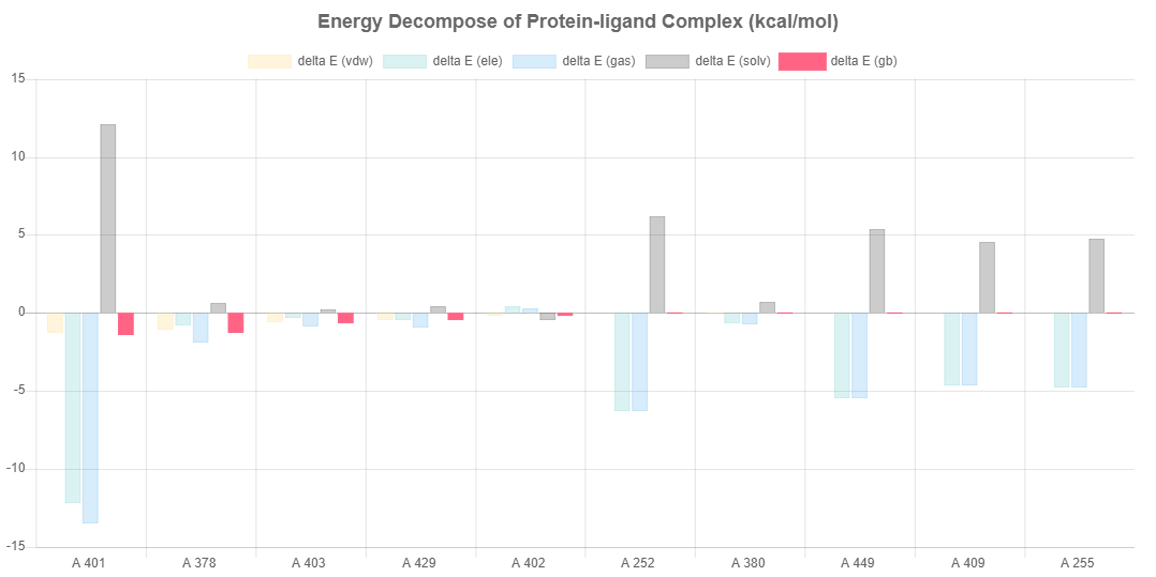
(C)

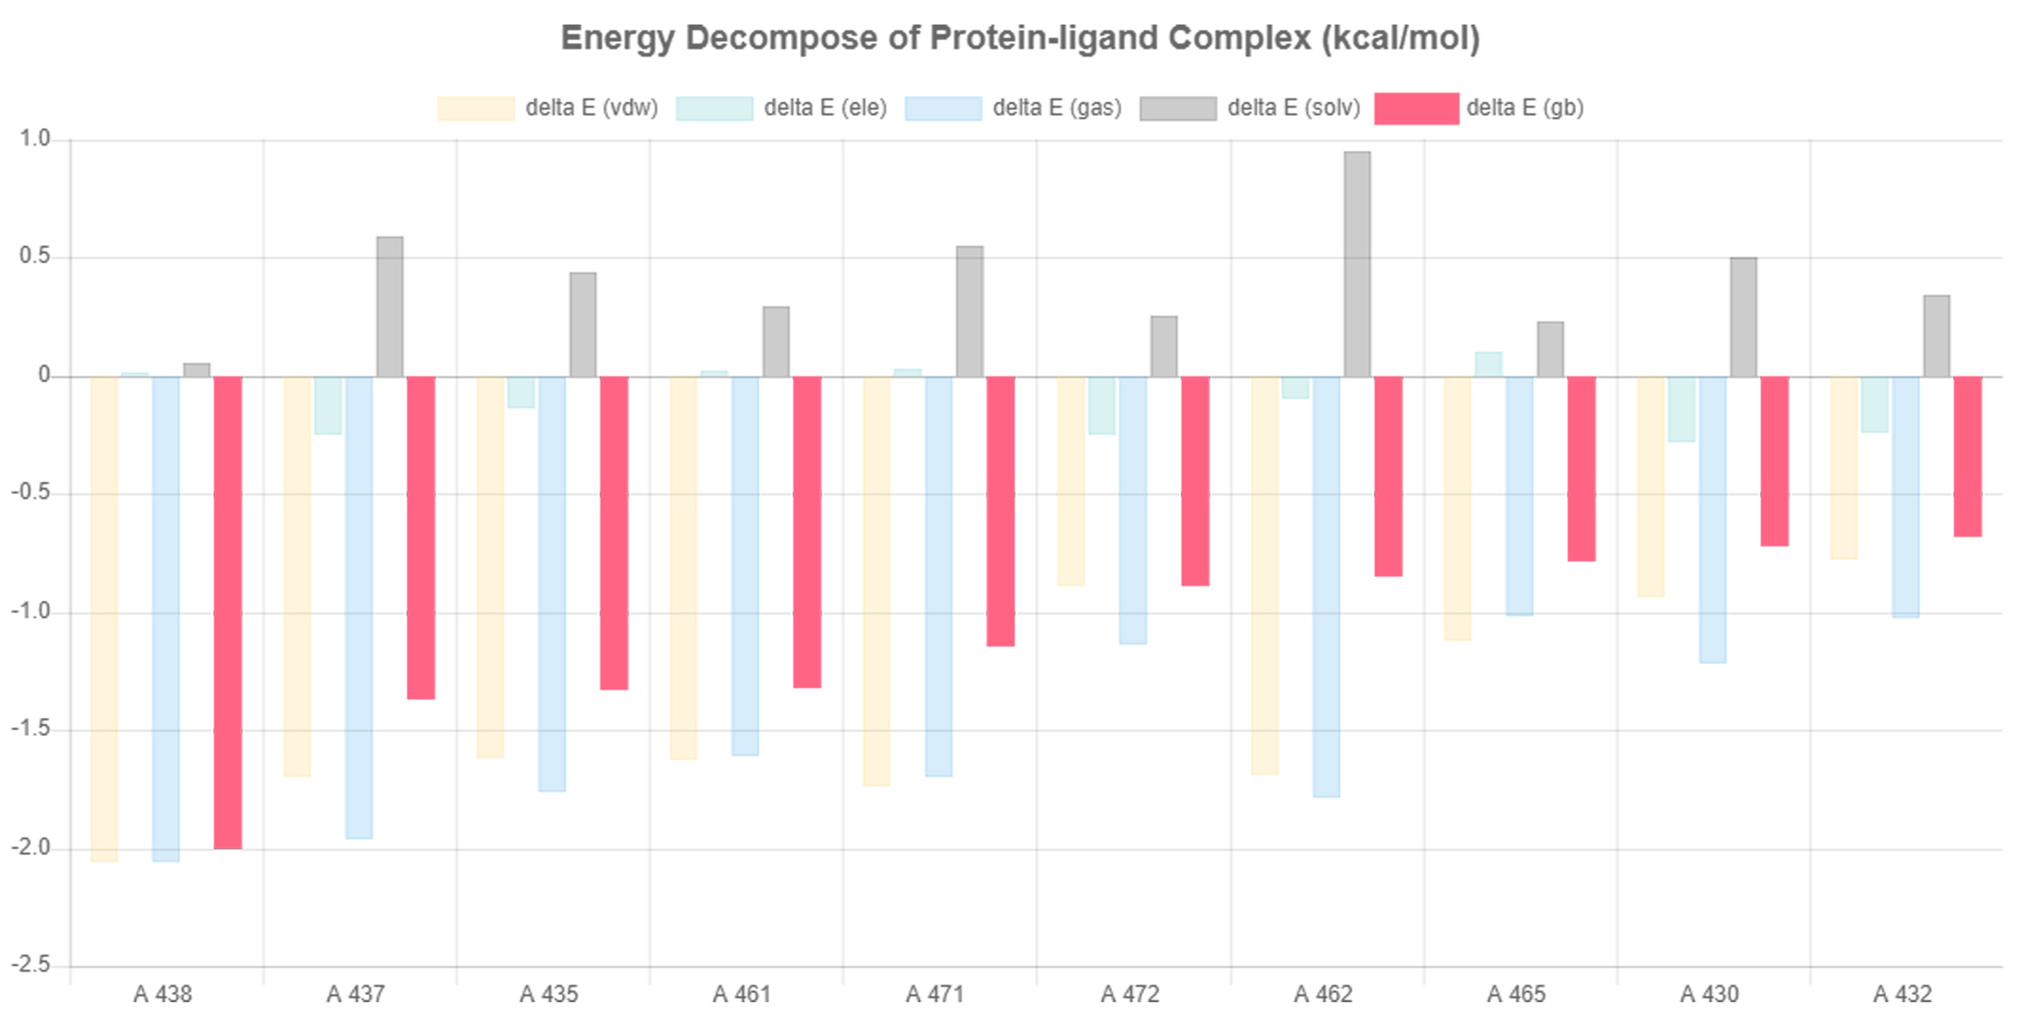
(D)

Figure S2: The binding free energy decomposition analysis for compounds-(A) Apigenin (B) Luteolin (C) Ferulic acid and (D) Nafamostat on a per-residue basis showing contributions from vdW energy (ΔE_{vdw}), electrostatic interactions (ΔE_{ele}), polar and non-polar solvation energy (ΔE_{solv}) for residues with the binding energies (ΔE_{gb}).
Table S1: Average geometric properties of unbound TMPRSS2 and TMPRSS2 docked complexes derived from MD simulation experiments.
Systems | RMSD (nm) |  | Rg (nm) | SASA (nm²) | Hydrogen bonds
Systems | Protein | Ligand | Rg (nm) | SASA (nm²) | Protein | Ligand
TMPRSS2 | 0.33161855±  0.020691134 | - | 2.072465355±  0.014329819 | 150.9597053±  3.249067344 | 225.1298701±  9.051691382 | -
TMPRSS2_Apigenin | 0.282429554±  0.043508183 | 0.247362992±  0.062295857 | 2.080123706±  0.012810064 | 152.919972±  2.82381675 | 215.3916084±  8.497675536 | 1.196803197  ±0.937139141
TMPRSS2_Luteolin | 0.32489471  ±0.045273601 | 0.576125057  ±0.214772452 | 2.06185013  ±0.013976506 | 152.9353017  ±3.806978439 | 218.1968032  ±8.978431365 | 1.545454545±  1.018912076
TMPRSS2_Ferulic acid | 0.304615439  ±0.032035141 | 0.730537652  ±0.21814513 | 2.067286903±  0.020060061 | 153.5488102±  5.332797744 | 225.8011988±  9.14677203 | 0.754245754±  0.907493502
TMPRSS2_Nafamostat | 0.300230713  ±0.028235882 | 0.507619867±  0.078623572 | 2.074381249±  0.01411647 | 153.0682637±  3.424944207 | 223.5194805±  8.42637942 | 1.632367632±  1.051052467

Table S2: MM/PB(GB)SA binding free energy analysis of protein-ligand complexes (kcal/mol).
Protein-ligand complexes | ELE¹ | VDW² | GAS³ | PBSOL⁴ | PBTOT⁵ | GBSOL⁴ | GBTOT⁵ | -TS⁶ | △G_{PB}⁷ | △G_{GB}⁷
TMPRSS2_Apigenin | -7.15±1.87 | -35.90±2.29 | -43.05±2.28 | 19.45±2.28 | -23.60±3.03 | 15.11±1.50 | -27.93±2.00 | 11.23±1.93 | -12.37 | -16.70
TMPRSS2_Luteolin | -6.92±2.21 | -40.16±2.34 | -47.08±2.70 | 24.61±2.45 | -22.47±2.66 | 17.64±2.37 | -29.44±2.15 | 15.64±1.28 | -6.40 | -10.05
TMPRSS2_Ferulic acid | -48.08±12.01 | -8.26±2.17 | -56..35±12.35 | 48.10±12.15 | -8.25±2.13 | 50.25±12.56 | -6.09±1.97 | 5.85±1.33 | -2.40 | -0.24
TMPRSS2_Nafamostat | -7.38±2.28 | -56.57±2.31 | -63.95±3.54 | 33.69±3.0 | -30.26±3.76 | 18.08±2.11 | -45.87±2.89 | 20.96±2.28 | -9.30 | -24.91
¹Electrostatic energy as calculated by the MM force field; ²Van der Waals contribution from MM; ³Total gas-phase energy; ⁴Non-polar and polar contributions to solvation based on PB/GB model; ⁵Final estimated binding free energy calculated from GAS and PBSOL/GBSOL; ⁶Entropy; ⁷Binding free energy with entropy

