**Supplementary Material**

**Peanut shell from agricultural wastes as a sustainable filler for polyamide biocomposites fabrication**

**Figure S1:** FTIR spectra of (a) PA6, (b) PSP, and (c) PSP after heat treatment.

Figure S2. X-ray diffraction patterns of (a) PA6, (b) its deconvolution, and that of PSP.

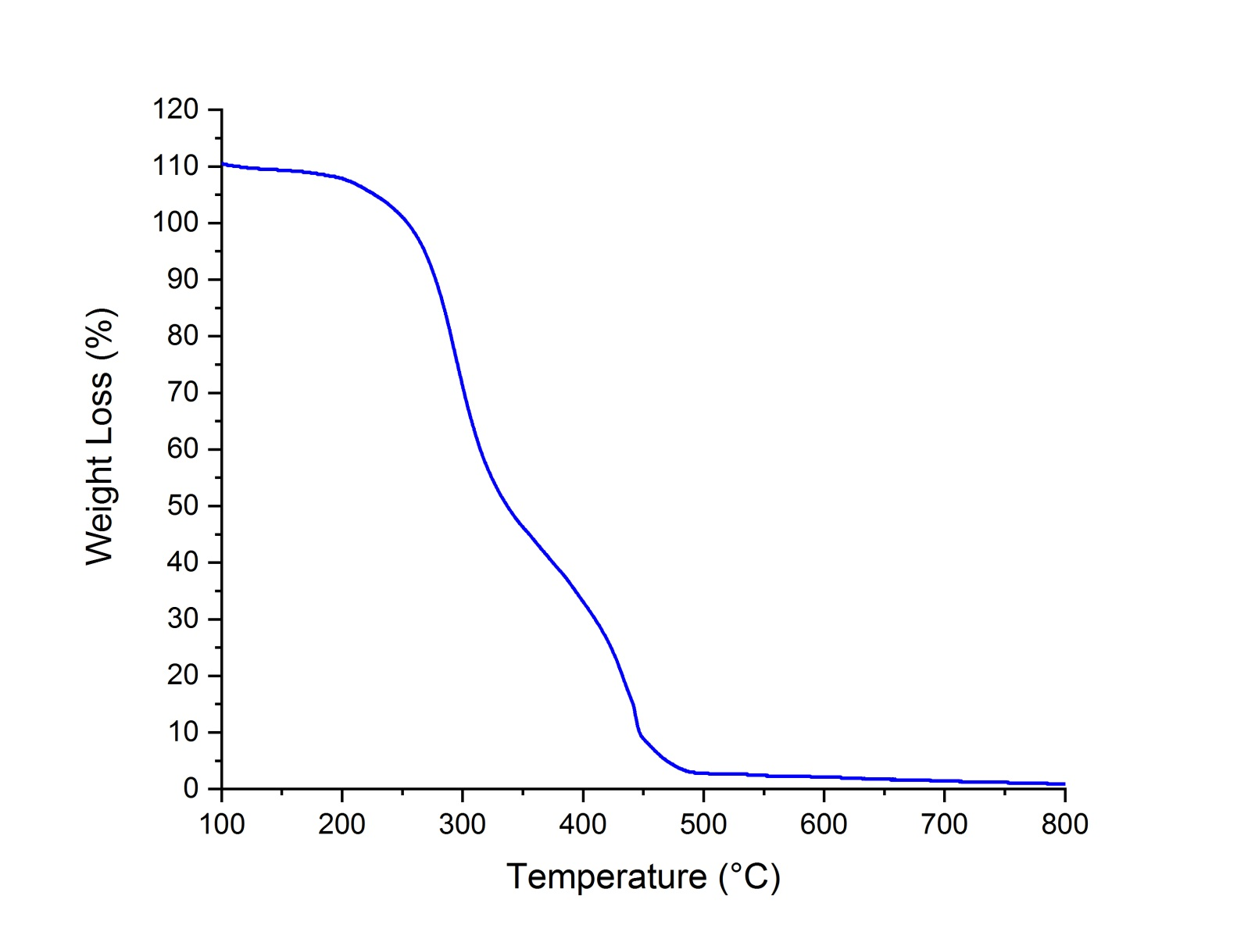

Figure S3. TGA curves of PSP.