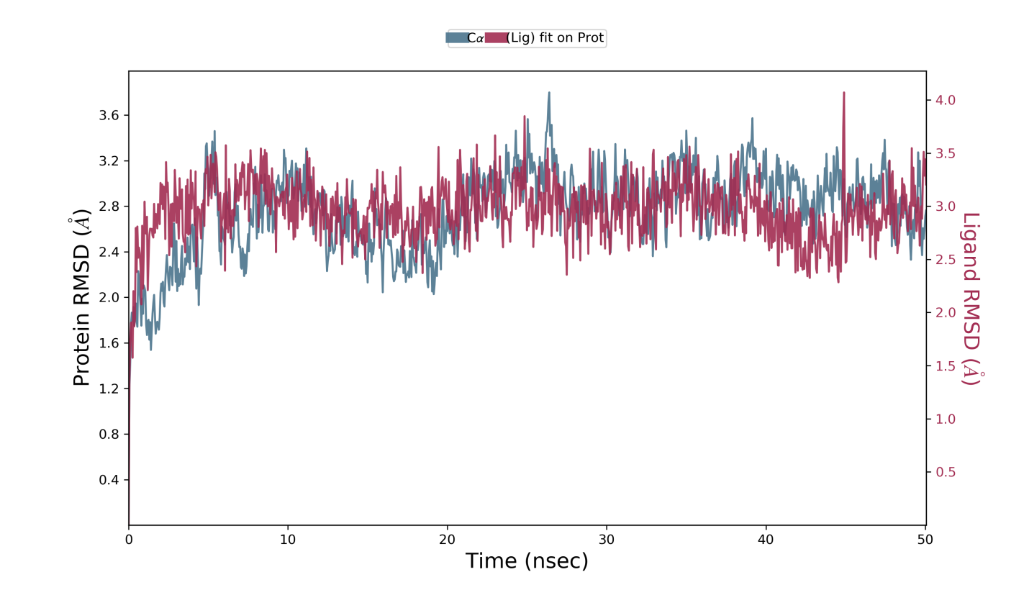

Figue S1. Protein-Ligand contacts RMSD evolution; protein (left Y-axis) and ligand (right Y-axis).

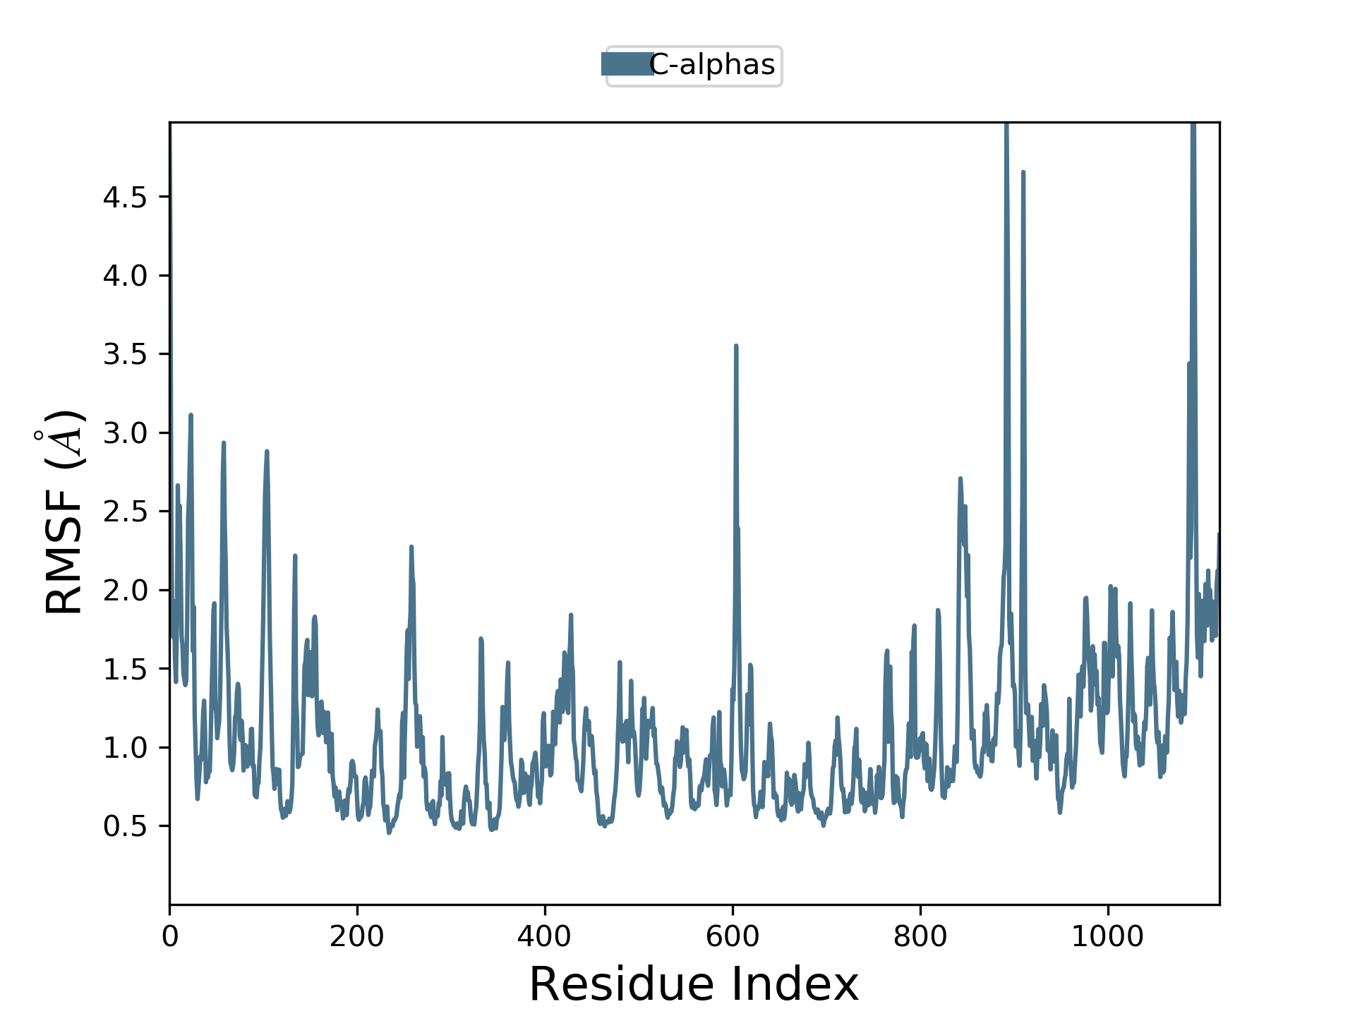

Figue S2. RMSF of the protein with fluctuations

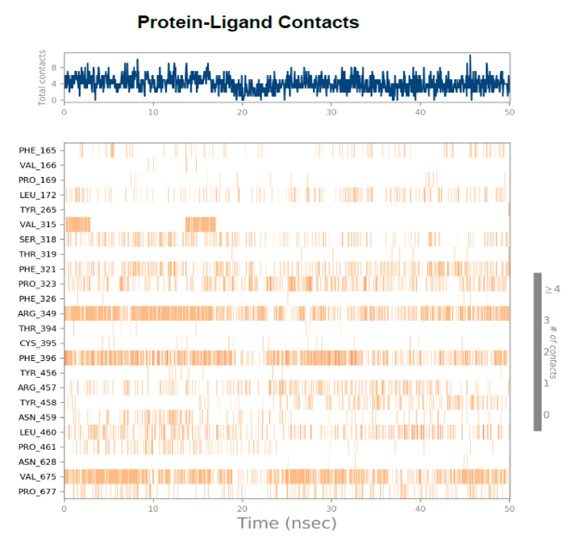

**Figure S3.** Interaction Timeline Protein-Ligand contacts

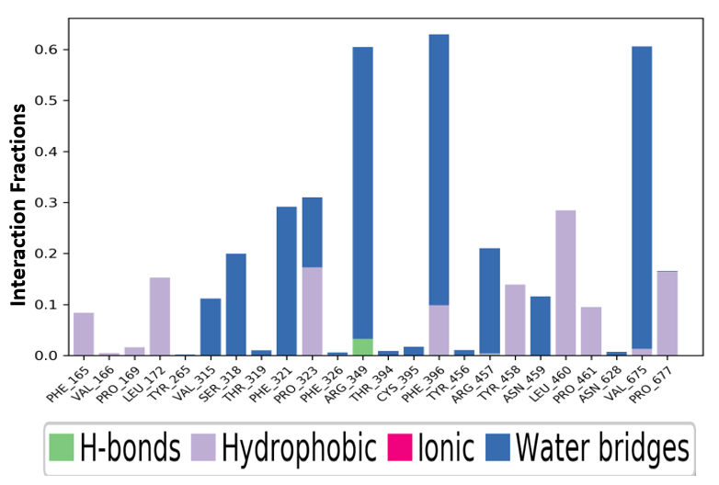

**Figure S4.** Protein-Ligand Contacts Histogram

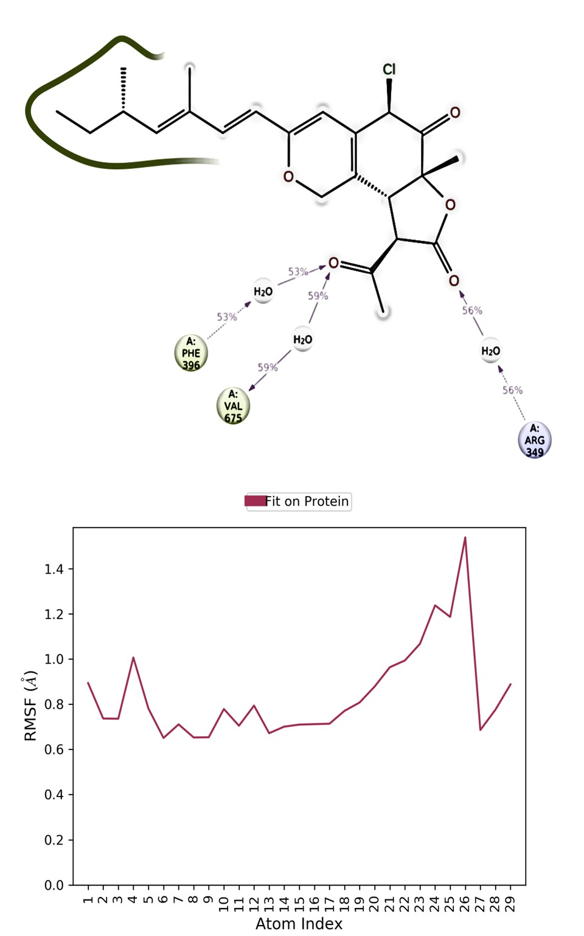

**Figure S5.** Ligand RMSF Fit on the Protein