Supplementary information

Computational studies on potential new anti-Covid-19 agents with a multi-target mode of action

Ranjan K. Mohapatra^{1*}, Mohammad Azam^{2*}, Pranab K. Mohapatra³, Ashish K. Sarangi⁴, Mohnad Abdalla⁵, Lina Perekhoda⁶, Oval Yadav⁷, Saud I. Al-Resayes², Kim Jong-Doo⁸, Kuldeep Dhama⁹, Azaj Ansari^{7*}, Veronique Seidel¹⁰, Sarika Verma^{11,12}, Mukesh K. Raval^{13*}

¹Department of Chemistry, Government College of Engineering, Keonjhar, Odisha 758002, India
²Department of Chemistry, College of Science, King Saud University, PO BOX 2455, Riyadh 11451, Saudi Arabia
³Department of Chemistry, C. V. Raman Global University, Bidyanagar, Mahura, Janla, Bhubaneswar, Odisha 752054, India
⁴Department of Chemistry, School of Applied Sciences, Centurion University of Technology and Management, Odisha, India
⁵Key Laboratory of Chemical Biology (Ministry of Education), Department of Pharmaceutics, School of Pharmaceutical Sciences, Cheeloo College of Medicine, Shandong University, 44 Cultural West Road, Shandong Province 250012, PR China
⁶Department of Medicinal Chemistry, National University of Pharmacy, Pushkinska Str. 53, Kharkiv 61002, Ukraine
⁷Department of Chemistry, Central University of Haryana, Mahendergarh, Haryana 123031, India
⁸Buddhist Culture College, Dongguk University, Gyeongju-si, Gyeongsangbuk-do, 780-714, South Korea
⁹Division of Pathology, ICAR-Indian Veterinary Research Institute, Izatnagar, Bareilly-243122, Uttar Pradesh, India
¹⁰Natural Products Research Laboratory, Strathclyde Institute of Pharmacy and Biomedical Sciences, University of Strathclyde, Glasgow G4 0RE, United Kingdom

¹¹Council of Scientific and Industrial Research-Advanced Materials and Processes Research Institute, Bhopal (MP) 462026, India.
¹²Academy of council Scientific and Industrial Research - Advanced Materials and Processes Research Institute (AMPRI), Hoshangabad Road, Bhopal (M.P),462026, India.
¹³Department of Chemistry, G. M. University, Sambalpur, Odisha, India

Corresponding Authors:
Dr. Mohammad Azam, Email: azam_res@yahoo.com
Dr. Ranjan K. Mohapatra, Email: ranjank_mohapatra@yahoo.com
Dr. Azaj Ansari, Email: ajaz.alam2@gmail.com
Prof. Dr. Mukesh K. Raval, Email: mraval@yahoo.com

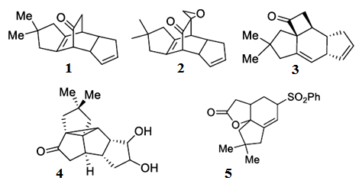
Figure S1. Structure of the investigated compounds 1-5

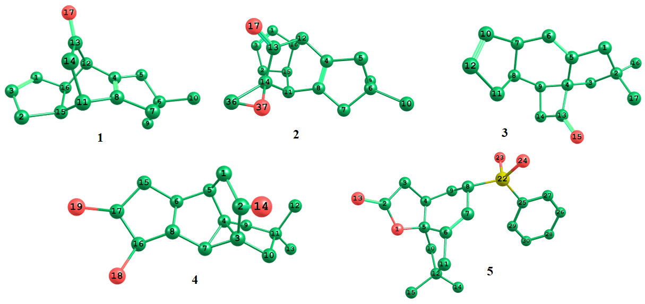

Figure S2. 3D structures of compounds 1-5

Figure S3. Schematic representation (percentage contribution) of the natural population (total Lewis and non-Lewis structure) analysis of compound (1-5)

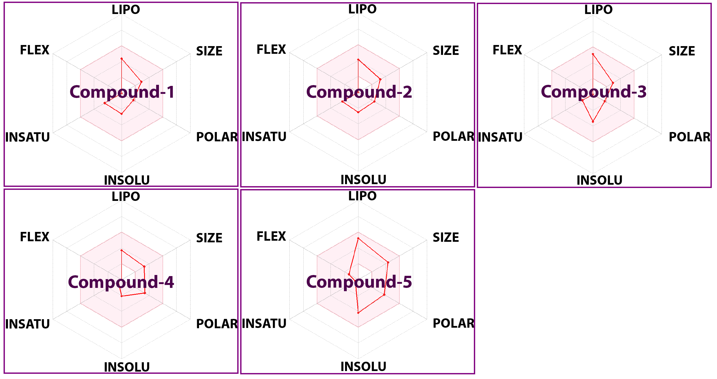

Figure S4. Pharmacokinetic and drug-likeness properties of the investigated compounds (LIPO: lipophilicity, INSOLU: insolubility, INSATU: insaturation, and FLEX: flexibility)

Table S1: Natural hybrid orbitals (NHO) data obtained for compounds 1-5 including NHO directionality and bending angles

NBO | Line of centers  θ φ | Hybrid 1  θ φ Dev | Hybrid 2  θ φ Dev
(1)σ(C13-O17) | 97.4 112.1 | 77.5 23.2 90.6 | 102.2 204.1 89.7
(2)σ(C13-O17) | 42.3 48.4 | 83.2 145.0 89.4 | 85.0 146.1 88.5
(3)σ(C13-O17) | 41.5 136.1 | 56.5 339.2 95.5 | 131.2 162.2 87.5
(4)σ(C13-O17) | 31.3 70.1 | 104.0 10.8 87.1 | 109.6 6.7 86.2
(5)σ(C13-O17) | 69.2 334.0 | 155.8 19.5 93.1 | 27.7 196.0 89.5
θ = Polar Angle
φ = Azimuthal Angle
Table S2. Interatomic distances, categories, and types of intermolecular interactions between ACE2 and compound 5
From | Chem | To | Chem | Category | Type | Distance  (Å)
A:LYS441:HZ3 | H-Donor | A:UNK1:O | H-Acceptor | Hydrogen bond | Conventional | 2.636
A:LYS441:HZ3 | H-Donor | A:UNK1:O | H-Acceptor | Hydrogen bond | Conventional | 2.530
A:GLN442:HE22 | H-Donor | A:UNK1:O | H-Acceptor | Hydrogen bond | Conventional | 3.092
A:LYS441:HE2 | H-Donor | A:UNK1:O | H-Acceptor | Hydrogen bond | Carbon hydrogen bond | 2.759
A:PHE438 | Pi-Orbitals | A:UNK1 | Pi-Orbitals | Hydrophobic | Pi-Pi T-shaped | 4.858
A:UNK1:C | Alkyl | A:ILE446 | Alkyl | Hydrophobic | Alkyl | 4.691
A:UNK1 | Pi-Orbitals | A:ALA413 | Alkyl | Hydrophobic | Pi-Alkyl | 5.150

Table S3. Interatomic distances, categories, and types of intermolecular interactions between RBD and compound 5
From | Chem | To | Chem | Category | Type | Distance  (Å)
E:GLY339:N | H-Donor | :UNL1:O | H-Acceptor | Hydrogen bond | Conventional | 3.052
E:SER371:OG | H-Donor | :UNL1:O | H-Acceptor | Hydrogen bond | Conventional | 3.188
E:PHE342 | Pi-Orbitals | :UNL1:C | Alkyl | Hydrophobic | Pi-Alkyl | 5.073
E:PHE374 | Pi-Orbitals | :UNL1:C | Alkyl | Hydrophobic | Pi-Alkyl | 4.571
:UNL1 | Pi-Orbitals | E:LEU335 | Alkyl | Hydrophobic | Pi-Alkyl | 5.099

Table S4. Interatomic distances, categories, and types of intermolecular interactions between PLpro and compound 5
From | Chem | To | Chem | Category | Type | Distance  (Å)
A:TYR273:HH | H-Donor | A:UNK1:O | H-Acceptor | Hydrogen bond | Conventional | 2.648
A:ASP164:HA | H-Donor | A:UNK1:O | H-Acceptor | Hydrogen bond | Carbon hydrogen bond | 2.901
A:PRO248:HD1 | H-Donor | A:UNK1:O | H-Acceptor | Hydrogen bond | Carbon hydrogen bond | 2.597
A:ASP164:OD2 | Negative | A:UNK1 | Pi-Orbitals | Electrostatic | Pi-Anion | 4.459
A:ASP164:HB1 | C-H | A:UNK1 | Pi-Orbitals | Hydrophobic | Pi-Sigma | 2.673
A:PRO248 | Alkyl | A:UNK1 | Alkyl | Hydrophobic | Alkyl | 4.997
A:UNK1:C | Alkyl | A:ARG166 | Alkyl | Hydrophobic | Alkyl | 4.265
A:UNK1:C | Alkyl | A:PRO247 | Alkyl | Hydrophobic | Alkyl | 4.378
A:UNK1:C | Alkyl | A:PRO248 | Alkyl | Hydrophobic | Alkyl | 4.973

Table S5. Interatomic distances, categories, and types of intermolecular interactions between RdRp and compound 5
From | Chem | To | Chem | Category | Type | Distance  (Å)
A:GLY327:HA2 | H-Donor | A:UNK1:O | H-Acceptor | Hydrogen bond | Carbon hydrogen bond | 2.829
A:PRO328:HD1 | H-Donor | A:UNK1:O | H-Acceptor | Hydrogen bond | Carbon hydrogen bond | 2.692
A:PRO328 | Alkyl | A:UNK1 | Alkyl | Hydrophobic | Alkyl | 4.653
A:VAL330 | Alkyl | A:UNK1 | Alkyl | Hydrophobic | Alkyl | 5.325
A:ALA379 | Alkyl | A:UNK1:C | Alkyl | Hydrophobic | Alkyl | 4.286
A:ALA382 | Alkyl | A:UNK1 | Alkyl | Hydrophobic | Alkyl | 4.873
A:ALA382 | Alkyl | A:UNK1:C | Alkyl | Hydrophobic | Alkyl | 3.738
A:ALA382 | Alkyl | A:UNK1:C | Alkyl | Hydrophobic | Alkyl | 3.752
A:UNK1:C | Alkyl | A:VAL330 | Alkyl | Hydrophobic | Alkyl | 4.199
A:UNK1:C | Alkyl | A:PRO328 | Alkyl | Hydrophobic | Alkyl | 4.329
A:UNK1:C | Alkyl | A:PRO378 | Alkyl | Hydrophobic | Alkyl | 4.434
A:UNK1:C | Alkyl | A:MET666 | Alkyl | Hydrophobic | Alkyl | 5.265

Table S6. Binding energy (BE), ligand efficiency (LE), and Ki values obtained for the best conformational positions of 1-5 with ACE2 (PDB ID:1R42)
Ligand | BE  (kcal/mol) | LE  [kcal/(mol*Atom)] | Ki (μM) | Interacting receptor residues (Chain A)
1 | ₋6.055 | 0.3562 | 36.444 | PRO 346, ASP 367, LEU 370, THR 371, HIS 374, GLU 375, GLU 406, SER 409
2 | ₋6.214 | 0.3271 | 27.866 | ASN 290, MET 366, ASP 367, LEU 370, SER 409, LEU 410, ALA 413, PHE 438, LYS 441, GLN 442, ILE 446
3 | ₋6.057 | 0.3563 | 36.321 | LEU 370, GLU 406, SER 409, LEU 410, ALA 413, PHE 438, LYS 441, GLN 442, THR 445, ILE 446, ARG 518, GLN 522
4 | ₋6.565 | 0.3455 | 15.410 | ASN 290, ILE 291, MET 366, ASP 367, LEU 370, GLU 406, SER 409, LEU 410, ALA 413, PHE 438, LYS 441, GLN 442, ILE 446, TYR 587
5 | ₋7.549 | 0.3145 | 2.928 | ASN 290, ILE 291, MET 366, LEU 370, GLU 406, SER 409, LEU 410, ALA 413, PHE 438, LYS 441, GLN 442, THR 445, ILE 446, ARG 518, GLN 522

Table S7. Binding energy (BE), ligand efficiency (LE), and Ki values obtained for the best conformational positions of 1-5 with RBD (PDB ID:6MOJ)
Ligand | BE  (kcal/mol) | LE  [kcal/(mol*Atom)] | Ki (μM) | Interacting receptor residues (Chain E)
1 | ₋7.101 | 0.4177 | 6.236 | GLY 339, PHE 342, ASN 343, VAL 367, LEU 368, SER 371, SER 373, PHE 374, TRP 436
2 | ₋7.598 | 0.3999 | 2.695 | PHE 338, GLY 339, PHE 342, ASN 343, VAL 367, LEU 368, SER 371, SER 373, PHE 374, TRP 436
3 | ₋6.858 | 0.4034 | 9.398 | CYS 336, PHE 338, GLY 339, PHE 342, ASN 343, VAL 367, LEU 368, SER 371, SER 373, PHE 374
4 | ₋6.841 | 0.3601 | 9.671 | PHE 338, GLY 339, PHE 342, ASN 343, VAL 367, LEU 368, SER 371, SER 373, PHE 374, TRP 436
5 | ₋7.392 | 0.308 | 3.816 | PHE 338, GLY 339, PHE 342, ASN 343, VAL 367, LEU 368, SER 371, SER 373, PHE 374, TRP 436

Table S8. Binding energy (BE), ligand efficiency (LE), and Ki values obtained for the best conformational positions of 1-5 with PLpro (PDB ID:7CJD)
Ligand | BE  (kcal/mol) | LE  [kcal/(mol*Atom)] | Ki (μM) | Interacting receptor residues (Chain A)
1 | ₋6.074 | 0.3573 | 35.29384 | ASP 164, ARG 166, MET 208, SER 245, ALA 246, PRO 247, PRO 248, TYR 264, GLY 266, ASN 267, TYR 268, TYR 273, THR 301, ASP 302
2 | ₋6.316 | 0.3324 | 23.45906 | ASP 164, GLU 167, MET 208, PRO 247, PRO 248, TYR 264, GLY 266, ASN 267, TYR 268, TYR 273, THR 301
3 | ₋6.645 | 0.3909 | 13.46327 | GLY 163, ASP 164, ARG 166, MET 208, PRO 247, PRO 248, TYR 264, ASN 267, TYR 268, TYR 273, THR 301
4 | ₋6.246 | 0.3287 | 26.40106 | LEU 162, GLY 163, ASP 164, PRO 247, PRO 248, TYR 264, ASN 267, TYR 268, TYR 273, THR 301
5 | ₋8.031 | 0.3346 | 1.297774 | LYS 157, LEU 162, GLY 163, ASP 164, ARG 166, GLU 167, MET 208, ALA 246, PRO 247, PRO 248, TYR 264, ASN 267, TYR 268, TYR 273, THR 301

Table S9. Binding energy (BE), ligand efficiency (LE), and Ki values obtained for the best conformational positions of 1-5 with RdRp (PDB ID:6YYT)
Ligand | BE  (kcal/mol) | LE  [kcal/(mol*Atom)] | Ki (μM) | Interacting receptor residues (Chain A)
1 | ₋6.603 | 0.3884 | 14.452 | LEU 270, LEU 271, LYS 272, TYR 273, THR 324, SER 325, PRO 328, LEU 329, VAL 330, ARG 331
2 | ₋6.349 | 0.3342 | 22.188 | LEU 270, TYR 273, THR 324, SER 325, PHE 326, GLY 327, PRO 328, LEU 329, VAL 330, PRO 378, ALA 379, ALA 382, PHE 396, VAL 398, MET 666, VAL 675
3 | ₋6.426 | 0.378 | 19.484 | THR 324, PHE 326, GLY 327, PRO 328, VAL 330, PRO 378, ALA 379, ALA 382, PHE 396, VAL 398, MET 666, VAL 675
4 | ₋6.723 | 0.3538 | 11.803 | THR 324, PHE 326, GLY 327, PRO 328, VAL 330, VAL 341, PRO 378, ALA 379, ALA 382, ALA 383, PHE 396, VAL 398, MET 666, VAL 675
5 | ₋7.883 | 0.3285 | 1.666 | LEU 270, LEU 271, TYR 273, THR 324, PHE 326, GLY 327, PRO 328, LEU 329, VAL 330, PRO 378, ALA 379, ALA 382, ALA 383, PHE 396, VAL 398, MET 666, VAL 675

Table. S10. Binding free energy (ΔG_{bind}) in kcal/mol determined by MM/PBSA (GBSA) for compound 5 with the target proteins (ignoring entropy components).
Procedure used | ACE2 | RBD | PLpro | RdRp
PB1 | 12.13 | ₋1.1 | ₋6.22 | ₋10.63
PB3 | ₋7.04 | 0.98 | ₋18.35 | ₋17.93
PB4 | ₋10.24 | ₋12.98 | ₋23.74 | ₋26.34
GB1 | ₋26.45 | ₋27.34 | ₋29.99 | ₋29.99
GB2 | ₋23.97 | ₋22.77 | ₋28.09 | ₋23.76
GB5 | ₋40.57 | ₋36.82 | ₋38.81 | ₋27.79
GB6 | ₋9.3 | ₋7.8 | ₋25.75 | ₋21.68

Table S11. Physicochemical properties of compounds 1-5
Ligand | Molecular weight  (g/mol) | Number of heavy atoms | Number of aromatic heavy atoms | Fraction Csp3 | Number of rotatable bonds | Number of  H-bond acceptors | Number of H-bond donors | Molar Refractivity | TPSA  (Å²)
1 | 228.33 | 17 | 0 | 0.69 | 0 | 1 | 0 | 69.56 | 17.07
2 | 256.34 | 19 | 0 | 0.71 | 0 | 2 | 0 | 73.38 | 29.60
3 | 230.35 | 17 | 0 | 0.81 | 0 | 1 | 0 | 69.78 | 17.07
4 | 262.34 | 19 | 0 | 0.94 | 0 | 3 | 2 | 70.20 | 57.53
5 | 354.50 | 24 | 0 | 0.95 | 2 | 4 | 0 | 95.02 | 68.82

Table S12. Pharmacokinetic properties of compounds 1-5
Ligand | GI absorption | BBB permeability | P-gp substrate | CYP1A2 inhibitor | CYP2C19 inhibitor | CYP2C9 inhibitor | CYP2D6 inhibitor | CYP3A4 inhibitor | Log K_{p}  (skin permeation)
1 | High | Yes | No | No | Yes | No | No | No | ₋6.17 cm/s
2 | High | Yes | No | No | No | No | No | No | ₋6.64 cm/s
3 | High | Yes | No | No | Yes | Yes | No | No | ₋5.27 cm/s
4 | High | Yes | Yes | No | No | No | No | No | ₋7.20 cm/s
5 | High | Yes | Yes | No | No | No | No | No | ₋5.88 cm/s

Table S13. Drug-likeness and toxicity class of compounds 1-5
Ligand | Lipinski | Ghose | Veber | Egan | Muegge | Bioavailability Score | LD50(mg/kg) | Toxicity class
1 | Yes; 0 violation | Yes | Yes | Yes | No; 1 violation: Heteroatoms<2 | 0.55 | 5000 | 5
2 | Yes; 0 violation | Yes | Yes | Yes | Yes | 0.55 | 750 | 4
3 | Yes; 0 violation | Yes | Yes | Yes | No; 1 violation: Heteroatoms<2 | 0.55 | 4600 | 5
4 | Yes; 0 violation | Yes | Yes | Yes | Yes | 0.55 | 1000 | 4
5 | Yes; 0 violation | Yes | Yes | Yes | Yes | 0.55 | 2000 | 4

Table S14. Medicinal properties of compounds 1-5
Ligand | PAINS | Brenk | Lead-likeness | Synthetic accessibility score
1 | 0 alert | 1 alert: isolated_alkene | No; 1 violation: MW<250 | 4.75
2 | 0 alert | 2 alerts: Three-membered_heterocycle, isolated_alkene | Yes | 5.15
3 | 0 alert | 1 alert: isolated_alkene | No; 1 violation: MW<250 | 4.98
4 | 0 alert | 0 alert | Yes | 4.72
5 | 0 alert | 0 alert | No; 2 violations: MW>350, XLOGP3>3.5 | 5.15

Table S15. Lipophilicity of compounds 1-5
Ligand | Log P_{o/w}  (iLOGP) | Log P_{o/w}  (XLOGP3) | Log P_{o/w}  (WLOGP) | Log P_{o/w}  (MLOGP) | Log P_{o/w}  (SILICOS-IT) | Consensus Log P_{o/w}
1 | 2.74 | 2.15 | 3.51 | 3.71 | 3.37 | 3.10
2 | 2.99 | 1.73 | 2.89 | 3.03 | 3.45 | 2.82
3 | 2.80 | 3.43 | 3.59 | 3.81 | 3.38 | 3.40
4 | 1.35 | 0.99 | 1.37 | 2.11 | 1.94 | 1.55
5 | 2.92 | 3.64 | 4.72 | 3.39 | 3.14 | 3.56

Table S16. Water solubility of compounds 1-5
 |  | 1 | 2 | 3 | 4 | 5
Log S (ESOL) |  | ₋2.61 | ₋2.52 | ₋3.43 | ₋2.09 | ₋4.20
Solubility |  | 5.60e-01 mg/mL; 2.45e-03 mol/L | 7.76e-01 mg/mL; 3.03e-03 mol/L | 8.58e-02 mg/mL; 3.72e-04 mol/L | 2.13e+00 mg/mL; 8.12e-03 mol/L | 2.24e-02 mg/mL; 6.32e-05 mol/L
Class |  | Soluble | Soluble | Soluble | Soluble | Moderately soluble
Log S (Ali) |  | ₋2.14 | ₋1.97 | ₋3.47 | ₋1.79 | ₋4.77
Solubility |  | 1.65e+00 mg/mL; 7.23e-03 mol/L | 2.76e+00 mg/mL; 1.08e-02 mol/L | 7.82e-02 mg/mL; 3.40e-04 mol/L | 4.29e+00 mg/mL; 1.63e-02 mol/L | 5.97e-03 mg/mL; 1.68e-05 mol/L
Class |  | Soluble | Very soluble | Soluble | Very soluble | Moderately soluble
Log S (SILICOS-IT) |  | ₋3.00 | ₋3.00 | ₋3.02 | ₋1.85 | ₋3.94
Solubility |  | 2.30e-01 mg/mL; 1.01e-03 mol/L | 2.59e-01 mg/mL; 1.01e-03 mol/L | 2.22e-01 mg/mL; 9.64e-04 mol/L | 3.71e+00 mg/mL; 1.41e-02 mol/L | 4.10e-02 mg/mL; 1.16e-04 mol/L
Class |  | Soluble | Soluble | Soluble | Soluble | Soluble

