**Journal of King Saud University of Science**

**Efficient removal potential of *Microbacterium* sp. strain 1S1 against arsenite isolated from polluted environment**

Shahid Shera,c, Syed Zajif Hussainb, Mohsin Tassawar Cheemac, Abid Hussaind, Abdul Rehmana*

Department of Microbiology and Molecular Genetics, University of the Punjab, Lahore, Pakistan

**Supplementary data (Figures)**

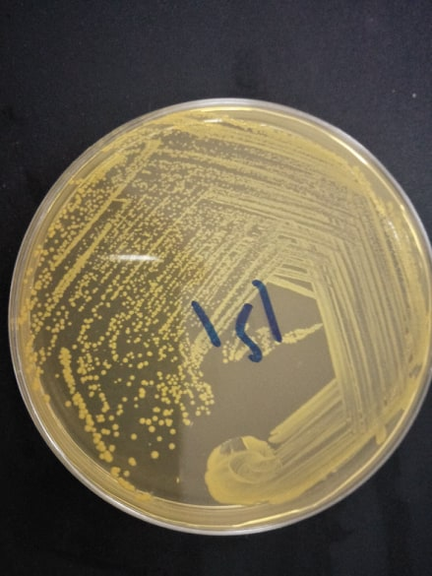

**Figure S1:** Growth of *Microbacterium* sp. 1S1 on LB agar plate after 24 h of incubation at 37°C and pH 7.

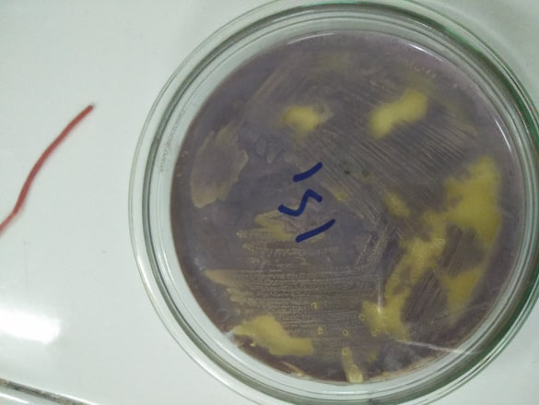

**Figure S2:** Appearance of brown precipitation after flooding with AgNO3.

**Figure S3:** Growth curves of *Microbacterium* sp. strain 1S1 in As-stress and non-stress after 28 h of incubation at optimum growth conditions.

**Table S1:** Morphological and biochemical characteristics of *Microbacterium* sp.1S1.

|  |  |
| --- | --- |
| Morphological and biochemical characteristics | *Microbacterium* sp.1S11 |
| Elevation | Raised |
| Shape | Round |
| Size | 1-2 mm |
| Color | Yellow |
| Texture | Smooth |
| Margin | Entire |
| Gram staining | +ve |
| Spore staining | -ve |
| Catalase | +ve |
| Oxidase | +ve |
| Citrate utilization test | +ve |
| Nitrate reduction test | +ve |
| Urease | +ve |
| Indole test | -ve |
| Methyl red | +ve |
| Voges-Proskauer | -ve |
| Motility | -ve |
| Starch hydrolysis | +ve |
| Triple sugar iron | +ve |
| H2S production | -ve |
| MacKonkey agar | -ve |
| Mannitol fermentation | +ve |
| Pigment production | +ve |

**Table S2: Glutathione and non-protein thiols concentration under 15 mM arsenite stress in isolated *Microbacterium* sp. strain 1S1.**

|  |  |  |  |  |  |  |  |
| --- | --- | --- | --- | --- | --- | --- | --- |
| **Arsenite concentration**  **(mM)** | **GSH**  **(mM g-1 FW)** | **GSSG**  **(mM g-1 FW)** | **GSH+ GSSG**  **(mM g-1 FW)** | **GSH/GSSG** | **% increase in**  **GSH/GSSG** | **Non-protein thiols** | **% increase in non-protein thiols** |
| 0 | 8.8 | 0.8 | 9.8 | 11 | 4.41:11*100  = 40.09 % | 2.8 | 2.2:2.8*100 =78.57 % |
| 15 | 18.5 | 1.2 | 19.6 | 15.41 |  | 4.4 |  |