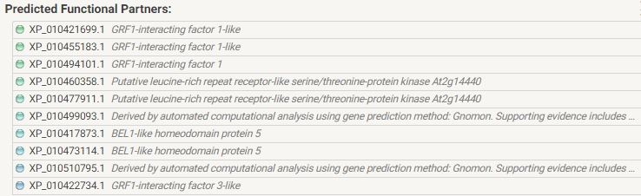

**Supplementary Fig. 1:** All Predicted functional partners of *Camelina sativa* GRF proteins

**GRF1**

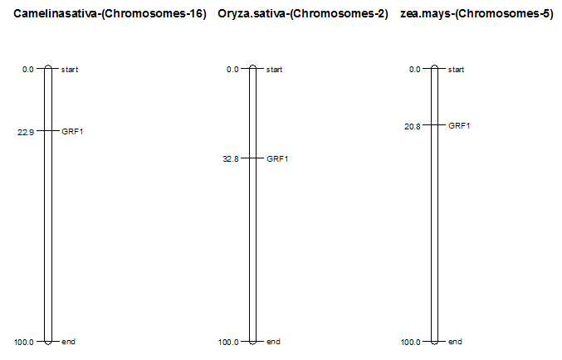

**GRF2**

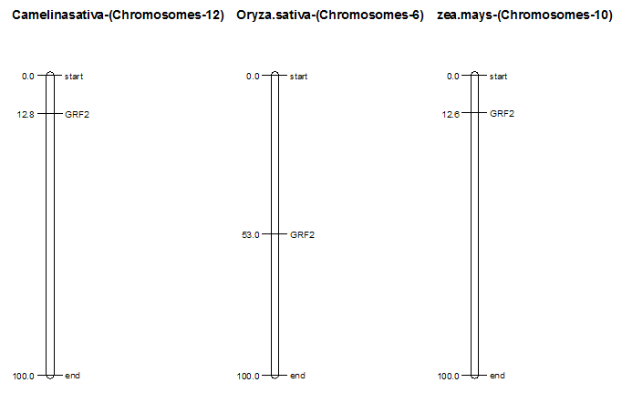

**GRF3**

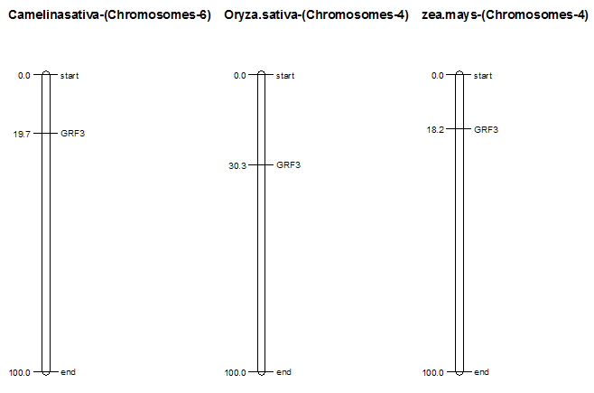

**GRF4**

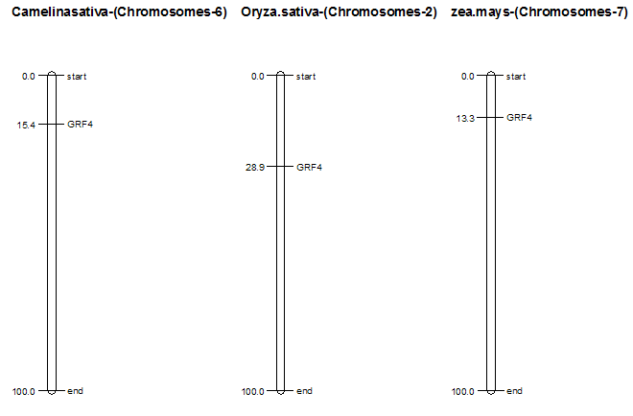

**GRF5**

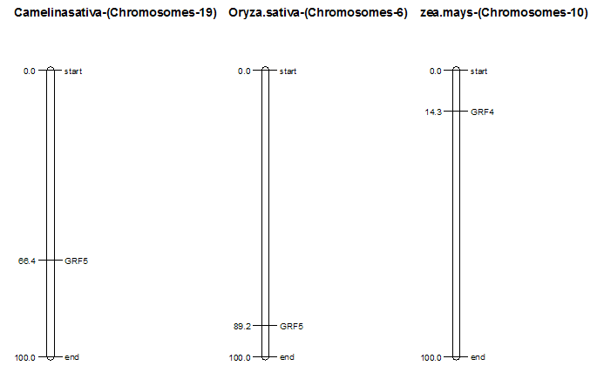

**GRF6**

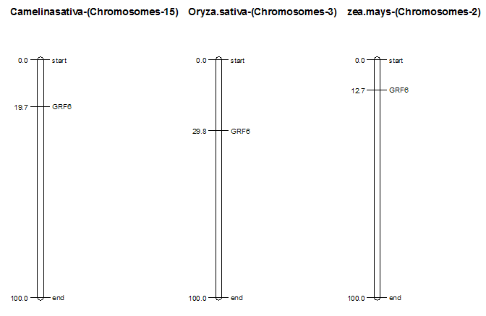

**GRF7**

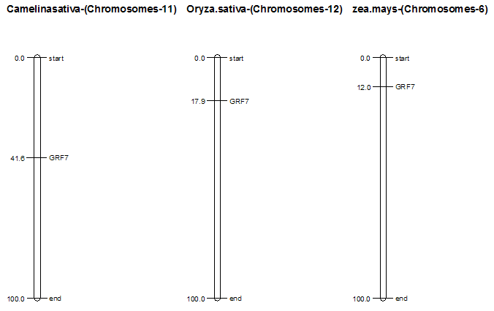

**GRF8**

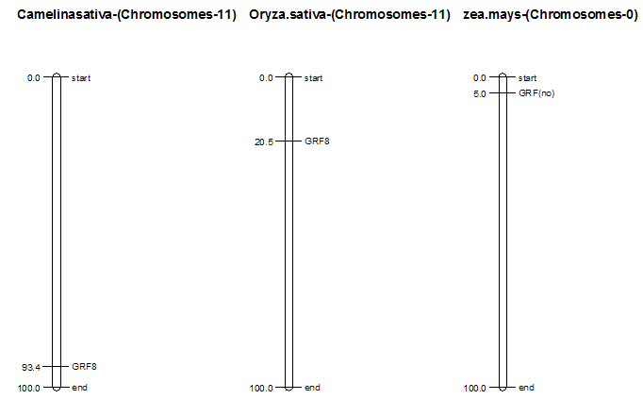

**GRF9**

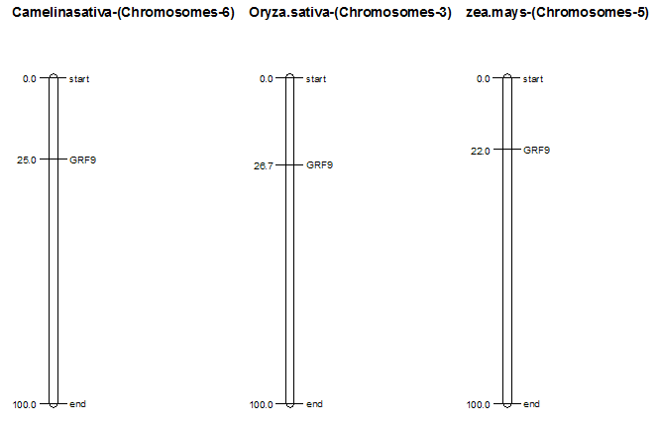

**Supplementary Fig. 2:** Chromosome mapping: The mapping of 9 GRF genes of *Camelina sativa* chromosomes with other two species *Oryza sativa* and *Zea mays*. The presented genes are indicating their absolute location on respective chromosome using accession numbers.

**Supplementary Table 1:** GRF genes of *Aradidopsis thaliana* details e.g. chromosome number, number of exons in each gene, protein length, trihelix domain and genomic length, CDS sequence, start and ending position of genes are indicated in the table. These gene are distributed in five clads.

|  |  |  |  |  |  |  |  |  |  |
| --- | --- | --- | --- | --- | --- | --- | --- | --- | --- |
| Accession # | Chr# | Exons | Protein  Length | Protein Mol.Weight | IP | Domain Size | Start and end position of each gene on genome | DNA length | CDS  length |
| AT2G06200.1 | 2 | 3 | 244 | 28210.6 | 8.7959 | 80-124,6-41 | 2426176..2427355 | 1117 | 936 |
| AT2G22840.1 | 2 | 4 | 530 | 56401.3 | 9.6778 | 196-240,132-168 | 9728480..9731301 | 2822 | 2114 |
| AT2G36400.1 | 2 | 4 | 398 | 43707.3 | 8.5051 | 144-188,75-111 | 15270088..15273115 | 3028 | 1197 |
| AT2G45480.1 | 2 | 5 | 429 | 48607.6 | 8.1757 | 88-131,305-346 | 18745249..18747634 | 2285 | 1290 |
| AT3G13960.1 | 3 | 4 | 397 | 44695.6 | 8.2019 | 81-125,16-51 | 4608076..4610497 | 2422 | 1194 |
| AT3G52910.1 | 3 | 4 | 380 | 42533.7 | 7.3746 | 151-195,83-117 | 19615977..19618507 | 2531 | 1143 |
| AT4G24150.1 | 4 | 6 | 493 | 54608.7 | 6.9262 | 244-287,149-183 | 12535972..12539576 | 3584 | 1482 |
| AT4G37740.1 | 4 | 4 | 535 | 5858.4 | 8.8943 | 227-270,163-199 | 17725337..17727909 | 2573 | 1608 |
| AT5G53660.1 | 5 | 3 | 365 | 40410.3 | 8.1837 | 108-151,59-90 | 21794177..21796092 | 1916 | 1098 |

|  |  |  |  |  |  |  |  |  |  |
| --- | --- | --- | --- | --- | --- | --- | --- | --- | --- |
| Gene name | [*Capsella rubella*](https://www.ncbi.nlm.nih.gov/Taxonomy/Browser/wwwtax.cgi?id=81985) | *Cicer arietinum* | *Populus trichocarpa* | *Ipomoea triloba* | *Nicotiana tabacum* | *Spinacia oleracea* | *Brassica oleracea* | *Solanum tuberosum* | *Coffea Arabica* |
| GRF1 | 1 | 2 | 3 | 1 | 7 | 1 | 1 | 1 | 1 |
| GRF2 | 1 | 0 | 0 | 1 | 0 | 2 | 2 | 2 | 2 |
| GRF3 | 1 | 0 | 2 | 1 | 3 | 1 | 1 | 1 | 1 |
| GRF4 | 1 | 1 | 5 | 1 | 1 | 3 | 3 | 3 | 3 |
| GRF5 | 1 | 1 | 3 | 0 | 2 | 1 | 1 | 1 | 1 |
| GRF6 | 1 | 0 | 0 | 0 | 0 | 1 | 1 | 1 | 1 |
| GRF7 | 1 | 0 | 0 | 1 | 0 | 1 | 1 | 1 | 1 |
| GRF8 | 1 | 0 | 2 | 0 | 2 | 2 | 2 | 2 | 2 |
| GRF9 | 2 | 1 | 3 | 2 | 1 | 2 | 2 | 2 | 2 |

**Supplementary Table 2:** Comparative analysis of GRF genes of *Camelina sativa* with other plant species.

|  |  |  |  |  |  |  |  |  |  |  |
| --- | --- | --- | --- | --- | --- | --- | --- | --- | --- | --- |
| Gene name | *Oryza sativa* | *Malus domestica* | *zea mays* | *Carica papaya* | *Arachis hypogaea* | *glycine max* | *Rosa chinensis* | *Helianthus annuus* | *Brassica rapa* | *Ananas comosua* |
| GRF1 | 1 | 2 | 1 | 1 | 3 | 6 | 3 | 2 | 1 | 1 |
| GRF2 | 1 | 0 | 2 | 0 | 0 | 0 | 0 | 0 | 2 | 0 |
| GRF3 | 1 | 1 | 1 | 1 | 3 | 3 | 1 | 1 | 3 | 0 |
| GRF4 | 1 | 1 | 1 | 1 | 5* | 3 | 1 | 1 | 3 | 4 |
| GRF5 | 1 | 1 | 1 | 1 | 3 | 2 | 2 | 1 | 1 | 0 |
| GRF6 | 1 | 1 | 1 | 0 | 5 | 0 | 1 | 1 | 1 | 1 |
| GRF7 | 1 | 0 | 1 | 1 | 1 | 2 | 0 | 0 | 1 | 1 |
| GRF8 | 1 | 1 | 0 | 0 | 0 | 0 | 2 | 3 | 2 | 0 |
| GRF9 | 1 | 1 | 1 | 0 | 3 | 3 | 1 | 2 | 1 | 0 |

**Supplementary Table 3:** Frequency distribution of various cis-regulatory elements in the promoter region of GRF genes

|  |  |  |  |  |  |
| --- | --- | --- | --- | --- | --- |
| **Accession no** | **CACTFTPPCA1** | **CURECORECR** | **GATABOX** | **ARR1AT** | **DOFCOREZM** |
| AT2G06200.1 | 14 | 6 | 9 | 11 | 23 |
| AT2G22840.1 | 16 | 2 | 12 | 15 | 22 |
| AT2G36400.1 | 21 | 4 | 9 | 11 | 27 |
| AT2G45480.1 | 30 | 0 | 9 | 11 | 22 |
| AT3G13960.1 | 22 | 0 | 11 | 14 | 32 |
| AT3G52910.1 | 26 | 2 | 16 | 9 | 26 |
| AT4G24150.1 | 17 | 8 | 7 | 7 | 10 |
| AT4G37740.1 | 17 | 6 | 12 | 9 | 22 |
| AT5G53660.1 | 16 | 2 | 12 | 15 | 22 |