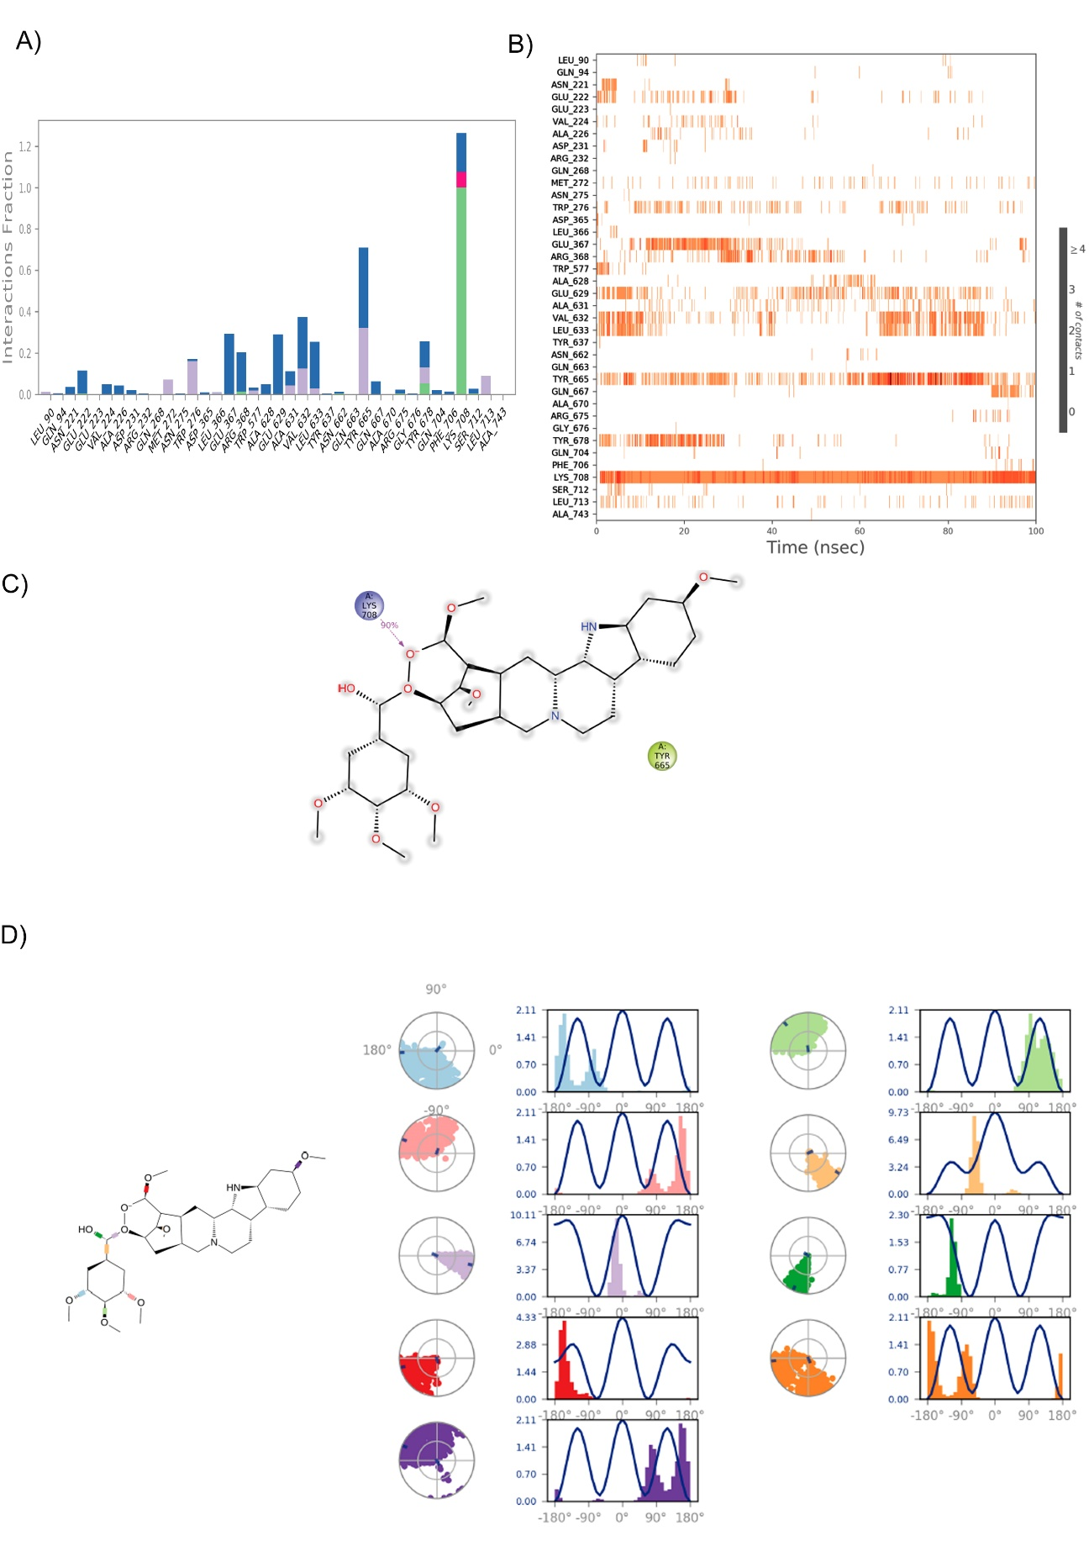
Supplementary Figure S1: 3D molecular docking view of Docetaxel, Reserpine and Irinotecan and GS3036656 with MTB-LeuRS
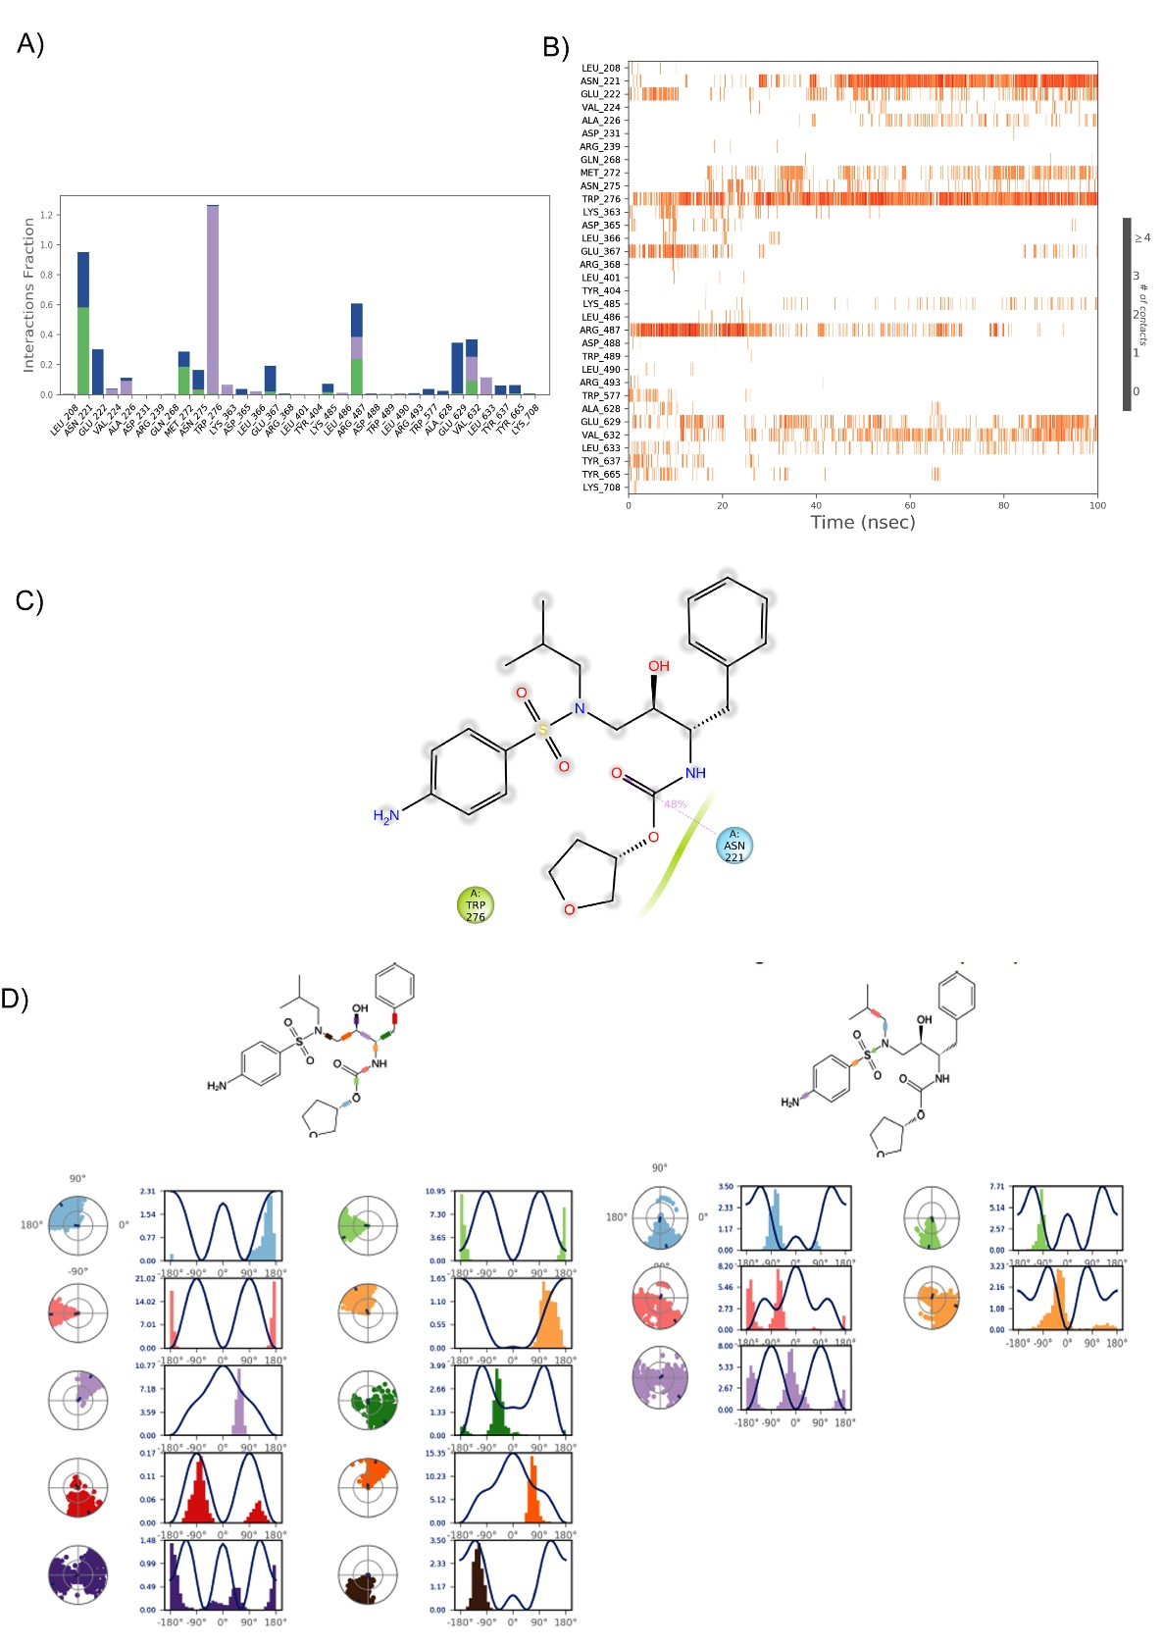
Supplementary Figure S2: Analysis of the LeuRS- Reserpine H-bond and torsional angel over a 100ns simulation period. A) The 37 ionic interactions formed during the simulation by natural Reserpine compound with the LeuRS protein. B) Heatmap of the LeuRS- Reserpine H-bonds over 100ns. C) the 2D structure of Reserpine stable interaction with LeuRS protein during simulation. D) The radial plots denote the 9 torsional angels’ conformation space of Reserpine during the simulation period, and the histogram represents the torsional energy profile of the LeuRS- Reserpine complex during the 100 ns simulation period.

