SUPPLEMENTARY MATERIAL

CNMP | 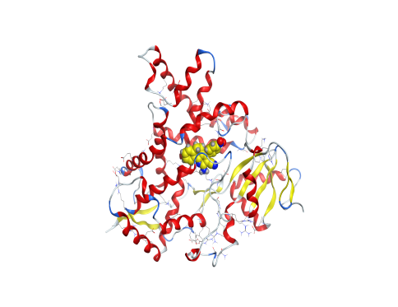 | 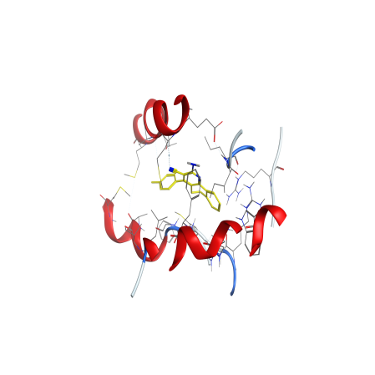
CPMP | 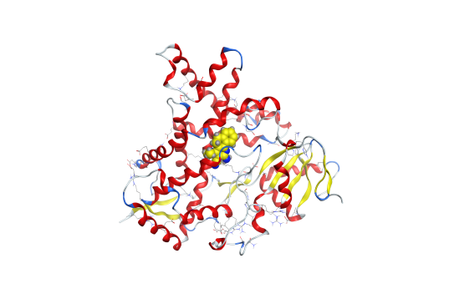 | 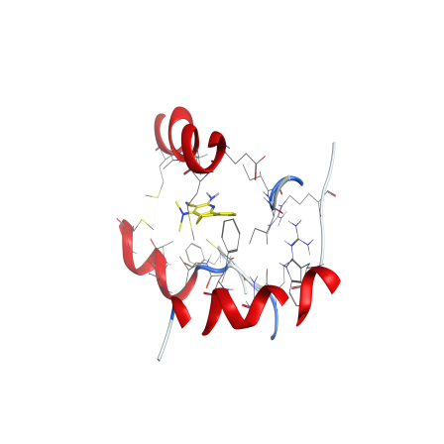
CRMP | 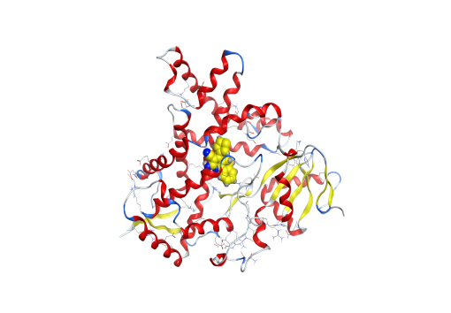 | 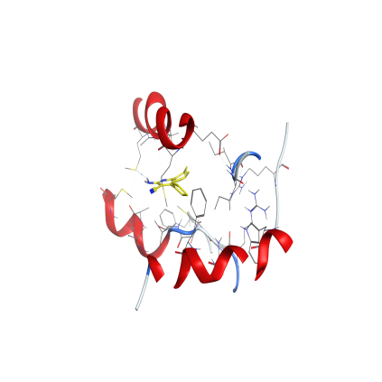
CTMP | 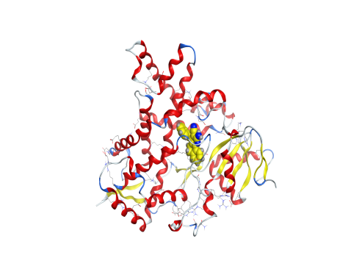 | 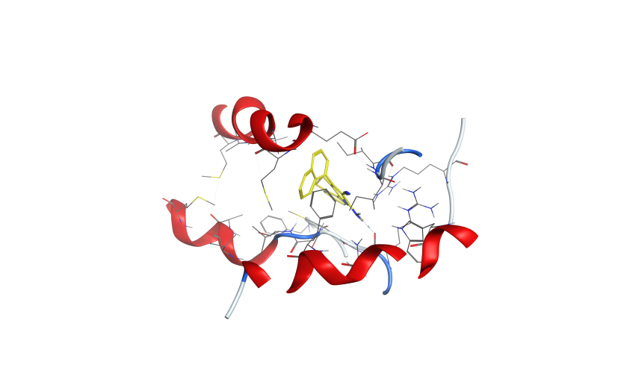
Figure S1: 3D docking and site view of the compounds and 3EQM protein cancer of breast cancer protein.

CNMP | 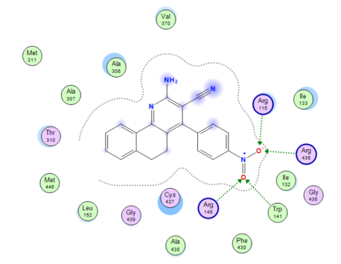
CPMP | 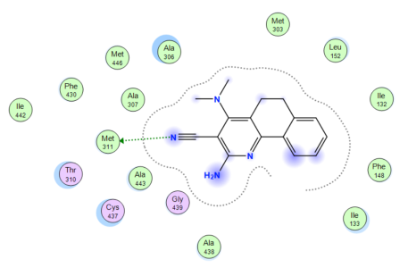
CRMP | 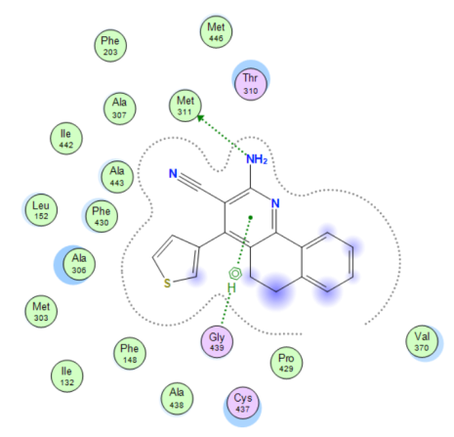
CTMP | 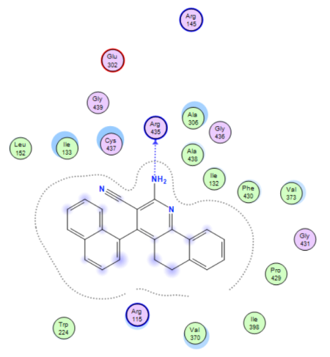

Figure S2: 2D docking of the compounds and 3EQM protein cancer of breast cancer protein

CNMP | 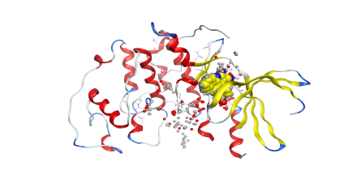 | 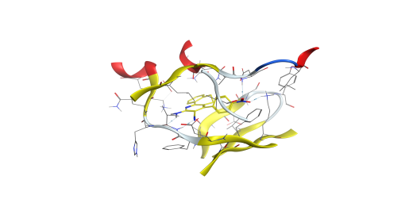
CPMP | 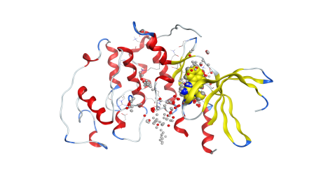 | 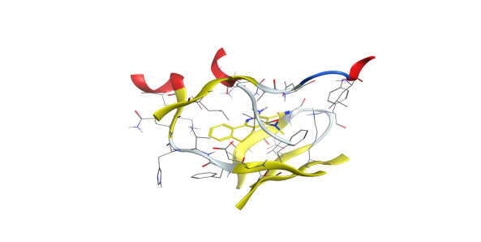
CRMP | 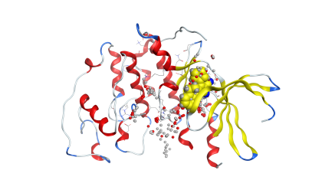 | 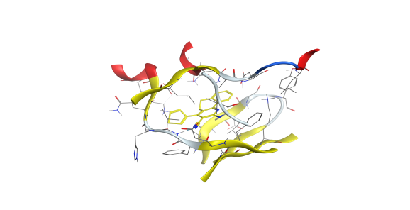
CTMP | 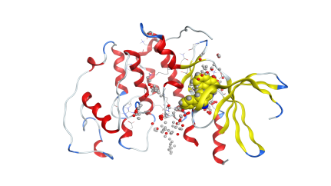 | 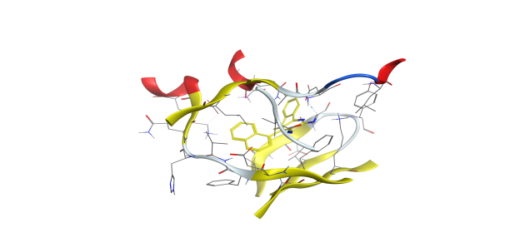
Figure S3: 3D docking and site view of the compounds and 3IG7 protein cancer of colon-cancer protein.

CNMP | 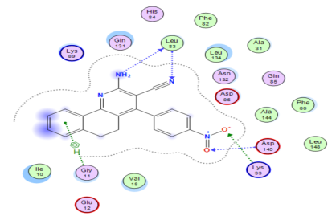
CPMP | 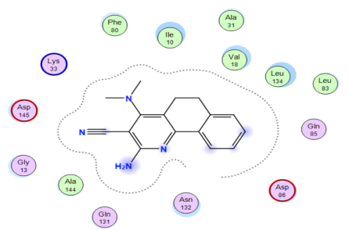
CRMP | 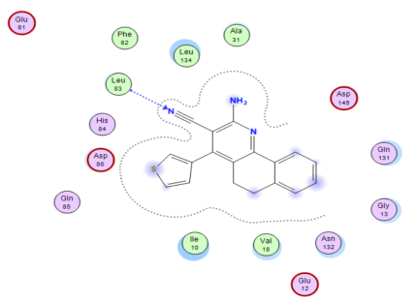
CTMP | 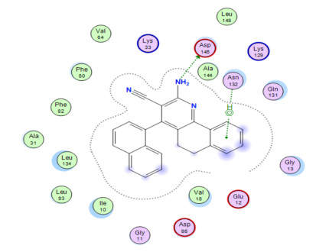
Figure S4: 2D interaction of the compounds and 3IG7 protein cancer of colon cancer-protein.

CNMP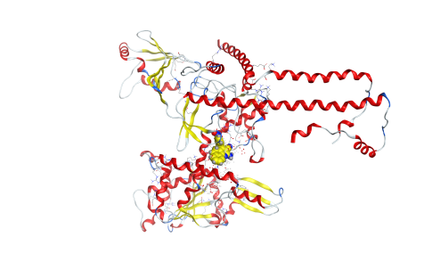 |  | 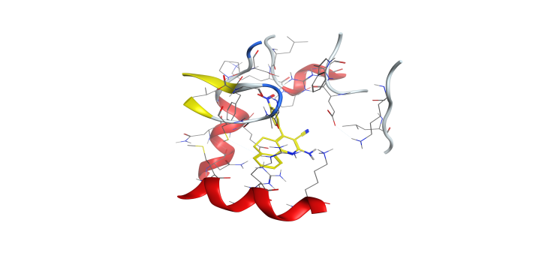
CPMP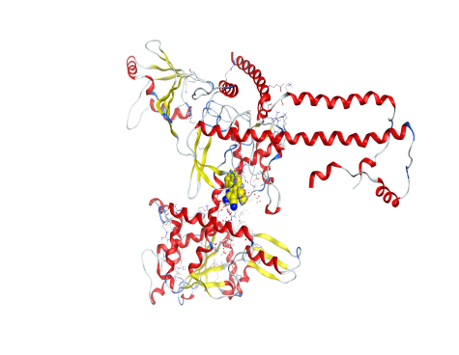 |  | 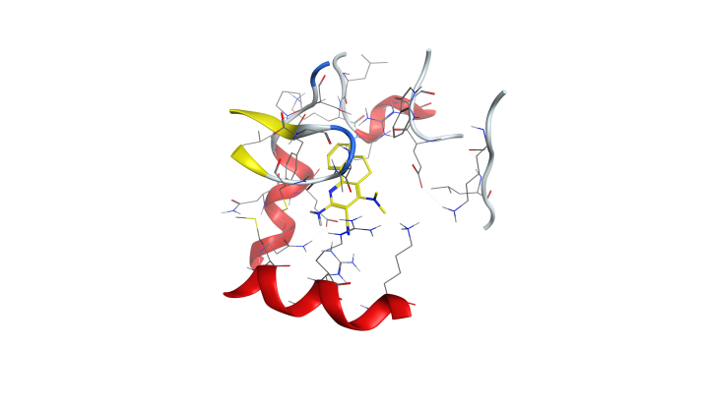
CRMP  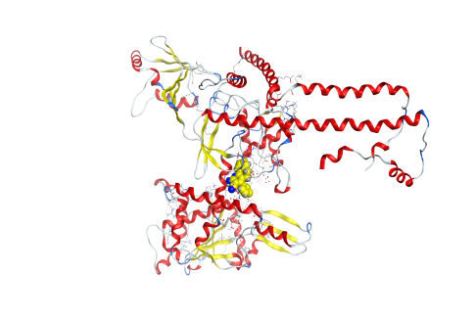 |  | 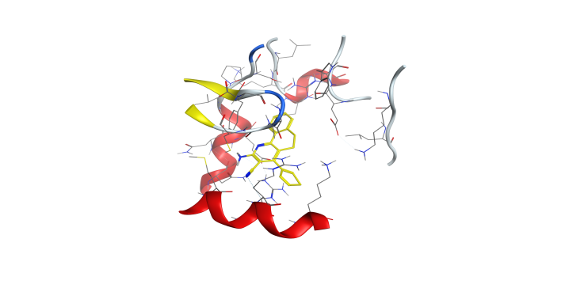
CTMP  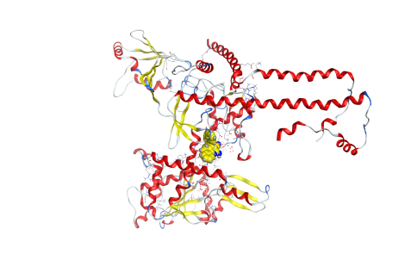 |  | 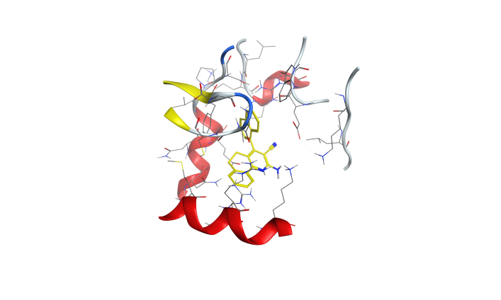
Figure S5: 3D docking and site view of the compounds and 4FM9 protein cancer of hepato-cancer protein.

CNMP | 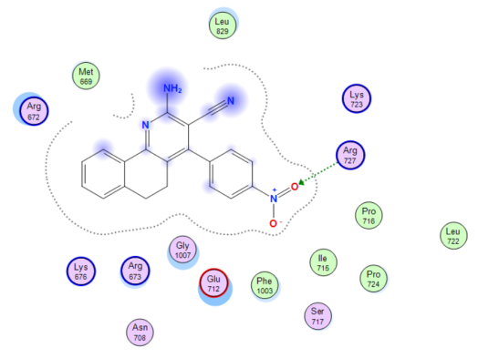
CPMP | 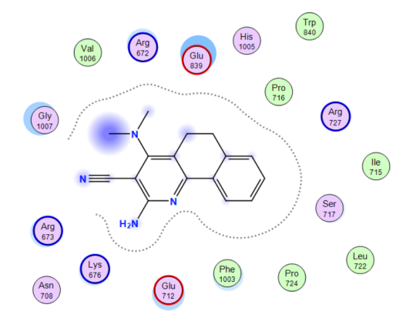
CRMP | 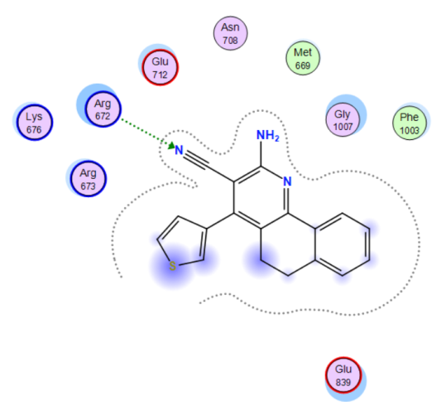
CTMP
Figure S6: 2D docking of the compounds and 4FM9 protein cancer of hepato-cancer protein.

Table S4: Docking score and energy of the compounds and 3IG7 protein cancer of colon cancer protein.

mol | S | rmsd_refine | E_conf | E_place | E_score1 | E_refine | E_score2
CMMP | -6.51 | 1.98 | -29.81 | -64.41 | -10.62 | -26.87 | -6.51
 | -6.50 | 3.36 | -37.67 | -52.74 | -10.44 | -31.97 | -6.50
 | -6.47 | 1.50 | -32.71 | -55.48 | -10.60 | -39.92 | -6.47
 | -6.37 | 0.67 | -38.09 | -86.72 | -10.65 | -28.45 | -6.37
 | -6.35 | 0.79 | -35.72 | -66.08 | -10.58 | -11.57 | -6.35
CNMP | -6.90 | 0.91 | 0.14 | -87.37 | -10.79 | -39.56 | -6.90
 | -6.80 | 1.77 | 5.67 | -91.57 | -10.82 | -39.11 | -6.80
 | -6.73 | 0.71 | -1.94 | -78.21 | -11.56 | -32.80 | -6.73
 | -6.64 | 1.95 | 3.88 | -58.62 | -10.89 | -35.75 | -6.64
 | -6.61 | 1.44 | 3.14 | -76.19 | -11.06 | -43.58 | -6.61
CPMP | -6.26 | 0.69 | -21.30 | -82.77 | -9.80 | -31.32 | -6.26
 | -6.19 | 0.89 | -17.89 | -73.16 | -9.62 | -32.54 | -6.19
 | -6.19 | 1.22 | -20.87 | -62.75 | -10.24 | -31.75 | -6.19
 | -6.18 | 1.22 | -17.71 | -66.34 | -9.92 | -29.41 | -6.18
 | -6.06 | 1.13 | -19.19 | -62.29 | -10.65 | -34.44 | -6.06
CRMP | -6.30 | 0.82 | -17.86 | -79.26 | -9.97 | -37.09 | -6.30
 | -6.24 | 1.58 | -22.08 | -73.00 | -10.17 | -31.96 | -6.24
 | -6.23 | 0.96 | -15.69 | -83.49 | -10.02 | -33.04 | -6.23
 | -6.20 | 1.83 | -19.40 | -57.29 | -10.04 | -29.38 | -6.20
 | -6.20 | 2.89 | -18.89 | -86.94 | -10.49 | -31.37 | -6.20
CTMP | -6.60 | 2.19 | -4.38 | -59.73 | -9.82 | -31.83 | -6.60
 | -6.53 | 1.52 | -2.39 | -68.77 | -9.45 | -38.67 | -6.53
 | -6.53 | 1.62 | -11.54 | -60.80 | -10.39 | -14.19 | -6.53
 | -6.49 | 2.30 | -15.79 | -51.94 | -9.49 | -22.05 | -6.49
 | -6.08 | 1.30 | -16.33 | -58.60 | -9.41 | -16.16 | -6.08

Table S5: Interaction table between the compounds and 3IG7 protein cancer of colon-cancer protein.

 | Ligand | Receptor | Interaction | Distance E | (kcal/mol)
CMMP | N 41 | N LEU 83 (A) | H-acceptor | 3.21 | -3.6
 | 6-ring | CG2 VAL 18 (A) | pi-H | 4.33 | -0.7
CNMP | N 33 | O LEU 83 (A) | H-donor | 3.34 | -1.2
 | O 37 | N ASP 145 (A) | H-acceptor | 3.05 | -1.2
 | O 38 | NZ LYS 33 (A) | H-acceptor | 3.26 | -3.3
 | N 40 | N LEU 83 (A) | H-acceptor | 3.53 | -2.1
 | 6-ring | CA GLY 11 (A) | pi-H | 3.99 | -0.9
CPMP | No measurable interaction
CRMP | N 35 | N LEU 83 (A) | H-acceptor | 3.04 | -4.7
CTMP | N 23 | OD1 ASP 145 (A) | H-donor | 3.08 | -0.8
 | 6-ring | ND2 ASN 132 (A) | pi-H | 3.36 | -0.6

Table S6: Energy and docking score of the compounds and 4FM9 protein cancer of hepato cancer protein.

mol | S | rmsd_refine | E_conf | E_place | E_score1 | E_refine | E_score2
CMMP | -6.60 | 1.35 | -36.78 | -65.36 | -9.25 | -31.49 | -6.60
 | -6.56 | 1.22 | -38.27 | -79.49 | -9.60 | -34.30 | -6.56
 | -6.35 | 1.24 | -37.84 | -60.92 | -9.20 | -27.37 | -6.35
 | -6.32 | 0.99 | -27.11 | -73.03 | -10.30 | -28.80 | -6.32
 | -6.21 | 1.61 | -38.42 | -64.72 | -9.60 | -30.71 | -6.21
CNMP | -6.90 | 2.52 | -2.09 | -51.43 | -10.17 | -41.65 | -6.90
 | -6.74 | 1.76 | 10.65 | -58.14 | -11.07 | -34.72 | -6.74
 | -6.70 | 1.08 | 11.04 | -72.09 | -10.31 | -38.05 | -6.70
 | -6.42 | 1.06 | -1.50 | -65.00 | -11.13 | -39.53 | -6.42
 | -6.36 | 1.46 | -1.78 | -82.79 | -10.00 | -34.10 | -6.36
CPMP | -6.17 | 0.83 | -20.68 | -79.46 | -8.98 | -25.90 | -6.17
 | -6.10 | 1.31 | -19.67 | -71.81 | -9.21 | -26.58 | -6.10
 | -5.89 | 1.97 | -13.90 | -70.02 | -10.42 | -26.96 | -5.89
 | -5.71 | 0.59 | -17.31 | -65.54 | -9.09 | -23.43 | -5.71
 | -5.62 | 1.21 | -17.08 | -69.58 | -10.55 | -22.76 | -5.62
CRMP | -6.24 | 0.65 | -16.38 | -98.72 | -9.88 | -26.67 | -6.24
 | -6.18 | 1.91 | -15.48 | -69.05 | -10.29 | -26.17 | -6.18
 | -6.17 | 2.44 | -15.03 | -65.30 | -10.21 | -26.51 | -6.17
 | -6.09 | 0.90 | -22.64 | -69.04 | -9.85 | -23.01 | -6.09
 | -6.02 | 1.86 | -7.94 | -55.61 | -10.97 | -27.54 | -6.02
CTMP | -6.83 | 1.63 | -25.52 | -62.64 | -9.67 | -37.95 | -6.93
 | -6.71 | 1.74 | -15.28 | -73.78 | -9.98 | -26.56 | -6.71
 | -6.58 | 2.03 | -19.89 | -54.47 | -9.80 | -34.71 | -6.58
 | -6.55 | 1.22 | -25.86 | -72.09 | -9.46 | -35.51 | -6.55
 | -6.45 | 1.44 | -15.76 | -57.28 | -9.62 | -29.54 | -6.45

Table S7: Interaction table between the compounds and 4FM9 protein cancer of hepato-cancer protein.

 | Ligand | Receptor | Interaction | Distance E | (kcal/mol)
CMMP
CNMP | O 37 | NH2 ARG 727 (A) | H-acceptor | 3.01 | -2.8
CPMP
CRMP | N 35 | CD ARG 672 (A) | H-acceptor | 3.51 | -0.7
CTMP

