**Supporting Information for**

**Combining habitat suitability and landscape connectivity to identify the potential regions for pest managements: A case study of *Semiothisa cinerearia* in Beijing, China**

**1. The detail results of Pearson correlation analyses among the eight environmental variables**

Table S2. Pearson’s bivariate correlation matrix among the environmental variables considered in modeling habitat suitability.

|  |  |  |  |  |  |  |  |
| --- | --- | --- | --- | --- | --- | --- | --- |
|  | **Build** | **Forest** | **Shrub** | **Meadow** | **Road** | **Water** | **Host** |
| **Forest** | 0.21519 |  |  |  |  |  |  |
| **Shrub** | 0.01884 | 0.03545 |  |  |  |  |  |
| **Meadow** | 0.15683 | 0.60393 | 0.03836 |  |  |  |  |
| **Road** | 0.34893 | 0.04657 | 0.00498 |  |  |  |  |
| **Water** | -0.04612 | -0.10404 | -0.02109 | -0.07247 | -0.05437 |  |  |
| **Host** | -0.11103 | -0.24552 | -0.03527 | -0.11936 | -0.05238 | 0.16709 |  |
| **Cropland** | -0.21028 | -0.02418 | -0.00047 | -0.05255 | -0.16619 | 0.14725 | 0.11433 |

*The names and descriptions of the environmental variables are coincidence with Table 1.

**2. The area under the receiver operating characteristics curve (AUC) of the MaxEnt model**



Figure S1. The area under the receiver operating characteristics curve (AUC) of the MaxEnt model.

**3. The relative contributions of the environmental variables to the MaxEnt model**

Table S3. The relative contributions of ecophysiological variables used in the MaxEnt model for habitat suitability of *Semiothisa cinerearia*

|  |  |  |
| --- | --- | --- |
| **Variable** | **Unit** | **Contribution (%)** |
| The percentage coverage of forests | % | 47.7 |
| The distance to host | m | 34.0 |
| The distance to road | m | 6.6 |
| The distance to buildings | m | 3.9 |
| The distance to cropland | m | 2.7 |
| The percentage coverage of meadows | % | 2.5 |
| The distance to water | m | 2.4 |
| The percentage coverage of shrubs | % | 0.2 |

**4. The developments of the five scenarios**

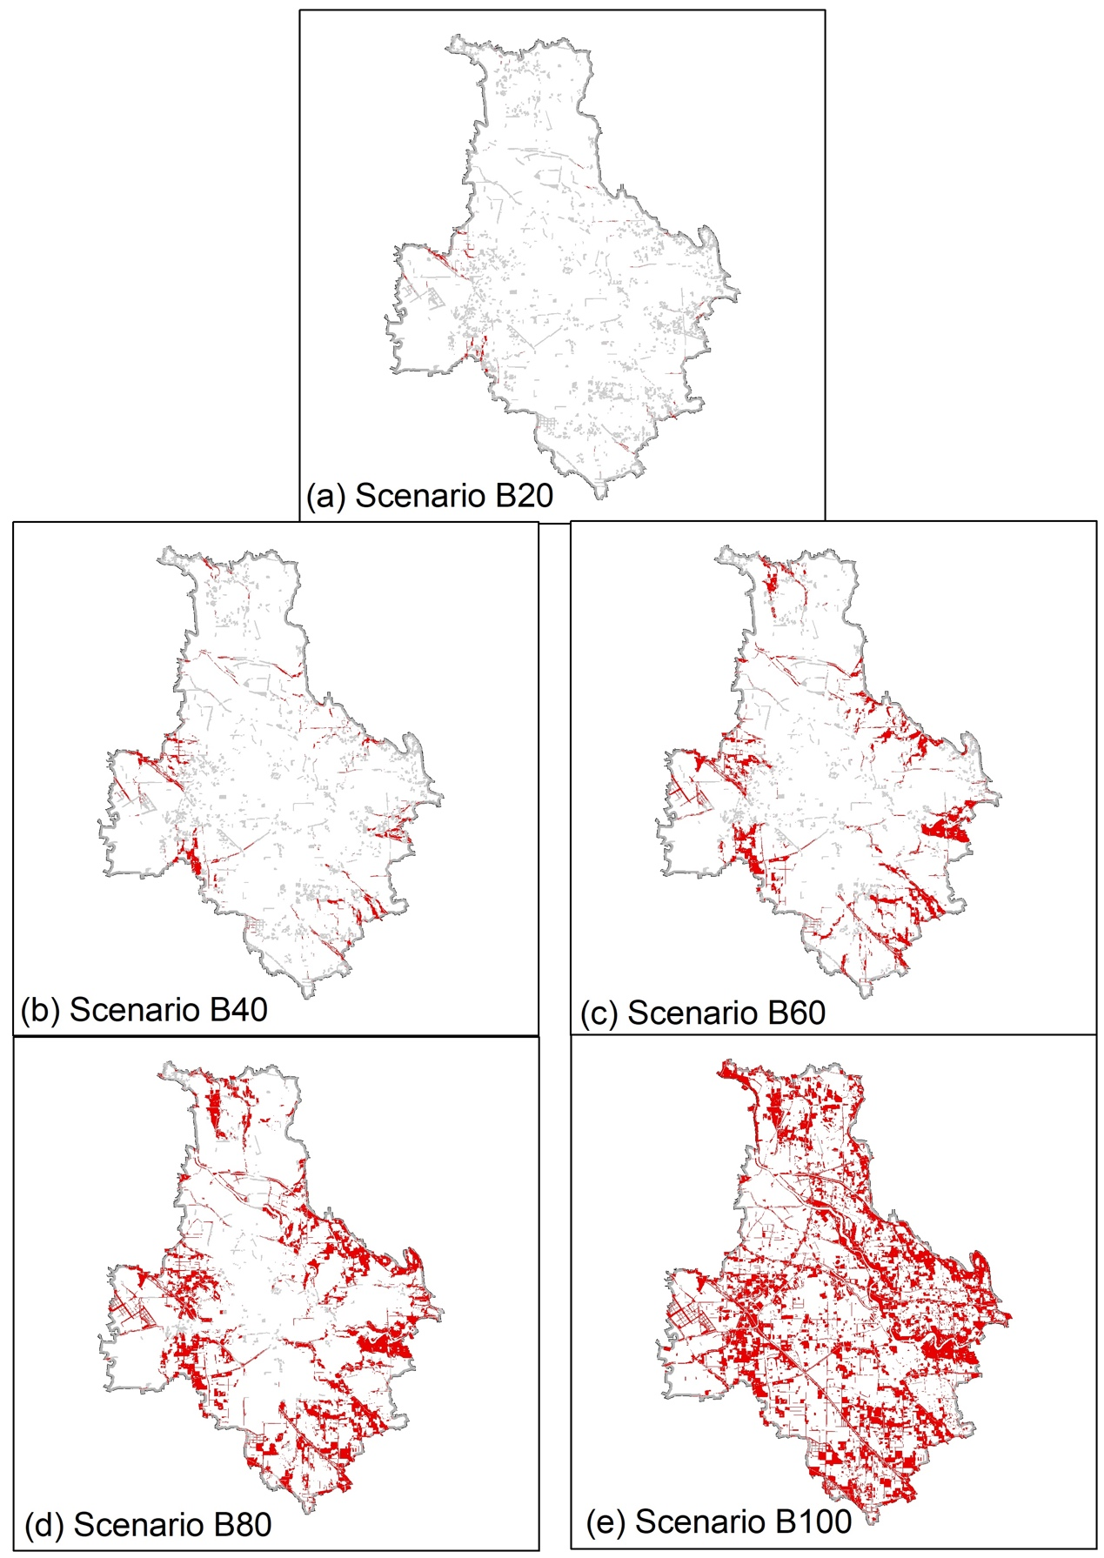

Figure S2. The pest management locations of Scenario B*n* (red and grey patches). The grey patches are the locations of host (sub-part A described in section 2.7 of the main body). The red patches are the locations of the other trees (sub-part B*n* described in section 2.7 of the main body). From the scenarios B20 to B100, the pest management locations are enlarging based on the range of landscape connectivity ranked by Jenks natural breaks.