**Figure S1.** Full scan of phenolic compounds of a walnut leaf on a HPLC-MS.

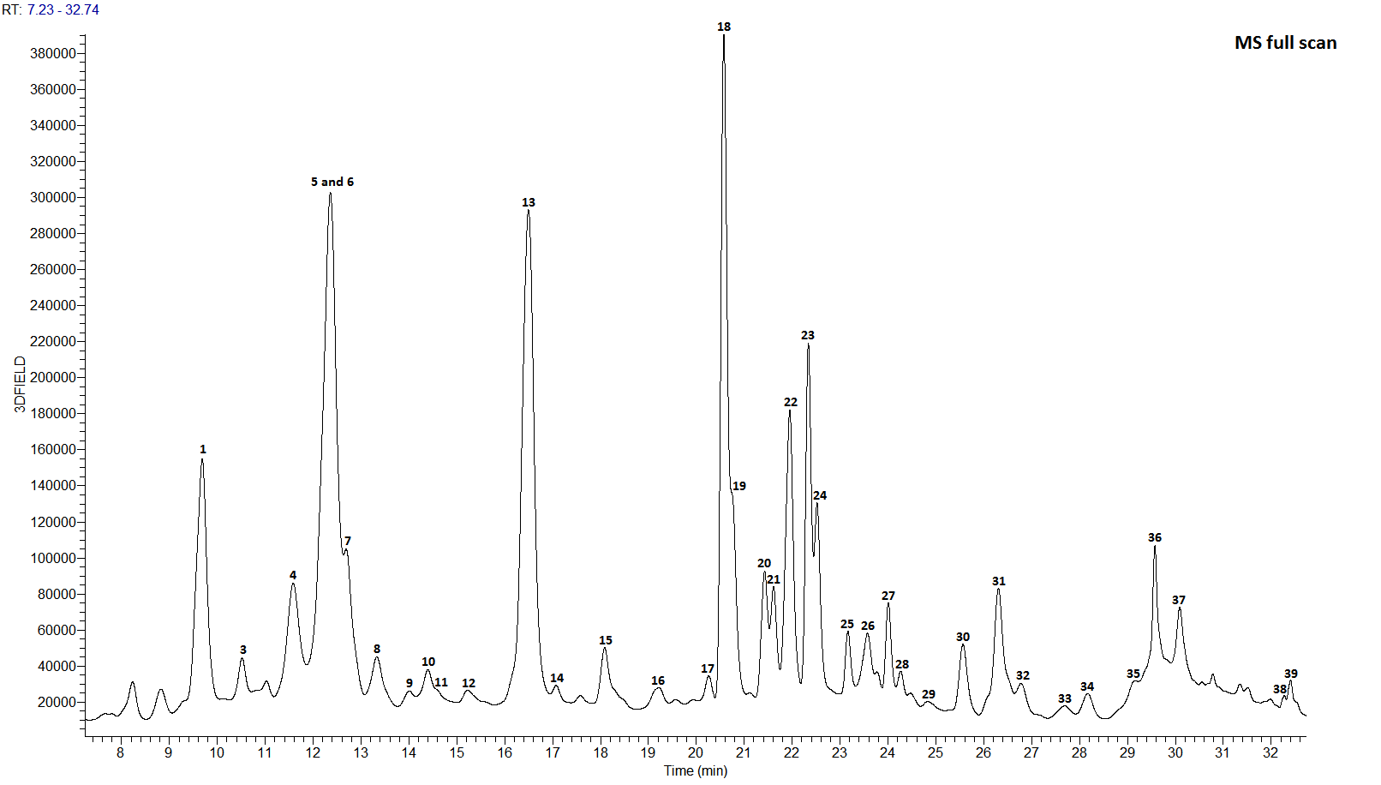

**1**= neochlorogenic acid (3-caffeoylquinic acid); **3**= procyanidin dimer 1; **4**= procyanidin dimer 2; **5** and **6**= dihydroxytetralone hexoside and *p*-coumaric acid hexoside 1 and 3-*p*-coumaoylquinic acid; **7**= (+) catechin; **8\***= chlorogenic acid (trans-5-caffeoylquinnic acid) and *p*-coumaric acid hexoside derivative 1 and *p*-coumaric acid hexoside 2; **9**= ferulic acid hexoside; **10**\*= *p*-coumaric acid derivative and *p*-coumaric acid hexoside 3; **11**= (-) epicatechin; **12**= procyanidin dimer 3; **13**= hydrojuglone β-D-glucopyranoside; **14**= procyanidin dimer 4; **20**= hydrojuglone derivative pentoside; **29**= caffeic acid hexoside derivative; **30\***= quercetin derivative and *p*-coumaric acid hexoside derivative 2; **32**= *p*-coumaric acid hexoside derivative 3 **33\***= quercetin dirhamnoside and 1,4-naphthoquinone and hydrojuglone; **34\***= *p*-coumaric acid hexoside derivative 4 and *p*-coumaric acid hexoside derivative 5; **36\***= *p*-coumaric acid hexoside 4 and hydrojuglone rutinoside; **37\***= juglone (5-hydroxy-1,4-naphthoquinone) and kaempferol-3-rutinoside; **38**= santin; **39**= 5,7-dihydroxy-3,4-dimetoxyflavone

**Figure S2.** Phenolic chromatogram of a walnut pellicle recorded at 280 nm.

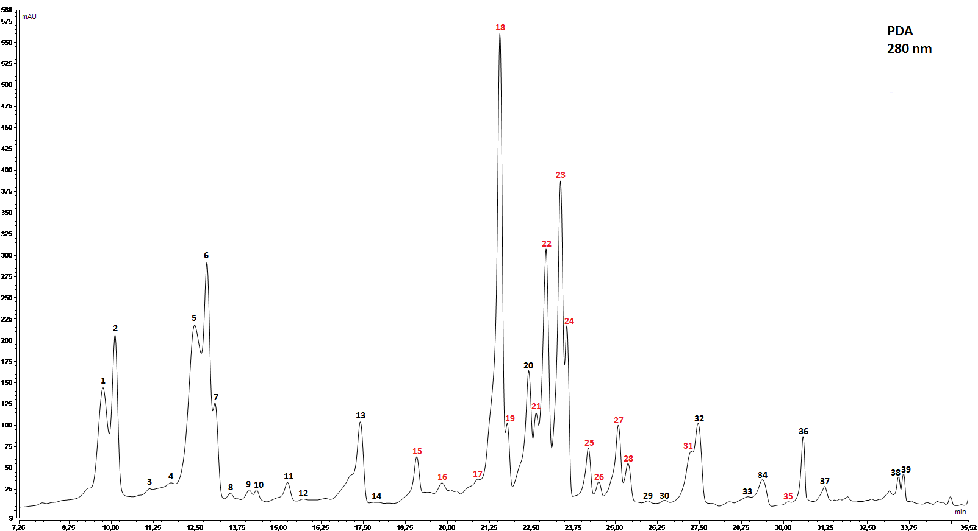

**1**and **2**= neochlorogenic acid (3-caffeoylquinic acid); **3**= procyanidin dimer 1; **4**= procyanidin dimer 2; **5\***= dihydroxytetralone hexoside and *p*-coumaric acid hexoside 1; **6**= 3-*p*-coumaoylquinic acid; **7**= (+) catechin; **8\***= chlorogenic acid (trans-5-caffeoylquinnic acid) and *p*-coumaric acid hexoside derivative 1 and *p*-coumaric acid hexoside 2; **9**= ferulic acid hexoside; **10**\*= *p*-coumaric acid derivative and *p*-coumaric acid hexoside 3; **11**= (-) epicatechin; **12**= procyanidin dimer 3; **13**= hydrojuglone β-D-glucopyranoside; **14**= procyanidin dimer 4; **20**= hydrojuglone derivative pentoside; **29**= caffeic acid hexoside derivative; **30\***= quercetin derivative and *p*-coumaric acid hexoside derivative 2; **32**= *p*-coumaric acid hexoside derivative 3 **33\***= quercetin dirhamnoside and 1,4-naphthoquinone and hydrojuglone; **34\***= *p*-coumaric acid hexoside derivative 4 and *p*-coumaric acid hexoside derivative 5; **36\***= *p*-coumaric acid hexoside 4 and hydrojuglone rutinoside; **37\***= juglone (5-hydroxy-1,4-naphthoquinone) and kaempferol-3-rutinoside; **38**= santin; **39**= 5,7-dihydroxy-3,4-dimetoxyflavone

**Figure S3.** Phenolic chromatogram of a peeled walnut kernel recorded at 350nm.

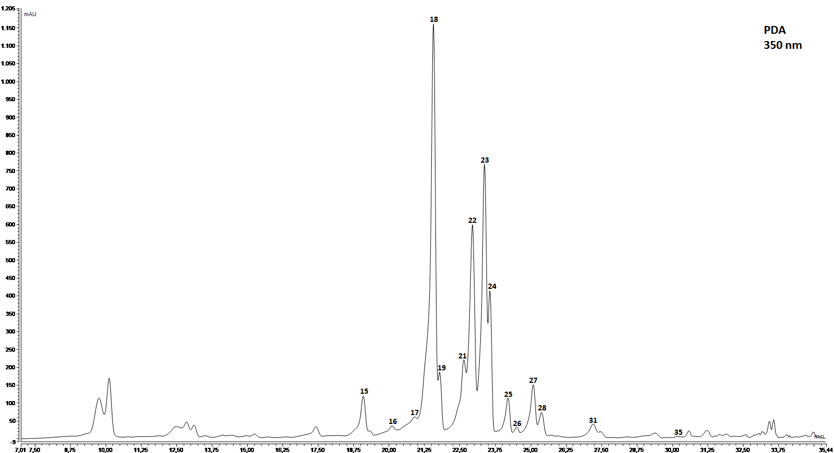

**15**= myricetin hexoside 1; **16**= myricetin pentoside; **17\***= myricetin-3-rhamnoside and myricetin pentoside; **18**= quercetin-3-galactoside; **19**= quercetin-3-glucoside; **21**= quercetin-3-xyloside; **22\***= kaempferol-3-galactoside and quercetin-3-arabinopyranoside; **23\***= quercetin-3-arabinofuranoside and kaempferol-3-glucoside; **24**= quercetin-3-rhamnoside; **25**= kaempferol pentoside 1; **26\***= kaempferol pentoside 2 and kaempferol derivative; **27**= kaempferol pentoside 3; **28**= kaempferol rhamnoside; **31**= quercetin-3-rhamnosyl hexoside**35**= quercetin