**Supplementary Material**

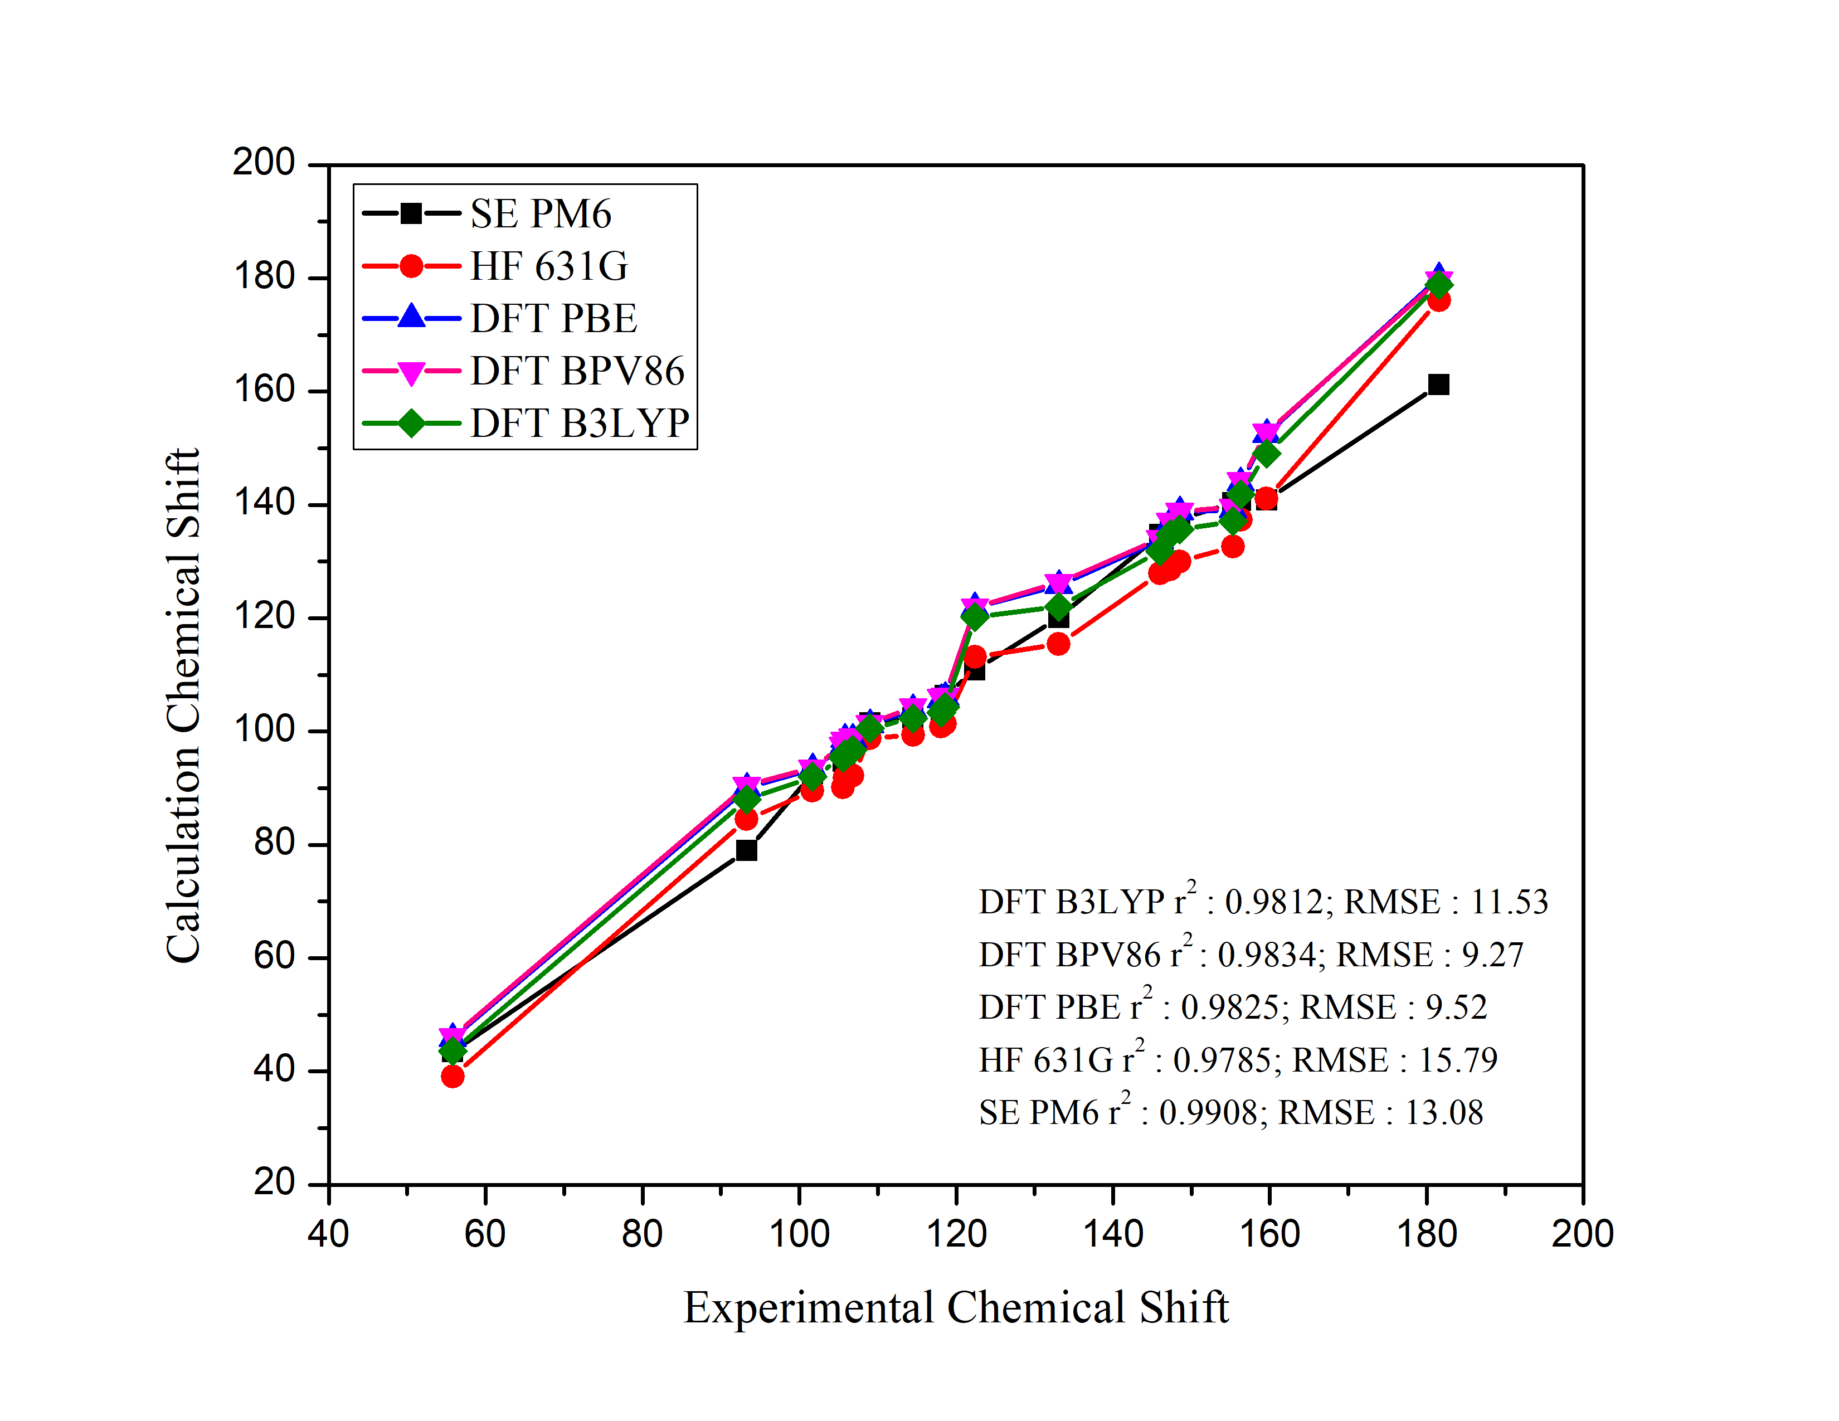

**Fig. S1.** The correlation of experimental 13C-NMR chemical shifts and theoretical 13C-NMR results using various optimization methods on compound 33D.

**Fig. S2.**  The correlation of experimental and predicted Log IC50 of anti-HCT training set.

**Fig. S3.** The correlation of experimental and predicted Log IC50 of anti-HCT test set.

**Fig. S4.**  The correlation of experimental and predicted Log IC50 of anti-hepatoma training set.

**Fig. S5.** The correlation of experimental and predicted Log IC50 of anti-hepatoma test set

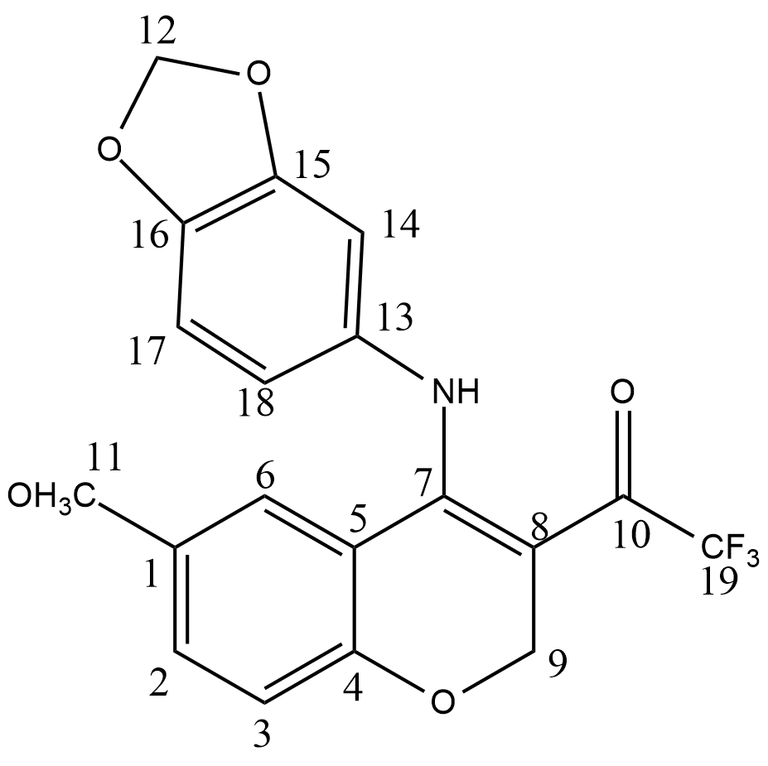

**Fig. S6.** The structure of compound 33d

**Table S1.** The different distance of some bonding in molecule 33d before and after optimization using DFT/BPV86 6-31G method.

|  |  |  |
| --- | --- | --- |
| **Atoms bond** | **Distance (**Å**)** | |
| **Before** | **After** |
| C11-O | 1.444 | 1.465 |
| C7-C8 | 1.338 | 1.412 |
| C10-C19 | 1.543 | 1.552 |
| N-H | 0.997 | 1.018 |
| C19-F | 1.354 | 1.405 |

**Table S2.** Developed QSAR models of anti-colon cancer activity resulted by MLR

|  |  |  |  |  |  |
| --- | --- | --- | --- | --- | --- |
| **Model** | **Descriptors** | **r** | **r2** | **Fcal/Ftab** | **SEE** |
| **1** | qC14, Log P, V, α | 0.899 | 0.807 | 4.283 | 0.200 |
| **2** | qC8, qC15, qC17 | 0.872 | 0.760 | 4.431 | 0.207 |
| **3** | qC14, qC15, qC17, ELUMO | 0.904 | 0.817 | 4.553 | 0.188 |
| **4** | qC15, qC17, Log P | 0.882 | 0.778 | 4.890 | 0.193 |
| **5** | qC7, qC8, SA, α | 0.887 | 0.787 | 3.769 | 0.193 |

**Table S3.** Developed QSAR models of anti-hepatoma activity resulted by MLR

|  |  |  |  |  |  |
| --- | --- | --- | --- | --- | --- |
| **Model** | **Descriptors** | **r** | **r2** | **Fcal/Ftab** | **SEE** |
| **1** | qC14, Log P, SA, α | 0.845 | 0.805 | 3.588 | 0.209 |
| **2** | qC2, qC17, qC18, Log P | 0.865 | 0.747 | 4.249 | 0.197 |
| **3** | qC1, qC16, μ, EHOMO | 0.915 | 0.837 | 7.400 | 0.162 |
| **4** | qC17, Log P, V, α, ELUMO | 0.883 | 0.779 | 3.954 | 0.193 |
| **5** | qC14, qC17, V, α, ∆E | 0.878 | 0.772 | 3.794 | 0.146 |