**(SUPPLEMENTARY DATA)**

**Nutritional efficacy of different diets supplemented with microalga *Arthrospira platensis* (spirulina) in honey bees (*Apis mellifera)***

Khalid Ali Khana, b, c,*, Hamed A. Ghramha,b,c

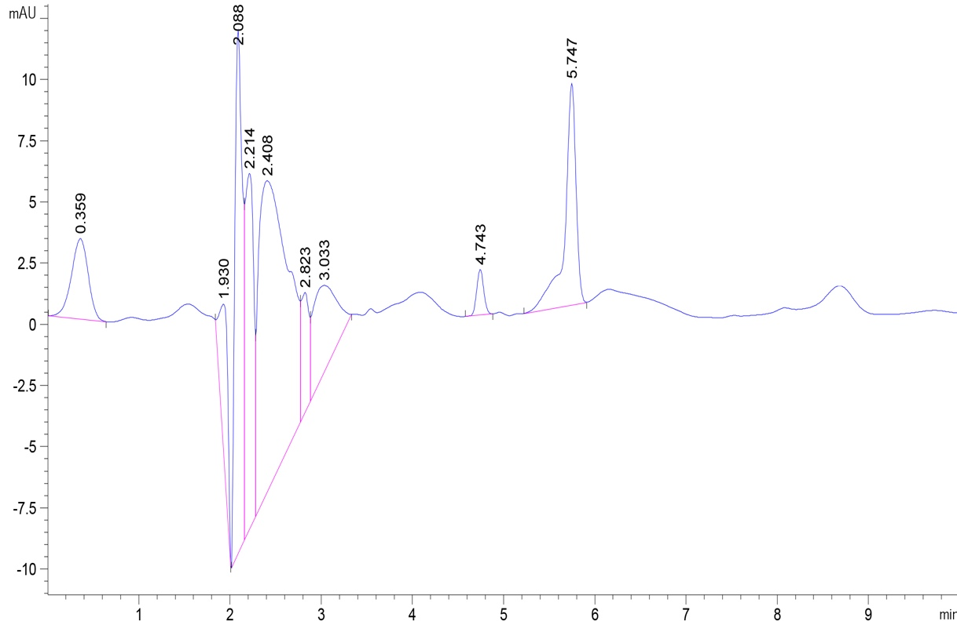

**Fig. 1S.** A chromatogram of commercial diet (Ajeena) by High-performance liquid chromatography / Diode Array HPLC Detector (HPLC-DAD) was monitored at the wavelength of 284 nm.

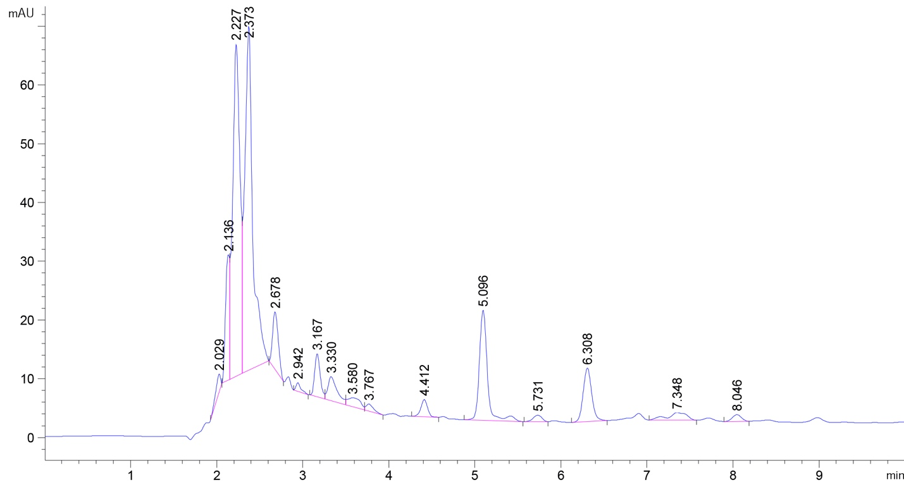

**Fig. 2S.** A chromatogram of date palm paste by High-performance liquid chromatography / Diode Array HPLC Detector (HPLC-DAD) was monitored at the wavelength of 284 nm.

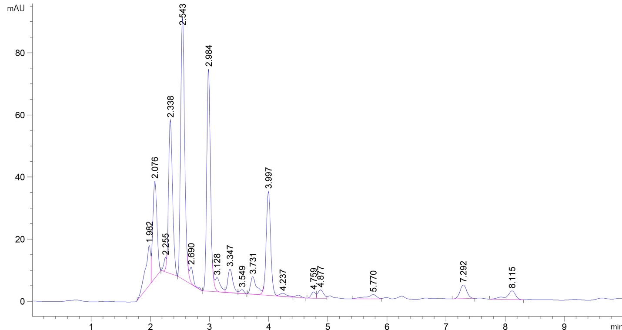

**Fig. 3S.** A chromatogram of local pollen (collected by honey bees) by High-performance liquid chromatography / Diode Array HPLC Detector (HPLC-DAD) was monitored at the wavelength of 284 nm.