# Self-assembly of a new cobalt complex, (C6H14N2)3[CoCl4]Cl : Synthesis, empirical and DFT calculations

Mariem Tahenti (a), Noureddine Issaoui (b) *, Thierry Roisnel (c), Houda Marouani (a),

Omar Al-Dossary d

(a) University of Carthage, Faculty of Sciences of Bizerte, Laboratory of Material Chemistry (LR13ES08), 7021 Bizerte, Tunisia

1. (b) University of Monastir, Faculty of Sciences, Laboratory of Quantum and Statistical Physics (LR18ES18), Monastir 5079, Tunisia

(c) Univ Rennes, CNRS, ISCR (Institut des Sciences Chimiques de Rennes) - UMR 6226, F-35000 Rennes, France

(d) Department of Physics and Astronomy, College of Science, King Saud University, PO Box 2455, Riyadh 11451, Saudi Arabia

*Corresponding author: [issaoui_noureddine@yahoo.fr](mailto:issaoui_noureddine@yahoo.fr)

**Table captions**

**Table S1:** Crystal data and structure parameters for (C6H14N)3[CoCl4]Cl.

**Table S2:** Enrichment ratio of different inter-contact and percentage of each atom on HS in (C6H14N)3[CoCl4]Cl.

**Table S3:** Global reactivity descriptors and calculated frontier molecular orbital parameters of (C6H14N)3[CoCl4]Cl compound.

**Figure captions**

**Fig. S1.** 2D-FP of the main interactions in the crystal packing and % age of atoms present in (C6H14N)3[CoCl4]Cl.

**Fig. S2.** Percentage of atoms present in (C6H14N)3[CoCl4]Cl.

**Fig. S3.** Theoretical and experimental IR spectrum of (C6H14N)3[CoCl4]Cl.

**Fig. S4.** DTA and TG curves of (C6H14N)3[CoCl4]Cl.

**Fig.S5.** HOMO-LUMO orbital plots of (C6H14N)3[CoCl4]Cl computed with B3LYP/6-311+G(d,p).

**Table S1:** Crystal data and structure parameters for (C6H14N)3[CoCl4]Cl.

CCDC 2102182

Temperature 150K

Empirical formula 3(C6H14N)·Cl4Co·Cl

Formula weight (g mol-1) 536.72

Crystal system Monoclinic

Space group *P*21/n

a 15.2645 (12) Å

b 10.0843(7) Å

c 17.4450(13) Å

  

Z 4

V 2670.8 (3) Å3

F(000) 1132

µ(Mo Kα) 0.71073 Å

Index ranges −19<hmax<19, −13<kmax<13, −22<lmax<22

Reflections collected 24384

Independent reflections 6103

Reflections with I>2σ(I) 4718

Rint 0.037

Absorption correction: *multi-scan* Tmin= 0.703, Tmax = 0.813

Refined parameters 271

R[F2> 2σ(F2)] 0.032

w*R*(F2) 0.071

Goodness of fit 1.03

Δρmax= 0.63 e Å−3 Δρmin=-0.58e Å−3

**Table S2:** Enrichment ratio of different inter-contact and percentage of each atom on HS in (C6H14N)3[CoCl4]Cl.

|  |  |  |  |
| --- | --- | --- | --- |
| **RE** | **H** | **Co** | **Cl** |
| **H** | 0.95 | - | 1.24 |
| **Co** |  | - | - |
| **Cl** |  | - | - |
| **%surface** | 79.45 | 0.25 | 19.8 |

**Table S3:** Global reactivity descriptors and calculated frontier molecular orbital parameters of (C6H14N)3[CoCl4]Cl using DFT/LANL2DZ level.

|  |  |
| --- | --- |
|  | |
| **Parameters (eV)** |  |
| EHOMO | |  | | --- | | -6.027913632 | |
| ELUMO | -3.459138592 |
| ∆E= ELUMO- EHOMO | **2.56877504** |
| EHOMO-1 | -6.276627656 |
| ELUMO+1 | 0.568178208 |
| ∆E= ELUMO+1- EHOMO-1 | **6.844805864** |
| Chemical potential (μ) | -4.743526112 |
| Softness (ς) | 0.389290609 |
| Ionization energy (I) | 6.027913632 |
| Electron affinity (A) | 3.459138592 |
| Electronegativity (χ) | 4.788526112 |
| Chemical hardness (η) | 1.28438752 |
| Electrophilicity index (ω) | 8.759443557 |

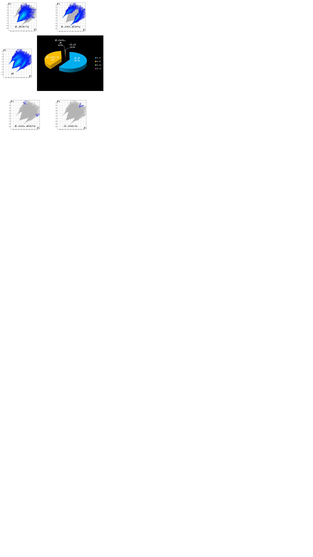

**Fig. S1**

**C:\Users\PC\Desktop\thèse\2éme composé(cyclo)\vvxxxxxffffff.tif**

**Fig. S2.** Percentage of atoms present in (C6H14N)3[CoCl4]Cl.

C:\Users\PC\Desktop\thèse\2éme composé(cyclo)\IR\Présentation17777777.tif

**Fig. S3.** Theoretical and experimental IR spectrum of (C6H14N)3[CoCl4]Cl.

C:\Users\PC\Desktop\thèse\2éme composé(cyclo)\Analyses thermique\Diapositive1.TIF

**Fig. S4**

C:\Users\PC\Desktop\thèse\2éme composé(cyclo)\Théoriques\homo lumo.tif

**Fig. S5**