Table S1. Information regarding Bifenthrin (Jaffer Group of Companies, Pakistan)
S. No. | Bifenthrin | Information
1 | CAS R. No. | 82657-04-3
2 | Active Ingredient | 10% (LC₅₀ 96 hr/10 => 60 µg/10 = 6 µg)
3 | Molecular Formula | C₂₃H₂₂CIF₃O₂
4 | Molecular Weight | 422.9 g/mol
5 | Chemical name | (2-methyl-3-phenylphenyl)methyl 2-[(Z)-2-chloro-3,3,3-trifluoroprop-1-enyl]-2,2-dimethylcyclopropane-1-carboxylate
6 | Chemical Structure | 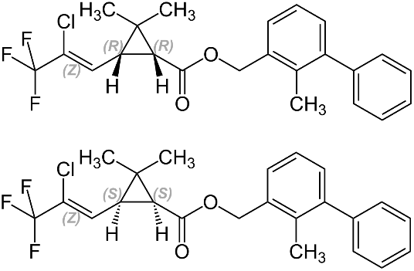

Table S2. Determination of LC50 of bifenthrin against Ctenopharyngodon idella for 96 h
S. No | Concentration Bifenthrin (µg/L) | Log Concentration | Number of fish exposed | No of alive fish | No of dead fish | Percent mortality (%) | Probit Mortality
1 | 15 | 1.1761 | 10 | 10 | 0 | 0 | 0.00
2 | 30 | 1.4771 | 10 | 9 | 1 | 10 | 3.72
3 | 45 | 1.6532 | 10 | 8 | 2 | 20 | 4.16
4 | 60 | 1.7782 | 10 | 6 | 4 | 40 | 4.75
5 | 75 | 1.8751 | 10 | 3 | 7 | 70 | 5.52
6 | 90 | 1.9542 | 10 | 0 | 10 | 100 | 8.09

Table S3. Behavioral profile of bifenthrin intoxicated Ctenopharyngodon idella
Behavior | Control | Treated
Jumping | ‒ | +
Erratic swimming | ‒ | +
Body twitches | ‒ | +
Motionless state | ‒ | +
Vertical position | ‒ | +
Air gulfing | ‒ | +
Rapid gill movement | ‒ | +
Equilibrium loss | ‒ | +
+ = Present; ‒ = Absent

Fig. S1. Determination of LC₅₀ of bifenthrin against Ctenopharyngodon idella for 96 h (Log Concentration × Percent Mortality; Probit Kill × Log Concentration)

