**Table S.1**

The mean length and net body weight of Nile Tilapia (*Oreochromis niloticus*) sample collected from six sampling sites during March 2019 from Lake Nasser.

|  |  |  |  |
| --- | --- | --- | --- |
| Sampling  sites | Sampling sites | Mean length (cm) ± SD | Mean body weight (g) ± SD |
| 1 | Abu-Simble | 31.30 ± 4.18 | 500 ± 27 |
| 2 | Armina | 28.00 ± 5.60 | 450 ± 19 |
| 3 | Tushka | 29.60 ± 3.50 | 300 ± 15 |
| 4 | Korosko | 21.50 ± 3.18 | 225.50 ± 26 |
| 5 | Kalabsha | 32.80 ± 5.00 | 500.50 ± 15 |
| 6 | High Dam | 25.00 ± 2.50 | 350 ± 18 |

**Table S.2**

Mean ± SD value of heavy metal content in Canadian standard fish samples, DORM 4 and DOLT 5.

|  |  |  |  |  |
| --- | --- | --- | --- | --- |
| Metal  (mg.kg-1 dry weight) | Measured Values  DORM4 (n = 30) | Certified Values  DORM4 | Measured Values  DOLT5 (n = 30) | Certified Values  DOLT5 |
| Cu | 14.90 ±0.23 | 15.70 ± 0.46 | 31.53 ± 2.5 | 35 ±2.40 |
| Zn | 52.00 ± 2.50 | 51.60 ± 2.80 | 106.82 ± 1.50 | 105.3 ± 2.40 |
| Cd | 0.295 ± 0.017 | 0.299 ± 0.018 | 14.01 ± 0.52 | 14.5 ±0.60 |
| Pb | 0.415 ± 0.050 | 0.404±0.062 | 0.166 ± 0.027 | 0.162 ± 0.032 |

**Table S.3**

Heavy metals concentrations in fish liver of Nile Tilapia (*Oreochromis niloticus*) of Lake Nasser.

|  |  |  |  |  |  |  |
| --- | --- | --- | --- | --- | --- | --- |
| Elements  Concentrations  mg.kg-1 | Measuring site | | | | | |
| 1  Abu-Simble | 2  Armina | 3  Tushka | 4  Korosko | 5  Kalabsha | 6  High Dam |
|
| Cu | 13.80 | 15.20 | 25.80 | 22.60 | 22.90 | 28.90 |
| Zn | 37.50 | 38.00 | 55.70 | 43.00 | 49.00 | 58.10 |
| Cd | 0.30 | 0.30 | 0.50 | 0.40 | 0.50 | 0.50 |
| Pb | 0.90 | 1.00 | 2.10 | 1.50 | 1.98 | 2.00 |
| MPI | 3.44 | 3.63 | 6.23 | 4.90 | 5.77 | 6.40 |

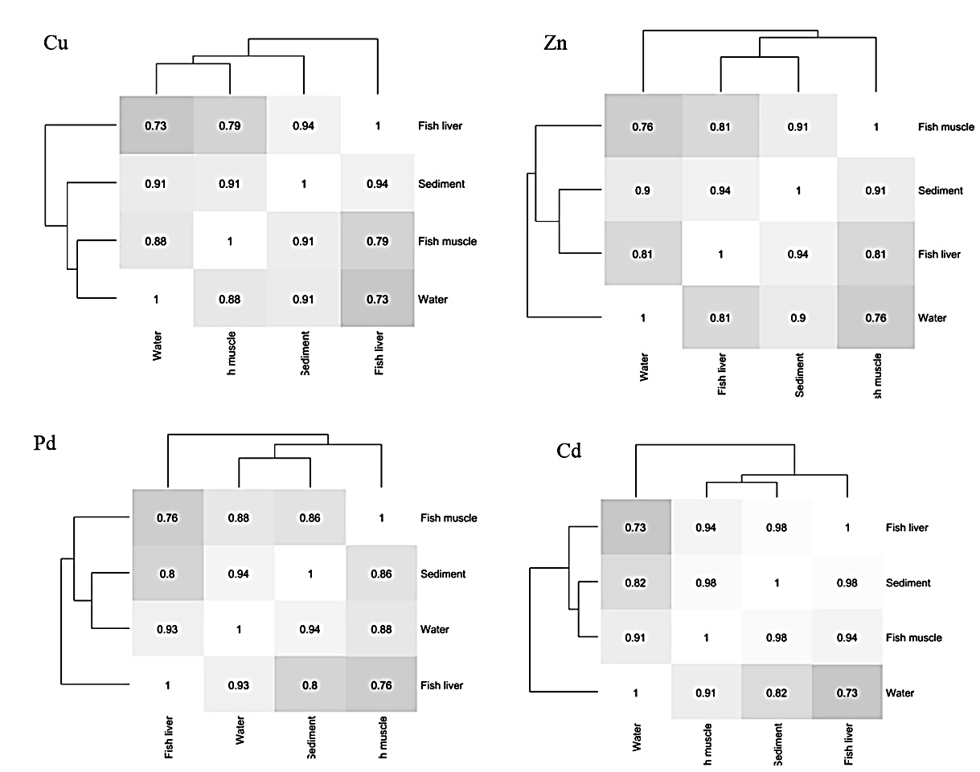

**Fig. S.1** Integrated correlations between elements in water, sediment, fish liver and fish muscles samples in Lake Nasser

**Fig. S.2** Metal Pollution Index for each sampling site