**Chemical Depolymerization of Recycled PET to Oxadiazole and Hydrazone Derivatives: Synthesis, Characterization, Molecular Docking and DFT study**

**Nazia Tarannum1,* Rizwan Khan1, Shoaiba Ansari1, Ranu Agrawal2, Swapnil Mishra3, Mohd Ubaidullah4, Abdulla A. Al-Kahtani4**

1Department of Chemistry, Chaudhary Charan Singh University Meerut, Uttar Pradesh, India-250005

2Department of applied science, SCRIET, Chaudhary Charan Singh University Meerut, Uttar Pradesh, India-250005

3Centre for Bioinformatics, Allahabad University, Allahabad, Uttar Pradesh, India-211002

4Department of Chemistry, College of Science, King Saud University, Riyadh 11451, Saudi Arabia Corresponding author: [naz1012@gmail.com](mailto:naz1012@gmail.com)

**Figure S1:** General and synthesized structure of oxadiazole and hydrazone derivatives

D:\scientific report paper\final paper nd reply revison\final figure\Fig 1.tif

**Figure S2:** FTIR spectra of oxadiazole derivatives (OCB and OHB)

D:\scientific report paper\final paper nd reply revison\final figure\Fig 3.TIF

**Figure S3:** FTIR spectra of hydrazone derivatives (TCA, TBA and THD)

D:\scientific report paper\final paper nd reply revison\final figure\Fig 4.TIF

**Figure S4:** 1H NMR and 13C NMR spectra with splitting pattern and structure of OHB

D:\scientific report paper\final paper nd reply revison\final figure\Fig 5.TIF

**Figure S5:** 1H NMR and 13C NMR spectra with splitting pattern and structure of TBA and THD

D:\scientific report paper\final paper nd reply revison\final figure\Fig 6.TIF

**Figure S6:** SEM micrograph showing the internal appearance of oxadiazole derivatives (a) OCB

(b) OHB at 100X magnification

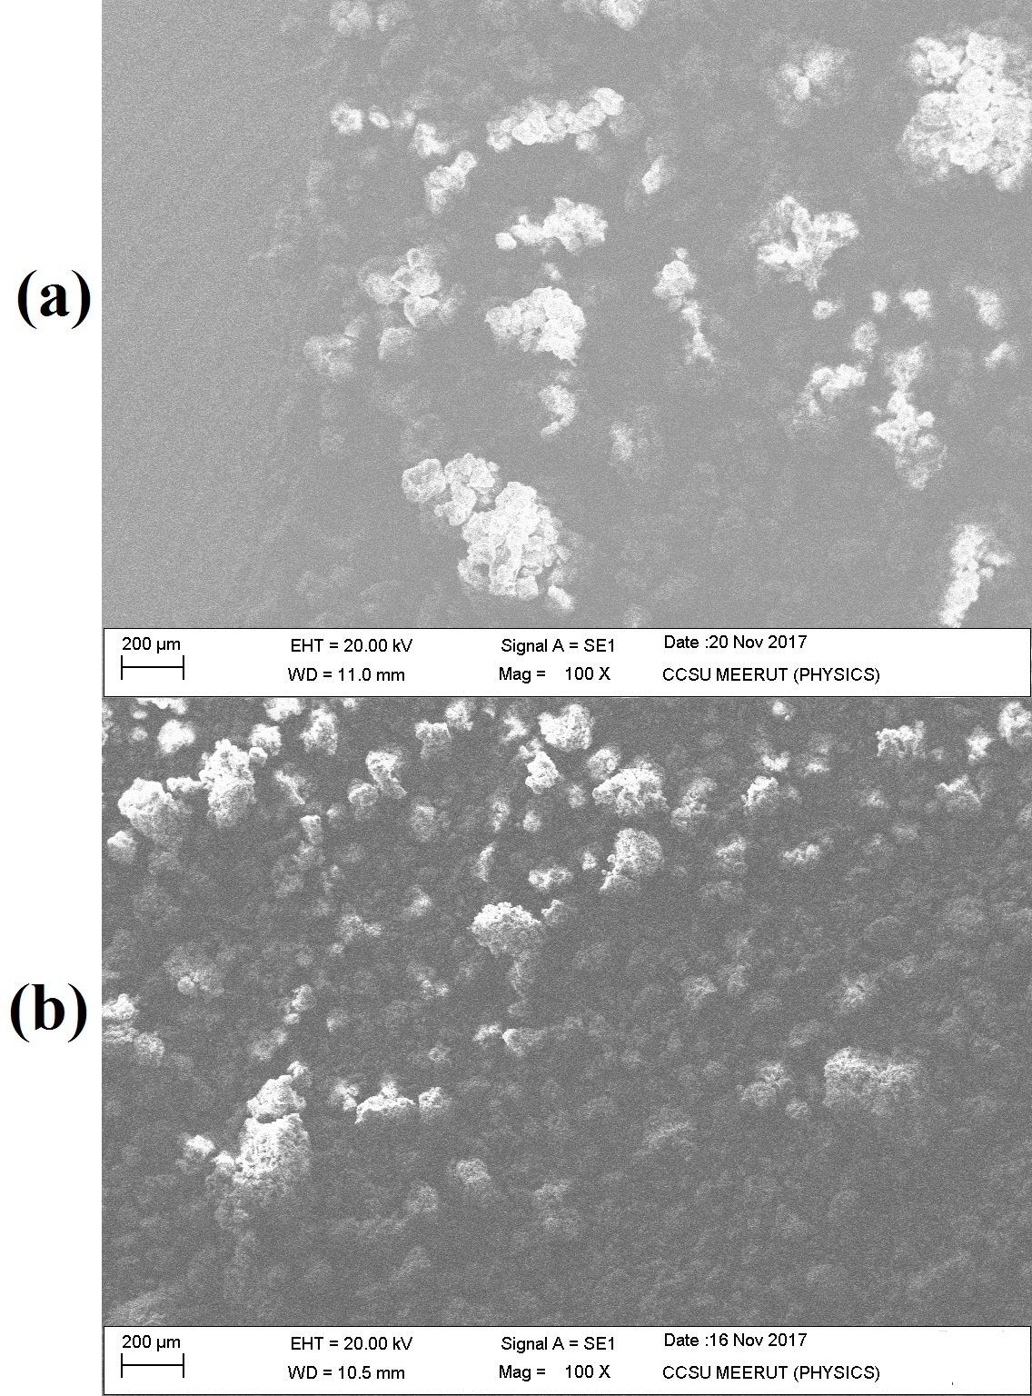

**Figure S7:** SEM micrograph showing the internal appearance of hydrazone derivatives (a) TCA

(b) TBA (c) THD at 500X magnification

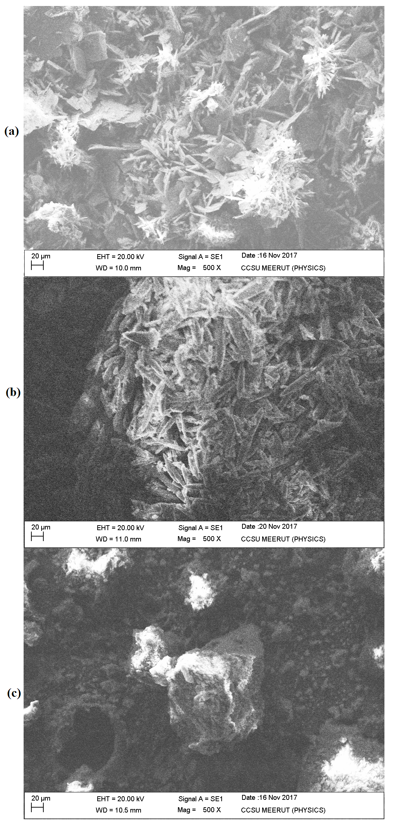

**Figure S8:** Thermogravimetric (TGA/DTA) curves for oxadiazole derivatives (OCB and OHB)

D:\scientific report paper\final paper nd reply revison\final figure\Fig 9.TIF

**Figure S9:** Thermogravimetric (TGA/DTA) curves for hydrazone derivatives (TCA, TBA and

THD)

D:\scientific report paper\final paper nd reply revison\final figure\Fig 10.TIF

**Figure S10:** DSC curve for hydrazone derivatives (TCA and TBA)

D:\scientific report paper\final paper nd reply revison\final figure\Fig 11.TIF

**Table S1: The solubility of the synthesized compounds in different solvents**

|  |  |  |  |  |  |  |
| --- | --- | --- | --- | --- | --- | --- |
| **S.N.** | **Solvent** | **Compound OCB** | **Compound OHB** | **Compoud TCA** | **Compound TBA** | **Compound THD** |
| **01** | [Dimethyl sulfoxide](https://en.wikipedia.org/wiki/Dimethyl_sulfoxide) (DMSO) | **×** | **Δ** | **×** | **Δ** | **Δ** |
| **02** | Distilled water | **×** | **×** | **×** | **×** | **×** |
| **03** | Benzene (C6H6) | **×** | **×** | **×** | **×** | **×** |
| **04** | Chloroform (CHCl3) | **÷** | **×** | **×** | **÷** | **÷** |
| **05** | [Tetrahydrofuran](https://en.wikipedia.org/wiki/Tetrahydrofuran) (THF) | **×** | **×** | **×** | **×** | **×** |
| **06** | Methanol (CH3OH) | **×** | **×** | **×** | **×** | **×** |
| **07** | Carbon tetrachloride (CCl4) | **×** | **Δ** | **×** | **×** | **÷** |
| **08** | Carbon disulphide (CS2) | **×** | **×** | **×** | **×** | **×** |
| **09** | Acetonitrile (CH3CN) | **×** | **×** | **×** | **×** | **×** |
| **10** | Dioxane (C4H8O2) | **×** | **×** | **×** | **×** | **×** |
| **11** | Benzyl alcohol (C6H5CH2OH) | **×** | **×** | **×** | **×** | **×** |
| **12** | 0.1 NH4Cl | **×** | **×** | **×** | **×** | **×** |
| **13** | Toulene (C7H8) | **×** | **×** | **×** | **×** | **×** |
| **14** | Acetic acid (CH3COOH) | **×** | **×** | **×** | **×** | **×** |
| **15** | Acetone (30%) + Methanol (20%) | **×** | **×** | **×** | **×** | **×** |
| **16** | Dimethylformamide (DMF) | **×** | **×** | **×** | **÷** | **×** |
| **17** | Triflouro -acetic acid (CF3COOH) | **Δ** | **÷** | **Δ** | **Ʃ** | **Δ** |
| **18** | Acetone (C3H6O) | **×** | **×** | **×** | **×** | **×** |

Note: Not Soluble: **×**, Partially Soluble: **÷**, Soluble on heating: Δ, Soluble at room temperature:Ʃ

**Table S2: Comparison of the theoretical and experimental elemental analysis results of the synthesized compounds**

**OCB**: 1,4-bis(5-(2-chlorophenyl)-1,3,4-oxadiazole-2-yl)benzene. **OHB:** 1,4-bis(5-(4-hydroxyphenyl)-1,3,4-oxadiazole-2-yl)benzene. **TCA**: N,N′-bis(2-chlorobenzylidene)terephthalo hydrazide. **TBA**: N,N′-bis(benzylidene)terephthalohydrazide.**THD**: N,N′-bis(4-hydroxybenzylidene)-terephthalo hydrazide

|  |  |  |  |  |  |  |  |  |
| --- | --- | --- | --- | --- | --- | --- | --- | --- |
| **Compounds** | **Experimental elemental analyses** | | | | **Theoretical elemental analyses** | | | |
| **C%** | **H%** | **N%** | **S%** | **C%** | **H%** | **N%** | **S%** |
| **OCB** | 67.50 | 2.35 | 12.29 | - | 66.68 | 2.75 | 12.85 | **-** |
| **OHB** | 65.85 | 3.68 | 14.17 | - | 66.33 | 3.51 | 14.07 | **-** |
| **TCA** | 60.28 | 4.41 | 12.58 | - | 60.13 | 4.10 | 12.75 | **-** |
| **TBA** | 70.56 | 4.61 | 15.20 | - | 71.35 | 4.86 | 15.13 | **-** |
| **THD** | 65.92 | 5.04 | 13.44 | - | 65.67 | 4.47 | 13.90 | **-** |

**Table S3: Thermodynamic parameters of the compounds, as obtained by the DFT study in the ground state**

|  |  |  |  |  |  |
| --- | --- | --- | --- | --- | --- |
|  | **OHB** | **OCB** | **TBA** | **TCA** | **THD** |
| **E (Thermal)**  **kcal/Mol** | 210.381 | 194.338 | 232.676 | 218.352 | 236.694 |
| **Cv**  **Cal/Mol-Kelvin** | 84.984 | 83.790 | 82.939 | 83.715 | 91.356 |
| **S**  **Cal/Mol-Kelvin** | 150.916 | 150.819 | 153.454 | 152.946 | 167.307 |
| **Degree of freedom** | 126 | 120 | 132 | 132 | 138 |
| **Full point group** | C1 | C1 | C1 | C1 | C1 |
| **Dipole Moment (Debye)** | 4.9268 | 3.8776 | 3.1281 | 3.7645 |  |
| **ZPVE**  **kcal/Mol** | 197.4787 | 181.491 | 219.700 | 204.3433 | 222.1189 |

**Table S4: Supplementary data of vibrational frequencies (cm-1) of the synthesized compounds**

|  |  |  |  |  |  |
| --- | --- | --- | --- | --- | --- |
| Vibrational  Frequencies (cm-1) | OCB | OHB | TBA | TCA | THD |
| 1. | 3038.4404 | 3288.1216 | 3263.1879 |  |  |
| 2. | 3042.9261 | 3861.8489 | 3256.5914 | 3651.9328 |  |
| 3. | 3042.1100 | 3861.9083 | 3040.7485 | 3654.8259 | 3860.2593 |
| 4. | 3031.7386 | 3037.9008 | 3030.2975 | 3095.0172 | 3841.4275 |
| 5 | 3032.0784 | 3039.3012 | 3029.6343 | 3042.1494 | 3644.7226 |
| 6. | 3035.4677 | 3032.3055 | 3020.8269 | 3039.8454 | 3240.4879 |
| 7. | 3019.2926 | 3020.6696 | 3010.6425 | 3028.7881 | 3283.8167 |
| 8. | 3021.2973 | 3011.7172 | 1655.6963 | 3008.8437 | 3039.4463 |
| 9. | 3021.7074 | 1655.7158 | 1652.5055 | 2694.3841 | 3027.9525 |
| 10. | 3010.2722 | 1655.2740 | 1640.1672 | 1842.0610 | 3033.1470 |
| 11. | 3017.2027 | 1638.4451 | 1616.4104 | 1650.8289 | 1655.3055 |
| 12. | 1638.3552 | 1555.4011 | 1550.0296 | 1633.0806 | 1639.0234 |
| 13. | 1626.9457 | 1563.3004 | 1555.3714 | 1622.0985 | 1563.9511 |
| 14. | 1533.7883 | 1467.7462 | 1424.5083 | 1574.4694 | 1509.9535 |
| 15. | 1336.9622 | 1402.5961 | 1454.3763 | 1539.2395 | 1522.2784 |
| 16. | 1286.0117 | 1287.9669 | 1511.7743 | 1516.4344 | 1459.3684 |
| 17. | 1179.7743 | 1326.0494 | 1408.4559 | 1523.1317 | 1445.3199 |
| 18. | 1161.4761 | 1168.3421 | 1376.3362 | 1466.5925 | 1375.6214 |
| 19. | 1143.6211 | 1217.5004 | 1217.0417 | 1453.5016 | 1342.8486 |
| 20. |  | 1163.9387 | 1189.3491 | 1377.8349 | 1232.8912 |
| 21. |  | 1123.1972 | 1174.1145 | 1320.8984 | 1207.2488 |
| 22. |  | 1124.8094 | 1167.7175 | 1209.7135 | 1118.7722 |
| 23. |  | 1083.5551 | 1090.5790 | 1173.5037 | 1104.7058 |
| 24. |  | 1011.7182 | 1072.1880 | 1163.8807  1172.7698  1093.2783  1087.5121 | 1045.4853 |

**Table S5: Molecular docking results of the five ligands with GlcN-6-P (PDB: 1jxa).**

|  |  |  |  |  |
| --- | --- | --- | --- | --- |
| **Compounds** | **BE (kcal/Mol)** | **Number of formed hydrogen bonds** | **H Bond distance (Å)** | **Residues involved in the formation of the hydrogen bonds with their respective distances** |
| **OCB** | −6.82 | 1 | 2.738 | Thr302 |
| **OHB** | −4.48 | 1 | 2.813 | Ser604 |
| **TCA** | −7.04 | 2 | 3.040, 3.066 | Gln348, Ser349 |
| **TBA** | −6.34 | 2 | 2.834, 3.148 | Gln348, Ser349 |
| **THD** | −8.30 | 3 | 3.230,  2.870, 3.30 | Thr302, Ser401, Ala602 |
| **Voriconazole** | −7.03 | Nil | - | - |

**Table S6: Molecular docking results of the five ligands, along with voriconazole with CYP51B(PDB:4uyl)**

|  |  |  |  |  |
| --- | --- | --- | --- | --- |
| **Compound** | **BE (kcal/Mol)** | **Number of formed hydrogen bonds** | **Hydrogen Bond distance (Å)** | **Residues involved in the formation of the hydrogen bonds with their respective distances** |
| **OCB** | −11.96 | 1 | 2.738 | Thr302 |
| **OHB** | −11.55 | 1 | 2.813 | Ser604 |
| **TCA** | −11.88 | 1 | 2.768 | His310 |
| **TBA** | −10.21 | 2 | 2.791, 2.984 | His310, Ala303 |
| **THD** | −9.35 | 2 | 2.693, 2.828 | Thy136, Ala303 |
| **Voriconazole** | −8.12 | 1 | 3.099 | His310 |