**ZnO/(X wt.%)La2O3/NiO Based Ternary Heterostructure Nano-photocatalyst: Preparation, Characterization and its Application for the Degradation of Methylene Blue**

**J.P. Shubha1,*, N.V. Sushma1, S.F. Adil2,*, Mujeeb Khan2, Mohamed E. Assal2 and Mohammad Rafe Hatshan2**

*1Department of Chemistry, Don Bosco Institute of Technology, Mysore Road, Bangalore -560074, India.*

*2Department of Chemistry, College of Science, King Saud University, P.O. Box 2455, Riyadh 11451, Saudi Arabia.*

**Corresponding Author’s**

E-mail addresses: sfadil@ksu.edu.sa (S.F.A.),shubhapranesh@gmail.com **(**J.P.S.).

*Characterization*

The prepared heterostrutures were characterized by X-ray diffraction, UV–Vis, FT-IR, FESEM and TEM. The XRD characterization is performed using Bruker diffractometer (Cu Kα (λ = 1.5406 Å) X-ray source). The spectral characterization was carried out by PerkinElmer UV-Vis spectrometer and Bruker IFS 66 v/S spectrometer are utilized for UV-Vis and FT-IR spectral analysis, respectively. The microscopic analysis such as SEM is carried to comprehend the surface morphology and particle size analysis is carried out by Field emission scanning electron microscope (FESEM) and TEM images are recorded with Transmission electron microscope, JEOL JEM2100 PLUS, operating at 200 kV accelerating voltage.

F:\BOX BOX 30 JUN 2020\Dr. Adil\ZnOLa2O3NiO\UV\UV ZnOLa2O3NiO.tif

**Fig. S1** UV–Vis. Spectra of the prepared ZnO/(3 wt.%)La2O3/NiOheterostructure.

F:\BOX BOX 30 JUN 2020\Dr. Adil\ZnOLa2O3NiO\XRD\1.tif

**Fig. S2** XRD analysis of the ZnO/(1 wt.%)La2O3/NiO, ZnO/(3 wt.%)La2O3/NiO and ZnO/(5 wt.%)La2O3/NiO samples.

F:\BOX BOX 30 JUN 2020\Dr. Adil\ZnOLa2O3NiO\FTIR\1.tif

**Fig. S3** FT-IR spectrum of the as-prepared ZnO/(3 wt.%)La2O3/NiOheterostructure.

F:\BOX BOX 30 JUN 2020\Dr. Adil\ZnOLa2O3NiO\SEM and TEM\SEM and TEM.tif

**Fig. S4** FESEM micrographs of the as-fabricated ZnO/(3 wt.%)La2O3/NiOnanocomposite.



**Fig. S5** HRTEM images of synthesized ZnO/(3 wt.%)La2O3/NiOheterostructure.

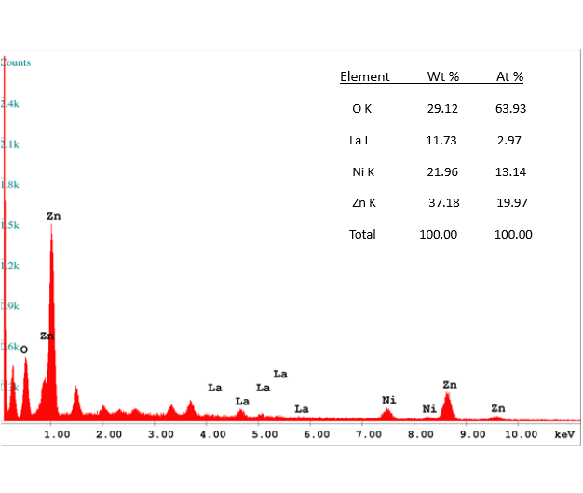

**Fig. S6** EDX spectrum of ZnO/(3 wt.%)La2O3/NiOheterostructure.