**Supplementary Data**

Supplementary Figure 1. Phytochemical profile of Leek methanolic extract (LME) using Gas chromatography and mass spectrophotometry analysis.

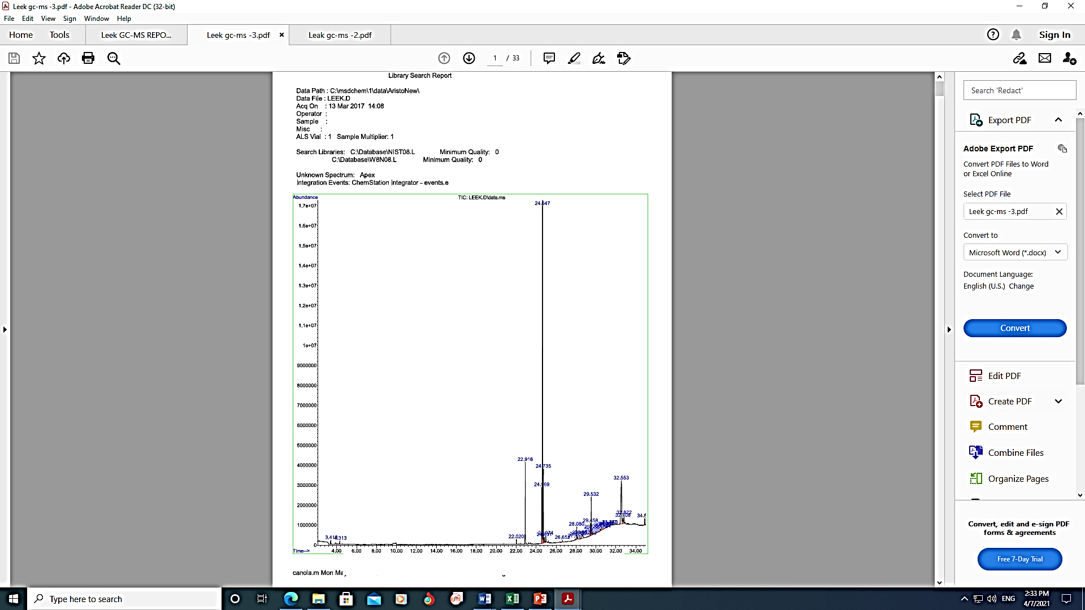

Supplementary table 1. Phytochemical profile of Leek methanolic extract (LME) using Gas chromatography and mass spectrophotometry analysis.

| S.No | Peak area  (Out of 100%) | Identified phytochemical from leek methanol extract  (Reference matched 90% and above in NIST01 & W8N08 library) |
| --- | --- | --- |
| 1 | 0.20 % | Methyl ester Dodecanoic acid |
| 2 | 6.91 % | Hexadecanoic acid |
| 3 | 2.91 % | 1, 3, 5,- Triazine |
| 4 | 74.42 % | 9, 12, 15 – Octadecatrienoic acid |
| 5 | 1.90 % | 11,13, -Dimethyl-12-tetradecen-1-ol acetate |
| 6 | 4.38% | 9, 12 –Octadecadienoic acid |
| 7 | 6.2 % | Cyclotrisiloxane |