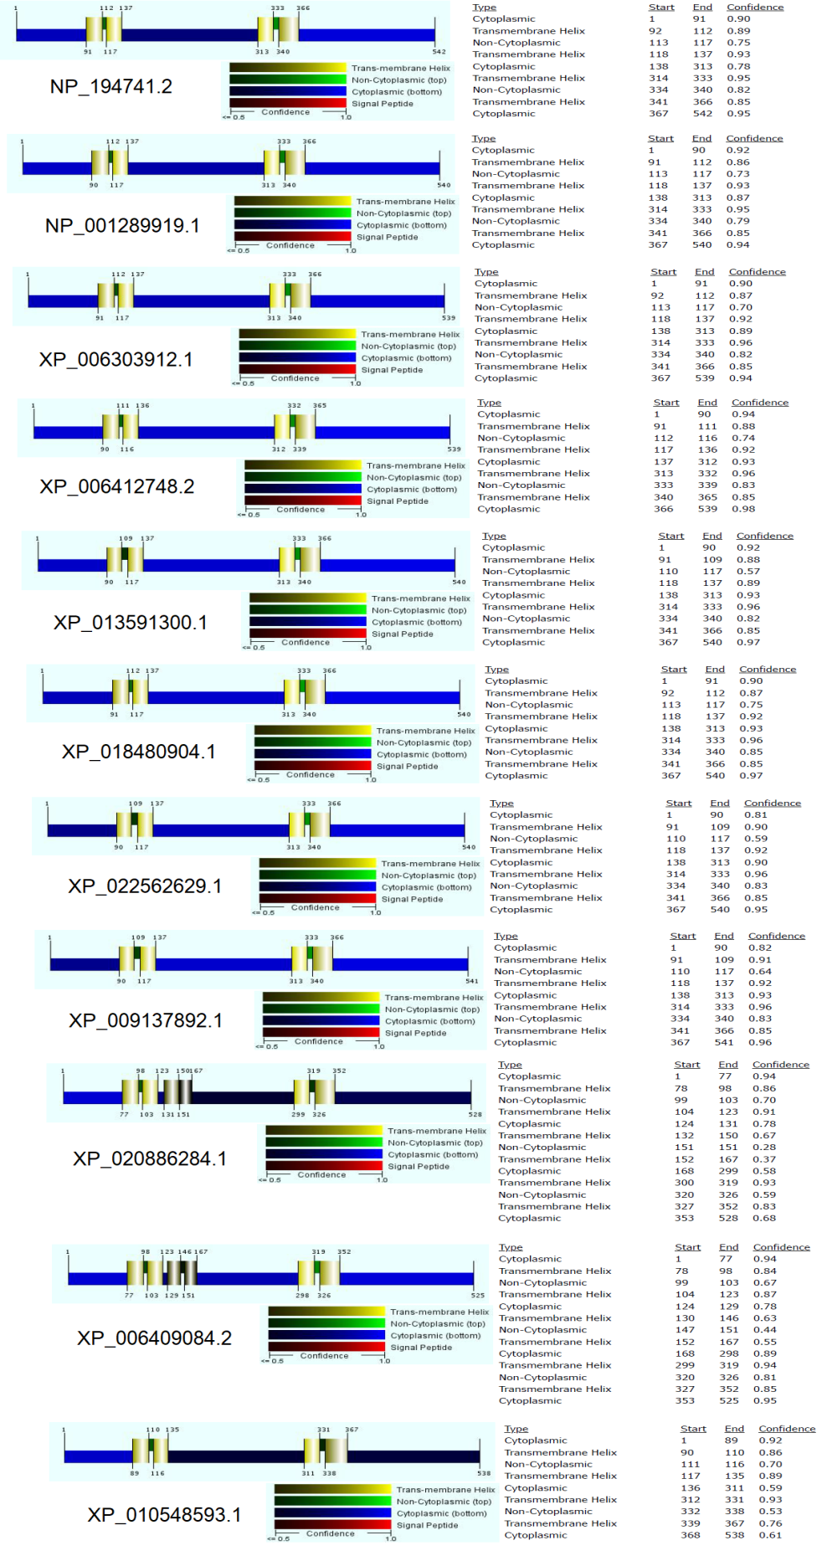

**Fig. S.1**. Prediction of transmembrane helix of HMA3 protein homologs.

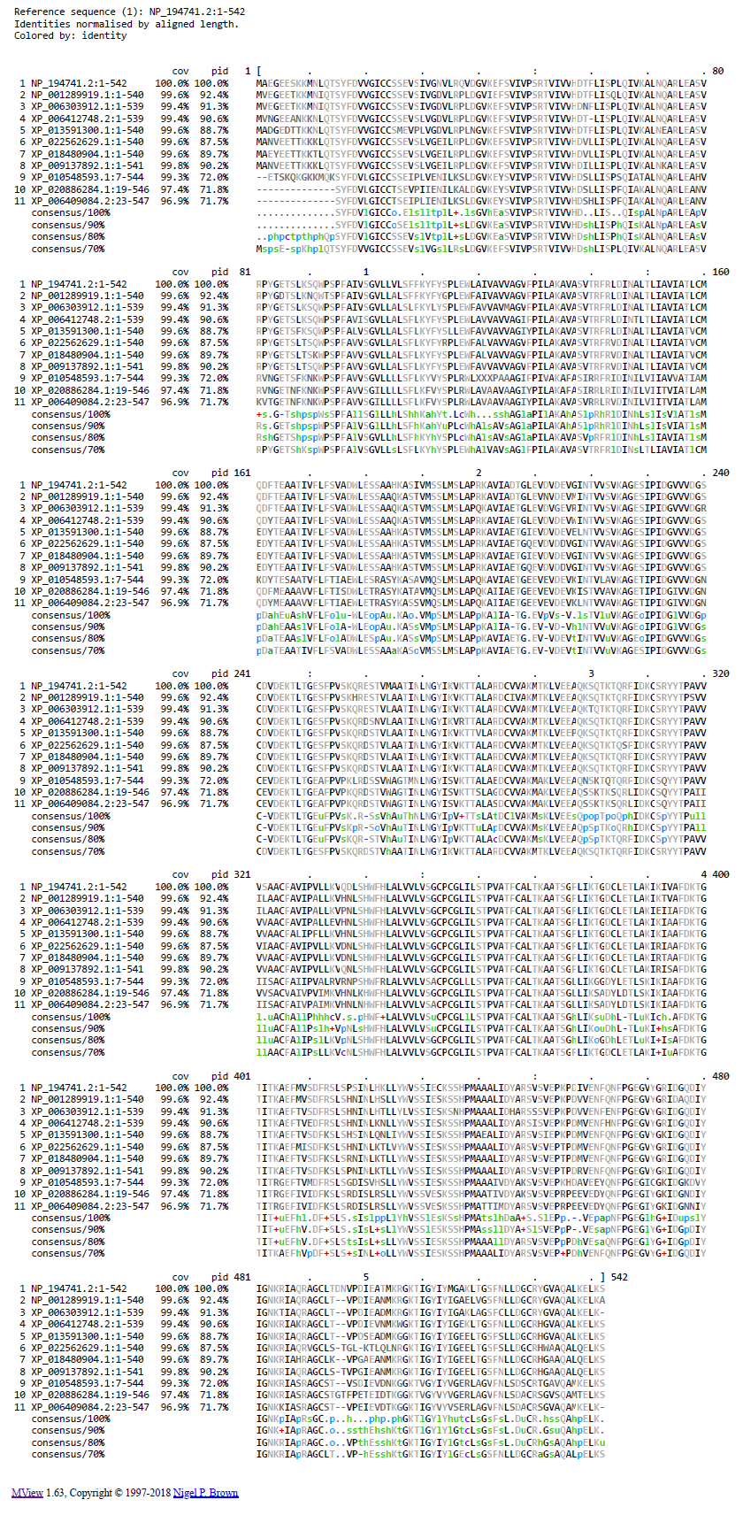

**Fig. S.2**. Multiple sequence alignment of HMA3protein homologs.