Supplementary Material

Article title: Responses of Enterococcus faecalis resistance, biofilm development, and quorum-sensing to nutrients in a constructed mesocosm

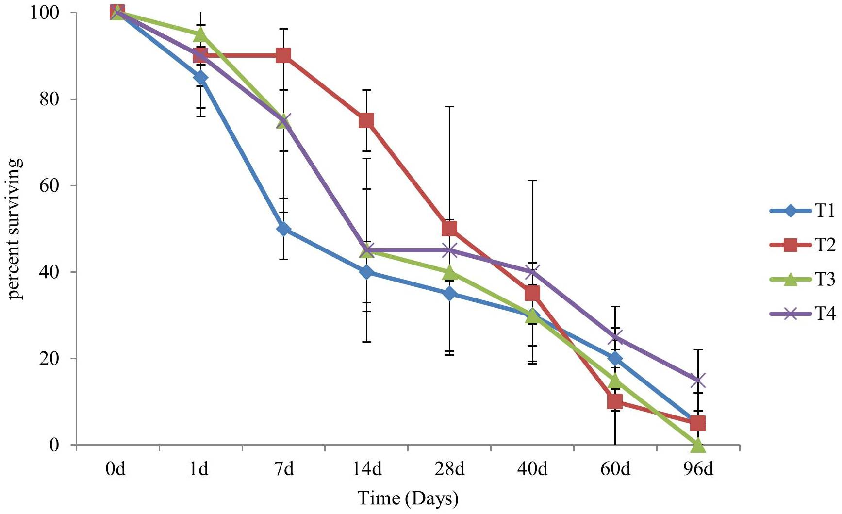

Figure S1. Survivorship of E. faecalis in the mesocosms experiments for the four treatments (T1, T2, T3 and T4), from August 31st (day 0) to December 5th (day 96), 2015

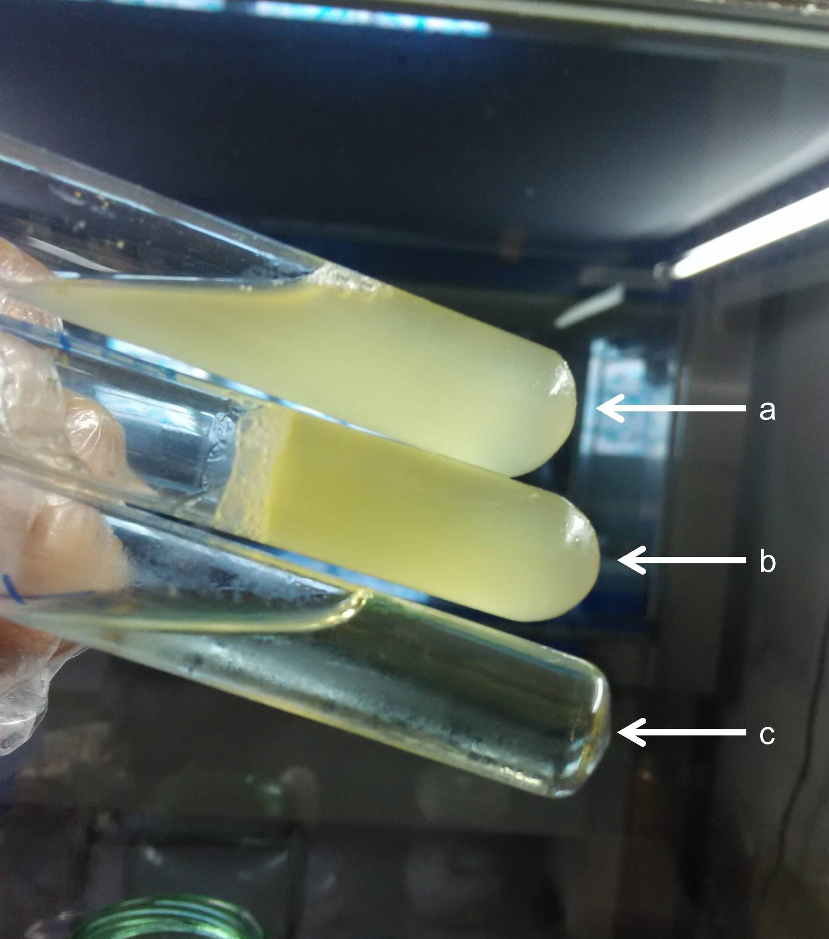

Figure S2. Hydrolysis of gelatin (a) gelatin positive: E. faecalis V583 strain as a gelatin positive control (b) gelatin negative: E. faecalis isolated from mesocosm (c) uncontaminated Mueller-Hinton broth.

Table S 1
PCR and quantitative real-time PCR (qPCR) primers used in this study.
Primers | Sequence (5ˊ-3ˊ) | Product Size (bp) | Amplification | References
16S rRNA-F  16S rRNA-R | CCGAGTGCTTGCACTCAATTGG  CTCTTATGCCATGCGGCATAAAC | 137 | PCR | [1]
cylL_{L}-F  cylL_{L}-R | CTGTTGCGGCGACAGCT  CCACCAACCCAGCCACAA | 52 | qPCR | [2]
cylL_{S}-F  cylL_{S}-R | GCTAAATAAGGAAAATCAAGAAAACTATTACTC  CAAAAGAAGGACCAACAAGTTCTAATT | 65 | qPCR | [2]
cylR1-F  cylR1-R | TTTATTTTTTTATTGGATATCATTTCTGTAGTC  TTCGCTCATCTTTTTTTGAATCAG | 96 | qPCR | [3]
cylR2-F  cylR2-R | CCAAAGTGAATTAGCTGCTTTATTAGAA  TTAATGCTAACTGTAAAGAAGGGTTATATTTATT | 95 | qPCR | [3]
cylM-F  cylM-R | TCGGACACGGTATATATAGCTATGT  GTTCTTCTTCAAAGTATGATTCTTTAAT | 108 | qPCR | [2]
cylB-F  cylB-R | GAAAAGATTGAAGTACGTTGCG  TTCTACTAGTGTACTTTGATTACCATAATAATT | 103 | qPCR | [2]
cylI-F  cylI-R | ACTTCTCGTAATCTTTACTCTTGTTTTTG  CTAAGTGCCCTAACTCATGTACAA | 101 | qPCR | [4]
gelE-F  gelE-R | GGAACAGACTGCCGGTTTAG  TTCTGGATTAGATGCACCCG | 103 | qPCR | [5]
23S rRNA -F  23S rRNA -R | CCTATCGGCCTCGGCTTAG  AGCGAAAGACAGGTGAGAATCC | 101 | qPCR | [3]

References:
[1] Sedgley CMM, Nagel ACC, Shelburne CEE, et al (2005) Quantitative real-time PCR detection of oral Enterococcus faecalis in humans. Arch Oral Biol 50:575-583. doi: 10.1016/j.archoralbio.2004.10.017
[2] Gilmore MS, Segarra RA, Booth MC, et al (1994) Genetic structure of the Enterococcus faecalis plasmid pAD1-encoded cytolytic toxin system and its relationship to lantibiotic determinants. J Bacteriol 176:7335-7344.
[3] Haas W, Shepard BD, Gilmore MS (2002) Two-component regulator of Enterococcus faecalis cytolysin responds to quorum-sensing autoinduction. Nature 415:84-87. doi: 10.1038/415084a
[4] Coburn PS, Hancock LE, Booth MC, Gilmore MS (1999) A novel means of self-protection, unrelated to toxin activation, confers immunity to the bactericidal effects of the Enterococcus faecalis cytolysin. Infect Immun 67:3339-3347.
[5] Lenz CA, Hew Ferstl CM, Vogel RF (2010) Sub-lethal stress effects on virulence gene expression in Enterococcus faecalis. Food Microbiol 27:317-326. doi: 10.1016/j.fm.2009.11.008
Table S 2 Physicochemical characteristics of four mesocosms from September 1st (day 1) to December 5th (day 96), 2015.
Time | TN |  |  |  |  | TP
 | T1 | T2 | T3 | T4 |  | T1 | T2 | T3 | T4
day | mg L⁻¹ N | mg L⁻¹ N | mg L⁻¹ N | mg L⁻¹ N |  | mg L⁻¹ P | mg L⁻¹ P | mg L⁻¹ P | mg L⁻¹ P
1d | 1.54 ± 0.35ª | 1.03 ± 0.11ª | 7.63 ± 1.19^{b} | 16.36 ± 1.02^{c} |  | 0.08 ± 0.07ª | 0.13 ± 0.02ª | 0.33 ± 0.16ª | 0.77 ± 0.16^{b}
7d | 1.53 ± 0.11 | 1.13 ± 0.16 | 5.22 ± 0.78 | 15.33 ± 1.66 |  | 0.03 ± 0.05 | 0.12 ± 0.01 | 0.23 ± 0.13 | 0.49 ± 0.17
14d | 1.63 ± 0.10 | 1.37 ± 0.06 | 3.68 ± 0.80 | 8.35 ± 1.06 |  | 0.03 ± 0.01 | 0.09 ± 0.02 | 0.07 ± 0.01 | 0.21 ± 0.13
28d | 1.39 ± 0.24 | 1.33 ± 0.11 | 2.84 ± 0.46 | 9.38 ± 0.88 |  | 0.03 ± 0.03 | 0.06 ± 0.02 | 0.07 ± 0.03 | 0.16 ± 0.14
40d | 1.64 ± 0.19 | 1.32 ± 0.10 | 2.63 ± 0.54 | 7.86 ± 1.49 |  | 0.04 ± 0.03 | 0.05 ± 0.01 | 0.05 ± 0.03 | 0.20 ± 0.22
60d | 1.47 ± 0.32 | 1.17 ± 0.11 | 3.22 ± 0.95 | 7.54 ± 1.17 |  | 0.01 ± 0.01 | 0.03 ± 0.02 | 0.04 ± 0.13 | 0.15 ± 0.17
96d | 1.60 ± 0.17 | 1.04 ± 0.14 | 2.78 ± 0.35 | 6.64 ± 1.16 |  | 0.01 ± 0.01 | 0.02 ± 0.03 | 0.04 ± 0.03 | 0.069 ± 0.04
Time | Conductivity |  |  |  |  | pH
 | T1 | T2 | T3 | T4 |  | T1 | T2 | T3 | T4
day | mS cm⁻¹ | mS cm⁻¹ | mS cm⁻¹ | mS cm⁻¹
1d | 7.43 ± 0.76ª | 10.43 ± 0.75^{b} | 11.67 ± 0.96^{b} | 12.27 ± 0.45^{b} |  | 7.07 ± 0.21ª | 7.1 ± 0.10^{b} | 7.07 ± 0.15^{b} | 7.1 ± 0.10^{b}
7d | 7.53 ± 0.84 | 10.5 ± 0.85 | 11.77 ± 1.05 | 12.47 ± 0.31 |  | 6.9 ± 0.20 | 7.27 ± 0.15 | 7.33 ± 0.15 | 7.1 ± 0.10
14d | 7.7 ± 0.87 | 11.27 ± 0.50 | 11.9 ± 0.87 | 12.73 ± 0.29 |  | 6.8 ± 0.10 | 7.63 ± 0.15 | 7.4 ± 0.10 | 7.2 ± 0.10
28d | 8.27 ± 1.01 | 12 ± 0.53 | 12.83 ± 0.51 | 13.37 ± 0.38 |  | 6.93 ± 0.15 | 7.57 ± 0.21 | 7.6 ± 0.10 | 7.43 ± 0.15
40d | 8.6 ± 1.13 | 12.67 ± 0.75 | 13.5 ± 1.25 | 14.6 ± 0.55 |  | 7.03 ± 0.21 | 7.8 ± 0.10 | 7.63 ± 0.15 | 7.9 ± 0.10
60d | 9.8 ± 0.36 | 13.47 ± 0.70 | 14.4 ± 0.89 | 15 ± 0.36 |  | 7.13 ± 0.25 | 8.1 ± 0.10 | 7.8 ± 0.10 | 7.97 ± 0.11
96d | 10.37 ±0.66 | 14.47 ± 0.71 | 16.7 ± 1.70 | 19.27 ± 1.01 |  | 7.17 ± 0.15 | 8.43 ± 0.05 | 8 ± 0.10 | 8 ± 0.10

Time | COD_{Mn} |  |  |  |  | SD |  |  |  |  | Temperature
 | T1 | T2 | T3 | T4 |  | T1 | T2 | T3 | T4
day | mg L⁻¹ | mg L⁻¹ | mg L⁻¹ | mg L⁻¹ |  | cm | cm | cm | cm |  | ºC
1d | 1.83 ± 0.58ª | 1.56 ± 0.17ª | 2.62 ± 0.52ª | 2.42 ± 1.25^{b} |  | 8.5 ± 0.10 | 8.37 ± 0.11 | 8.3 ± 0.10 | 8.47 ± 0.15 |  | 28.2
7d | 2.78 ± 1.47 | 3.33 ± 0.71 | 5.03 ± 1.78 | 6.09 ± 5.09 |  | 8.2 ± 0.10 | 7.9 ± 0.10 | 8.03 ± 0.15 | 8.17 ± 0.15 |  | 28
14d | 2.62 ± 1.34 | 3.78 ± 0.88 | 3.74 ± 1.18 | 9.45 ± 6.34 |  | 8 ± 0.10 | 7.73 ± 0.11 | 7.73 ± 0.15 | 7.83 ± 0.21 |  | 27.7
28d | 4.29 ± 1.38 | 5.08 ± 1.71 | 4.21 ± 0.22 | 7.83 ± 4.83 |  | 7.5 ± 0.10 | 7.36 ± 0.25 | 7.37 ± 0.15 | 7.47 ± 0.42 |  | 27
40d | 3.12 ± 1.02 | 3.47 ± 0.49 | 4.42 ± 1.09 | 8.29 ±4.88 |  | 7.1 ± 0.10 | 6.9 ± 0.10 | 6.9 ± 0.20 | 6.6 ± 0.36 |  | 23.3
60d | 3.41 ± 0.64 | 3.02 ± 0.24 | 4.38 ± 0.95 | 9.16 ±5.19 |  | 6.1 ± 0.10 | 5.97 ± 0.21 | 5.67 ± 0.25 | 5.57 ± 0.50 |  | 20.8
96d | 2.47 ± 1.24 | 2.76 ± 0.41 | 5.26 ± 1.32 | 11.28 ± 8.61 |  | 5.1 ± 0.10 | 4.77 ± 0.49 | 4.83 ± 0.31 | 4.13 ± 0.31 |  | 15.5
Table S 2 continued
Each value represents the average ± standard deviation except temperature.
T1 (without nutrient-enrichment), T2 (low-dose of N and P), T3 (mid-dose of N and P) and T4 (addition of nitrogen and phosphorus with high concentration) are four treatments.
Different superscript letters indicate significant differences between the treatments (p < 0.05) in Total Nitrogen (TN), Total Phosphorous (TP), (COD_{Mn)}, Conductivity, pH, and Secchi Depth (SD).

