Figure S1.1 Gray Francolin.

Figure S1.2 Common Quail. © Mahdi Sughayir 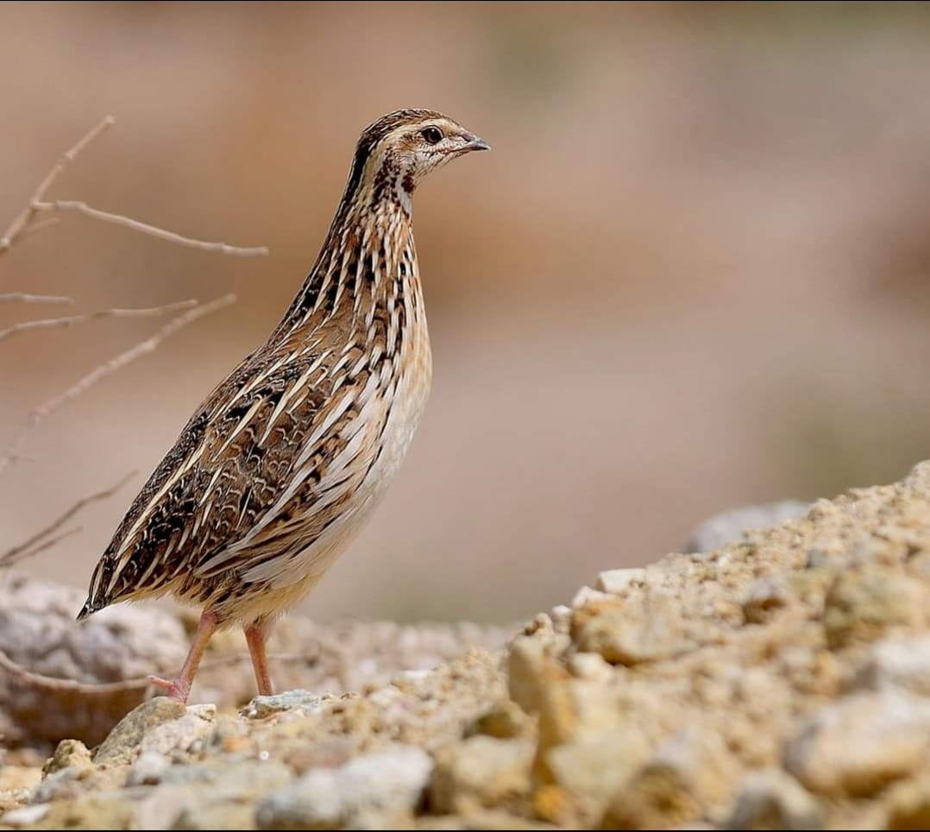

Figure S1.3 Black-winged Kite. © Faisal Hajwal 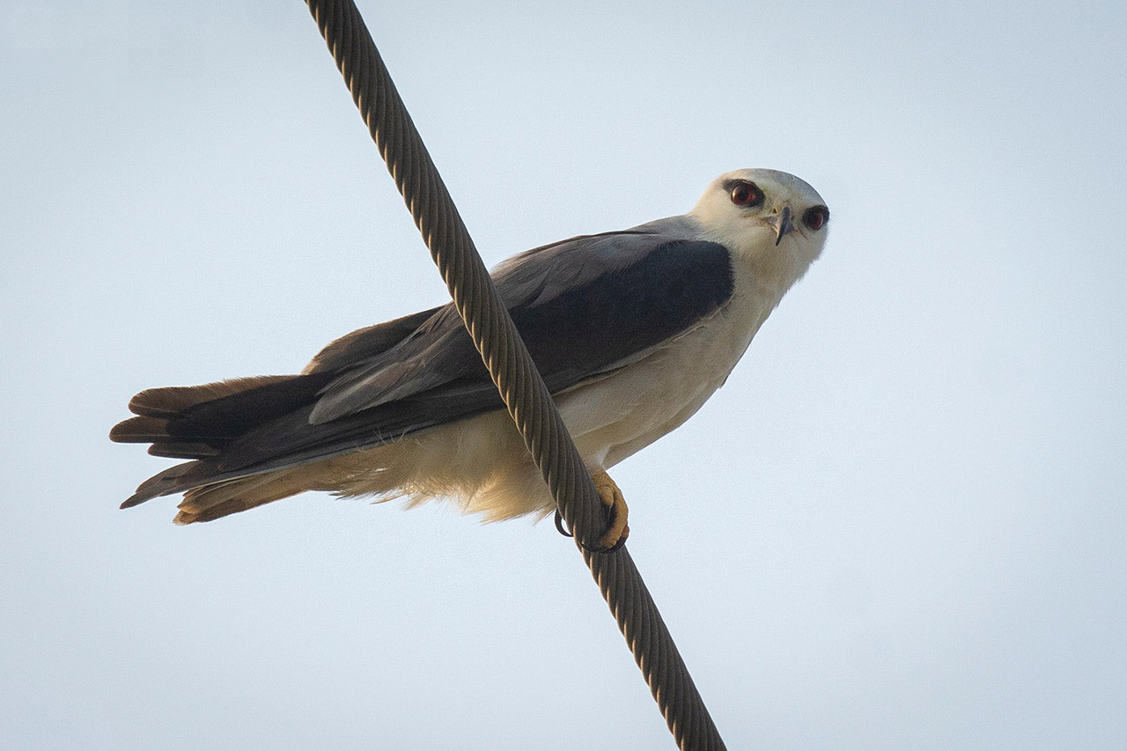

Figure S1.4 Eurasian Dove.

Figure S1.5 Laughing Dove. © Ali Alamrad

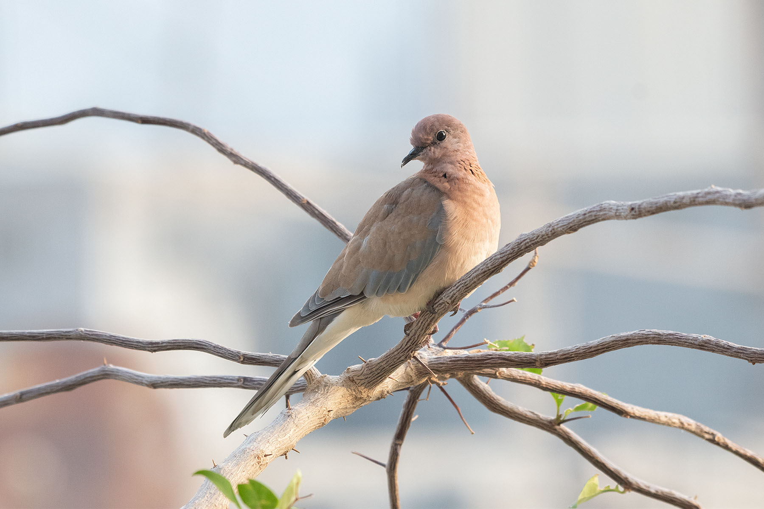

Figure S1.6 Namaqua.

Figure S1.7 Alexandrine Parakeet.

Figure S1.8 Rose-ringed Parakeet. © Atheer Ali 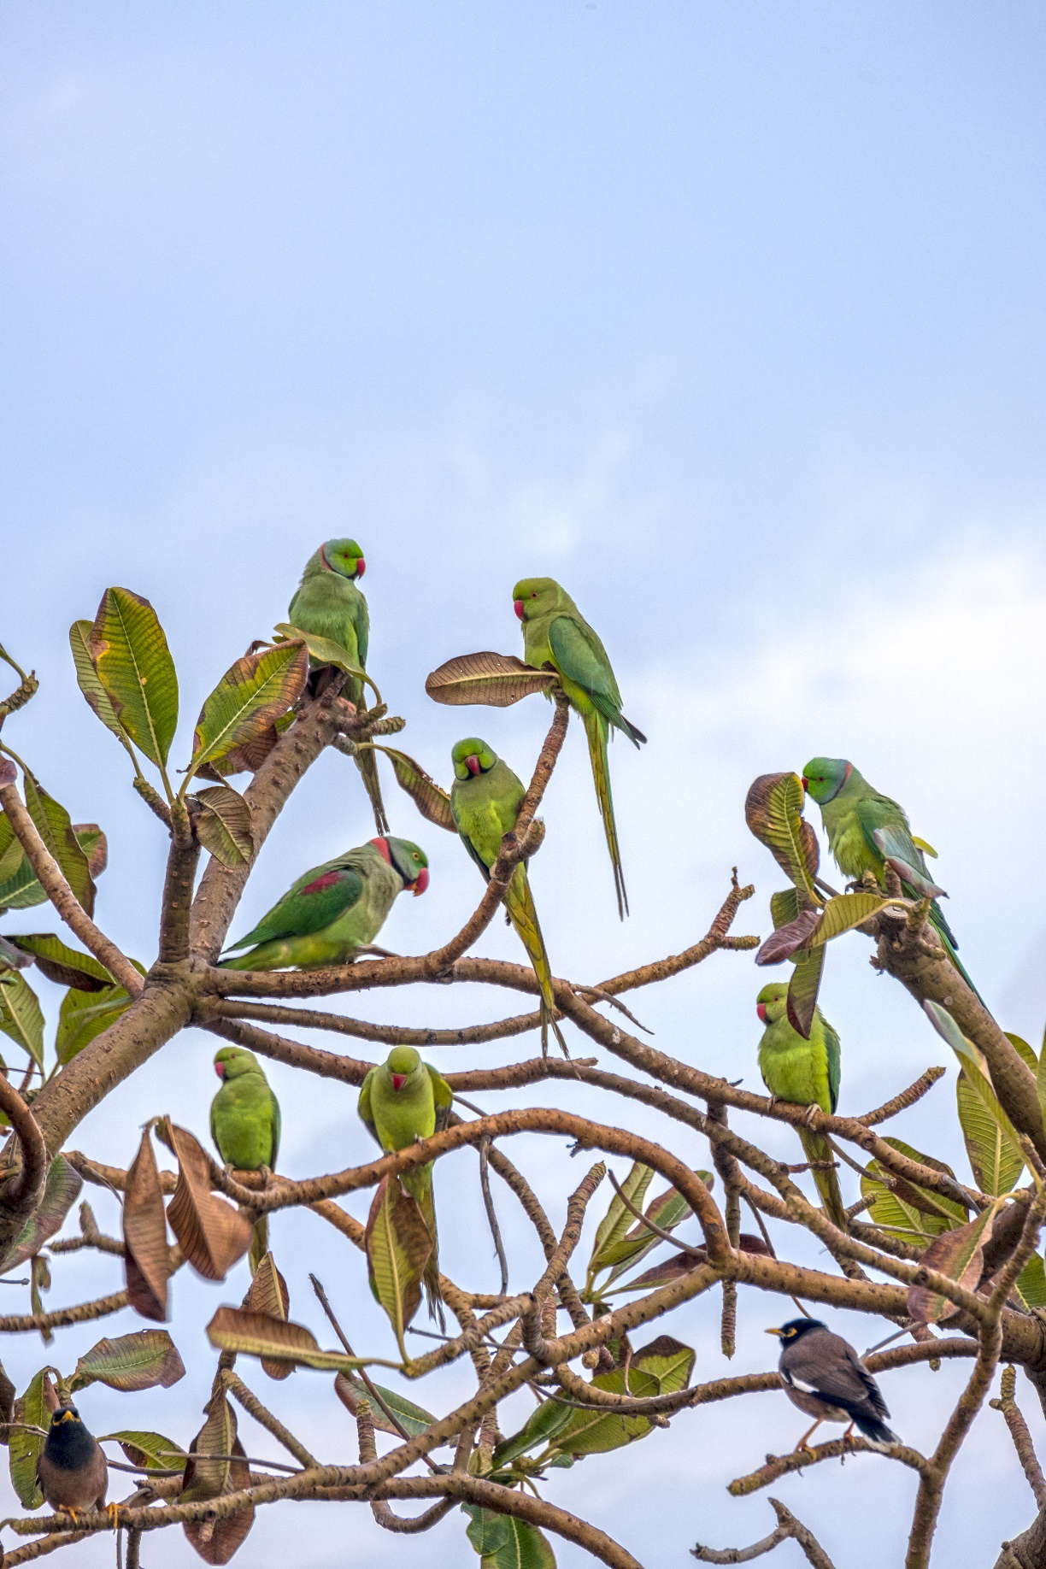

Figure S1.9 House Crow. © Ali Alamrad 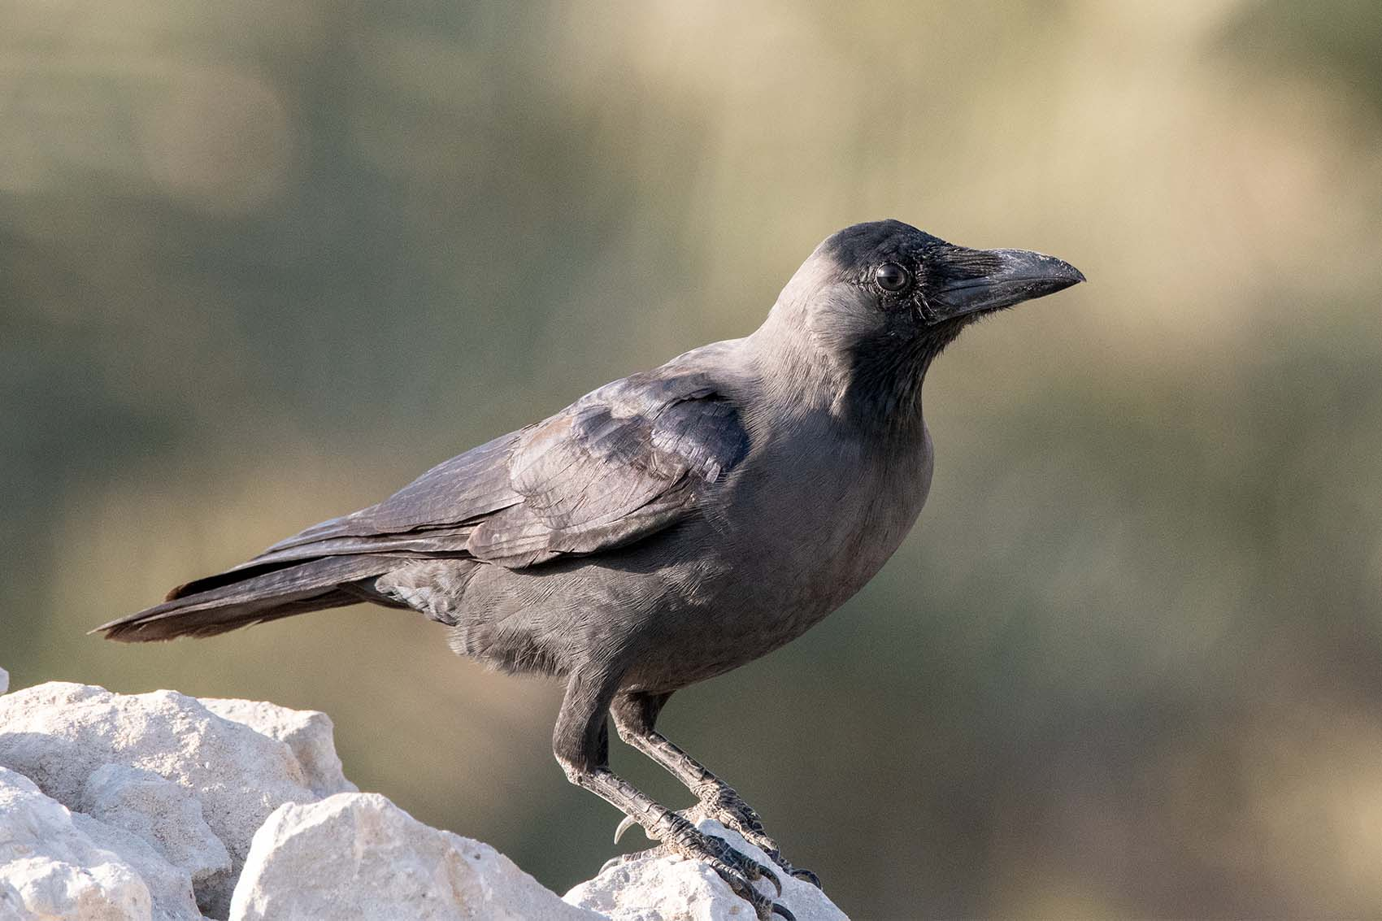

Figure S1.10 White Spectacled Bulbul.

Figure S1.11 White-eared Bulbul.

Figure S1.12 Red-vented Bulbul.

Figure S1.14 Common Myna. © Mohammed Alzayer 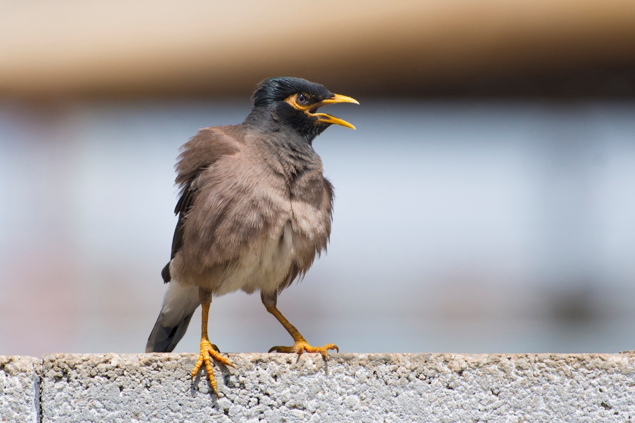

Figure S1.15 Arabian Golden Sparrow. ©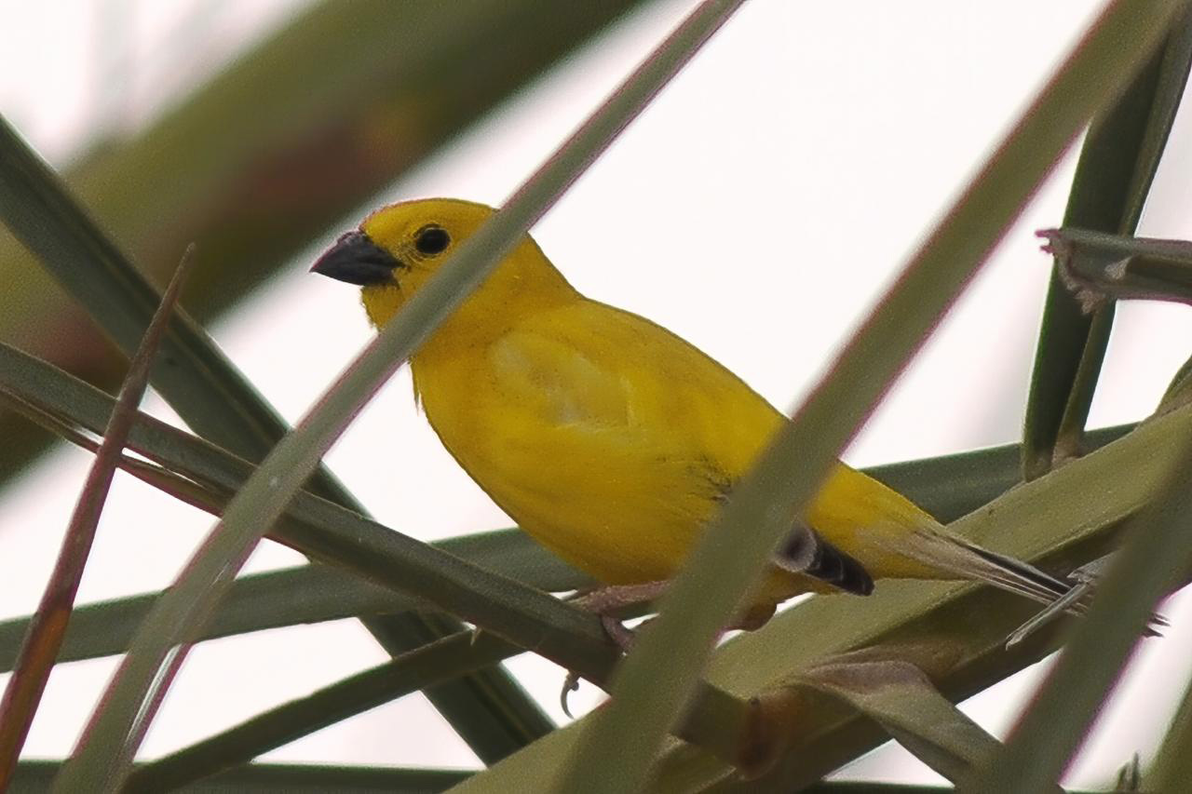

Figure S1.16 Ruppell’s Weaver.

Figure S1.17 Streaked Weaver.

Figure S1.18 Red Avadavat. © Hussain Salan 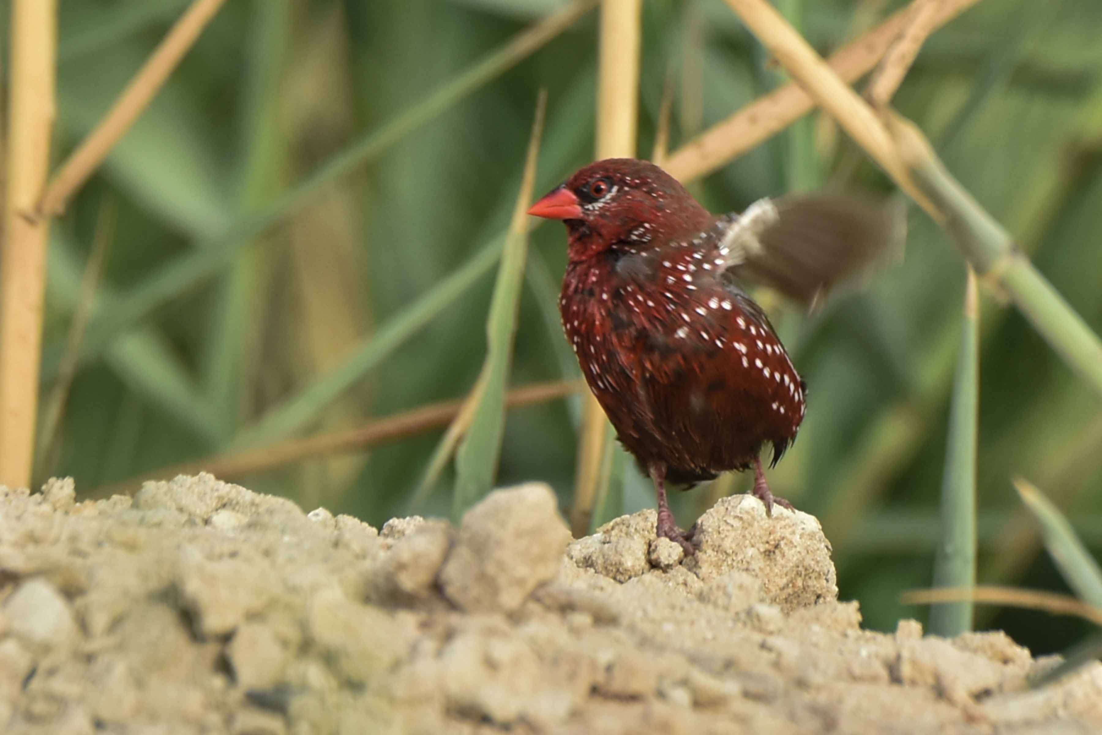

Figure S1.19 Indian Silverbill. © Ali Alamrad 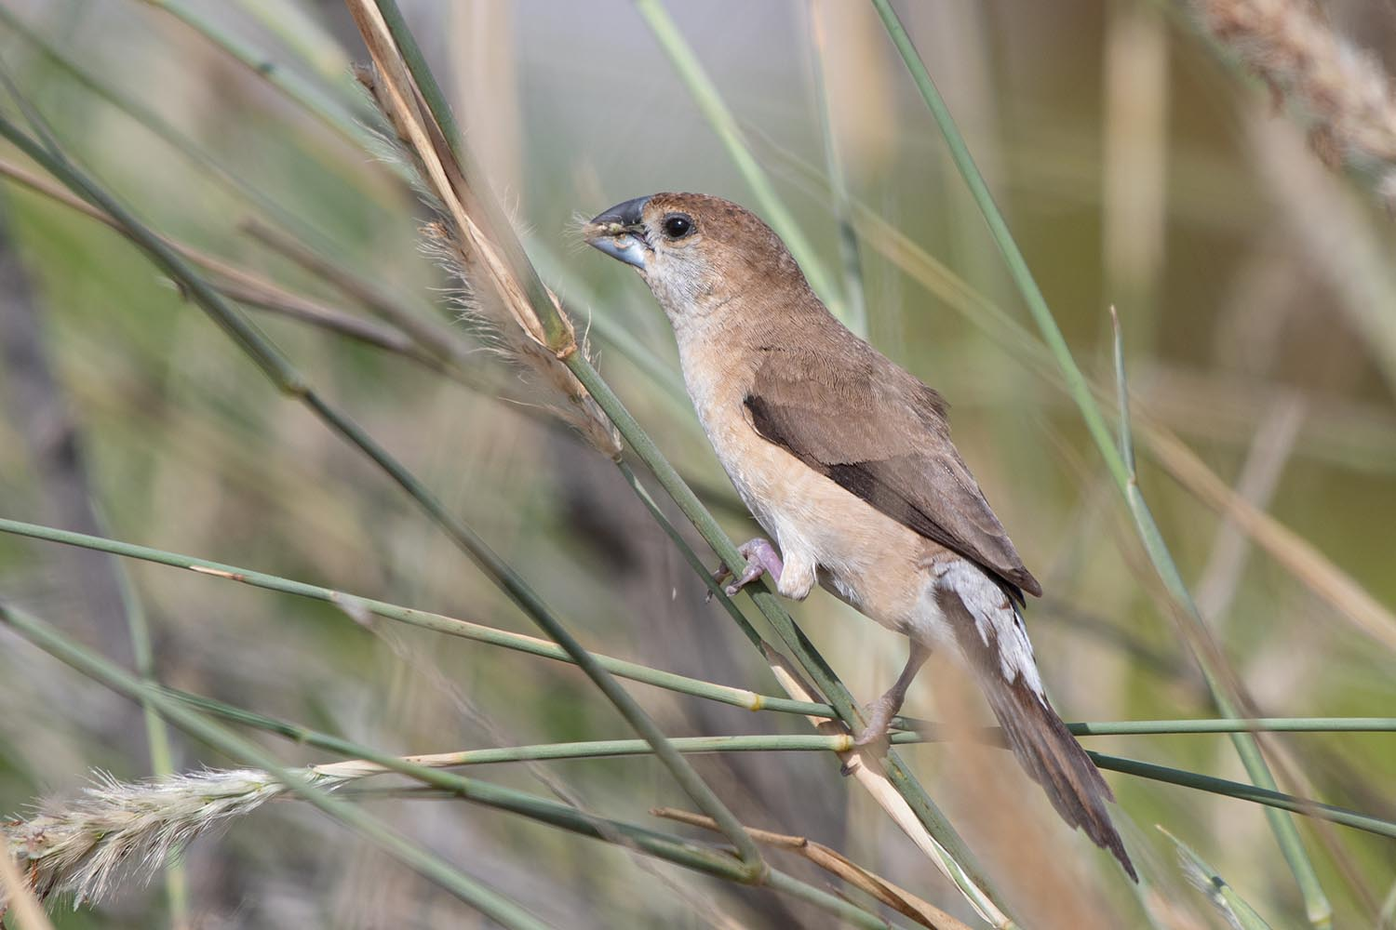

Figure S1.20 Desert Finch. Figure S1.21 Arabian Serin. © Faisal Hajwal