**E-Suppl. Table 1:** ApCDS sequence analysis representing various protein parameters

|  |  |
| --- | --- |
| **PARAMETERS** | **ApCDS** |
| Formula | C3049H4756N842O922S5 |
| Molecular weight | 68.120 kDa |
| Isoelectric point | 5.52 |
| Hydropathicity | ‐0.236 |
| Instability index | 39.47 |
| Aliphatic index | 90.05 |
| No of amino acid | 625 |



**E-Suppl. Fig. 1.** Nucleotide and deduced the amino acid structure of *A. platensis* cysteine desulfurase. Nucleotide structure is given in capital letters and correspondingly, the amino acids are given in small letters. The mRNA translate region (573-585) is highlighted in red color. Cysteine desulfurase like domain (243-616) is highlighted in yellow background, and aminotransferase class V (244-612) is underlined in black color. Letters highlighted in the blue color background showed Pyridoxal 5’-phosphate binding site and Magenta background highlights catalytic residue.

C:\Users\Admin\Desktop\Purabi\Bioinformatic.tif

**E-Suppl. Fig 2.** I: Multiple sequence analysis of *A. platensis* cysteine desulfurase sequences with other homologs from *Cucurbita maxima* (XP02298619)*, Helianthus* *annus* (XP022009056), *Coffea arabica* (XP027104619) and *Momordica charantia* (XP022153071).The conserved residues are highlighted in black background and semi-conserved residues in grey, whereas the variable residues are presented in multiple colors. The highly conserved antioxidant peptide region (GP13) is highlighted in a box. II: (A). The three-dimensional structure of *A. platensis* cysteine desulfurase highlights the peptides predicted by I-TASSAR model. The red spirals denote the helix region, green lines represent the coil region and yellow arrows denote the beta sheet. In addition, the cysteine desulfurase like domain (243-616) and aminotranferase class V (244-612) is highlighted in blue color. The active site (437) is highlighted in yellow color spheres; the brown spheres denote the chemical binding site (312-313,316,334,417,429-420,436-437). (B) Magenta color represents the predicted antioxidant peptide, GP13, and purple color represents the antioxidant amino acids. (C) Helical wheel projection of GP13 peptide showing the hydrophobic, hydrophilic, charged, and uncharged amino acids.



**E-Suppl. Fig. 3.** Phylogenetic analysis of *A. platensis* cysteine desulfurase with other homologous sequences constructed by the Neighbour-Joining Method. The tree is based on an alignment corresponding to the full length amino acid sequence using ClustalW and MEGA 6.0. Organisms with accession number *A. platensis* (WP00850878), *Synechoccus elongates* (WP126148299), *Microcystis aeroginosa* (WP043995527), *Klebsormidium nitens* (GAQ84435), *Gonium pectoral* (KXZ52773), *Chlamydomonas eustigma* (GAX85245), *Monoraphidium neglectum* (XP013904310) and *Osteococcus tauri* (OUS43901) highlighted in orange color box belongs to Algae. *Helianthus annus* (XP022009056), *Coffea arabica* (XP027104619), *Cucurbita maxima* (XP02298619), *Momordica charantia* (XP022153071), *Dendronium catenatum* (XP0207032013), *Selaginella* *moellendorffi* (XP00296636) and *Physcomitrella patens* (XP02463150) belongs to Plantae and highlighted in green color box. *Nitrosomonas oligotropha* (WP107804438), *Aquabacterium commune* (WP133605676), *Dyadobacter beijingensis* (WP106596544), *Azozarcus sp*. (WP136383070), *Azotobacter bejerinckii* (WP090733167) and *Sphaerotilus hippie* (PXW93400) were highlighted in bluecolor box, which belongs to Bacteria.

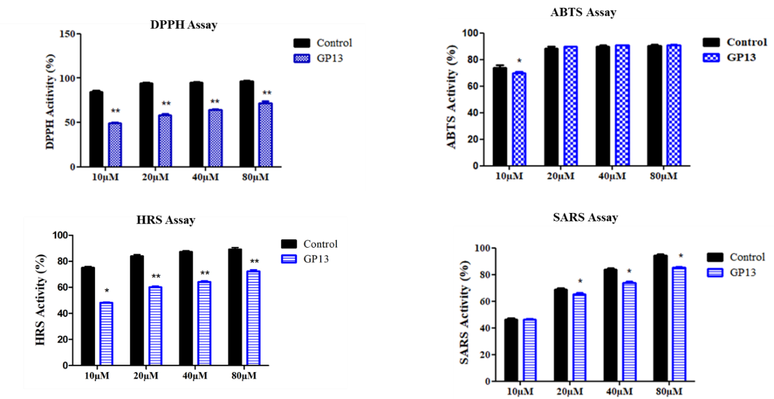

**E-Suppl. Fig. 4.** *In vitro* antioxidant activity of GP13. Radical scavenging ability of GP13 peptide compared with that of standard antioxidant control, Trolox. (A) 2,2-diphenyl-1-picryly hydrazyl assay on DPPH radical, (B) 2,2-Azino-Bis-3-Ethylbenzothiazoline-6-sulfonic acid assay on ABTS radical, (C) Hydroxyl radical scavenging assay on hydroxyl ions and (D) Superoxide anion radical scavenging assay on superoxide anion radical at different concentration of P13. Single asterisk (*) and double asterisks (**) denotes the significant difference between control (Trolox) and treatments (GP13) at *p < 0.05* and *p < 0.01* level one-way ANOVA followed by Bonferroni post-hoc test using Graph Pad Prism 5.0. All values were given in mean of three replicates ± SD.

C:\Users\Admin\Desktop\Purabi\ZEBRAFISH TOXICITY.tif

**E-Suppl. Fig. 5.** Effect of GP13 on survival and heart rate of zebrafish larvae. **(**A) Survival rate of 96 hpf zebrafish larvae treated with GP13 and (B) Effects of GP13 peptide on a heart rate of 72 hpf zebrafish larvae. Untreated treated larvae as control and H2O2 as a positive control. Values are shown in mean ± SD of three replicates. Asterisk (*) represents significance (P < 0.05) of peptide concentration compared with control analyzed using one-way ANOVA followed by Bonferroni post-hoc test on Graph Pad Prism 5.0.



**E-Suppl. Fig. 6.** *In vivo* antioxidant enzyme activity of GP13 in H2O2 stressed zebrafish larvae supernatant. (A) Superoxide dismutase activity, (B) Catalase activity, and (C) Lipid peroxidation assay. Values are shown in mean ± SD (n = 3). Untreated larvae as control and H2O2 as a positive control. Double asterisks (**) represent significance at *p < 0.01* and single asterisk (*) represents significance at *p < 0.05* between the peptide exposed and non-exposed by one-way ANOVA and Bonferroni post-hoc test in Graph Pad 5.0.