*Supplementary Information*

Multispectroscopic and molecular modeling strategy to explore the interaction of cholest-5-en-7-one with human serum albumin: DFT and Hirshfeld surface analysis: DFT and Hirshfeld surface analysis

**Mahboob Alam**

Division of Chemistry & Biotechnology, Dongguk University, 123 Dongdae-ro, Gyeongju, Republic of Korea

*Materials and Methods*

Before use, all glassware was dried. The chemicals and solvents used in this study were of analytical reagent (AR) grade and used without any extra purification process. Starting material; cholest-5-ene (1) was synthesized using a literature procedure [1]. Microanalytical data (C, H, and N) were collected using a Carlo Erba analyzer model 1108. The melting points were determined using a Kofler hot-stage apparatus and were uncorrected. The following instruments were used to collect spectroscopic data: Fourier transform infrared spectra (KBr discs, 4000-400 cm-1) from a Shimadzu IR-408 Perkin-Elmer 1800 instrument; UV-Vis spectrum from Perkin Elmer spectrophotometer; High-resolution ESI mass spectra from a Bruker Daltonics McriOTOF II mass spectrometer; 1H NMR and 13C NMR spectra from a Bruker Avance-II 400 MHz instrument (400 MHz for 1H and 100 MHZ for 13C NMR) using CDCl3 as the solvent and TMS as the internal standard. Chemical shift (δ) was measured in parts per million (ppm). Human serum albumin (HSA) was obtained from Sigma-Aldrich (Sigma-Aldrich). It was stored in the refrigerator after being dissolved in phosphate buffer saline (PBS, pH 7.4). The UV–vis absorption spectra of HSA was used to calculate its concentration. Throughout the experiments, ultrapure water with a resistivity of MΩ cm was employed.

*UV–vis absorption titration*

At 298 K, the UV-vis absorption spectra of HSA were recorded alone and in the presence of increasing concentrations of cholest-5-en-7-one with Perkin-Elmer-Lambda double beam UV-Vis spectrophotometer associated to Peltier temperature programmer (PTP-1) using quartz cuvette of path length 1 cm. Concentration of HSA was kept constant at 5 µM and titrated with increasing concentrations of cholest-5-en-7-one in a 20 mM sodium phosphate buffer with a pH of 7.4. Appropriate values for negative controls are subtracted from HSA- cholest-5-en-7-one to eliminate sample absorbance

*Fluorescence quenching Measurement*

A Shimadzu fluorescence spectrophotometer model RF-5301 with a quartz cuvette with a 1 cm path length was used to measure fluorescence. The intrinsic fluorescence of HSA was measured at 295 nm and the emission spectra were collected in the 300-400 nm range. Both excitation and emission slit widths were set to 5 nm. The Stern-Volmer equation (1) was used to further investigate the fluorescence quenching experiment as shown below [2-4].

F0/F=Ksv [Q] +1=kqτ0 [Q] +1 (1)

Where Ksv is the Stern-Volmer quenching constant, [Q] is the quencher's molar concentration, and kq and τ0 are the bimolecular rate constant are for the quenching reaction and average integral fluorescence lifetime of fluorophore tryptophan equivalent to 5.7×10-9 s, respectively. By assessing fluorescence quenching data with equation 2 and free energy change (ΔG0) of the process with equation 3, a quantitative evaluation of binding constant (Kb) and number of binding sites (n) for interaction of HSA samples was examined.

Log (F0/F-1) = log Kb+ n log [Q] (2)

Where F0 and F signify fluorescence intensities in the absence and presence of quencher (sample), Kb denotes the binding constant, and *n* the number of binding sites, respectively.

∆G 0= -RTlnKb (3)

Where ΔG° is the change in free energy, Kb is the bonding constant at temperature T, R is the universal gas constant (1.987 cal mol-1K-1) and T is the absolute temperature (K).

*Synchronous Fluorescence Spectroscopy*

The conformational alteration around the tyrosine and tryptophan residues of HSA can be noticed when the wavelength interval (Δλ) was set at 15 and 60 nm, respectively, in synchronous fluorescence spectroscopy spectra of sample- HSA in various simultaneously scanning periods of Δλ (Δλ=Δλex-Δλem) referred the excitation and emission monochromators [5]. For tyrosine, the excitation wavelength was set to 240 nm, and emission spectra were recorded in the 255-400 nm range. Similarly, the excitation wavelength for tryptophan was adjusted at 240 nm, with an emission wavelength range of 300-400 nm. The HSA concentration was kept constant at 5 M, while the compound concentration ranged from 5 μM to 30 and 50 μM**.**

*Circular dichroism spectra*

Circular dichroism (CD) spectra of HSA and of combined HSA-sample complex was recorded at 25 °C using a quartz cell with a path length of 0.1 cm on a JASCO-J 813 Spectropolarimeter equipped with a Peltier-type temperature controller. CD can be used as a complement to fluorescence and UV-Vis spectroscopy to confirm the results. Each spectrum averaged three sweeps and was performed in the far-UV CD region of 190–260 nm. The concentration of HSA was 5 μM, while the concentration of cholest-5-ene-7-one was 50 μM. All CD spectra were adjusted by comparing them to blank solutions and plotting the corrected spectra.

*Dynamic light scattering (DLS)*

DynaProTC-04 dynamic light scattering equipment with a temperature controlled micro-sampler was used to make Dynamic light scattering (DLS) measurements at 830 nm. HSA (2 mg mL-1) was incubated with cholest-5-ene-7-one in the protein to drug molar ratio of 1:0 and 1:10 for 8 h. The HSA and HSA-steroid were whirled at 10,000 rpm for 10 min before being filtered through 0.22 and 0.02 mM Whatman syringe filters directly into a 12 mL quartz cuvette. Twenty measurements were taken for each experiment. Dynamic software was used to study average hydrodynamic radius (Rh) and polydispersity at optimal resolution. The Rh was calculated using an autocorrelation analysis of scattered light intensity data based on the translational diffusion coefficient by Stokes-Einstein equation 4 [6].

$$R_{h}=\frac{kT}{6πηD} (4)$$

Where Rh, K, T, η, and D represent the hydrodynamic radius, Boltzmann constant, temperature, water viscosity, and diffusion coefficient, respectively.

*Statistical Analysis*

The mean and standard deviation (SD) values were shown, with n = the number of separate experiments.

*Molecular docking*

The crystallographic information (cif) of the cholest-5-and-7-one reported elsewhere [12], was used as a ligand for docking setup. The 3D- crystal structure of human serum albumin (HSA) (PDB ID: 1H9Z) was utilized as a receptor (protein) for molecular docking simulations. Multiple active HSA sites were identified [7], resulting in the construction of three separate docking grid boxes with grid spacing of 0.375 and 60*60 *60 points in three binding sites, with centers set at coordinates x = 30.025, y = 9.580, z = 10.295 for binding site I, x = 12.005, y = 8.737, z = 20.079 for binding site II, and x = 33.049, y = 18.888, z = 35.8 for binding site III. The lowest energy structure docked at active sites was selected when the docking calculations were completed, and the Discovery studio and LigPlus+ were used to render the output and analyze the hydrogen bonds and nonbonding interactions between receptor and cholest-5-ene-7-one.

*Molecular Dynamics Simulation*

An orthorhombic simulation box with boundaries at least 10 Å away from the protein was created in the system builder. The TIP3P explicit solvent model was used to neutralize the system, and proper counter-ions were added. Before beginning the simulation, the entire system was energy-minimized with the OPLS3e forcefield until it converged to 1 kcal/mol/Å. A Nose-Hoover Chain thermostat [8] (Brańka 2000) and a Martyna–Tobias–Klein barostat [9] were used to keep the temperature and pressure constant. The MD simulation results were saved and recorded with a time step of 2 fs and every 10 ps and analyzed with MAESTRO (Maestro, Schrödinger, LLC, New York, NY, USA).

*Computational details*

The optimized structure was identified at true minima at the potential energy level, as confirmed by real values of frequencies derived at the same level of theory. At the same theory level, FMOs (HOMO and LUMO) and associated energy values, MEP, thermodynamic parameters, dipole moment, and polarization of cholest-5-ene-7-one were obtained. The best docking posture obtained from molecular docking findings was used to calculate the geometry-minimized protein-ligand complex in ONIOM using the hybrid QM/MM approach provided in Gaussian [10]. The QM part includes cholest-5-ene-7-one and crucial binding site amino acids, whereas the rest of the component was designated as the molecular mechanics (MM) region with Universal Force Field. The ligand and binding site residues were allowed to move during geometry optimization, while the rest of the system was frozen. There was no tautomer/species conversion during the geometry optimization operation. To determine weak intermolecular interactions in the crystal, CrystalExplorer 21.5 [11] was used to compute Hirshfeld surfaces and two-dimensional fingerprint plots over the crystal structure of cholest-5-ene-7-one (2) (Scheme 1 in main text).

*Chemical shift and UV-Vis spectrum of steroid*

1HNMR (CDCl3, 300 MHz); δ: δ 5.9 (s, 1H, C6-H), 1.1 (s, 3H, C10-Me), 0.67 (s, 3H, C13-Me), 0.91 and 0.88 ppm for others steroidal side chain methyls; 13C NMR (CDCl3, 100 MHz): δ 193.7 (C7), 142.3 (C5), 123.3 (C6), 55.9 (C14), 54.1 (C9), 40.5 (C17), 40.3 (C13), 40.1 (C24), 39.7 (C10), 37.6 (C1), 36.3 (C22), 35.8 (C8), 34.9 (C4), 32.1 (C12), 30.7 (C3), 28.3 (C20), 28.0 (C2), 22.9 (C25), 22.7 (C23), 21.5 (C15), 21.3 (C16), 20.8 (C26), 20.7 (C27), 20.5 (C11), 18.7 (C21), 17.3 (C19), 11.9 (C18).

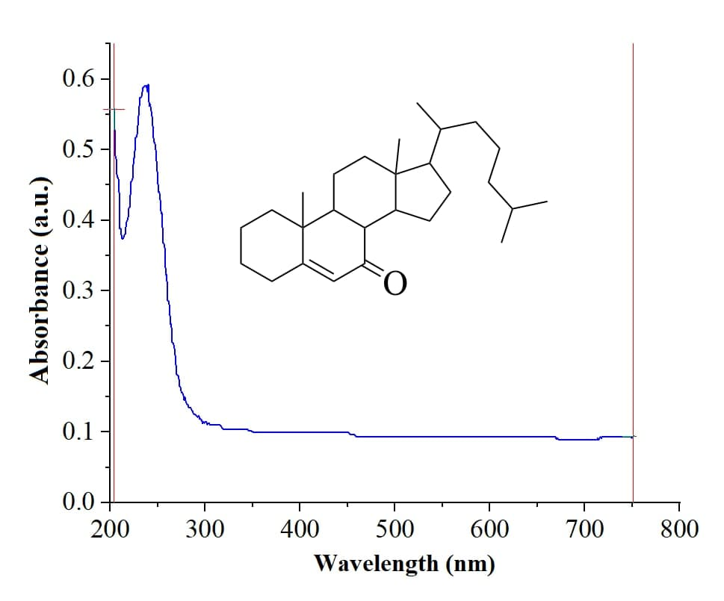

**Figure S1**: UV-Vis spectrum of cholest-5-en-7-one

*Molecular geometry of the synthesized* cholest-5-ene-7-one

The optimized steroid has a dipole moment of 4.0 Debye and an energy of -709651.85 kcal/mol.The molecule was also optimized in the solution phase to determine the energy difference between the vacuum and solvent phases. The optimized energy computed in the solvent phase (-709656.15 kcal/mol) by continuum models and in vacuum has no noticeable difference. As a result, the entire calculation was carried out in the gaseous phase. Table S1 compares the XRD findings with structural parameters like as bond lengths, bond angles, and dihedral angles of steroid. There is a variation of less than 0.03Å in most values between calculated and experimental bond lengths, except for the length of the C-H bond, which has not been adequately defined by XRD data. The majority of the predicted bond lengths are close to those obtained from X-ray diffraction data (**Figure 1b** in main text). Theoretical bond angles of steroid (2) are found to be close to observed bond angles within a 2° variation. In the case of steroid dihedral angles (2), as shown in **Table S1** (supplementary information), there are slightly more variations between some calculated and experimental dihedral angles, such as 25.7**°** for O1C27C28C30 (XRD value **∼**19.8**°**)**,** 7.8**°** for H26C25C27O1 (XRD value **∼**4.7**°**), -175.3**°** for C24C25C27O1 (XRD value **∼**-172.6**°)** and -155.1**°** for C3C2C38C35 (XRD -**∼**151.2**°**). In general, the inclusion of an oxygen atom in the calculation of dihedral angles causes some additional divergence from the respective bond angles. However, predicted dihedral angles differed considerably from experimental data due to the presence of intermolecular interactions in crystal, some steroidal skeleton values, particularly the side chain, varied noticeably from experimental results. In general, the optimization is performed in a vacuum, and the dihedral angles are relatively flexible. All bonds and bond angles, on the other hand, would be highly constrained in the crystal structures. Furthermore, the divergence from normal parameter values may be attributed to the fact that theoretical calculations are performed for an isolated molecule in gas phase, whereas experimental data are for the solid state. Intermolecular forces, crystal stacking forces, and other types of supramolecular interactions significantly regulate the structure of molecules in solid state. Despite this, the computationally determined structural parameters of the current molecule are found to be quite close to those stated in previous papers.

**Table S1**. Important parameters of the optimized structure compared to XRD data parameters of **2** (Scheme 1, main text)

|  |  |  |  |  |  |  |  |  |
| --- | --- | --- | --- | --- | --- | --- | --- | --- |
| **Bonds (Å)** | **Expt.a** | **DFT\*** | **Angles (°)** | **Expt.a** | **DFT\*** | **Dihedral angles (°)** | **Expt.a** | **DFT\*** |
| C27O1 | 1.21 | 1.22 | C3C2C30 | 106.4 | 107.0 | C38C2C3H4 | -63.9 | -63.0 |
| C25C27 | 1.46 | 1.47 | C3C2C38 | 116.0 | 116.4 | C38C2C3H5 | 178.5 | 179.5 |
| C24C25 | 1.34 | 1.34 | C3C2C61 | 1111. | 110.5 | C30C2C3C6 | 57.4 | 57.8 |
| C11C24 | 1.52 | 1.52 | C30C2C38 | 100.3 | 99.8 | C38C2C3C6 | 168.2 | 168.4 |
| C11C65 | 1.54 | 1.55 | C30C2C61 | 111.1 | 112.3 | C61C2C3C6 | -64.7 | -64.8 |
| C25H26 | 0.93 | 1.09 | C38C2C61 | 109.2 | 110.2 | C3C2C30C28 | -61.6 | -59.1 |
| C21H23 | 0.97 | 1.09 | C2C2H4 | 109.2 | 108.7 | C3C2C30C32 | 166.2 | 168.8 |
| C21H22 | 0.97 | 1. 09 | C2C3C6 | 111.9 | 111.6 | C38C2C30H31 | 177.1 | 179.1 |
| C27C28 | 1.53 | 1.53 | H4C3H5 | 107.9 | 106.5 | C38C2C30C32 | 44.9 | 47.1 |
| C28H29 | 0.98 | 1.09 | C11C9C28 | 113.3 | 112.8 | C51C2C30C28 | 60.0 | 62.4 |
| C28C9 | 1.55 | 1.55 | C9C11C12 | 108.0 | 108.5 | C51C2C30C32 | -72.2 | -69.6 |
| C9H10 | 0.98 | 1.09 | C9C11C24 | 110.0 | 109.8 | C3C2C38C35 | -151.2 | -155.1 |
| C11C12 | 1.55 | 1.56 | C24C11C12 | 107.6 | 108.8 | C3C2C38H39 | -38.7 | -41.6 |
| C12H13 | 0.97 | 1.09 | C11C12C15 | 114.4 | 115.1 | C3C2C38C40 | 83.6 | 79.4 |
| C12C15 | 1.53 | 1.53 | C12C15C18 | 109.9 | 110.9 | C30C2C38C35 | -38.0 | -40.4 |
| C15C18 | 1.53 | 1.53 | C18C21C24 | 112.7 | 112.7 | C30C2C38C40 | -165.2 | -165.8 |
| C2C51 | 1.53 | 1.55 | H23C21C24 | 109.1 | 109.3 | C51C2C38C35 | 80.3 | 77.9 |
| C51H54 | 0.96 | 1.09 | C5C10C9 | 117.0 | 117.5 | C51C2C38H39 | -166.2 | -168.5 |
| C2C30 | 1.53 | 1.56 | C11C24C25 | 122.7 | 122.4 | C51C2C38C40 | -44.0 | -47.4 |
| C30H31 | 0.98 | 1.10 | C30C32C35 | 103.8 | 103.7 | C3C2C51H52 | -55.3 | -56.4 |
| C30C32 | 1.53 | 1.54 | C32C35C38 | 107.5 | 107.3 | C6C9C11C24 | -173.8 | -177.0 |
| C32H33 | 0.97 | 1.09 | C2C38C35 | 103.9 | 103.0 | C6C9C11C12 | 67.4 | 64.0 |
| C32C35 | 1.54 | 1.55 | C2C38C40 | 119.3 | 119.3 | C6C9C11C65 | -54.2 | -56.9 |
| C35C38 | 1.55 | 1.56 | C38C40C42 | 111.7 | 113.9 | C12C11C9C28 | -165.4 | -166.5 |
| C38H39 | 0.98 | 1.09 | C38C40C69 | 114.0 | 114.0 | C28C9C11C24 | -46.7 | -47.6 |
| C38C40 | 1.54 | 1.55 | C42C40C69 | 110.3 | 110.0 | C24C25C27O1 | -175.3 | -172.6 |
| C40H41 | 0.98 | 1.10 | C53C51C57 | 109.7 | 111.0 | H26C25C27O1 | 4.7 | 7.8 |
| C40C69 | 1.52 | 1.54 | H52C51C53 | 107.5 | 106.9 | O1C27C28C4 | 147.9 | 143.5 |
| C40C42 | 1.54 | 1.55 | C48C51C57 | 112.6 | 112.6 | O1C27C28C30 | 19.8 | 25.7 |
| C51C57 | 1.50 | 1.54 | C44C48C51 | 115.2 | 116.0 | C53C51C57H60 | 177.9 | 179.0 |
| C51H52 | 0.97 | 1.09 | O1C27C28 | 123.0 | 123.4 | C42C45C48C51 | 179.7 | -174.5 |

*Numbering scheme is taken from figure1 (a); a Ref [12]

**Table S2**. Calculated quantum chemical parameters of 2 using DFT/B3LYP /6-311G (d, p) method in the gas phase.

|  |  |
| --- | --- |
| Parameters (eV) | B3LYP/6-311G(d, p) |
| EHOMO | -6.80 |
| ELUMO | -0.86 |
| Eg (ELUMO - EHOMO) | 5.94 |
| Ionization potential | 6.80 |
| Electron affinity | 0.86 |
| Electronegativity | 3.83 |
| Chemical potential | -3.83 |
| Chemical hardness | 2.97 |
| Chemical softness | 0.33 |
| Electrophilicity index | 2.46 |

*Frontier molecular orbital and Molecular electrostatic potential (MEP)Analysis*

#### According to Pauli's antisymmetric principle, Molecular eigenfunctions (LCAO-MO) with the maximal eigenvalue possessed by a pair/one electron (s) in a molecule and the direct empty virtual, known as HOMO (highest molecular orbital occupied) and LUMO (lowest unoccupied molecular orbital), respectively, are called FMOs combinedly [13]. Frontier molecular orbitals (FMOs) play an essential role in chemical reactivity, molecular electronics, charge transfer, photo-excitation, and magnetism. Their features are mostly connected to changes in ground state electronic structure and bandgap (ΔEg). HOMO-LUMO analysis was effectively used to demonstrate the influence of intramolecular charge transfer (ICT) in living organisms involving multiple electrochemical reactions.

The molecular electrostatic potential (MEP) map derived using the B3LYP/6–311G(d,p) basis set was used to study the preferred nucleophilic and electrophilic attack modes of the molecule. In the study of biological recognition processes and hydrogen bonding interactions, the MEP map is highly beneficial for qualitative interpretation of electrophilic and nucleophilic reactions. The result of MEP derived using the same level theory as used in compound optimization was displayed using ArgusLab, as shown in the figure 2b. Different shades depict different electrostatic potential values, with red being the most negative electrostatic potential and white representing the most positive electrostatic potential. Negative and positive electrostatic potential (MEP) zones are related with electrophilic and nucleophilic reactivity, respectively, and correspond to the attraction of the proton by the evaluated electron density in the molecule and the repulsion of the protons by the atomic nuclei. As can be observed in the figure 2b, the negative regions represented by red color are primarily over the oxygen of the carbonyl system of compound (2) which can also involve in the formation of a hydrogen bond with the receptor as shown in docking as well as QM/MM in the section molecular docking and QM/MM analysis. The presence of active sites was found to provide convincing evidence of biological activity in the steroid molecule (2) participating in the receptor-drug complex. In the 2D contour map of cholest-5-ene-7-one visualized by and GaussView, the red color lines represent highly reactive sites, while the yellow color lines represent less reactive sites, and the dark red lines surrounding the oxygen atom have a negative potential, while the light green color is scattered in a positive potential region depending on the contour representation of the ESP at B3LYP/6–311G(d,p) level theory.

*Molecular Hirshfeld surfaces analysis*

Generally, crystal structures with definitive stoichiometry and geometry are determined by inter- and intramolecular interactions that contribute to the formation of the crystals. The stability of organic crystals is sustained by distinctive intermolecular and intramolecular interactions, which are regarded the backbone of the crystal, thus, both qualitative and quantitative measurement of these interactions is an important aspect of crystal engineering. The 3D Hirshfeld surface analysis is a useful way of evaluating the intermolecular and intramolecular interactions that occur in crystal packing. CrystalExplorer 21.5 was used to construct two-dimensional fingerprint plots based on a Hirshfeld surface study. The Hirshfeld surface carved by the isovalue = 0.5, mapped over dnorm, color-mapped from red (a shorter distance than the sum of van der Waals radii) via white to blue (longer distance than the sum of the van der Waals radii) for steroid (2) was presented in figure 3 including fingerprint plots. The large flat region denoted by a blue border in the curvedness surface depicted in the figure S2b suggests cycle stacking interactions within the molecule. The 3D mapping was performed from -0.0143 to 1.6312 dnorm values, with red, blue, and white indicating negative, positive, and zero values, as well as short, long, and weak contacts, respectively. The C—H and C—H intermolecular interaction in a compound can be viewed on the Hirshfeld surface as a red circle spot on the -C-H of a steroid's pentacyclic ring (2) (Fig S2a). However, in Fig. S2 (c-f)), a 2D fingerprint plot of cholest-5-ene-7-one is shown, with three unique spikes indicating various interactions between two nearby molecules in the crystal structure. Reciprocal H... H; C... H; and O... H intermolecular interactions emerge as single, double, and double spikes in the 2D fingerprint plots, contributing 90.1; 22.7; and 7.1% to the total plot, respectively (Fig. 3(d-f)). As seen in the Figure S2e, the H–H interactions are more responsible for crystal stability, which is reflected in the centre of scattered points. The H–H contacts make up a very significant contribution to 90.1% of the total Hirschfeld surfaces.



**Figure S2**. The Hirshfeld surface of cholest-5-ene-7-one mapped over dnorm (a) and curvedness (b); the overall two-dimensional finger plot (c) demonstrating reciprocal contact and delineated into: OH … H (7.1%) (d), H … H (90.1%) (e) and C … H (22.8%) representing the percentage contact contributing to the total Hirshfeld surface area of the compound.

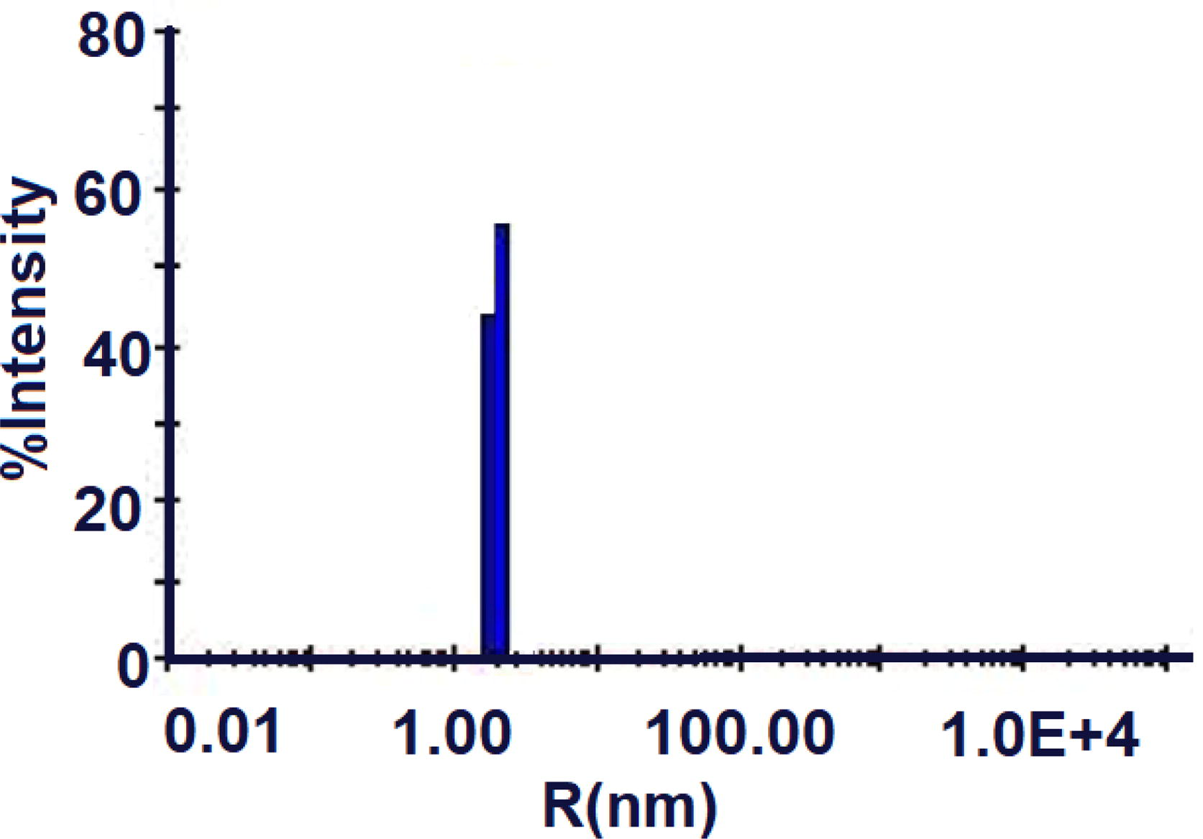

**Figure S3**. Hydrodynamic radii of HSA in presence of steroid (2).

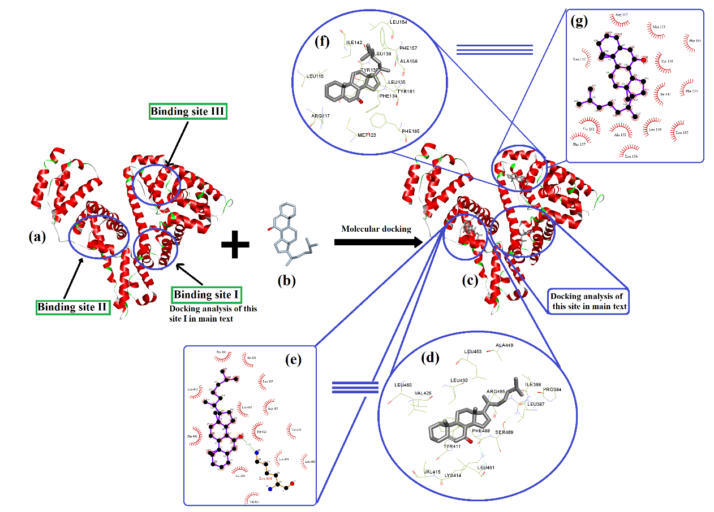

**Figure S4:** Molecular docking analysis, (a) HSA receptor with different active binding sites, (b) docking ligand (steroid), (c) steroid docked in the various binding sites, I, II & III of HSA, (d, e) steroid in the cavity of HSA at binding site II showing various interactions including hydrogen bonding and its 2-dimensional interactions, (f, g) a steroid docked into the cavity of an HSA at binding site 3 showing various interaction and its 2-dimensional interactions generated by LIGPLOT+.

**Ligand Properties derived from MD simulation**

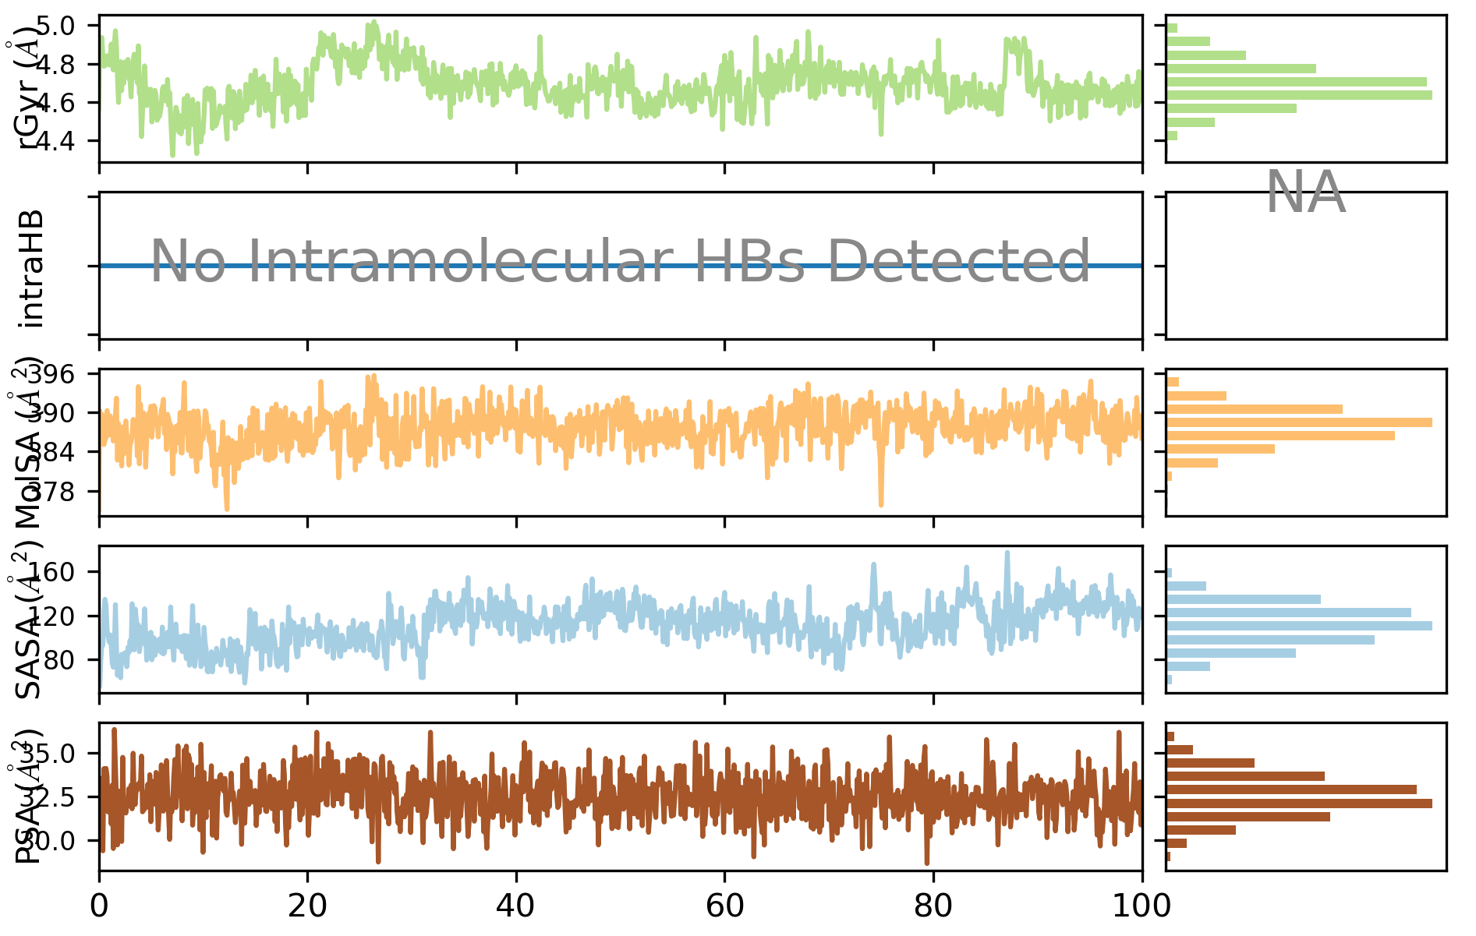

**Figure S5**: Various ligand properties obtained from 100 ns MD simulation

**QM/MM approach**

The cholest-5-ene-7-one docked to the active site of the protein in the ligand-protein complex is referred to as the QM region, while the rest of the system is referred to as the MM region, as illustrated in the figure S2. The QM region, which included a ligand surrounded by an active site, was treated using quantum mechanical approaches, whereas the MM portion was treated using MM force fields [14-17]. These two regions are interconnected via electrostatic interactions. The Hamiltonian of the hybrid QM/MM is then stated using the equation below[17].

H = HQM + HMM + HQM/MM (1)

The effective Hamiltonian is composed of three terms: the QM region, the MM region, and the interaction region (QM/MM). The latter relates to the interaction of MM point charges with electrons in the QM system, as well as MM charges with QM nuclei. Covalent interaction is not taken into account here, but Hamiltonian interactions are the total of electrostatic and Lennard Jones potentials. However, the literature also noted that ONIOM [18] energy is expressed as

EONIOM = EMM(QM,MM) + EQM(QM) − EMM(QM) (2)

where, the MM energy of the entire system is EMM(QM,MM), while the QM and MM energies of the QM region are EQM(QM) and EMM(QM), respectively.

The intermolecular interactions between the steroid molecule and the HSA were explored with the docking data after the QM/MM minimization and are shown in Figure S6b. Figure S6 shows the QM/MM-minimized steroid-receptor complex and the corresponding interactions. The hydrogen bonding interaction distance between the carbonyl group of cholest-5-ene-7-one and the LYS414 residue is little altered (2.81 Å) and is nearly unchanged before and after QM/MM minimization indicating that the complex system was stabilized under both docking and QM/MM circumstances. The approaching distance of π-sigma interaction between aromatic ring of TYR414 and alkyl group at C10-steroidal skeleton was slightly adjusted and found to be 2.60 Å, indicating that cholest-5-ene-7-one is more stable in the active pocket of HSA and has a higher binding affinity for receptor. The ONIOM energy of components dispersed from each layer was found to be -733280.07 Kcal/mol, whereas the energy of the MM and QM layers was determined to be 568.28 and -733737.37 Kcal/mol, respectively. The binding energy [19] of the system was computed using equation 7 and found to be -111.0 Kcal/mol, indicating that the system became -111.0 Kcal/mol more stable following docking with receptor and ligand. The receptor (HSA) is willing to receive a compound into its cavity and form an HSA-ligand complex.

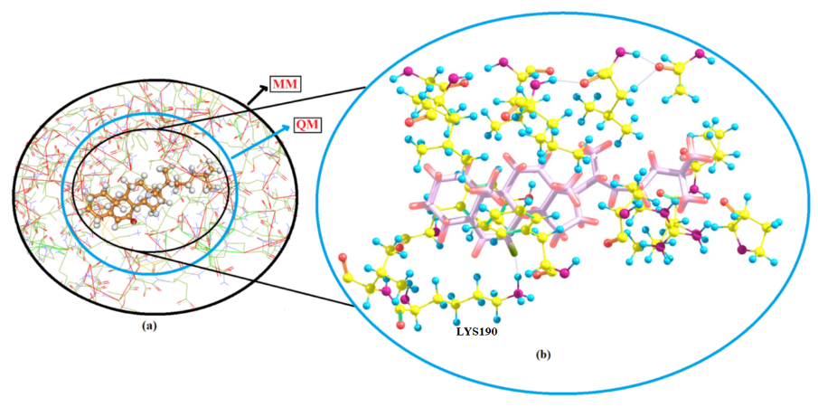

**Figure S6.** QM/MM analysis (a) division of a biological system into a QM (high level) encompassing steroid in the active site of amino acids as shown in docking analysis section and MM (low level) covering the remaining portion of amino acids and (b) intermolecular interactions of steroid (2) with HSA receptor after QM/MM minimization

References

1. Dauben, W.G.; Takemura, K. A Study of the Mechanism of Conversion of Acetate to Cholesterol via Squalene1. *Journal of the American Chemical Society* **1953**, *75*, 6302-6304.
2. Anand, U.; Jash, C.; Mukherjee, S. Spectroscopic probing of the microenvironment in a protein− surfactant assembly. *The Journal of Physical Chemistry B* **2010**, *114*, 15839-15845.
3. Wu, H.; Zhao, X.; Wang, P.; Dai, Z.; Zou, X. Electrochemical site marker competitive method for probing the binding site and binding mode between bovine serum albumin and alizarin red S. *Electrochimica acta* **2011**, *56*, 4181-4187.
4. Neamtu, S.; Mic, M.; Bogdan, M.; Turcu, I. The artifactual nature of stavudine binding to human serum albumin. A fluorescence quenching and isothermal titration calorimetry study. *Journal of pharmaceutical and biomedical analysis* **2013**, *72*, 134-138.
5. Liu, S.; Sui, Y.; Guo, K.; Yin, Z.; Gao, X. Spectroscopic study on the interaction of pristine C 60 and serum albumins in solution. *Nanoscale research letters* **2012**, *7*, 1-7.
6. Stetefeld, J.; McKenna, S.A.; Patel, T.R. Dynamic light scattering: a practical guide and applications in biomedical sciences. *Biophysical reviews* **2016**, *8*, 409-427.
7. Tabish Rehman, M.; U Khan, A. Understanding the interaction between human serum albumin and anti-bacterial/anti-cancer compounds. *Current pharmaceutical design* **2015**, *21*, 1785-1799.
8. Brańka, A.J.P.R.E. Nosé-Hoover chain method for nonequilibrium molecular dynamics simulation. **2000**, *61*, 4769.
9. Martyna, G.J.; Tobias, D.J.; Klein, M.L.J.T.J.o.c.p. Constant pressure molecular dynamics algorithms. **1994**, *101*, 4177-4189.
10. Chung, L.W.; Sameera, W.; Ramozzi, R.; Page, A.J.; Hatanaka, M.; Petrova, G.P.; Harris, T.V.; Li, X.; Ke, Z.; Liu, F. The ONIOM method and its applications. *Chemical reviews* **2015**, *115*, 5678-5796.
11. Spackman, P.R.; Turner, M.J.; McKinnon, J.J.; Wolff, S.K.; Grimwood, D.J.; Jayatilaka, D.; Spackman, M.A. CrystalExplorer: a program for Hirshfeld surface analysis, visualization and quantitative analysis of molecular crystals. *Journal of Applied Crystallography* **2021**, *54*.
12. Khan, M.S.; Sulaiman, O.; Hashim, R.; Quah, C.K.; Fun, H.-K. Cholest-5-en-7-one. Acta Crystallographica Section E: Structure Reports Online 2010, 66, o1668-o1668.
13. Garg, U.; Azim, Y.; Alam, M. In acid-aminopyrimidine continuum: experimental and computational studies of furan tetracarboxylate-2-aminopyrimidinium salt. *RSC Advances* **2021**, *11*, 21463-21474.
14. Natesan, S.; Subramaniam, R.; Bergeron, C.; Balaz, S. Binding affinity prediction for ligands and receptors forming tautomers and ionization species: inhibition of mitogen-activated protein kinase-activated protein kinase 2 (MK2). Journal of medicinal chemistry 2012, 55, 2035-2047.
15. Groenhof, G. Introduction to QM/MM simulations. Biomolecular Simulations 2013, 43-66.
16. Senn, H.M.; Thiel, W. QM/MM methods for biomolecular systems. Angewandte Chemie International Edition 2009, 48, 1198-1229.
17. Jia, X.; Mei, Y.; Zhang, J.Z.; Mo, Y. Hybrid QM/MM study of FMO complex with polarized protein-specific charge. Scientific reports 2015, 5, 1-10.
18. Hratchian, H.P.; Parandekar, P.V.; Raghavachari, K.; Frisch, M.J.; Vreven, T. QM: QM electronic embedding using Mulliken atomic charges: Energies and analytic gradients in an ONIOM framework. The Journal of chemical physics 2008, 128, 034107.
19. Reinhardt, C.R.; Hu, Q.H.; Bresnahan, C.G.; Hati, S.; Bhattacharyya, S. Cyclic Changes in Active Site Polarization and Dynamics Drive the “Ping-pong” Kinetics in NRH: Quinone Oxidoreductase 2: An Insight from QM/MM Simulations. ACS catalysis 2018, 8, 12015-12029.