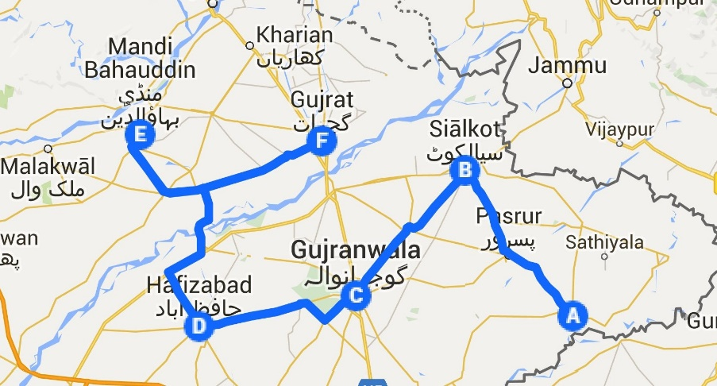

Fig S1: Survey areas of Gujranwala division, Pakistan

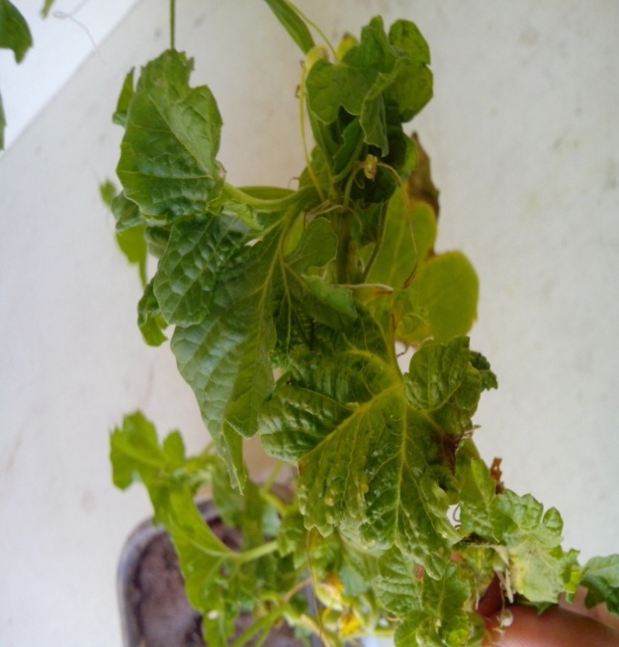

Fig S2:Cucumber plant showing curling and mosaic after inoculating with potyvirus



Fig S3:ZYMV showing similarity with other ZYMV isolates reported in the world based on nucleotides pairwise sequence comparisons