**Fabrication and characterization of high-performance photodetectors based on Au/CdS/Au and Au/Ni:CdS/Au junctions**

**Hasan Albargi1,2*, Z.R. Khan3, R. Marnadu4, H.Y. Ammar2, Hassan Algadi1,5, Ahmad Umar1,6*, M. Ashraf7, Mohd. Shkir*7,8**

*1 Promising Centre for Sensors and Electronic Devices (PCSED), Najran University, Najran-11001, Kingdom of Saudi Arabia.*

*2 Department of Physics, Faculty of Science and Arts, Najran University, Najran-11001, Kingdom of Saudi Arabia*

*3 Department of Physics, Faculty of Science, University of Hai’l, P.O. Box 2440, Hai’l, Saudi Arabia.*

*4 Nanotechnology Laboratory, Department of Physics, Sri Ramakrishna Mission Vidyalaya College of Arts and Science, Coimbatore, 641 020, Tamil Nadu, India*

*5 Department of Electrical Engineering, Faculty of Engineering, Najran University, Najran-11001, Kingdom of Saudi Arabia*

*6 Department of Chemistry, Faculty of Science and Arts, Najran University, Najran-11001, Kingdom of Saudi Arabia*

*7 Advanced Functional Materials and Optoelectronics Laboratory (AFMOL), Department of Physics, College of Science, King Khalid University, Abha, 61413, Saudi Arabia*

***8*** *School of Science and Technology, Glocal University, Saharanpur 247001, Uttar Pradesh, India*

**\*Corresponding authors:**

**Dr. Hassan Albargi** ([albargih@yahoo.com](mailto:albargih@yahoo.com))

**Prof. Ahmad Umar** ([ahmadumar786@gmail.com](mailto:ahmadumar786@gmail.com))

**Dr. Mohd. Shkir** ([shkirphysics@gmail.com](mailto:shkirphysics@gmail.com))

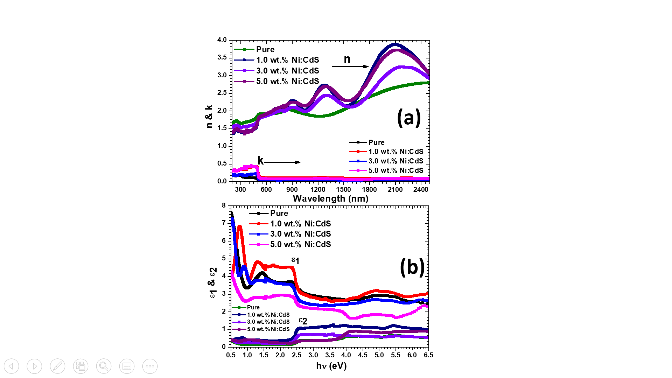

**Fig.S1.** (a)Absorption index *k* and refractive index *n* (b) Dielectric constant and Dielectric loss of nanostructure thin films with different Ni doping concentrations.

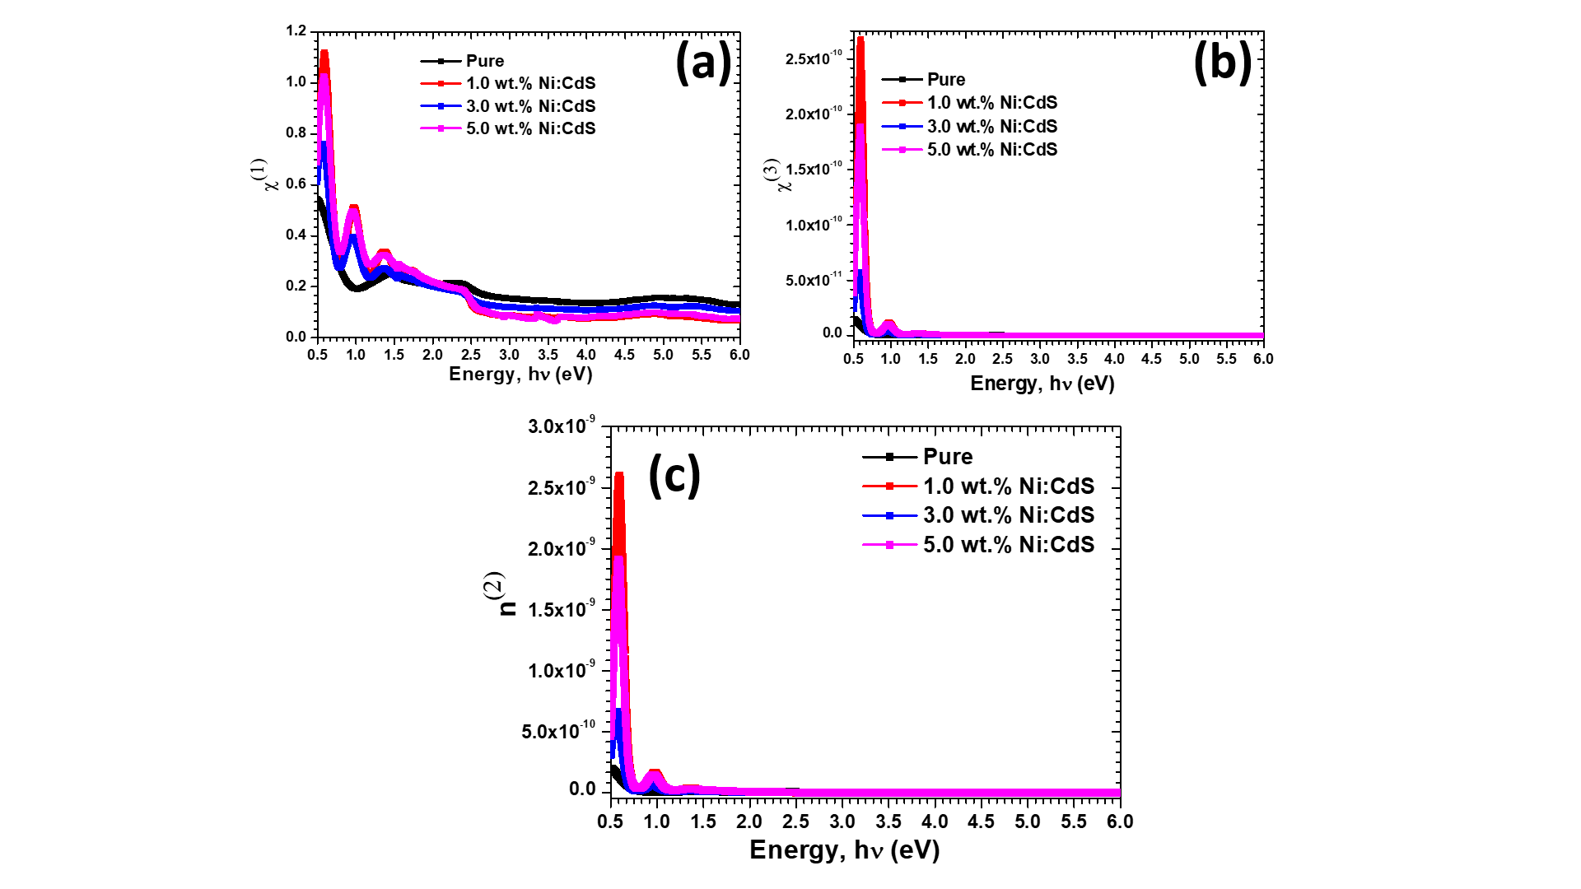

**Fig. S2.** (a) Linear optical susceptibility *(χ1)* (b) Nonlinear optical susceptibility *(χ3)* and (c) Nonlinear refractive index *(n(2))* of pure and Ni doped nanostructured thin films.