**FIGURE CAPTIONS**

**Figure S1:** Experimental UV spectrum of CFMP.

**Figure S2:** HOMO-LUMO plots of CFMP computed at TD-DFT/ B3LYP/6-311++G(d. p).

**Figure S3:**Mulliken population analysis of CFMP.

**Figure S4:**Experimental FT-IR and theoretical FT-IR spectra of CFMP.

**Figure S5:**2D fingerprint plots of the Hirshfeld surface contact contributing 100 percent of CFMP.

**Figure S6:** 2D Fingerprint plots (a) to (j) of the significant intercontact and percentage of various intermolecular contacts contributed to the Hirshfeld surfaces (a1) to (e1) in CFMP compound.

**Figure S7:** The majorpercentage contributionsto the Hirshfeld surface area for the various close intermolecular contact of CFMP.

**Figure S8:** 3D (left) and 2D (right) molecular docking of CFMP ligandwith 4e7y, 1DRF, 6CM4, and 6LVM proteins.

**TABLE CAPTIONS**

**Table S1:** NLO parameters determined of CFMP by DFT method.

**Table S2:** Frequencies calculated of CFMP using the DFT/B3LYP with 6-311++G(d,p) method as well as vibrational assignments.

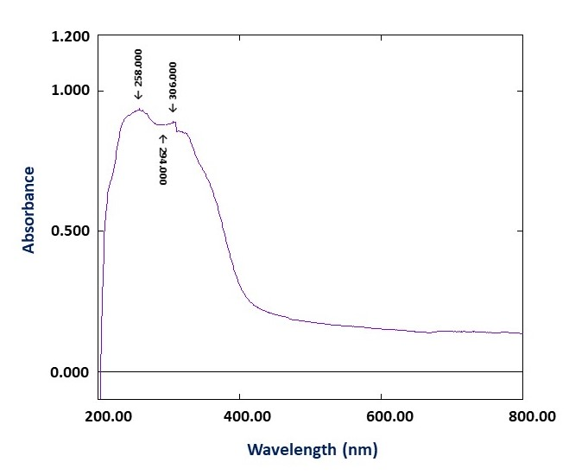

**Figure S1**

|  |
| --- |
| H:\S. Sivakumar-R. Arulraj\HOMO-LUMO.tif |
| **Figure S2** |
| H:\Fluro paper - Noureddine ISSAOUI\DFT - Noureddine ISSAOUI paper\Mulliken.png |
|  |

**Figure S3**

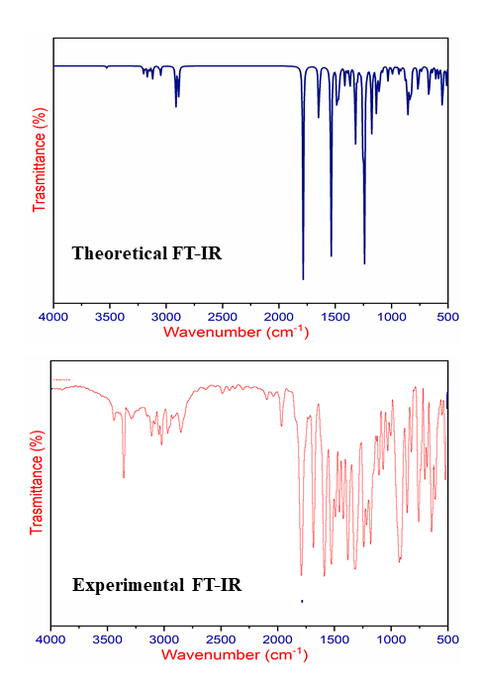

**Figure S4**

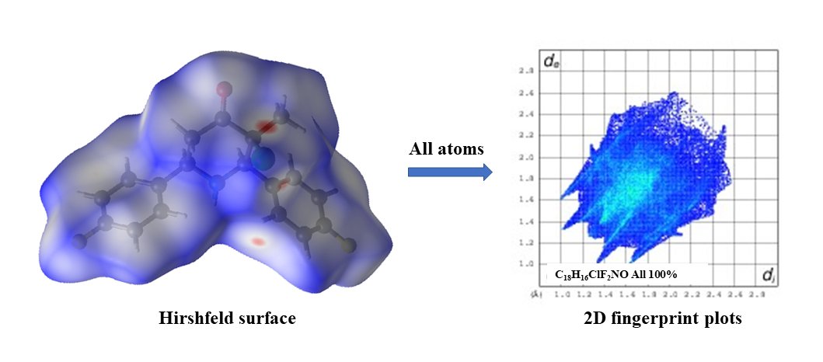

**Figure S5**

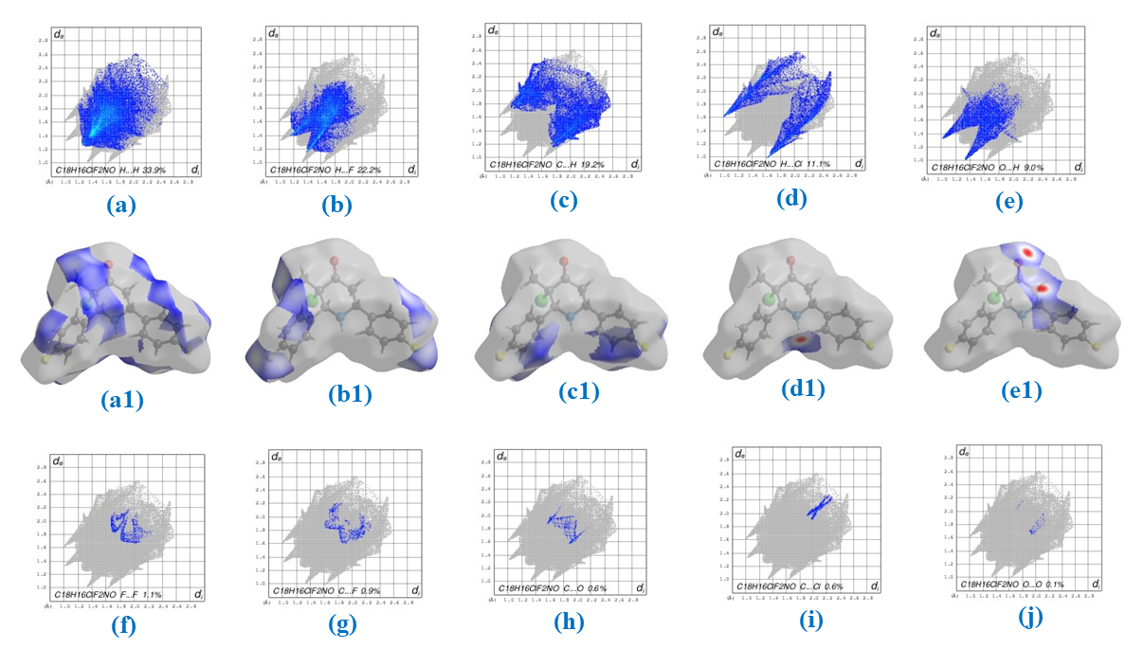

**Figure S6**

**Figure S7**

|  |  |
| --- | --- |
|  |  |

**Table S1.**

|  |  |  |  |  |  |
| --- | --- | --- | --- | --- | --- |
| **Dipole moment (μ)**  **(Debye)** | | **Polarizability (α)** | | **Hyperpolarizability (β)** | |
| **µx** | -0.038 | **αxx** | 273.309 | **βxxx** | 48.224 |
| **µy** | -0.391 | **αxy** | -0.930 | **βxxy** | 201.866 |
| **µz** | -0.810 | **αyy** | 211.060 | **βxyy** | -1.829 |
| **µtot** | 0.900 | **αxz** | -2.836 | **βyyy** | 90.658 |
|  |  | **αyz** | -21.939 | **βxxz** | -127.046 |
|  |  | **αzz** | 201.624 | **βxyz** | 22.108 |
|  |  | **αtot(a.u)** | 228.664 | **βyyz** | -19.665 |
|  |  | **αtot(e.s.u)** | 3.388×10-23 | **βxzz** | -5.613 |
|  |  |  |  | **βyzz** | 14.802 |
|  |  |  |  | **βzzz** | -98.838 |
|  |  |  |  | **βtot(a.u)** | 395.440 |
|  |  |  |  | **βtot(e.s.u)** | 3.416×10-30 |

α: 1a.u = 0.1482 ×10-24esu. β:1a.u = 8.6393×10-33

**Table S2:Frequencies calculated of CFMP using the DFT/B3LYP with 6-311++G(d,p) method as well as vibrational assignments.**

|  |  |  |  |  |
| --- | --- | --- | --- | --- |
| **Theoretical Frequency (cm-1)** | | **Experimental Frequency** | **IIR** | **Vibrational Assignments (**[**%**](https://fr.wikipedia.org/wiki/Pour_cent)**)** |
| υ**calculated** | υ**corrected** |
| 3528 | 3396 | 3326.5 | 2.37 | υNH(100) |
| 3216 | 3096 | 3256.1 | 0.40 | υCH(88) υCH(12) |
| 3202 | 3083 |  | 2.93 | υCH(90) |
| 3201 | 3082 |  | 2.41 | υCH(94) |
| 3201 | 3082 | 3074.3 | 1.68 | υCH(89) |
| 3216 | 3096 |  | 2.64 | υCH(12), υCH(87) |
| 3185 | 3066 |  | 2.35 | υCH(88) |
| 3167 | 3049 |  | 6.52 | υCH(95) |
| 3165 | 3047 |  | 6.65 | υCH(96) |
| 3147 | 3030 |  | 6.29 | υCH(93) |
| 3123 | 3007 | 3009.1 | 8.66 | υCH(93) |
| 3119 | 3003 | 2983.8 | 8.04 | υCH(92) |
| 3062 | 2948 |  | 2.78 | υCH(94) |
| 3049 | 2935 | 2929.3 | 9.59 | υCH(98) |
| 2914 | 2805 | 2808.1 | 48.93 | υCH(98) |
| 2890 | 2782 | 1898.2 | 39.98 | υCH(98) |
| 1785 | 1718 | 1718.6 | 232.01 | υOC(92) |
| 1645 | 1584 | 1607.3 | 32.57 | υCC(56), υCC(12), |
| 1645 | 1584 |  | 42.80 | υCC(52), υCC(15), |
| 1635 | 1574 |  | 7.11 | υCC(66) |
| 1633 | 1572 |  | 2.37 | υCC(63), |
| 1539 | 1482 | 1509.1 | 81.16 | δHCC(48), δHCC(10) |
| 1537 | 1480 |  | 160.33 | δHCH(43), δHCC(10) |
| 1487 | 1432 | 1446.1 | 14.30 | δHCH(86) |
| 1486 | 1431 |  | 23.10 | δHCH(73), δHCH(14) |
| 1486 | 1431 | 1409.9 | 51.88 | δHNH (11), δHNH(57) |
| 1462 | 1408 |  | 15.82 | δHCH (94) |
| 1451 | 1397 |  | 0.90 | δCCC(12) |
| 1451 | 1397 | 1373.2 | 1.12 | υCC(10), υCC(19) |
| 1417 | 1364 |  | 20.33 | δHCH (93) |
| 1395 | 1343 | 1337.4 | 7.30 | δHCN(49), δHCN(21) |
| 1372 | 1321 |  | 15.34 | υCC(12), υCC(13), υCC(10), υCC(18) |
| 1370 | 1319 | 1296.8 | 12.56 | τCCCl(59), τCCCl(15) |
| 1328 | 1279 |  | 3.14 | υCC(48) |
| 1325 | 1276 |  | 11.26 | δHCC(11), δHCC(35) |
| 1322 | 1273 |  | 62.96 | δHCN(63) |
| 1320 | 1271 |  | 22.30 | δHCC(62) |
| 1301 | 1253 |  | 10.88 | δHCC(19), δHCC(32), δHCC(13) |
| 1282 | 1234 | 1228.9 | 4.20 | δHCC(69) |
| 1372 | 1321 |  | 71.84 | δHCC(10), δHCC(37) |
| 1244 | 1198 |  | 97.16 | υFC(64) |
| 1241 | 1195 |  | 160.39 | υFC(66) |
| 1222 | 1176 |  | 3.74 | υCC(38) |
| 1215 | 1170 |  | 2.22 | υCC(32), υCC(13) |
| 1191 | 1147 | 1152.2 | 1.78 | υCC(24), υCC(10) |
| 1179 | 1135 |  | 33.59 | δHCC(18), δHCC(65) |
| 1176 | 1132 |  | 45.70 | δHCC(12), δHCC(63) |
| 1164 | 1121 | 1128.2 | 5.69 | δHCC(47) |
| 1136 | 1094 |  | 44.92 | υNC(51) |
| 1129 | 1087 | 1089.9 | 9.05 | δHCC(11), δHCC(14), δHCC(24) |
| 1116 | 1074 |  | 9.55 | δHCC(17), δHCC(46) |
| 1113 | 1072 |  | 17.96 | υNC(34), υNC(14) |
| 1102 | 1061 |  | 15.74 | υCC(45) |
| 1082 | 1042 | 1013.8 | 6.78 | δHCC(43), δHCC(10) |
| 1032 | 994 |  | 5.91 | δCCC(78) |
| 1031 | 993 |  | 10.33 | δCCC(52) |
| 997 | 960 | 978.6 | 9.30 | τCCNC(10), τCCNC(11) |
| 989 | 952 |  | 1.89 | τHCCH(73), τHCCH(11) |
| 984 | 947 | 935.4 | 1.18 | τHCCH(73), τHCCH(11) |
| 964 | 928 |  | 0.46 | τHCCC(45), τHCCC(10) |
| 959 | 923 |  | 0.90 | τHCCH(82) |
| 936 | 901 | 907.9 | 7.82 | υCC(21) |
| 917 | 883 |  | 5.99 | υCC(16), υCN(41) |
| 878 | 845 |  | 13.10 | τHCCC(10), τHCCC(12) |
| 867 | 835 | 831.6 | 14.49 | δCCC(29) |
| 858 | 826 |  | 52.33 | τHCCC(68) |
| 843 | 812 |  | 42.03 | τHCCC(19), τHCCC(16), τHCCC(11) |
| 834 | 803 |  | 4.77 | τHCCC(73) |
| 832 | 801 |  | 3.81 | τHCCC(81) |
| 829 | 798 |  | 20.24 | υFC(18), υFN(22) |
| 825 | 794 |  | 17.23 | δCCC(10) |
| 768 | 739 | 759.8 | 15.10 | τHNCC(33) |
| 763 | 735 | 720.2 | 20.56 | δCCC(10), δCCC(12) |
| 740 | 712 |  | 1.51 | τCCCC(40), τCCCC(28) |
| 733 | 706 |  | 5.44 | τCCCC(14), τCCCC(16) |
| 669 | 644 | 655.8 | 50.37 | τHNCC(23) |
| 655 | 631 |  | 1.39 | δCCC(54), δCCC(14) |
| 648 | 624 |  | 0.06 | δCCC(69) |
| 638 | 614 | 599.9 | 6.67 | τCCCC(14), τCCCC(10) |
| 607 | 584 | 577.7 | 13.10 | δCCC(10), δCCC(24) |
| 582 | 560 |  | 14.47 | υCC(13) |
| 552 | 531 | 538.7 | 35.42 | δCNC(14), δCNC(12) |
| 544 | 524 |  | 19.76 | τCNCC(15), τCNCC(21) |
| 526 | 506 | 506.7 | 1.89 | υCC(29) |
| 513 | 494 |  | 19.81 | δCCC(11) |
| 491 | 473 |  | 1.08 | τHNCC(13), τHNCC(25), τHNCC(10) |
| 439 | 423 |  | 1.93 | δCCC(47) |
| 431 | 415 |  | 0.09 | τCCCC(81) |
| 428 | 412 |  | 0.04 | τCCCC(11), τCCCC(77) |
| 418 | 402 |  | 4.03 | δCCF(64) |
| 413 | 398 |  | 5.79 | δCCF(64) |
| 398 | 383 |  | 7.22 | δCCN(29), δCCN(12) |
| 384 | 370 |  | 1.25 | τCCNC(42), τCCNC(17) |
| 335 | 323 |  | 0.69 | τCCCC(18), τCCCC(32) |
| 323 | 311 |  | 1.04 | δCCC(40) |
| 301 | 290 |  | 2.31 | δCCC(14) |
| 278 | 268 |  | 1.67 | δCCC(52) |
| 245 | 236 |  | 0.18 | δHCC(40) |
| 226 | 218 |  | 0.08 | υNC(15), υNC(12) |
| 203 | 195 |  | 0.71 | δCCN(47), δCCN(12) |
| 193 | 186 |  | 0.48 | δCCCl(55), δCCNC(11) |
| 173 | 167 |  | 0.63 | τHCCC(55), τHCCC(11), τHCCC(12) |
| 165 | 159 |  | 0.56 | τCCNC(10), τCCNC(33) |
| 156 | 150 |  | 0.34 | δCCN(18) |
| 107 | 103 |  | 1.76 | δCCCl(18), δCCCl(22) |
| 74 | 71 |  | 2.68 | τCCCC(11), τCCCC(31), τCCCC(18), τCCCC(11) |
| 68 | 66 |  | 0.86 | τCCNC(32) |
| 50 | 48 |  | 0.78 | τCNCC(61) |
| 43 | 41 |  | 0.45 | τCCCC(26) |
| 39 | 37 |  | 0.04 | τCNCC(47), τCNCC(12) |
| 32 | 31 |  | 0.08 | γCCCC(52), γCCCC(11) |