Non covalent interactions and molecular docking studies on morphine compound

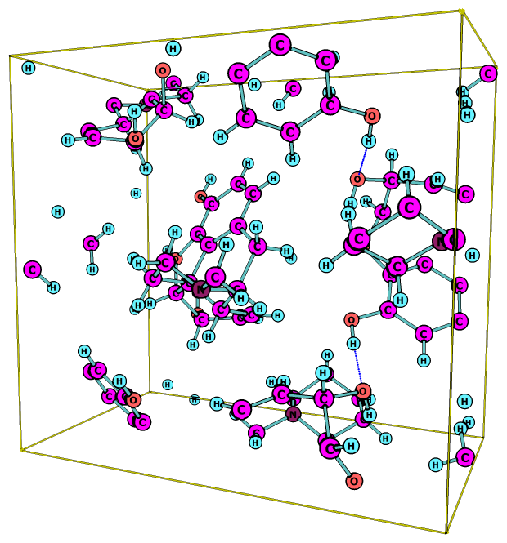
Figure S1: The crystal packing representation of morphine compound.

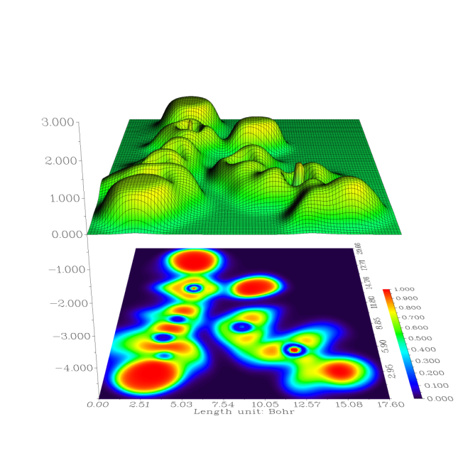
Figure S2: The ELF surface projection effect of the title compound.

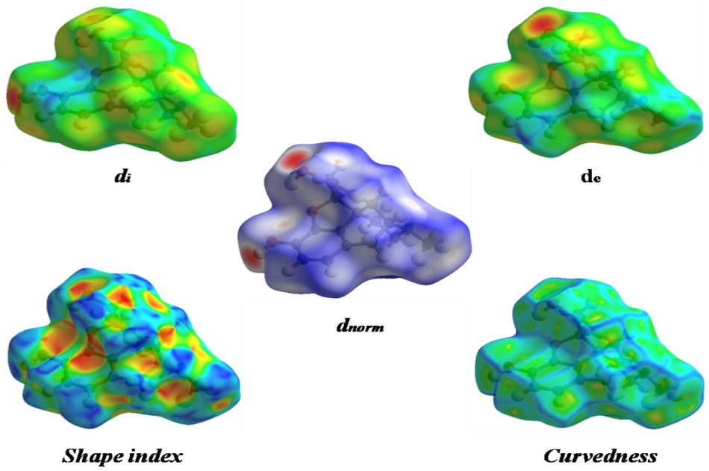
Figure S3: The d_{norm}, d_{i}, d_{e}, shape index and curvedness Hirshfeld surface plots.

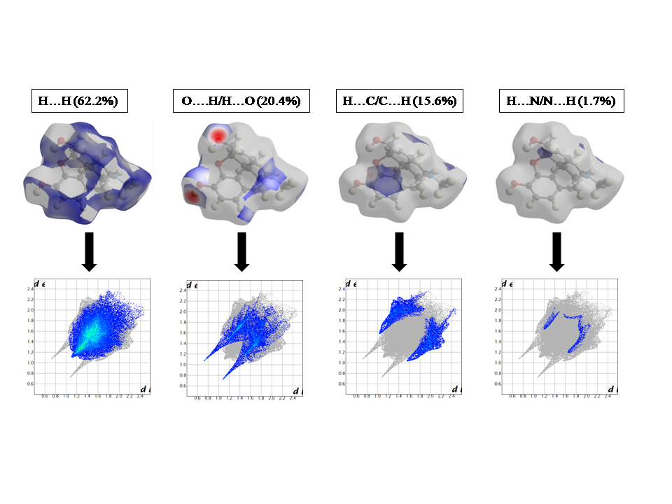
Figure S4: The fingerprint plots of each contribution along with the different percentages.

