**Supplementary material**

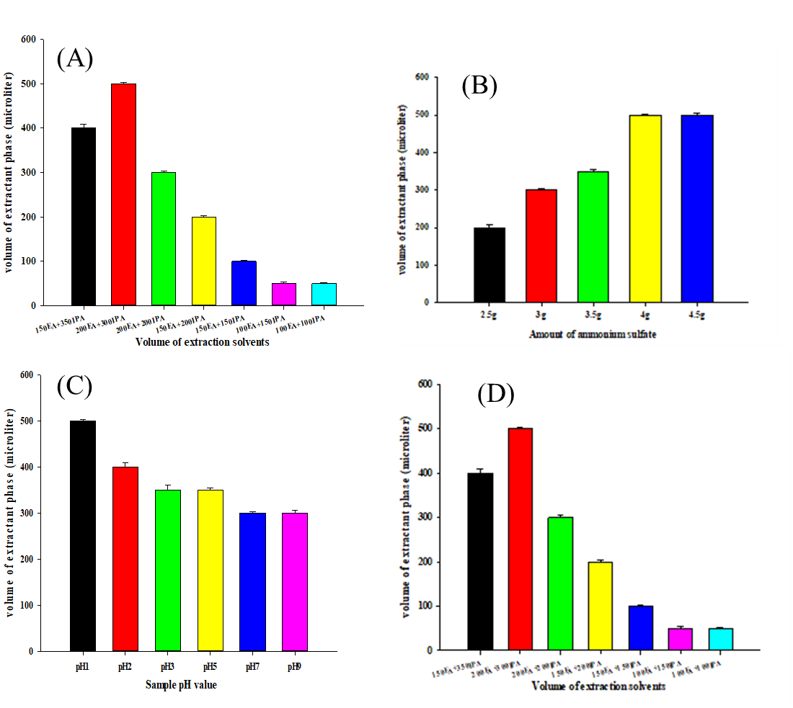

**Fig. S1. Different volume of organic extraction phase under different conditions by USA-SI-LLME method** (A) Extraction solvent agents; (B) amount of ammonium sulfate; (C) sample pH values; (D) extraction volume. Three independent experiments (mean ± SD).

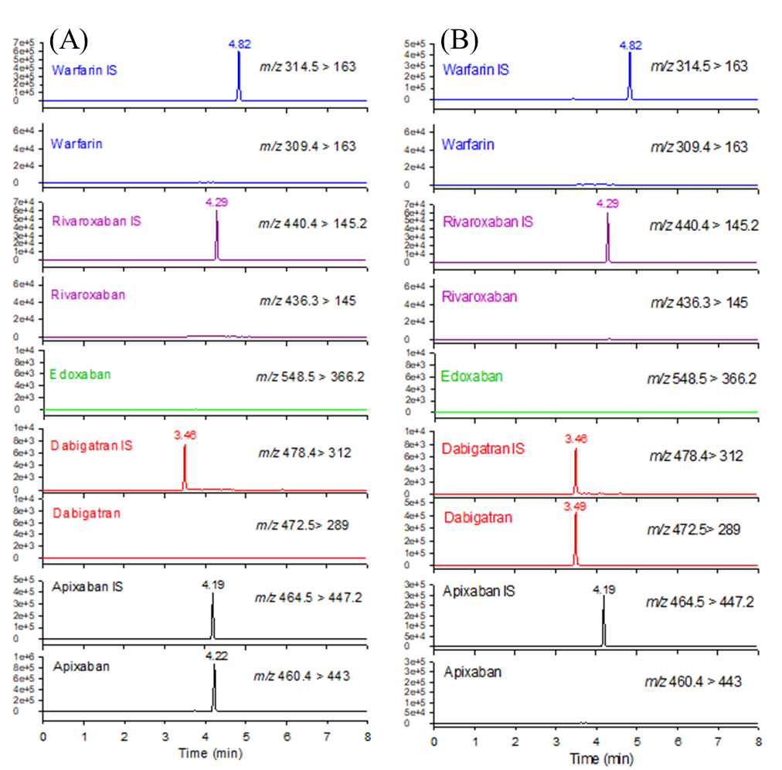

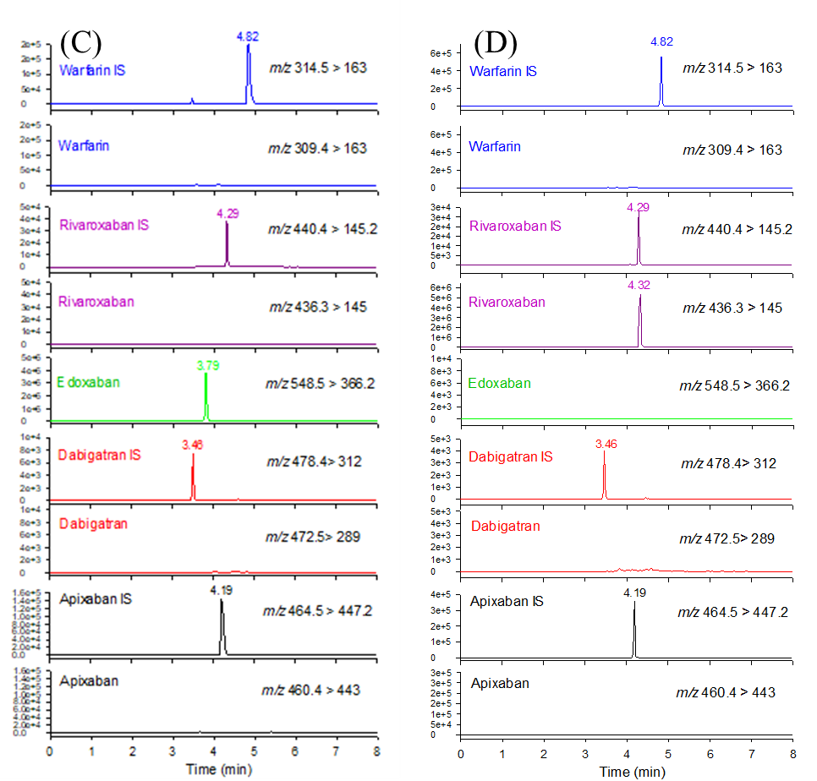

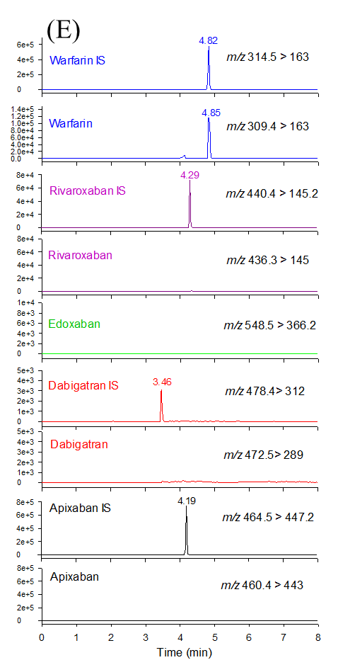

**Fig. S2. Extracted ion current chromatograms.** The chromatograms based on our analysis of warfarin and NOACs in one-spot urine samples obtained from patients treated with the anticoagulants (A) Apixaban, (B) Dabigatran, (C) Edoxaban, (D) Rivoraxaban and (E) Warfarin.

**Table S1**. The condition of HPLC-MS/MS parameters for the quantification of anticoagulants.

|  |  |  |  |  |  |  |  |
| --- | --- | --- | --- | --- | --- | --- | --- |
| **Analytes** | **Q1  (m/z)** | **Q3  (m/z)** | **RT  (min)** | **DP (V)** | **EP (V)** | **CE (V)** | **CXP (V)** |
| Apixaban | 460.4 | 443.0 | 4.22 | 100 | 10 | 23 | 12 |
| Dabigatran | 472.5 | 289.0 | 3.49 | 75 | 10 | 40 | 16 |
| Edoxaban | 548.5 | 366.2 | 3.79 | 70 | 10 | 30 | 8 |
| Rivaroxaban | 436.3 | 145.0 | 4.32 | 60 | 10 | 35 | 12 |
| Warfarin | 309.4 | 163.0 | 4.84 | 55 | 10 | 21 | 10 |
| [13C.d3]-Apixaban | 464.5 | 447.2 | 4.19 | 95 | 10 | 35 | 10 |
| [13C6]-Dabigatran | 478.4 | 295.2 | 3.46 | 40 | 10 | 30 | 18 |
| Rivaroxaban-d4 | 440.4 | 145.2 | 4.29 | 100 | 10 | 60 | 22 |
| Warfarin-d5 | 314.5 | 163.0 | 4.82 | 45 | 10 | 20 | 7 |

Note: CE, collision energy; CXP, collision cell exit potential; DP, declustering potential; EP, entrance potential; Q1, precursor ion; Q3, product ion; RT, retention time