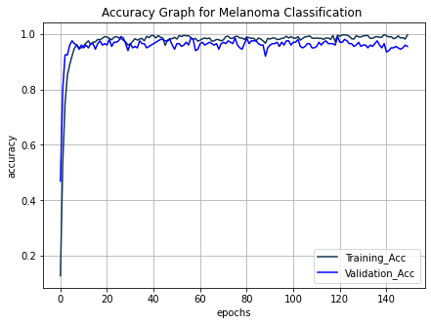

Figure SI Accuracy graph for Melanoma Recognition

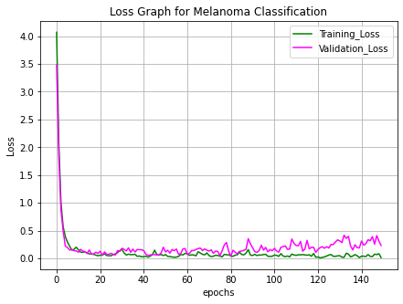

Figure SII Loss Graph for Melanoma Recognition

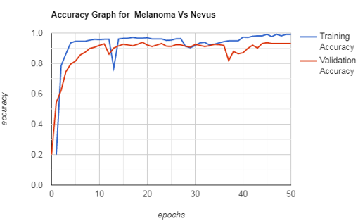

Figure SIII Accuracy graph for Melanoma Vs Nevus

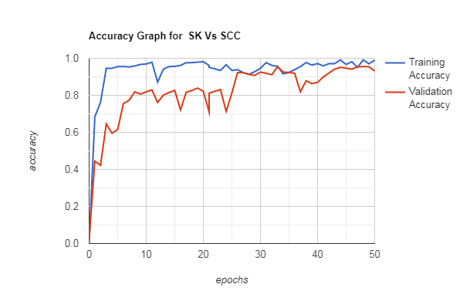

Figure SIVAccuracy graph for SK Vs SCC

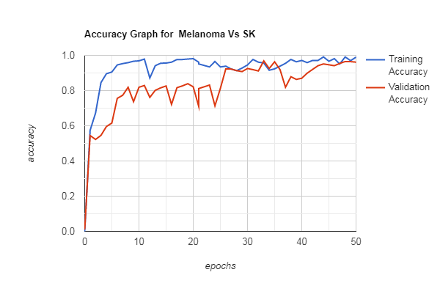

Figure SV Accuracy graph for Melanoma Vs SK

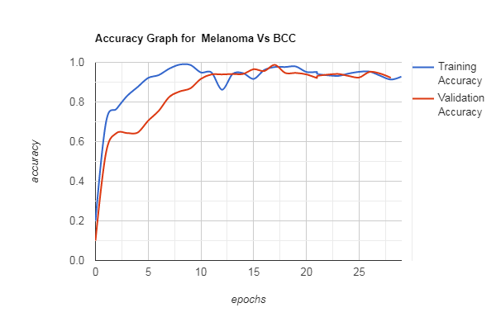

Figure SVI Accuracy graph for Melanoma Vs BCC

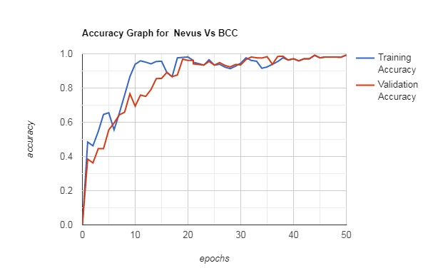

Figure SVII Accuracy graph for Nevus Vs BCC